**Number：01**

**Version: 05**





**Fabric Defect Detection System**

**Test Plans**

Software Project Management Group 11

Time：2023.5.26

## 1. Test Background

In order to ensure the organisation of the testing work of the cloth defect detection system project and to improve the quality and efficiency of the testing work, complete test objectives, test scope, test rounds, test tools, test schedules and functional tests are provided for the testing work of the cloth defect detection system project to ensure the smooth and orderly operation of the testing project.

## 2. Test Objectives

The test objectives for the cloth defect detection system test program :

1. 60% coverage of interface procedures and 100% revision of interface errors

2. 60% functional coverage and 100% execution rate of test cases

3. 90% regression test coverage of modified test issues

4. 60% test record closure rate

## 3. Test range

1. Test planning and design: Develop test plans and test protocols according to software requirement specification, including collection of test methods, test cases, test tools, etc.

2. Unit testing: According to the detailed system design, develop test plan and test plan. This item is self-tested by the developer.

1. Integration testing: Combine each module for testing to ensure all functions and interfaces are correct. Load testing of key modules of the product to ensure that the software performance meets the requirements of the software requirement specification

**4.** **Testing tools**

| **Uses** | **Tools** |
| --- | --- |
| Test Management | WeChat,Github |
| Function Tests | JUnit |
| API Tests | API POST |

## 5. Schedule

       The cloth defect detection project is small and the testing work includes for test planning, test case writing, integration test execution, performance test execution and the schedule is shown below.

|  |  |  |  |  |
| --- | --- | --- | --- | --- |
| **Test phase** | **Test tasks** | **Workload estimates** | **Staff** | **Start and finsh times** |
| Model Test | Modify the model. | 14 Days | Testers | 4.10-4.23 |
| Function Tests | Test the defect of the system. | 28 Days | Testers | 4.24-5..21 |
| API Tests | Test the api of the system. | 10 Days | Testers | 5.22-6.1 |
| Help and user manual tests | 1. Help test  2. User manual test | 10 Days | Testers | 5.22-6.1 |
| Test instructions | Test summary and analysis, problem feedback | 10 Days | Testers | 5.22-6.1 |

## 6. Functional testing

Login Registration

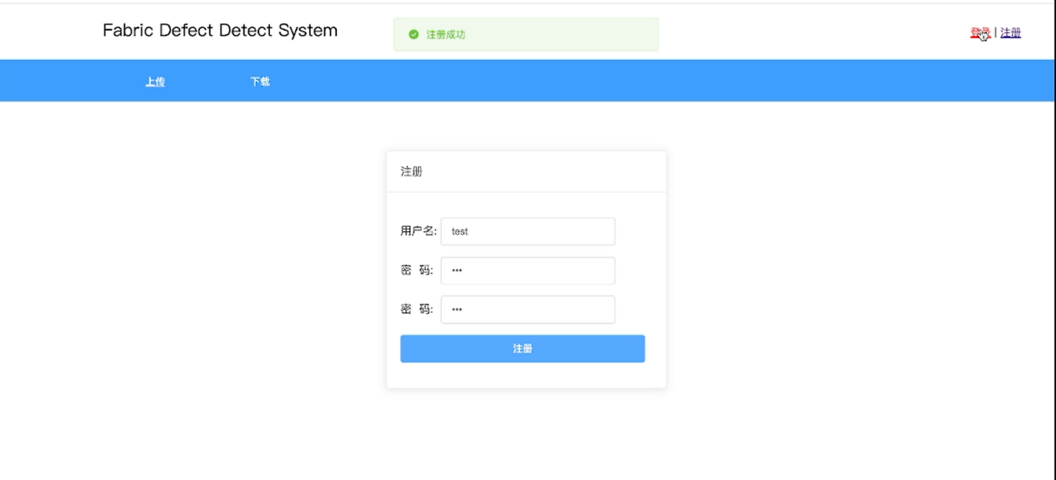

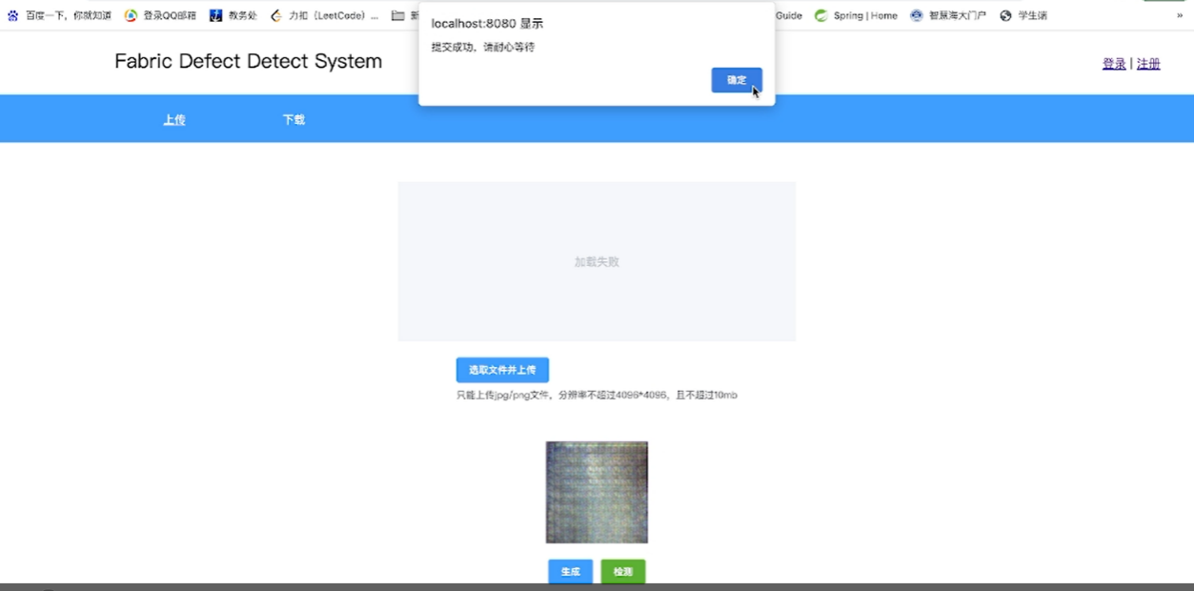Upload fabric images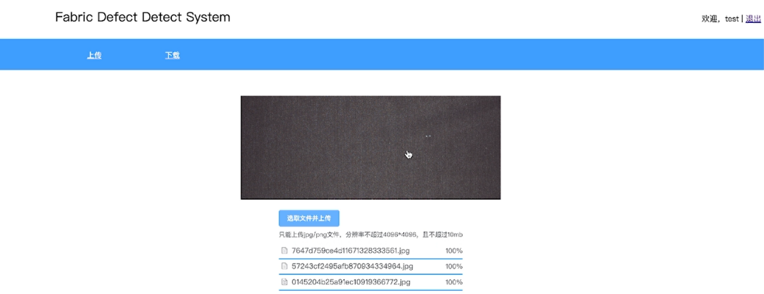

Download results

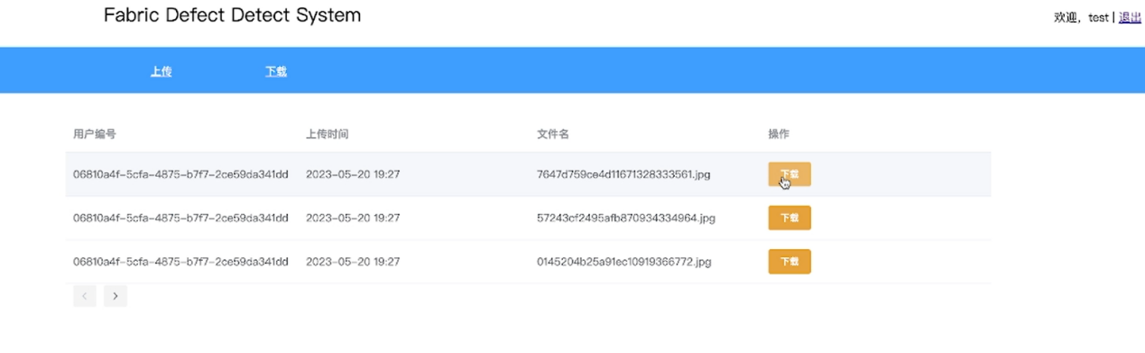

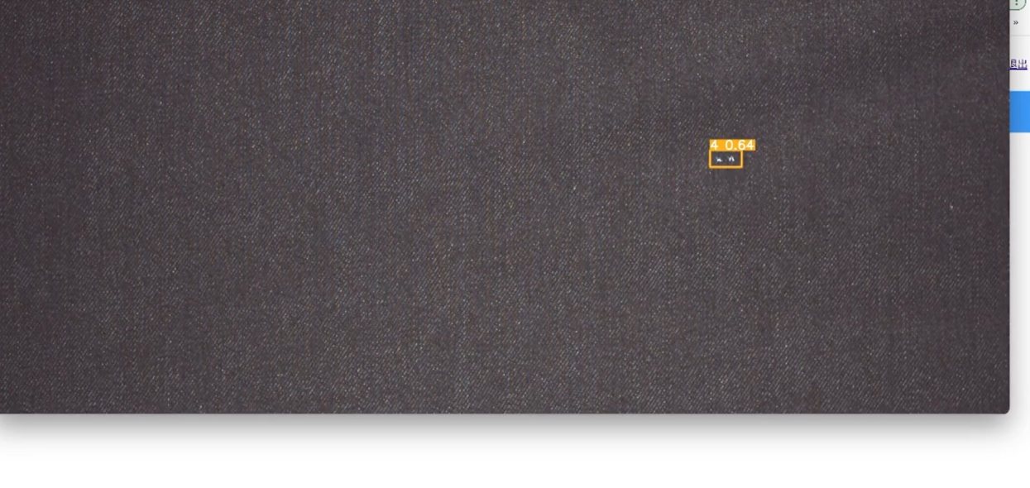

## 7. Test instructions

System account registration and login has been implemented (including risk testing of user names and passwords)

Uploading of fabric images has been implemented (including risk testing of other image uploads)

Downloading of fabric defect test results has been implemented (including downloading to local functionality)