**Number：01**

**Version: 04**





**Fabric Defect Detection System**

**User Manual**

Group 11

Time：2023.5.20

**1.Project overview**

This project aims to develop an online fabric defect detection system. It is mainly composed of an online detection module and a deep learning module. The online detection module provides an interface on which users can upload images for detection or generate images for performance testing. The deep learning module is mainly composed of corresponding models to provide defect detection function.

The system is developed by B/S architecture, and the entire system will be released together after completion, rather than individually for each module.

**2.Operating environment**

(1) Hardware environment: A PC with a memory of 4G RAM or more

(2) Operating system: Windows 7 or above or MacOS

(3) Database: MySQL 8.0.28

(4) Network environment: A more stable network

**3.Sign up**

Users can access this system by entering the correct website address in the browser,

Then register a personal account, which is shown in Figure 1.1.

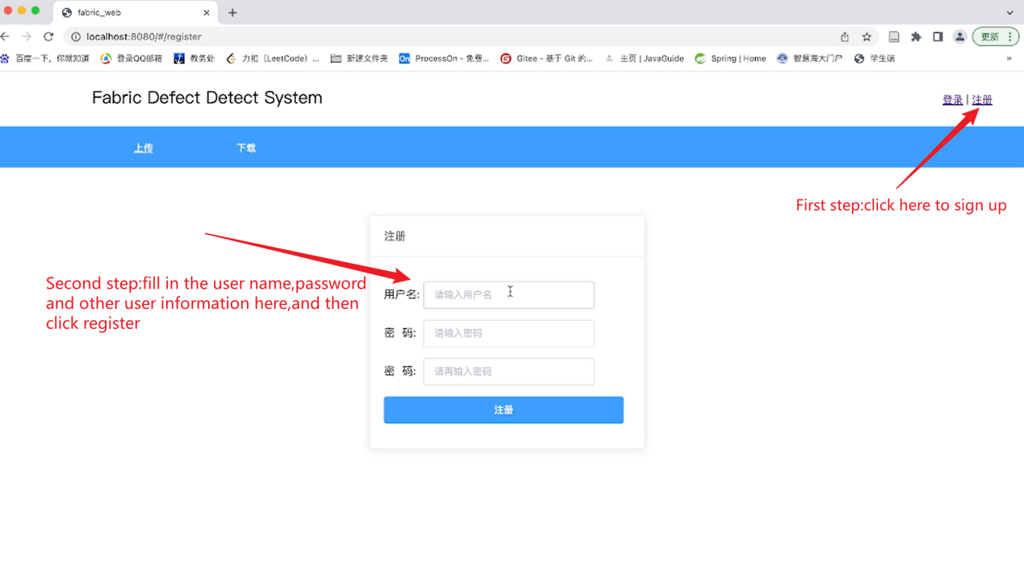

Figure 1.1

**4.Login**

After registering a personal account, the user enters the login web page and enters information such as username and password to login. The login steps are shown in Figure 1.2

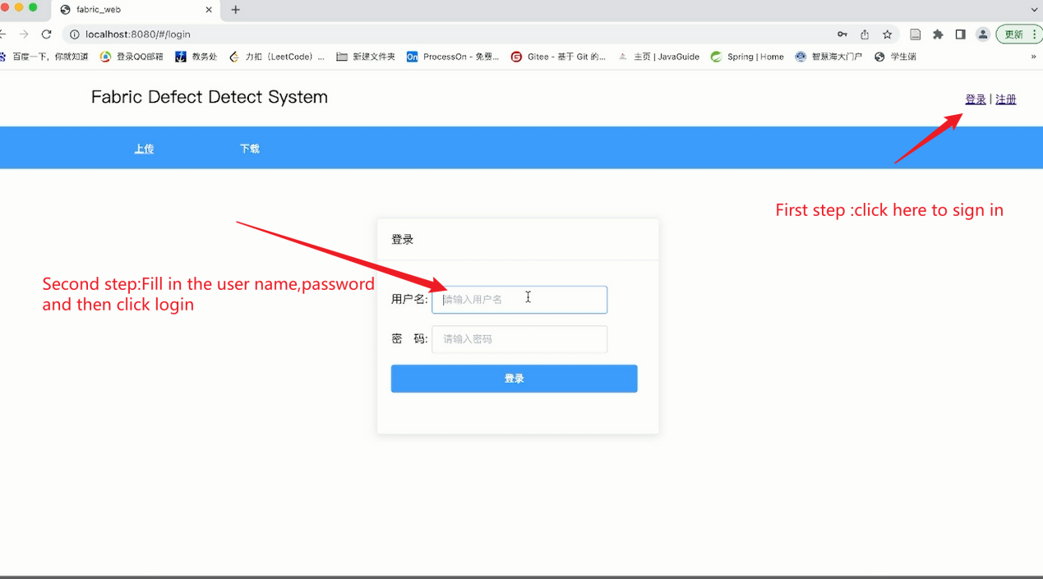

Figure 1.2

**5.Upload and detect**

After logging into the system, users can upload images of the fabric to detect or generate a fake picture to test our system, which is shown in Figure 1.3

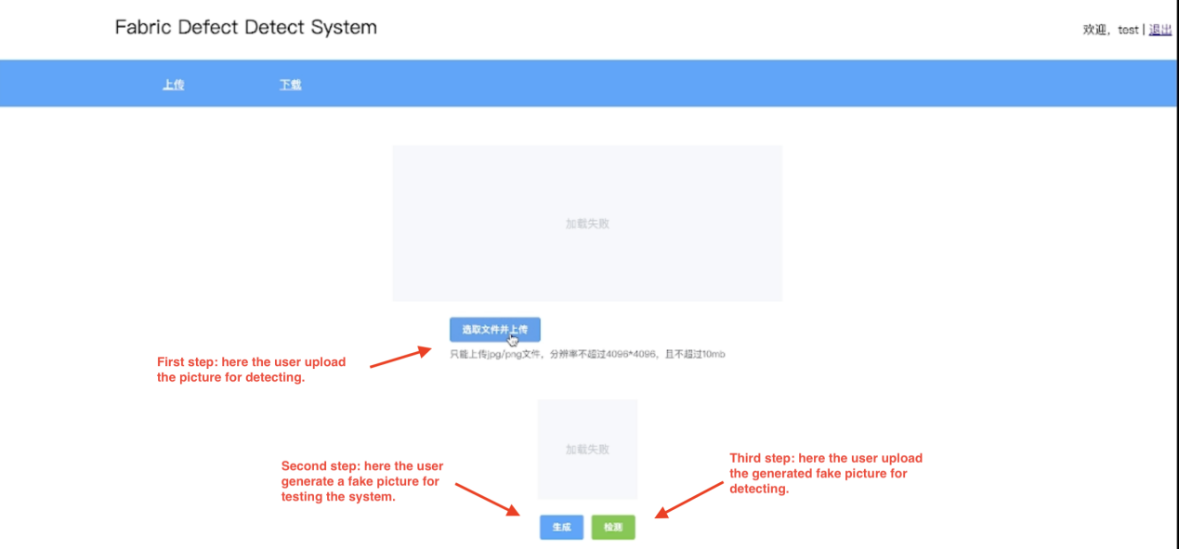

Figure 1.3

**6.Download**

After the system detects the images, users can download the detected images in the download page. The step and outcome are shown in Figures 1.4 and 1.5

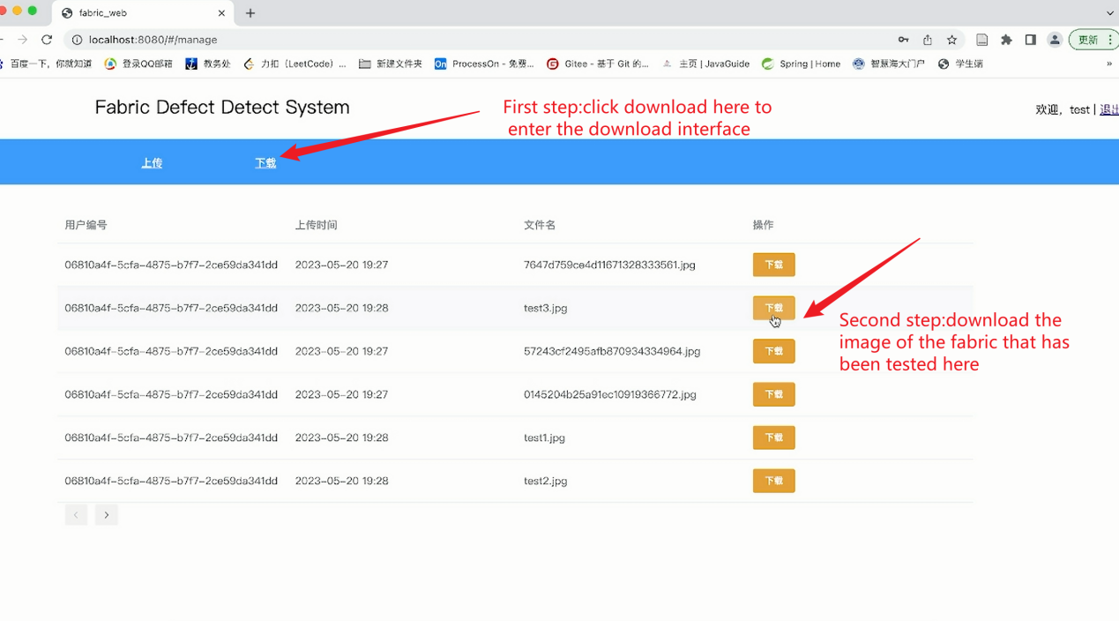

Figures 1.4

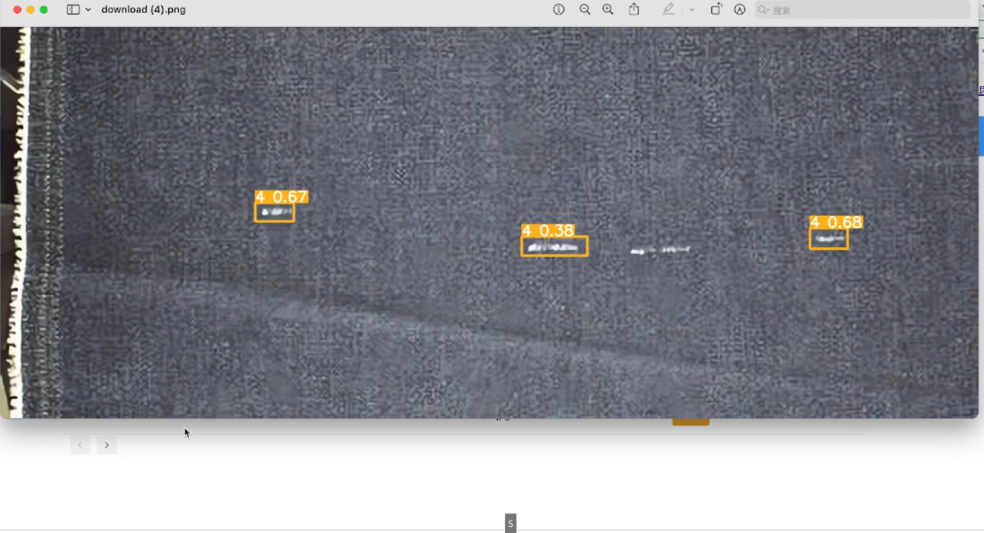

Figures 1.5