

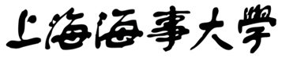

**Software project plan**

Project Name：Fabric Defect Detection System

|  |  |
| --- | --- |
| Member： | 谢逸晨 |
|  | 宋昱辰 |
|  | 鹿路 |
|  | 徐铎瀚 |

Time：2023.3.28

Table of contents

Software project plan 1

1.Project Outline 1

1.1 Background 1

1.2 Project overview 1

1.4 Final Content 1

1.5 Project development environment 2

1.6 Project acceptance method 2

2.Technology Introduction 3

2.1 System structure diagram 3

2.2 Model 3

2.3 System 5

3.Project Team Organization 6

3.1 Character 6

3.2 Organization structure 6

3.3 Task 7

3.4 Implementation and communication 7

4.Project development plan 8

4.1Task description 8

4.2Project Schedule 9

4.3Milestone Description 12

5.Project Risk 14

**1.Project Outline**

**1.1 Background**

Artificial intelligence is a strategic emerging industry in China. With the continuous improvement and upgrading of various industries, industrial informatization has gradually been put on the agenda. AI plays an important role in informatization, which can replace human to complete some complex and time-consuming tasks in the past.

Fabric defect detection is an important part of production and quality management in the textile industry, and intelligent detection of fabric defects has been a technical bottleneck that has puzzled the industry for many years. Currently, almost all of the detection are manual tasks, which are susceptible to subjective factors and lack consistency; And long-term work under strong light has a huge impact on testers’ health. Using advanced technologies such as AI and CV to achieve intelligent detection of fabric defects is undoubtedly of great value.

**1.2 Project overview**

This project aims to develop an online fabric defect detection system. It is mainly composed of an online detection module and a deep learning module. The online detection module provides an interface on which users can upload images for detection or generate images for performance testing. The deep learning module is mainly composed of corresponding models to provide defect detection function.

The system is developed by B/S architecture, and the entire system will be released together after completion, rather than individually for each module.

**1.3 Technical advantage analysis of the project**

Currently, both industry and academia have do a lot of research on generation models and target detection models, and have achieved excellent performance. Many fabric defect detection systems currently on the market also use the most advanced models. However, these advanced models are often difficult to reproduce and have a large number of parameters, which also require a lot of money to establish. Therefore, our system has chosen the most popular and stable model to provide a relatively reliable system with minimal investment.

**1.4 Final Content**

The final contents of this system mainly include:System, Source code, trained model files, project plans, technical documents, user manuals, etc.

System: The system refers to a complete system. Users can log in to the system and perform corresponding operations to detect fabric defects.

Source code:The source code mainly includes the source code of the system and the source code of the model. The source code is responsible for showing the specific details and implementation of the project, but also can show the workload. Open source code can also be used by other users and peers for secondary development or reference.

Trained model files: The trained model refers to the model that has been trained locally. Users can directly use the model to fulfill the corresponding requirements.

Project Plan: Project plan refers to the complete plan of the whole project development period, for others to check the introduction of the system, the various arrangements and plans during the development, and the treatment of special cases.

Technical documents: It mainly includes interface documents and test documents. Interface documents are mainly used in coordinated development, and the parameters, return values and excuses of each interface specified in the document are introduced. The test document mainly records the test results of each module of the project, so as to ensure the executable of the code and prevent the occurrence of software defects.

User manuals: The user manual is mainly responsible for helping users understand the main functions of the system, and providing examples to teach users how to use the system.

**1.5 Project development environment**

The development environment of this project is four PC.

**1.6 Project acceptance method**

All content of the system will be submitted to GitHub for teachers to check and the system will be introduced through a presentation in the last week.

**2.Technology Introduction**

**2.1 System structure diagram**

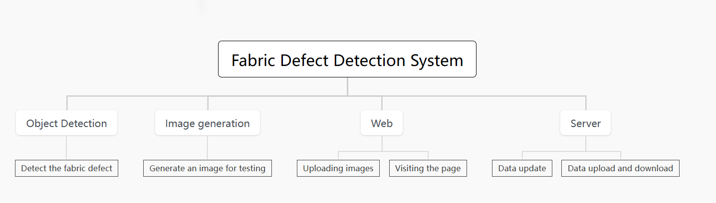

**2.2 Model**

**2.2.1 Main model**

The most important function of this system is to realize the object detection module.This system uses the object detection module to detect fabric defects. The model used in the object detection module is yolov3.

Yolov3 model is a very traditional but classic model in the field of object detection. The model mainly consists of three parts, namely Darknet-53 backbone network and its residual network, feature fusion layer (concat) and the final classification and detection structure

The structure of Yolov3 is shown below. The detection of fabric defects by yolov3 in this system is mainly divided into two steps: determining the position of the defect, and then determining whether it is a defect class or a fabric class. To refine the specific operation process of the model, yolov3 will convert it into a 416×416 size grid, add gray bars to prevent distortion, and then the picture will be divided into three grid pictures (13×13, 26×26, 52×52). The model obtains the prediction results according to the features, and extracts three feature layers. Depending on the size of the defect, the feature layer is used, which produces red boxes. Next, the prediction results need to be decoded. The predicted red box generated by the feature layer is calculated to obtain the coordinates of the bounding box bx,by and the position of the bounding box. The calculation process is as follows. The boxes and scores of each class whose score is greater than a certain threshold are taken out and sorted. Non-maximal suppression is performed using the position and score of the box. The final bounding box with the highest probability is the one that is displayed last.

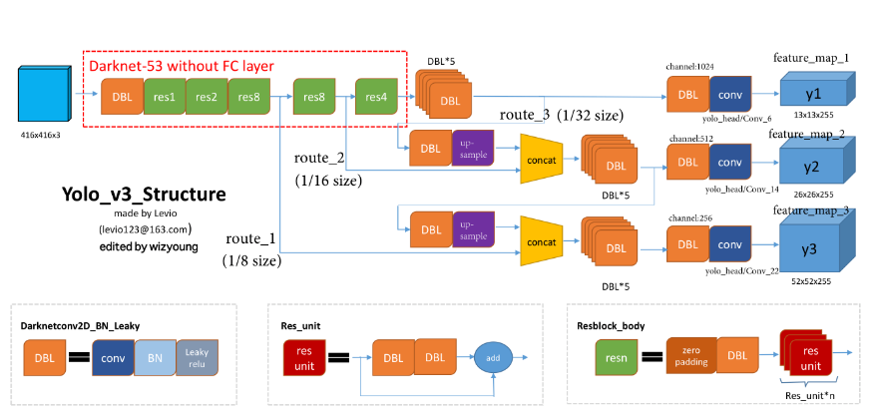

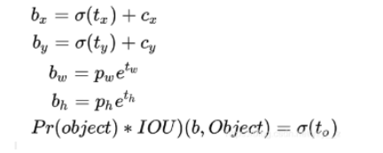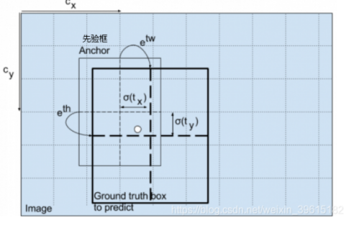  
**2.2.2 Secondary model**  
 The secondary function of our system is to use the generative model to assist the object detection module.

In this system, high qulity images with 2K resolution are used to train the object detect model, but in real application scenarios, many images cannot achieve 2K resolution, so we need to use low-qulity fabric images to test the model, but we lack a low-qulity image dataset, so we propose a solution: A generative network is used to generate fake and low-quality images. At the same time, for users who want to use the system but can not upload pictures for various reasons, the system can generate a picture for testing.

This system uses generative adversarial networks to generate fabric images.GAN is the one of most famous generative model .The main structure of GAN includes a generator G and a discriminator D. The generator will use random noise to fit the true distribution and train it with the true distribution in the discriminator until the discriminator cannot distinguish whether the image comes from the true distribution or the generator fitted distribution.

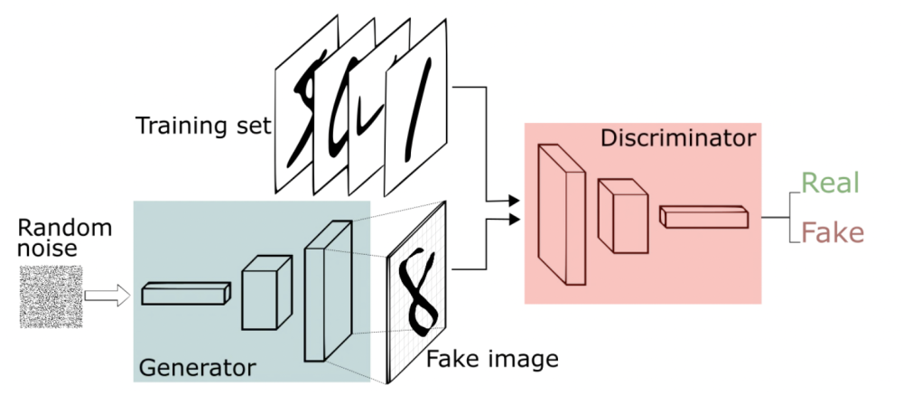

**2.3 System**  
 This system needs a carrier to display the predicted and generated results of the model, so we choose to develop a webapp with B/S architecture to display the prediction and generated results. The B/S architecture is chosen because the current mainstream webapp is this architecture, and users only need to use a browser to access our website to obtain services, which greatly improves the user experience.

The front-end of this system is implemented with Vue.js, which is a Javascript framework for building user interfaces. It is built based on HTML,CSS and Javasccript, and provides a set of declarative and component-based programming models to help users develop user interfaces in a funny way.

The system back-end is written in java, and Springboot is used to build the whole back-end project. Spring Boot is a new framework from the Pivotal team that's designed to simplify the initial process of building and developing Spring applications. The framework uses a specific way to do configuration so that the developer does not need to define boilerplate configuration. In this way, Spring Boot is committed to becoming a leader in the burgeoning field of rapid application development.

**3.Project Team Organization**

**3.1 Character**

For efficient development and effective project management, this system mainly has the following roles:

Project Manager(PM, 1 person): The project manager is responsible for coordinating the planning and execution of the project to ensure the smooth and active operation of the team. The project manager is also responsible for managing relevant stakeholders and coordinating relationships between different departments. The project manager manages all the processes, assigning tasks and ensuring that each team member is consistent with the project schedule.

Developer(2 person): Responsible for the development of the front-end and back-end of the system and the construction of the model. Develop the person responsible for writing the actual code. The front-end developers work on the visible elements of the product, the back-end developers work on the server side of the product, and the algorithm developers build the models.All three are called Developer.

Test(1 person) : The tester is responsible for testing the various modules of the system.

Quality Assurance (QA, 1 person) : A quality assurance engineer tests the product to ensure that it meets standards and customer expectations. Think of them as the ultimate editor with a keen attention to the tinier details. They detect errors and defects in a timely manner so that the team can fix them before the end users evaluate the product.

**3.2 Organization structure**

The project called “fabric-defect-detection system” is developed by our team. In terms of the organization structure of the team, it’s not fixed but everone has his main character. There are four members in the team, in different periods of development, members with relatively less task will become project managers to organize and supervise the progress of the project, so as to ensure the project can be completed

|  |  |  |
| --- | --- | --- |
| Name | Advantage | Character |
| Yichen Xie | Development | 1.Developer  2.Test |
| Yuchen Song | Development | 1.Developer  2.QA |
| Lu Lu | Manage | 1.PM  2.Test |
| Duohan Xu | Manage | 1.PM  2.QA |

**3.3 Task**

There are four members in the team. As mentioned above, the core function of the project is defect detection, which will mainly have four functional modules: detection model corresponding to target detection, generative model corresponding to generation adversarial net, basic web page, and server. The target prediction model will be led by one person and assisted by others, while the generation model will be led by one person and assisted by others. The web page display will be led by one person, and the server will be led by two person. As mentioned above, a single functional module will be led by one person and assisted by others, and the team members will participate in the whole project development. Everyone need work in the whole project cycle.

**3.4 Implementation and communication**

In terms of project implementation and communication, the team will hold a weekly meeting to arrange tasks and summarize the current project results. If necessary, a temporary online meeting will be held to communicate and implement the project.

**4.Project development plan**

**4.1Task description**

This part shows all the tasks of the system and their corresponding subtasks, and gives the approximate submission time and the content to be submitted.

|  |  |  |  |  |
| --- | --- | --- | --- | --- |
| Task | Sub-task | Finish Time | Submit Content  (most important content) | Description |
| Preparing | Making  team | Week 3 | Team list |  |
| Selecting  project | Week 4 | Brief description of the project | Fabric defect detection |
| Write plan | Week 5  Week 6 | Project Plan | Because of the lesson,we will submit it at Week 7. |
| Modify the plan | Week 7  Week 8 | Modified Project Plan | We will update the project plan with more details. |
| Learning | Learning deep learning and developing | Week 7  To  Week 15 | A report | The report is about what you have learned or worked in this week |
| Model building | Learning the generative model and detection model | Week 8 | Submit a demo | Member who is responsible for the model should sumbit a demo using open access datasets.The demo is about the model you learned. |
| Building the model for the project. | Week 9 | Submit the model | The model may not be prefect or complete.  However,it must be used to solve the real problem |
| Finishing the model | Week 10 | Submit the model | The model must be used to solve the proposed problem.  Member need to submit a relatively complete model. |

|  |  |  |  |  |
| --- | --- | --- | --- | --- |
| Work | Sub-work | Finish Time | Submit Content  (most important content) | Description |
|  | Updating the model | Week 10  To  Week 15 | Update the model | If the model can’t solve problem perfectly, members can update the model. |
| Development | Developing the server of system | Week11  To  Week12 | Source Code of the server. |  |
| Developing the web page | Week 13  To  Week 14 | Source Code of the web page. |  |
| Testing | Testing the module of the system | Week 8  To  Week 14 | Test Documentation |  |
| Testing the complete system | Week 15 | Test Documentation |  |
| Finishing | Finishing the project | Week 15 | The complete system and documents |  |

**4.2Project Schedule**

This section mainly introduces the schedule of the whole project, and gives the project schedule and Gantt chart. The specific content is shown in the figure below.

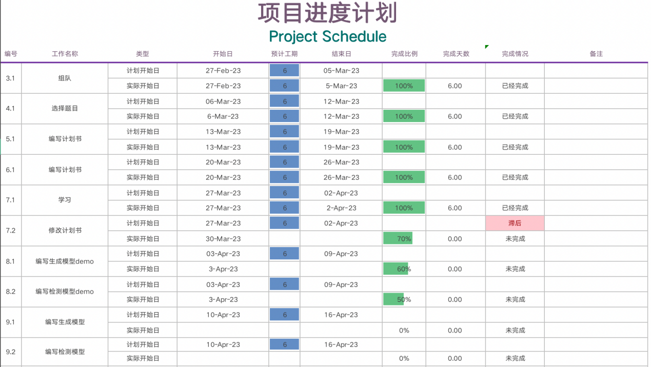

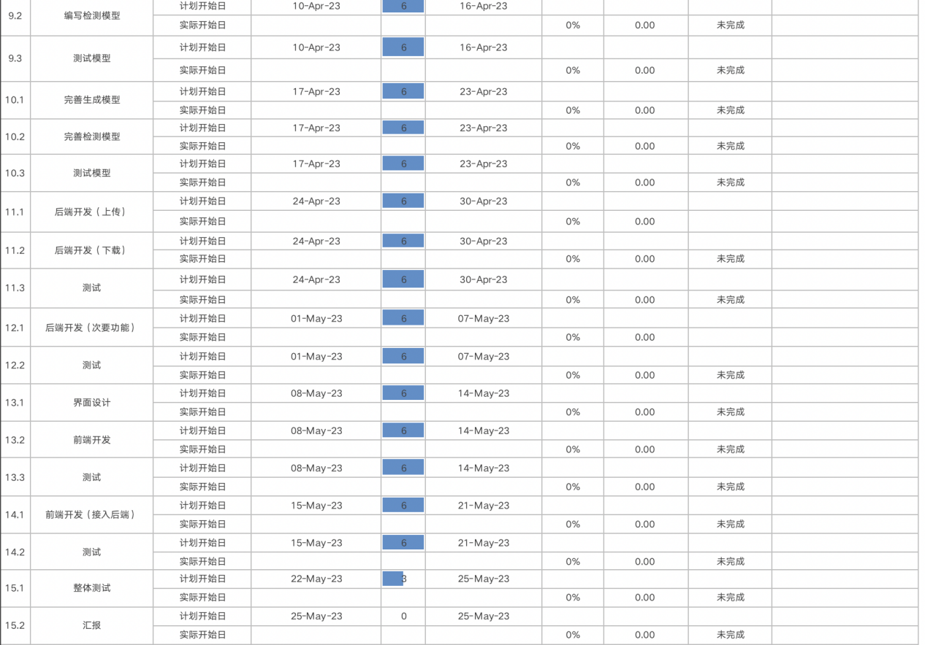

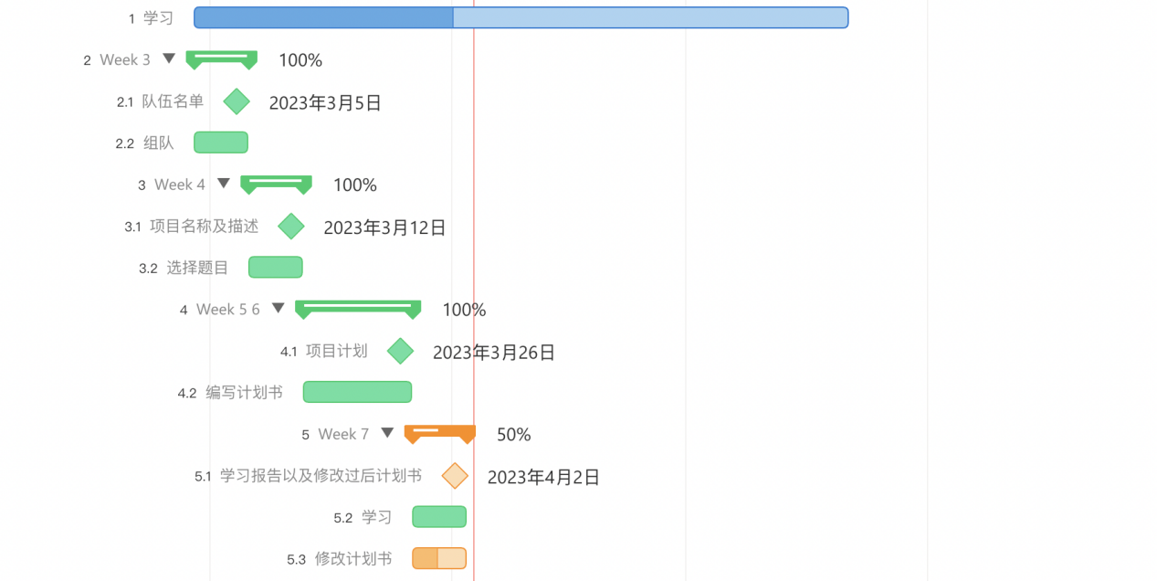

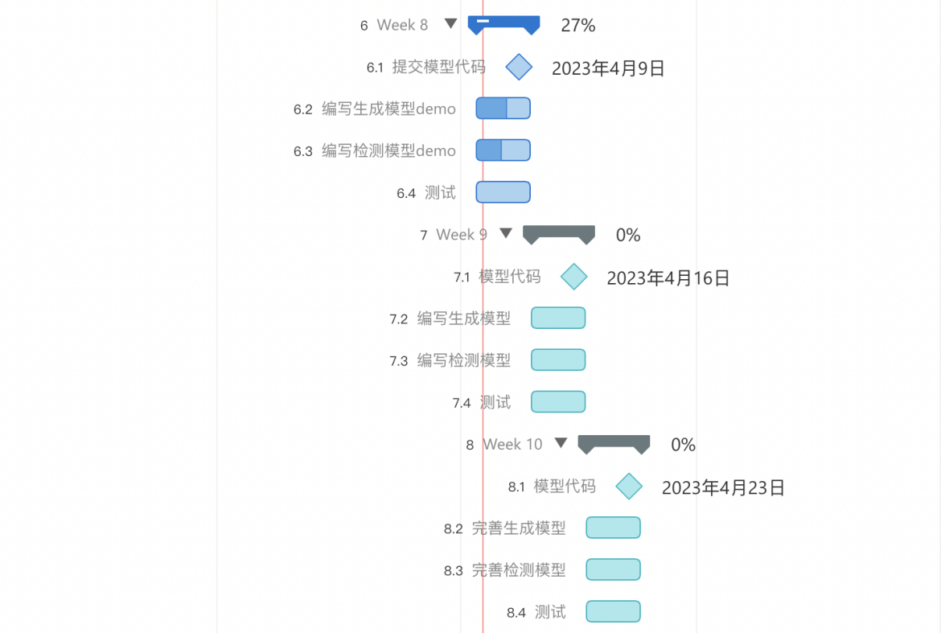

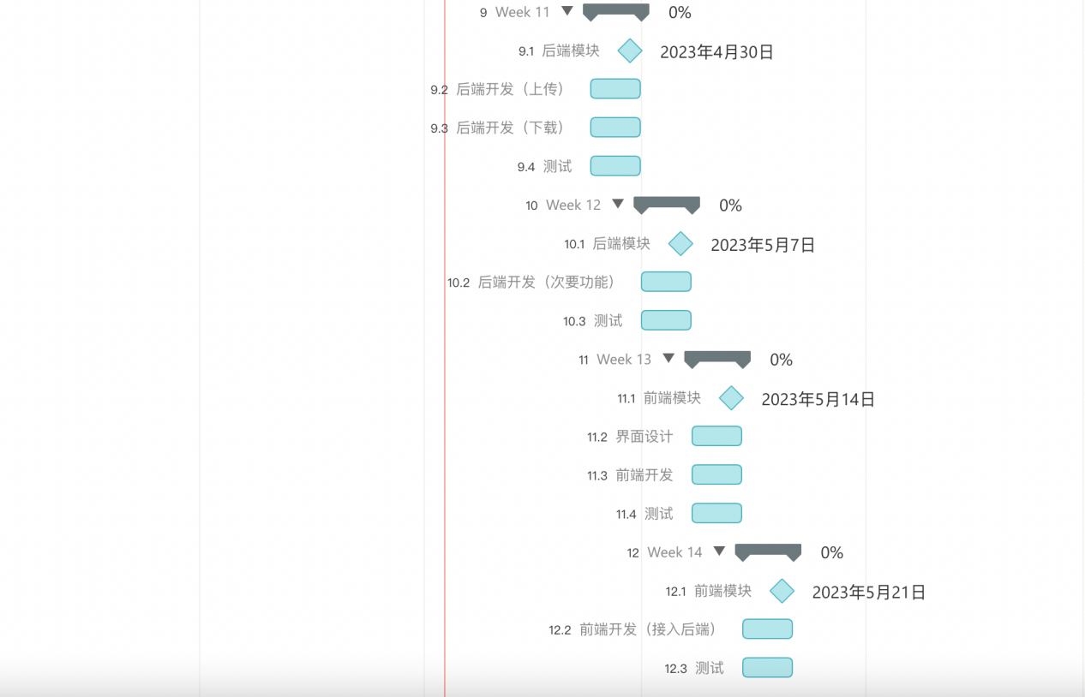

**4.3Milestone Description**

|  |  |  |
| --- | --- | --- |
| Time | Milestone | Description |
| Sprint 1 | | |
| Week3 | Team leader submits team list. |  |
| Week 4 | Team leader submits the project and a brief description on the online document. |  |
| Week 5  Week 6 | Team leader submits the project plan | Team leader submits the project plan at week 7. |
| Week 7. | Everyone must submit a report about what you have learned in this week. |  |
| Week 8 | The member who is responsible for the model submits a demo. | The demo must be runnable and the member must submit the outcome of the demo.  The other members should submit their own work in this week. |
| Week 9 | The member who is responsible for the model submits the model. | The model is used to solve most of the real problem we proposed.  The model contains of souce code ,the parameter and outcome.  The other members should submit their own work in this week. |
| Week 10 | The member who is responsible for the model submits the complete model. | The model is used to solve all of the real problem we proposed.  The model contains of souce code ,the parameter and outcome.  The other members should submit their own work in this week. |
| Sprint 2 | | |
| Week 11  Week 12 | The member submits the a module of the server. | The module can be used to solve the corresponding requirement.  The other members should submit their own work in this week. |
| Week 13  Week 14 | The member submits the a module of web page. | The module can be used to solve the corresponding requirement.  The other members should submit their own work in this week. |
| Week 15 | The teams submit the system. | The team give the presentation of the system. |

**5.Project Risk**

During the execution of the project, it is inevitable that there will be various kinds of accidents, which may lead to the failure of the whole project. Therefore, we must put forward all possible accidents in the plan, and propose corresponding solutions for these accidents.

|  |  |  |  |
| --- | --- | --- | --- |
| Risk Type | Risk | Impact | Solution |
| schedule risk | Unable to complete due to time constraints.  The project plan may faces delays. | High | Member should fully consider various potential factors and make plans.  Breakdown of tasks should be in detail.  Members should strictly follow the project plan,. |
| Technical risks | Team is unable to build a robust model due to hardware performance.  Team chooses a wrong model that can’t solve the problem proposed. | High | The performance of the model can be allowed to be weak，but it must be able to complete corresponding tasks. |
| Human Resources Risk | Members cannot complete this week's task due to special reasons. | Low | Members need to notify other members in advance, and other members are responsible for completing the module. |
| Requirement Risk | There are imperfections in the requirements presented, resulting in the need to change the requirements and revise the overall plan. | Medium | Team members need to inform the project manager of the new requirement, and the project manager will organize a meeting to discuss whether to add the new requirement. If all team members agree, the new requirement will be added. |
| Management Risk | The difference in the ability and level of the project management team brings uncertainty risk to the project construction. These management capabilities and levels include: the preparation and implementation of project schedule plan, the ability to plan and manage project human resources, the ability to manage project change, the ability to manage project communication, and the ability to manage project risk. | High | Each team member needs to be familiar with project management and keep learning.  At the same time, it is necessary to strengthen communication. When there is any problem, it is necessary to inform the project manager, and then the project manager organizes a meeting to discuss. |