IPO charts

Membership Page/(Index)

Input | Process | Output
User opens Homepage | Loads main page | Displayed Homepage
User presses navigation link | Redirects to selected page | Selected Page Displayed (Membership, Classes, PT, Products. Locations, etc.)
User presses ‘’apply now’’ | Application form load in redirected link | Application form displayed

Classes Page

Input | Process | Output
Carousel Displayed | Carousel Loads | Carousel Works

PT Page

Input | Process | Output
User presses PT on navigation | Page Loads | Page Displayed
User scrolls down | Section Cards Load | Section Cards Displayed
User Presses Card | Card open | Card loads to PT description
User presses icon | Link opens | Redirected to selected media page

Products Page

Input | Process | Output
User presses Products on navigation | Page Loads | Page Displayed
User scrolls down | Section Cards Load | Section Cards Displayed
User Presses Card | Card open | Card loads to PT description
User presses icon | Button opens loads page | Button loads into Shopping Cart

Location Page

Input | Process | Output
User opens Location | Page Loads | Page Displayed

Contact Page

Input | Process | Output
User presses Contact page | Pag Loads | Page displayed
Form displayed | Data inputted | On button clicked message is sent.

About us Page

Input | Process | Output
User Presses About us Page | Page Loads | Page Displayed
Information Displayed | Information Shown | Information Displayed

Test Tables

Test case table: Membership (Homepage)

Test Case | Excepted Results | Actual Results | Results
‘’Apply Button’’ | For page to open | Page opens on click | Worked
‘’Buy Button’’ | To load on click to shopping cart | Button did not redirect to shopping cart | Fail
‘’Carousel’’ | To swipe Left or Right on click | Carousel swipes left and right on click | Worked
Verify ‘’1 Week membership details’’ Check card | Card opens | Card does not open | Fail

Test case table: Classes
Test Case | Excepted Results | Actual Results | Results
Carousel | Carousel moves | Carousel moves | Worked

Test case table: PT

Test Case | Excepted Results | Actual Results | Results
Cards | Cards to hover when passing over them | Cards to hover when passing over them | Worked
Icons | Icon to redirect to page | Icon to redirect to page | Worked
Cards | On click to open | On click it opened | Worked

Test case table: Products
Test Case | Excepted Results | Actual Results | Results
Open Products page | Page opens successfully and displays all options | Page opens successfully and displays all options | Worked
Shopping Cart Icon | On click it opens on shopping cart page | On click it opens on shopping cart page | Fail
Shopping Cart Icon | When going over it hovers | When going over it hovers | Worked
Carousel | Carousel to move right and left on click | Carousel to move right and left on click | Worked

Test case table: Location

Test Case | Excepted Results | Actual Results | Results
‘’Map’’ | On click maps open. | On click maps open. | Worked

Test case table: Contact Us

Test Case | Excepted Results | Actual Results | Results
Open Contact Page | Contact Form Appears | Form Displayed | Worked
Type Name | Name field accept text | Text Entered | Worked
Type Email | Email field accept text | Text Entered | Worked
Type Message | Message field accept text | Text Entered | Worked
Click Send | On Click input data is sent | Data Sent | Worked

Test case table: About Us

Test Case | Excepted Results | Actual Results | Results
Open About Us | Page loads Text Data | Page loaded Text | Worked
Card | Card loads with Image | Card loads with Image | Worked

Code Validation Analysis

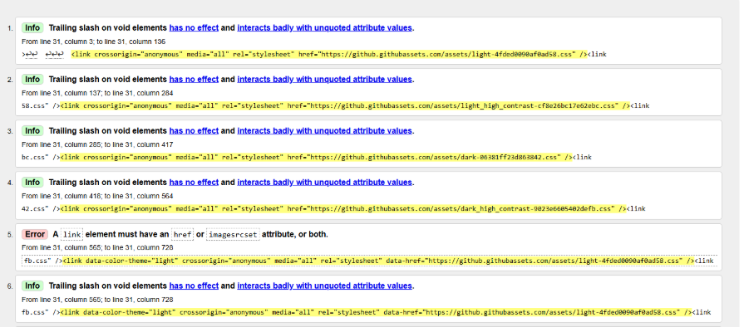
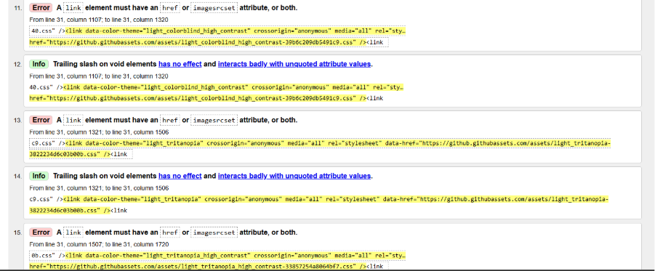
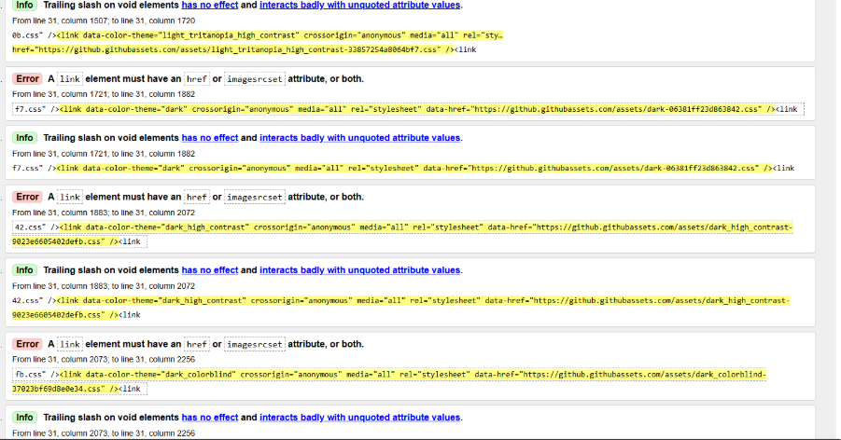
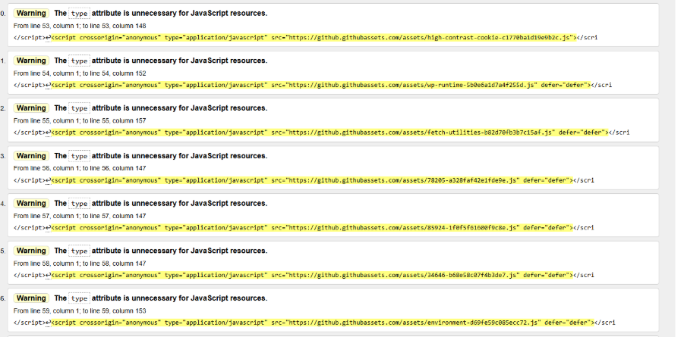

During the HTML validation, multiple warnings were found, that relate to external JavaScript source. The validator has reported an issue that the type attributed specifically on multiple script elements, that was unnecessary for JavaScript files in HTML5. This indicates that the code does not fully goes accordingly to HTML5.

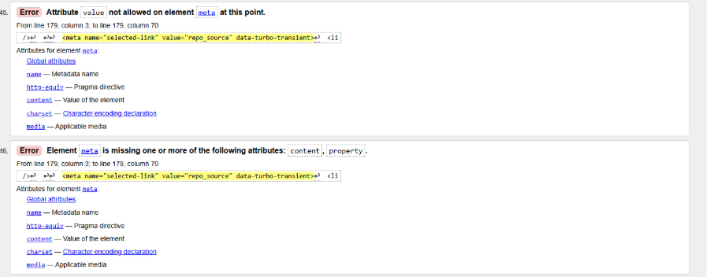

During the HTML validation, these errors were detected in the meta element. The validator has identified the use of invalid value and reported that the required content was not there. In conclusion the page did not pass HTML validation.

Suggestions for further ideas:
- Implement a live chat feature for faster customer help
- Include fitness tips, or a blog section to keep viewers engaged
- Offer promotional discounts and special offers
- Introduce a fitness progress tracker for registered members

Overall, the website was interactive and worked well, the website navigation was easy to be guided and did not have a lot of errors.

