Blinkit Business Intelligence Project

Project Overview

This project focused on analysing Blinkit's business data to gain an understanding of how different areas of their business were performing. I used multiple data sets relating to customers, orders, products, deliveries, inventory & marketing to gain a better insight into the business.
The aim of this project was to understand more than just the raw data and look for valuable insights within the data. I used Python to analyse and explore the data sets, I used MySQL to query the data using SQL & answer business questions and I used Power BI to create interactive dashboards.
I looked at trends in sales, customer activity, product performance, delivery efficiency, inventory levels & marketing performance. This analysis has helped me to identify key trends and understand how data can be used to help make better business decisions.

  - Project Workflow
  - Data Collection
  - Python Analysis
  - SQL Analysis
  - Power BI Dashboard

2. Problem Statement
Blinkit is a company that creates business data through various activities like Customer Orders, Product Sales, Deliveries, Inventory and Marketing Campaigns. Analyzing the data from each activity individually can make it hard to get an overall view of how your business is performing and where you may want to focus your efforts.
This project was created to collate the data from each source and analyze what it tells us about the business. Using Python, SQL and Power BI, I was able to analyze key business metrics and identify trends in the data.
This project focuses on extracting insights from our raw business data to help us better understand how the business is performing.

3. Project Objectives

  - Explore various data sources associated with Blinkit.
  - Understand the sales patterns of the company, customer behaviour and product trends.
  - Analyse delivery patterns and investigate potential causes for delays.
  - Investigate inventory data to get an understanding of stock availability.
  - Analyse the effectiveness of marketing campaigns using key business metrics.
  - Create interactive dashboards in Power BI and provide business insights.

4. Tools and Technologies Used
The following tools and technologies were used in this project:

Tool/Technology | Purpose
Pyhton | Exploring and analysing the datasets
Pandas & Numpy | Working with and analysing data
Jupyter Notebook | Performing Python analysis
MySQL | Writing SQL queries and analysing business data
MySQL Workbench | Managing and executing SQL queries
Microsoft Power BI | Creating interactive dashboards and presenting business insights

5. Dataset Description

For this project, I worked with nine datasets covering different business activities.
Each dataset helped me understand a specific area of Blinkit's operations.

These dataet were used together to explore different aspects of the business, including sales, customers, products, deliveries, inventory, and marketing.

Dataset | Description
blinkit_customers | Contains customer-related information.
blinkit_customer_feedback | Contains customer feedback and ratings.
blinkit_delivery_performance | Provides information about delivery performance and delays.
blinkit_inventory | Contains inventory and stock-related information.
blinkit_inventoryNew | Provides additional inventory records.
blinkit_marketing_performance | Contains information about marketing campaigns and their performance.
blinkit_orders | Contains order-related details.
blinkit_orders_items | Provides details about the products included in orders.
blinkit_products | Contains product information and related attributes.

6. Python Analysis

I have used python (Jupyter notebook) to analyse the 9 datasets of Blinkit.
This has helped me understand what the dataset contains, how it is structured, what columns are present in it, what records are available and what information will help us in our business.
Mainly using Pandas and Numpy to understand the data, this step helped me get familiar with the datasets to carry out SQL analysis and create dashboards.

7. SQL Analysis

Now, after exploring the dataset with Python, I proceeded with the SQL analysis by using MySQL Workbench.
I created SQL queries that looked into various aspects of Blinkit like Sales, Product Performance, Customer Behaviour, Delivery, Marketing, Inventory etc.
This helped me get insights from the data from various business perspectives and perform database queries.
The SQL queries were divided into different files according to the aspect of analysis.

8.Power BI Dashboard

To make the analysis easier to understand, I used Microsoft Power BI to create interactive dashboards based on the blinkit business data.

The dashboards present important business through charts, graphs, and key performance indicators(KPIs). They help explore different areas of the business, such as sales, products, customers, marketing, and overall performance.

I organized the dashboard into different sections so that the information is easy to navigate and understand. This makes it easier to identify pattens, compare performance, and explore useful business insights.

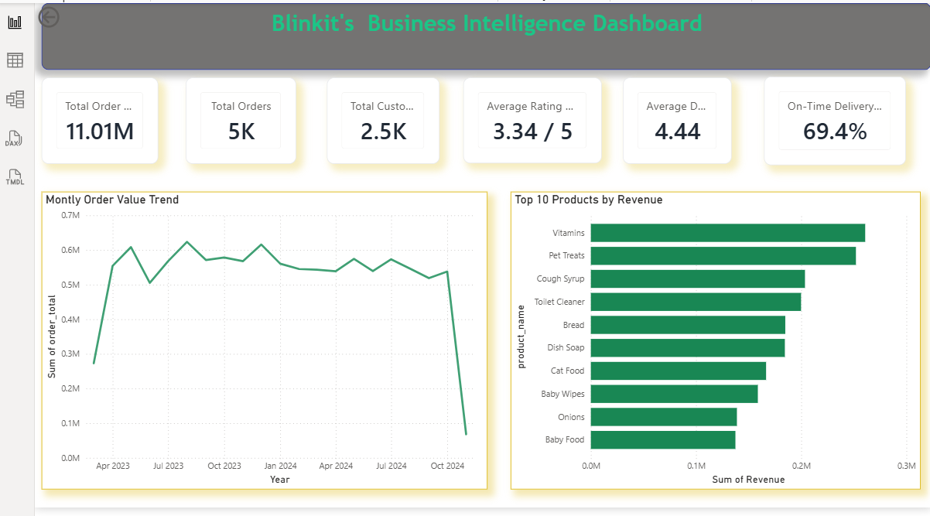

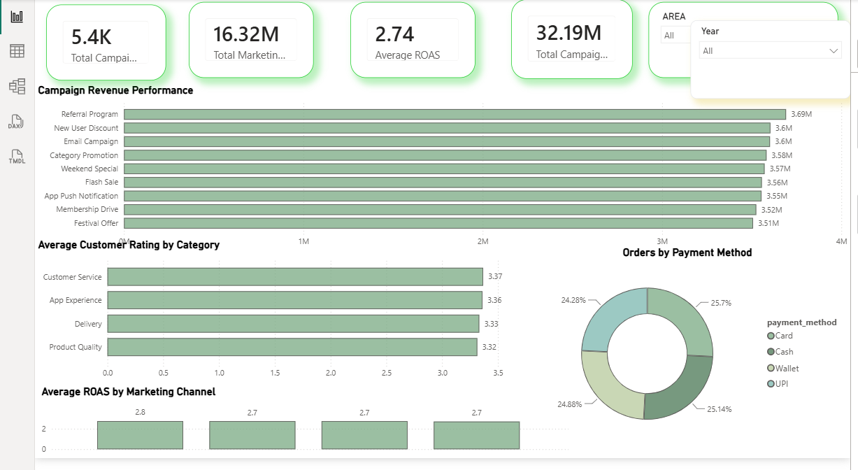
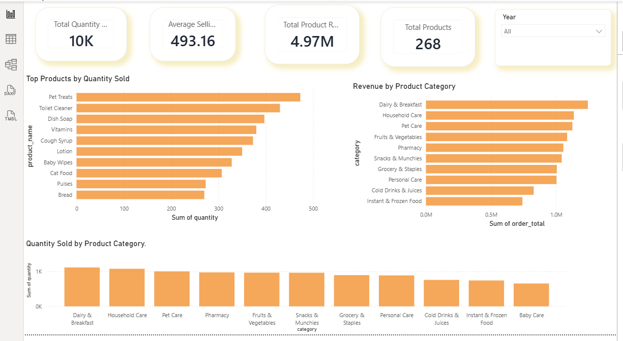

Key Business Insights

The analysis provided several useful insights into Blinkit's business performance.

  - Sales Performance: The dataset recorded total sales of ₹1,10,09,308.50 across 5,000 orders, with an average order value of ₹2,201.86.

  - Delivery Performance: Out of 5,000 orders, 3,470 were delivered on time, representing 69.4% of total orders.

  - Payment Methods: Customers used different payment options, including Card, Cash, Wallet, and UPI, with relatively balanced order counts.

  - Marketing Performance: The marketing analysis recorded an average Return on Ad Spend (ROAS) of 2.74.

  - Business Analysis: Python, SQL, and Power BI helped examine different areas of the business and present the findings in an understandable format.

These findings helped me better understand Blinkit's sales, delivery operations, customer payment preferences, and marketing performance.

MySQL CSV Import Instructions

MySQL Database Setup and CSV Import Process
1. Open MySQL Workbench and connect to the local MySQL Server.
2. Create the database using the SQL command.
3. Select the newly created database.
4. Open the database and use the Table Data Import Wizard.
5. Select the required CSV file from the project’s 01_DATA folder.
6. Choose the destination table name.
7. Configure the column names and data types.
8. Review the column mapping and import settings.
9. Click Next and complete the import.
10. Repeat the process for all nine CSV datasets.
11. Verify the imported records using SQL queries.

Conclusion

Working on this BLINKIT BUSNIESS INTELLIHENCE PROJECT gave me an opportunity to understand how business data can be explored and used to find meaningful insights.

Throught out the project, I worked with Python, MySQL, and Power BI to analyse different areas of blinkit's operations. Each tool played an important role, from exploring the datasets and writing SQL queries to presenting the findings through interactive dashboards.

This project helped me improve my practical skills in Data analysis, SQL and business intelligence. More importantly, it gave me a better understanding of how data can help business evaluate their performance and make informed decisions.

Project Folder Structure

The project files are organised into separate folders to keep the datasets, analysis files, SQL queries, dashboards, and documentation easy to find.

Blinkit_Business_Intelligence/
│
├── 01_DATA/
│
├── 02_PYTHON_ANALYSIS/
│
├── 03_SQL_ANALYSIS/
│
├── 04_POWERBI_DASHBOARD/
│
├── 05_PROJECT_DOCUMENTATION/
│
└── README.md

