BLINKIT BUSINESS INTELLIGENCE & ANALYTICS

1. Project Overview

This is a data analytics project to understand the sales performance, customer behaviour, product performance, delivery performance, marketing performance and inventory related information using business intelligence techniques.
Python has been used to clean the data and do the exploratory data analysis. MySQL has been used to manage the database and do the SQL analysis. Microsoft Power BI has been used to create interactive dashboards.
The goal of this project is to derive useful insights from the raw business data. This dashboard provides a summary view of key business indicators and can be used to understand the sales, marketing, customer and product performance.

2. Business Problem

Blinkit collects data from various business aspects such as orders, sales, deliveries, marketing, feedback, and stock.
Analysing multiple datasets independently makes it challenging to obtain a consolidated view of business performance and identify meaningful patterns.
This will make it more difficult to identify key sales patterns, customer buying habits, campaign effectiveness, delivery performance, and best selling products.
As a result of this, we will focus on analyzing the data available to us from Blinkit using Python, MySQL, and Power BI. This will help us organize our business data, identify key insights, and create dashboards to highlight important discoveries.
This will allow us to gain greater insight into our business and make better decisions based on our data.

3. Project Objectives

The main objectives of the Blinkit Business Intelligence & Analytics project include:
- Analysing Blinkit business data sets to understand the overall performance of the business.
- Cleaning, pre-processing raw data sets using Python and Pandas.
- Conducting exploratory data analysis to understand the trends and patterns in the business data.
- Using MySQL and creating SQL queries to extract, analyse and summarise business data.
- Analysing sales performance, customer behaviour, product performance and delivery performance.
- Analysing the performance of marketing campaigns using the appropriate business metrics.
- Creating interactive dashboards in Power BI to show key business metrics.
- Extracting useful insight from the business data to help make data driven decisions.

4. Technologies Stack

The following technologies have been used in the Blinkit Business Intelligence & Analytics project.
4.1 Python
To load, clean and pre-process data. Exploratory data analysis was also performed using this tool.

4.2 Pandas
CSV data sets were loaded using pandas. Data can be manipulated, null values can be dealt with and duplicates found.

4.3 NumPy
Allows numerical calculations and operations.

4.4 Jupyter Notebook
Interactively run Python code. Analyse data sets and record analysis.

4.5 MySQL
Used as a relational database system to store business data.

4.6 MySQL Workbench
Used to connect to the MySQL database. SQL queries can be run and analysis performed.

4.7 Microsoft Power BI
Used to create interactive dashboards. Visualisations can be created to show business metrics.

4.8 GitHub
Used to manage version of project. Organise source code. Share files and documentation for project.

5. Dataset Description:
There are total nine csv datasets included in this project. The data is related to Blinkit Sales, Customers, Products, Delivery, Marketing, Customer Feedback and Inventory.
These datasets are used as main data sources for analyses in python, for querying in SQL and for developing dashboards in Power BI.

5.1 Dataset Description:

Sl. No | Dataset Name | No. of Records
1 | blinkit_customers.csv | 2500
2 | blinkit_customer_feedback.csv | 5000
3 | blinkit_delivery_performance.csv | 5000
4 | blinkit_inventory.csv | 75,172
5 | blinkit_inventoryNew.csv | 18,105
6 | blinkit_marketing_performance.csv | 5,400
7 | blinkit_orders.csv | 5000
8 | blinkit_order_items.csv | 5000
9 | blinkit_products.csv | 268

5.2 DatasetOverview:
- Customer dataset which includes customer related information
- Customer Feedback dataset which includes customer feedback related information to understand their satisfaction and ratings
- Delivery Performance dataset which includes delivery related information to understand the delivery performance.
- Inventory datasets which include inventory related information to understand the inventory.
- Marketing Performance dataset which includes campaign related information to understand the marketing performance.
- Orders dataset which includes order related information to understand sales and orders.
- Order Items dataset which includes order related information on product level to understand products and sales.
- Products dataset which includes product related information to understand products.

5.3 Dataset Usage :
The data from csv files are imported into python with pandas library to understand, clean, preprocess and explore the data. The structured business data is also used for analyses using SQL and for creating interactive dashboards using Power BI.

6. Data Cleaning and Prepartion:

Data cleaning can be an essential step in preparing data for analysis.
This project uses Python and Pandas to clean and prepare the available Blinkit data sets.

6.1 Load Data Sets

All 9 CSV data sets were loaded into the Jupyter Notebook using Pandas. These were then analysed to understand the data structure, quantity of rows, column names, and data type.

6.2 Initial Data Analysis

- Initial data analysis was carried out to identify:
- Missing/Null Data
- Duplicate Entries
- Column Data Types
- Data Set Size
- Consistency of Data

6.3 Data Preparation
The following data preparation operations are performed:
- Identification and removal of duplicate records where applicable.
- Conversion of date-related columns into appropriate date formats.
- Inspection of missing values.
- Verification of data types and dataset structure.

6.4 Prepare Data For Analysis

Once the data has been cleaned, it can now be prepared for analysis. This processed data can be used to calculate business metrics, identify trends, investigate customer and product performance, and create visualisations.

6.5 Libraries Used

The main libraries used in this project were:

- Pandas – Load, clean, manipulate, and analyse data.

- NumPy – Perform numerical calculations.

- Matplotlib and Seaborn – Visualise data where appropriate in the notebook.

7. Exploratory Data Analysis (EDA)

Exploratory Data Analysis (EDA) is performed to understand business data, identify patterns, examine relationships, and calculate important business metrics.

In this project, Python and Pandas are used to analyse different aspects of Blinkit's business operations.

7.1 Sales Performance Analysis

Sales data is analysed to understand overall revenue performance, order volume, and average order value.

The analysis includes:
- Total revenue calculation.
- Total number of orders.
- Average Order Value (AOV).
- Monthly sales trends.

Key Results:
- Total Orders: 5,000
- Total Revenue: ₹11,009,308.50
- Average Order Value: ₹2,201.86

7.2 Customer Analysis

Customer data is analysed to understand purchasing behaviour and identify repeat customers.

The analysis includes:
- Total unique customers.
- Repeat customer identification.
- Repeat customer rate.

Key Result:
- Repeat Customer Rate: 68.69%

7.3 Delivery Performance Analysis

Delivery data is examined to evaluate delivery efficiency and understand delivery duration and status.

The analysis includes:
- Delivery status distribution.
- Average delivery duration.
- On-time delivery performance.

Key Results:
- On-Time Delivery Rate: 69.4%
- Average Delivery Duration: 19.43 minutes

7.4 Payment Method Analysis

Order data is analysed to understand customer payment preferences and the distribution of orders across different payment methods.

The analysis considers:
- Card payments.
- Cash payments.
- Wallet payments.
- UPI payments.

7.5 Product Analysis
Product-related data is examined to identify product categories and high-performing products.
The analysis includes:
- Product category analysis.
- Top 10 products by revenue.
- Product performance comparisons.

7.6 Customer Feedback Analysis

Customer feedback data is examined to understand customer opinions and feedback patterns.

The analysis includes:
- Feedback sentiment distribution.
- Customer feedback categories.
- Identification of the most frequent sentiment.

Key Observation: Neutral sentiment is the most frequently occurring feedback sentiment.

7.7 Inventory Analysis

Inventory data is inspected to understand stock-related information.

The analysis includes:
- Stock received.
- Damaged stock.
- Inventory damage rates.

7.8 Marketing Dataset Inspection

The marketing performance dataset is loaded and inspected to understand its structure and available fields. Further marketing performance visualisation is presented separately in the Power BI dashboard.

8. SQL Data Analysis

SQL is used in this project to retrieve, validate, summarise, and analyse structured business data stored in the MySQL database.
MySQL Workbench is used to execute SQL queries and examine business information.

8.1 Data Validation

SQL queries are used to validate the database records by checking:
- Total number of orders.
- Unique order IDs.
- Duplicate and missing order IDs.
- Missing customer IDs.
- Missing payment methods and delivery information.
- Delivery status distribution.

8.2 Sales Performance Analysis

Sales-related SQL queries are used to examine:
- Total sales revenue.
- Total orders.
- Average Order Value.
- Monthly revenue trends.
- Revenue by payment method.
- Revenue by delivery status.
- Top-performing orders.

8.3 Delivery Performance Analysis

Delivery-related queries are used to examine:
- Average delivery duration.
- Delivery status distribution.
- Delivery delay reasons.
- Delivery performance based on distance.
- Delivery duration across distance ranges.

8.4 Business Summary Analysis

Business summary queries are used to retrieve:
- Total orders and order items.
- Total sales and Average Order Value.
- Payment method distribution.
- Delivery status distribution.
- Top products based on quantity and revenue.
- Sales performance across delivery statuses.

8.5 SQL Script Organisation

The project contains eight SQL script files organised by analysis category:

1. Data Validation
2. Sales Performance
3. Product Analysis
4. Customer Analysis
5. Delivery Analysis
6. Marketing Analysis
7. Inventory Analysis
8. Business Summary

The scripts are organised into separate files to maintain a structured approach to database analysis.

9. Power BI Dashboard Development

Microsoft Power BI is used to develop interactive dashboards that present important business metrics and analytical findings from the Blinkit datasets.

The dashboard provides a visual overview of business performance and allows users to explore different aspects of sales, marketing, customers, and products.

The Power BI dashboard consists of three main pages.

9.1 Executive Overview

The Executive Overview page provides a summary of overall business performance through key performance indicators (KPIs) and visualisations.

The page includes:
- Total Revenue.
- Total Orders.
- Total Customers.
- Average Customer Rating.
- Average Delivery Time.
- On-Time Delivery Rate.
- Monthly Revenue Trend.
- Top 10 Products by Revenue.
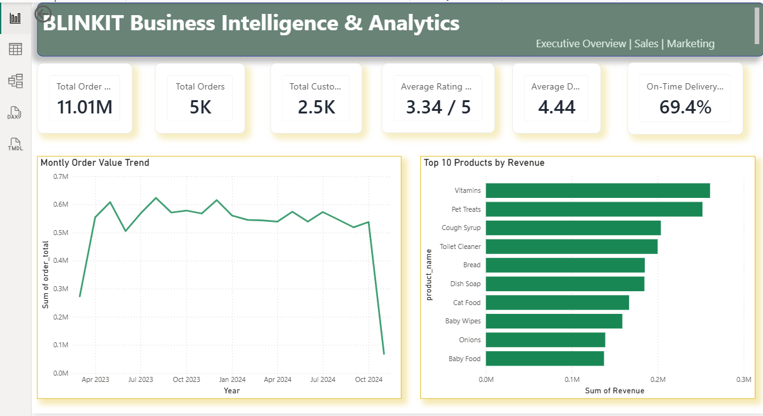

9.2 Marketing & Customer Insights

This page focuses on marketing campaign performance, customer feedback, and payment behaviour.

The page includes:
- Total Campaigns.
- Total Marketing Spend.
- Average Return on Advertising Spend (ROAS).
- Total Campaign Revenue.
- Campaign Revenue Performance.
- Average Customer Rating by Category.
- Orders by Payment Method.
- Average ROAS by Marketing Channel.
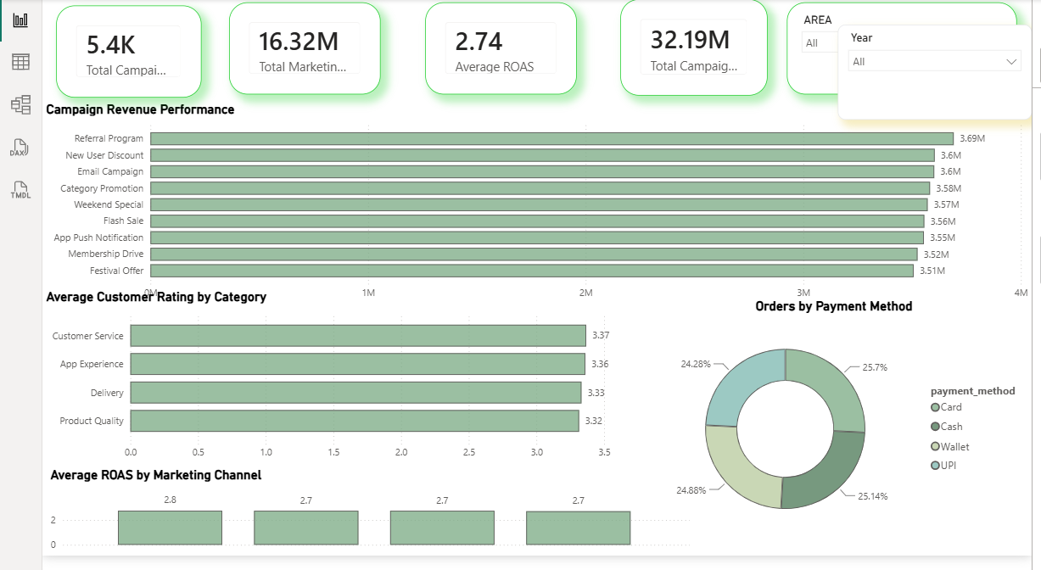

9.3 Product & Sales Analysis

This page focuses on product-level performance and sales distribution across product categories.

The page includes:
- Total Quantity Sold.
- Average Selling Price.
- Total Product Revenue.
- Total Products.
- Top Products by Quantity Sold.
- Revenue by Product Category.
- Quantity Sold by Product Category.

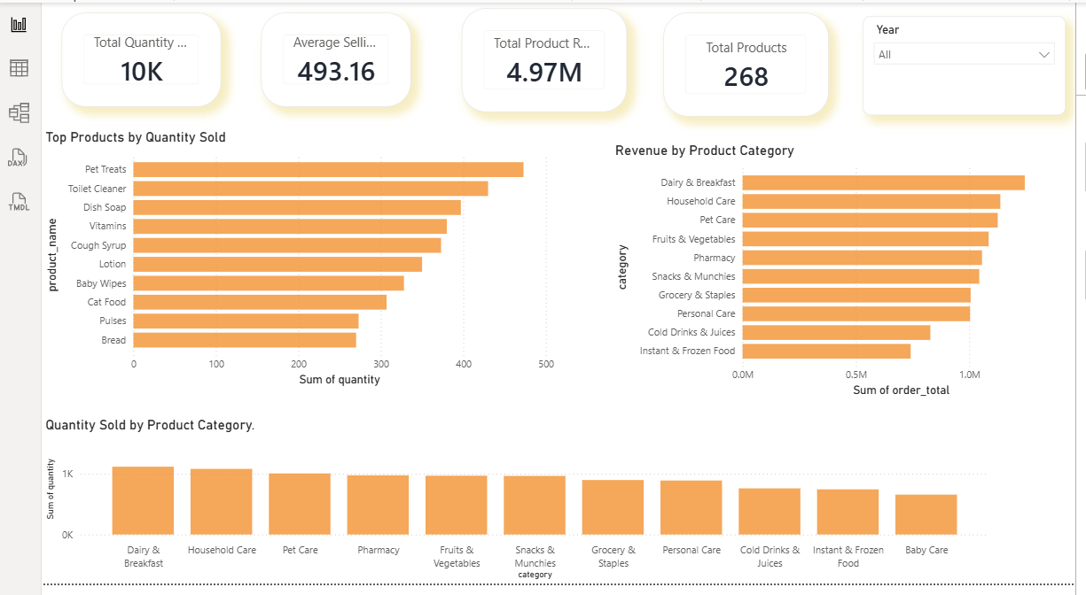

9.4 Dashboard Interactivity

The dashboard includes interactive filters and visualisations that allow users to explore business information based on available dimensions such as year and area.

These interactive elements help users examine business performance from different perspectives and understand patterns across the available datasets.

10. Results and Business Insights
The analysis of Blinkit datasets using Python, SQL, and Power BI provides an overview of sales performance, customer behaviour, delivery operations, and product-related activities.
The following key results were obtained from the Python analysis:
10.1 Sales Performance
- Total Orders: 5,000
- Total Revenue: ₹11,009,308.50
- Average Order Value: ₹2,201.86
10.2 Customer Behaviour
- Repeat Customer Rate: 68.69%
- Repeat customers identified: 1,492
10.3 Delivery Performance
- On-Time Delivery Rate: 69.4%
- Average Delivery Duration: 19.43 minutes
10.4 Customer Feedback
- Neutral sentiment was the most frequently occurring feedback category.
10.5 Product and Marketing Analysis
Product performance, category-level sales, marketing campaign revenue, and channel performance are explored through the available datasets and Power BI visualisations.
10.6 Overall Business Insights
The analysis provides a structured view of important business metrics and helps identify areas that may require further investigation, including delivery performance, customer satisfaction, sales trends, and marketing effectiveness.
These findings demonstrate how data analytics and interactive dashboards can support business performance monitoring and informed decision-making.

11. Conclusion

This project explores how data analytical methods can be applied to a dataset to understand business performance.

Python and Pandas have been used for data cleansing, and exploratory data analysis. MySQL and SQL have been used to extract, verify and summarise business data. Microsoft Power BI was used to create an interactive dashboard, which displays key business performance metrics.

This project provides some insights into how sales are performing, customer behaviour, delivery operations, product performance and marketing.

Overall, this project shows how Python, SQL and Business Intelligence tools can be used together to turn raw business data into useful information.

12. Future Enhancements

The Blinkit Business Intelligence & Analytics project can be further improved by introducing additional analytical capabilities and advanced business intelligence features.

The following enhancements can be considered in future development:

1. Advanced Predictive Analytics: Implement machine learning models to forecast future sales and customer purchasing trends.

2. Customer Segmentation: Develop customer segmentation techniques to identify different customer groups based on purchasing behaviour.

3. Demand Forecasting: Use historical sales and inventory data to predict future product demand.

4. Enhanced Inventory Analysis: Develop additional analytical features to monitor stock levels, identify potential shortages, and improve inventory management.

5. Delivery Performance Improvement: Analyse delivery patterns and develop predictive approaches to identify potential delivery delays.

6. Advanced Marketing Analysis: Expand campaign analysis to evaluate marketing effectiveness and identify opportunities for improving campaign performance.

7. Automated Data Refresh: Implement automated data pipelines to update datasets and refresh Power BI dashboards regularly.

8. Dashboard Enhancements: Introduce additional interactive filters, detailed drill-through reports, and advanced visualisations.

13. References
The following tools, technologies, and documentation resources were used during the development of this project.
- Python Documentation: https://docs.python.org/3/
- Pandas Documentation: https://pandas.pydata.org/docs/
- NumPy Documentation: https://numpy.org/doc/
- Jupyter Documentation: https://docs.jupyter.org/
- MySQL Documentation: https://dev.mysql.com/doc/
- Microsoft Power BI Documentation: https://learn.microsoft.com/en-us/power-bi/
- GitHub Documentation: https://docs.github.com/
Project Repository
GitHub Repository: https://github.com/Sheshapgol/Blinkit_Busniess_Intelligence-

