Alfido Tech Internship
Task 1: Python File Handling & Automation

🎯 Goal
Understand Python file handling, automation logic, and exception handling.

📝 Requirements
- Read and write files (txt, csv)
- Rename, move, and delete files
- Use try-except for error handling
- Proper comments in code

💻 Description
In this task, I implemented Python file handling operations such as creating, reading, renaming, and deleting files with proper exception handling.

📂 Files
- file_handling.py
- Output screenshots

🧩 Code
# Task 1: File Handling and Automation

import os

try:
# Create and write to a text file
with open("sample.txt", "w") as file:
file.write("Hello Alfido Tech Internship!")

# Read the file
with open("sample.txt", "r") as file:
content = file.read()
print("File Content:", content)

# Rename the file
os.rename("sample.txt", "renamed_sample.txt")

# Move the file to a new folder
os.makedirs("moved_folder", exist_ok=True)
os.replace("renamed_sample.txt", "moved_folder/renamed_sample.txt")

# Delete the file
os.remove("moved_folder/renamed_sample.txt")

print("All file operations completed successfully!")

except Exception as e:
print("Error occurred:", e)
📸 Screenshot: Source Code in VS Code
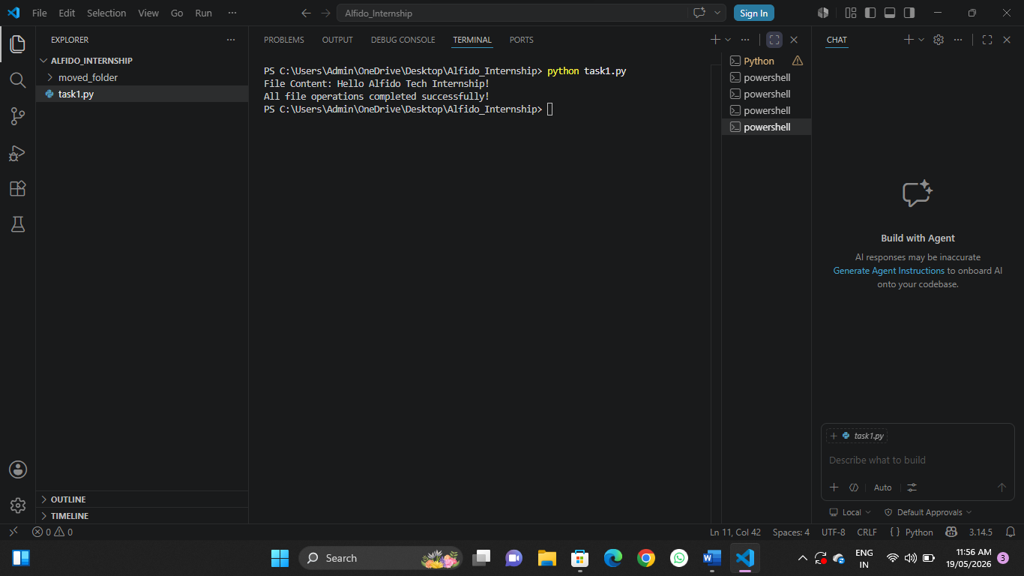
📸 Screenshot: Program Output in Terminal
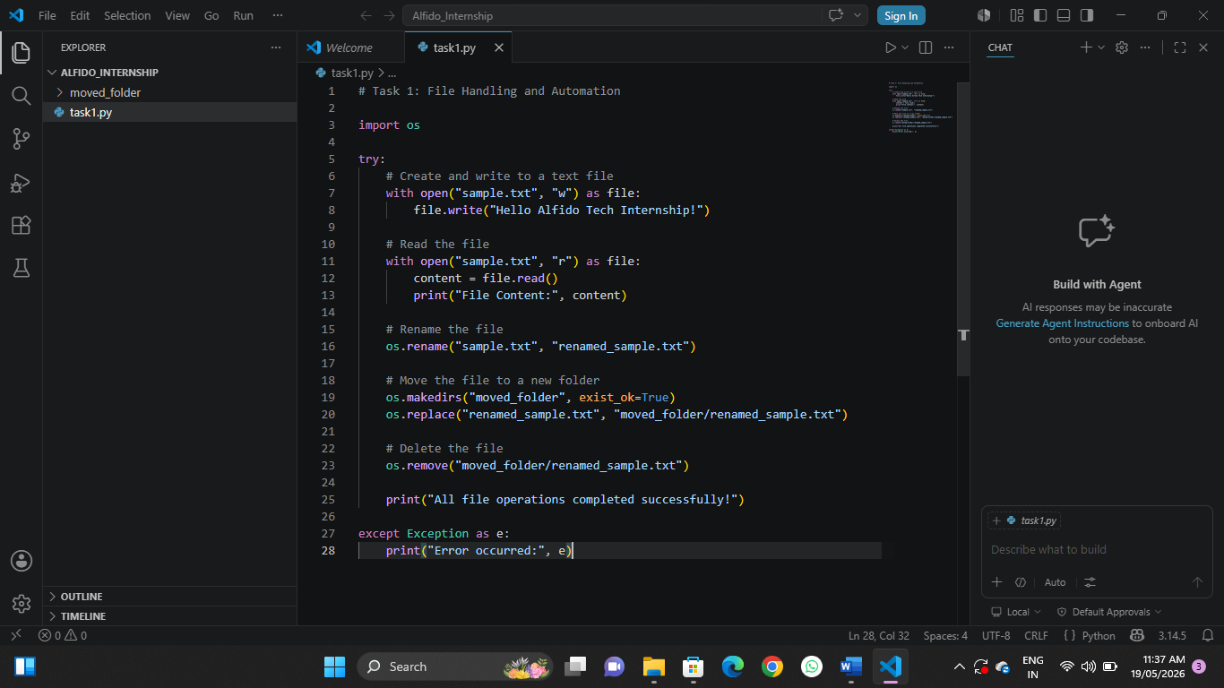

✅ Result
The script successfully created, read, renamed, moved, and deleted the file, printing "All file operations completed successfully!" with no errors.

