Alfido Tech Internship
Task 2: API Integration & JSON Handling

🎯 Goal
Learn how Python communicates with external APIs and handles JSON data.

📝 Requirements
- Fetch data using Requests library
- Parse JSON responses
- Apply filtering or search logic
- Handle API errors

💻 Description
In this task, I developed a Python application that fetches data from an external API and processes JSON responses using Python. The project demonstrates API integration, JSON parsing, filtering logic, and error handling.

🛠 Technologies Used
- Python
- Requests Library
- JSON
- VS Code
- GitHub

📂 Files Included
- task2.py
- README.md
- Dockerfile
- Screenshots

🚀 Features Implemented
- API data fetching
- JSON data parsing
- Search and filtering operations
- Exception handling for API errors

📚 Skills Gained
- API Integration
- JSON Handling
- Python Requests Module
- Error Handling
- GitHub Repository Management

🧩 Code
import requests

# API URL
url = "https://jsonplaceholder.typicode.com/users"

try:
# Fetch data from API
response = requests.get(url)

# Check for successful response
response.raise_for_status()

# Convert JSON response into Python data
users = response.json()

print("USER DETAILS\n")

# Display user information
for user in users:
print(f"ID: {user['id']}")
print(f"Name: {user['name']}")
print(f"Email: {user['email']}")
print(f"City: {user['address']['city']}")
print("-" * 30)

# Filtering logic
print("\nUsers from South Christy:\n")
for user in users:
if user['address']['city'] == "South Christy":
print(user['name'])

# Error handling
except requests.exceptions.RequestException as e:
print("Error fetching data:")
print(e)
📸 Screenshot: Program Output (Part 1)
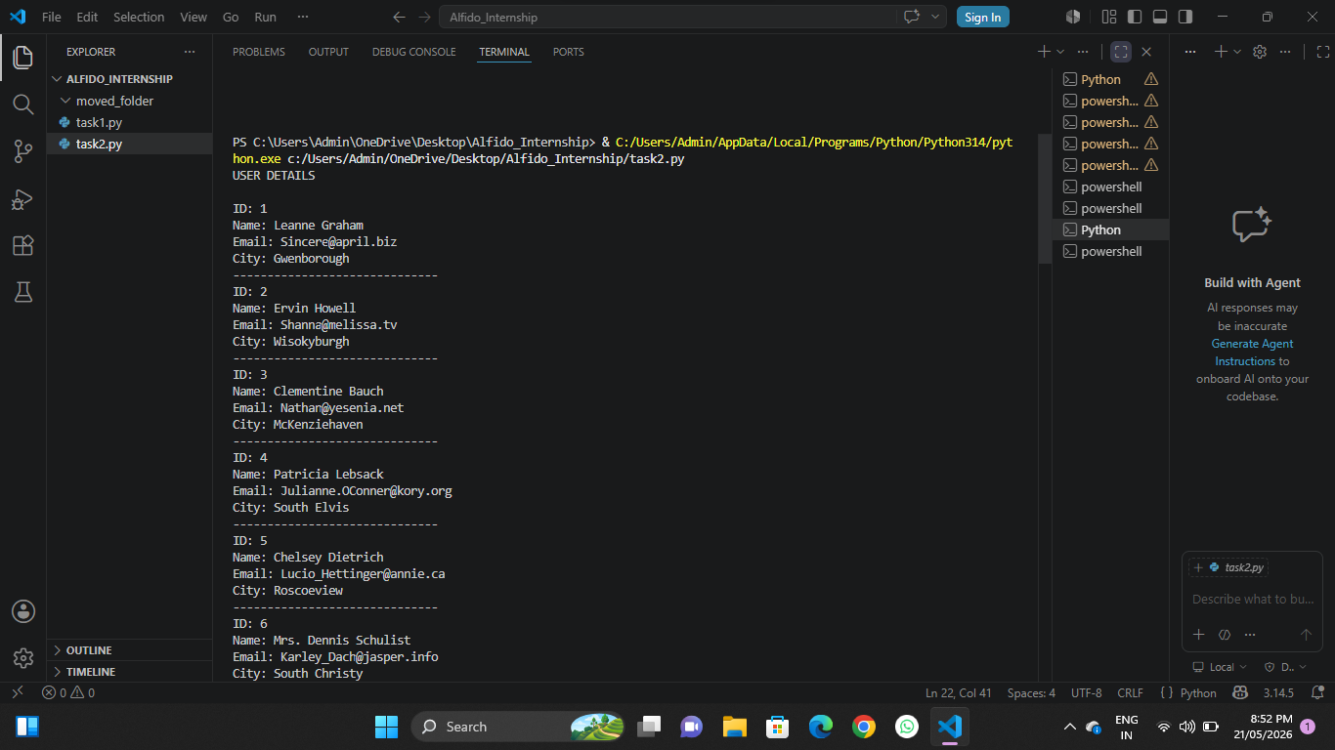
📸 Screenshot: Program Output (Part 2)
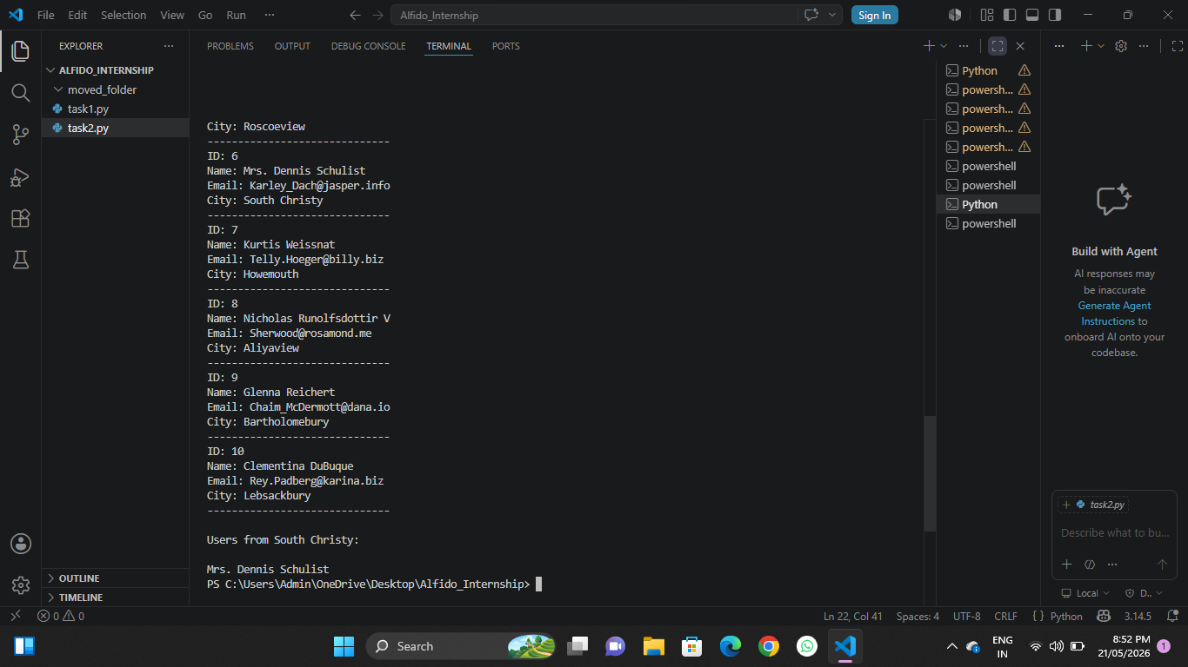

✅ Result
The script successfully fetched user data from the API, parsed the JSON response, displayed all user details, and correctly filtered users located in "South Christy" with no errors.

