Alfido Tech Internship
Task 3: Data Analysis with Pandas

🎯 Goal
Learn how to analyze tabular data in Python using the pandas library, including inspecting, filtering, and summarizing data.

📋 Requirements
- Load data from a CSV file
- Inspect the dataset (rows, structure)
- Check for missing values
- Filter data based on a condition
- Group and summarize data

📝 Description
In this task, I used the pandas library to load and analyze an employee dataset from a CSV file. The script displays the full dataset, previews the first five rows, checks for missing values, filters employees with a salary above 50,000, and calculates the average salary grouped by department.

🛠️ Technology Stack
- Python
- Pandas Library
- VS Code
- GitHub

📂 Files Included
- task3.py
- employees.csv
- Screenshots
- README.md

✨ Features Implemented
- CSV data loading with pandas
- Dataset preview (head)
- Missing value detection
- Conditional filtering (salary > 50,000)
- Grouped aggregation (average salary by department)

🎓 Skills Gained
- Pandas Fundamentals
- Data Cleaning & Inspection
- Data Filtering
- Group-by Aggregation
- Version Control with GitHub

📊 Input Data: employees.csv

ID | Name | Department | Salary
1 | Rahul | IT | 50000
2 | Priya | HR | 40000
3 | Arjun | IT | 60000
4 | Sneha | Finance | 55000
5 | Kiran | HR | 45000
6 | Anjali | IT | 70000

🧩 Code
import pandas as pd

# Load CSV file
df = pd.read_csv(r"task 3 data analysis/employees.csv")

print("----- Dataset -----")
print(df)

print("\n----- First 5 Rows -----")
print(df.head())

print("\n----- Missing Values -----")
print(df.isnull().sum())

print("\n----- Employees with Salary > 50000 -----")
print(df[df["Salary"] > 50000])

print("\n----- Average Salary by Department -----")
print(df.groupby("Department")["Salary"].mean())
📸 Screenshot: Program Output in Terminal
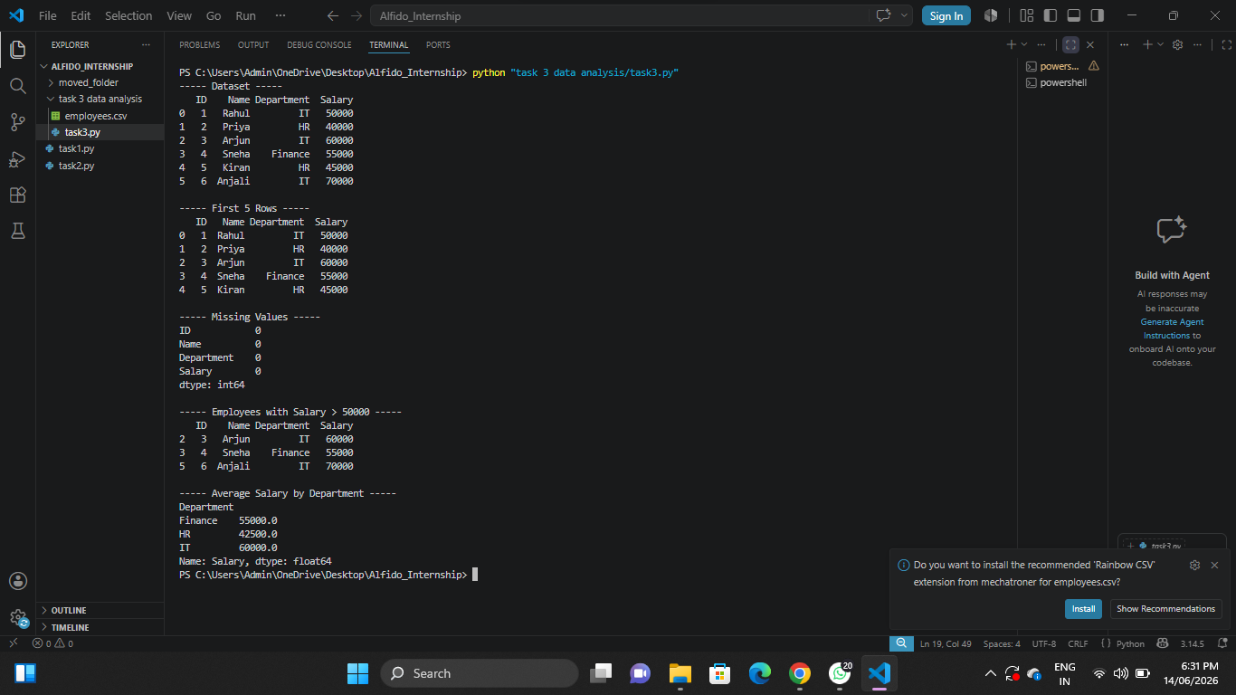

✅ Outcome
Successfully loaded and analyzed the employee dataset using pandas, gaining hands-on experience in data inspection, filtering, and aggregation.

