PERSONAL FINANCE
ADVISOR BOT
Project Documentation
A web-based personal budgeting, expense tracking and financial guidance platform
Technology Stack
Python • Flask • SQLAlchemy • SQLite • HTML/CSS/JavaScript • Chart.js • Google Gemini (optional)
Prepared from project documentation and deployed application screenshots
October 2026
Author – Arnav Shete

Project Overview
Personal Finance Advisor Bot is a full-stack web application that helps a user track monthly income and expenses, calculate savings, compare spending with recommended budget guidelines, and review a monthly financial summary. Its advice module provides rule-based recommendations and can optionally use Google Gemini when configured.

Project Objectives
- Record monthly income and day-to-day expenses in Indian rupees.
- Organize expenses into categories including Rent, Food, Transport, Utilities, Education, Shopping, Healthcare, Entertainment and Other.
- Calculate total expenses, net savings and savings rate for a selected month.
- Compare actual category spending with suggested budget allocations.
- Present financial metrics and charts through a dashboard.
- Offer educational financial suggestions through rule-based logic or optional AI integration.

Application Modules
Module | Purpose
Dashboard | Shows monthly income, expenses, savings rate, transaction count and charts.
Expenses | Records and reviews expense transactions.
Budget Advisor | Compares recommended category budgets with actual spending.
AI Advisor | Displays financial tips, with a rule-based fallback if AI is unavailable.
Monthly Summary | Shows category spending, key insights and recommendations.

Scope and Limitations
The project is documented as a personal, single-user application without authentication. Budget percentages are guidelines, not professional financial advice. SQLite data may not persist across redeployments on hosting with ephemeral storage.

Project Scenarios

Scenario 1: Monthly Income Setup
The user selects a month and enters monthly income. The amount is stored for that month and used in savings and budget calculations.

Scenario 2: Expense Tracking
The user records an amount, category, date and optional description. The transaction is associated with the month derived from its date.

Scenario 3: Budget Review
The Budget Advisor compares recommended category limits with actual spending. Positive difference means spending is below the recommendation; negative difference means overspending.

Scenario 4: AI Financial Advice
The advisor uses recorded financial data to generate tips. If Gemini is unavailable or not configured, rule-based advice is shown.

Scenario 5: Monthly Financial Review
The Monthly Summary combines income, expenses, savings and category-level insights for the selected month.

Typical User Flow
Select Month → Set Income → Add Expenses → Review Dashboard → Check Budget → Read Advice → View Monthly Summary

System Architecture
The application follows a client-server architecture. The browser renders the interface and charts, JavaScript sends requests to Flask API endpoints, and the backend validates and processes requests. SQLAlchemy communicates with SQLite, and JSON responses update the frontend.
Component | Responsibility
User / Browser | Interacts with forms, navigation, tables and charts.
HTML/CSS/JavaScript | Renders screens, handles interactions, calls APIs and updates page content.
Flask API | Handles routes, validation and business logic.
SQLAlchemy ORM | Connects application operations to database records.
SQLite | Stores monthly income and expense transactions.
Chart.js | Displays expense breakdown and income-versus-expenses charts.
Optional Gemini | Generates AI-powered advice when configured and available.
Rule-based Advisor | Provides fallback tips without an external AI service.

High-Level Request Flow
Browser → JavaScript API Request → Flask Route → Validation / Calculations → SQLAlchemy → SQLite → JSON Response → UI Update

Architecture Note
This description follows the repository documentation. The supplied AI Advisor screenshot shows Gemini unavailable at capture time and rule-based recommendations displayed.

Project Workflow

Milestone 1: Requirements and Data Model
- Identify income, expense, budgeting and summary requirements.
- Define income and expense records and month-based filtering.

Milestone 2: Backend and Database
- Implement Flask routes for income and expense operations.
- Use SQLAlchemy with SQLite and provide JSON API responses.

Milestone 3: Frontend and Visualizations
- Build the single-page interface and sidebar navigation.
- Create metric cards, tables and Chart.js visualizations.

Milestone 4: Budget and Advice Logic
- Calculate recommended category allocations.
- Compare actual spending and provide rule-based or optional AI advice.

Milestone 5: Testing and Deployment
- Test API operations, validation, calculations and month filters.
- Configure secrets safely and deploy the application.

Module 1 – Dashboard
The Dashboard is the main overview screen. It presents the selected month's financial status and offers navigation to the other application modules.
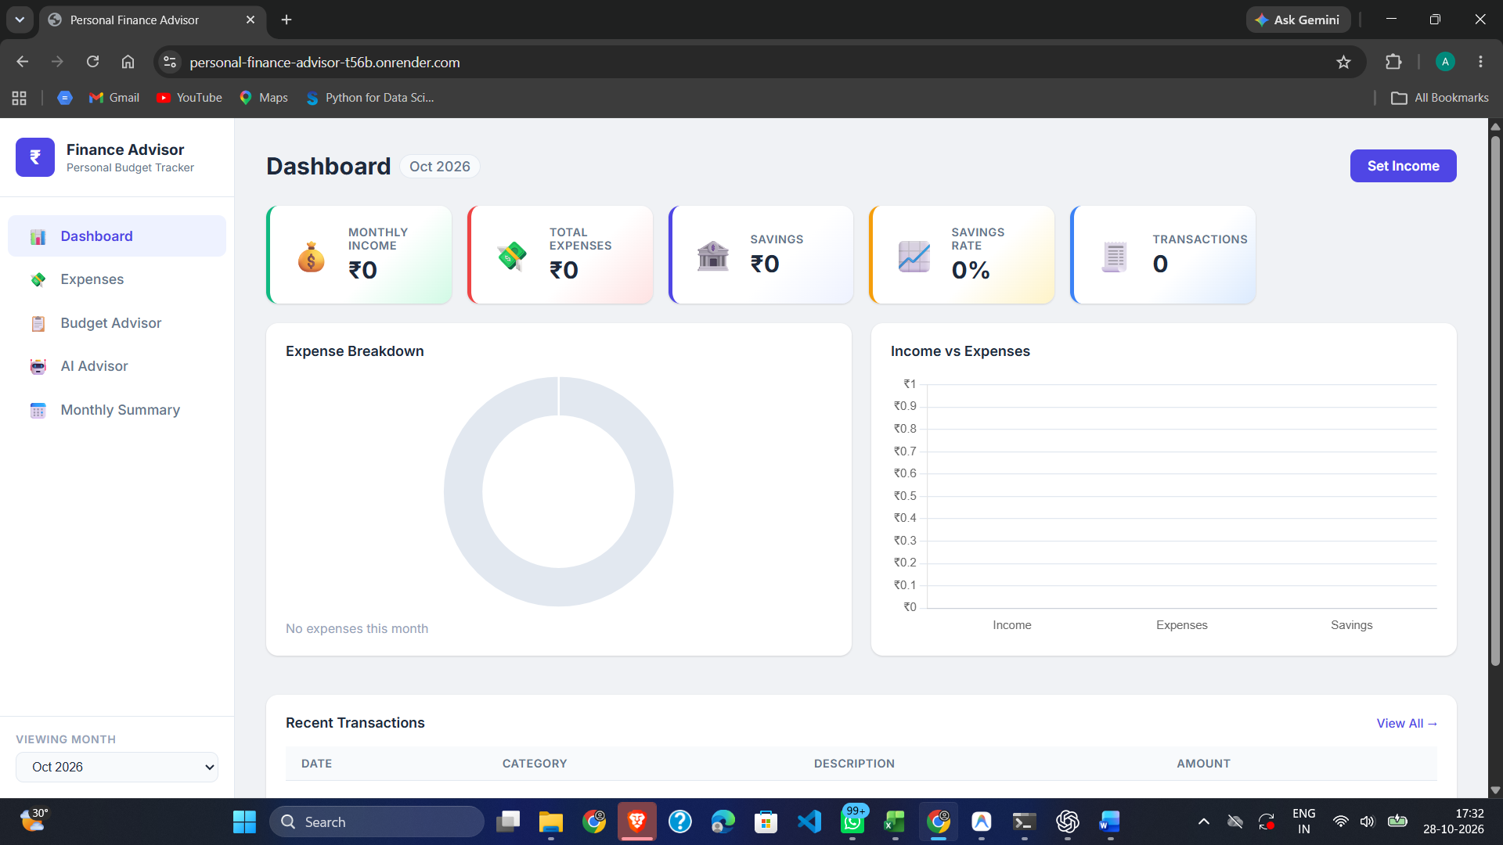
Figure 1. Deployed Dashboard interface supplied by the project owner.

Main Elements
- Monthly Income — income recorded for the selected month.
- Total Expenses — sum of expense transactions for the month.
- Savings — income minus total expenses.
- Savings Rate — savings expressed as a percentage of income.
- Transactions — number of recorded transactions.
- Expense Breakdown — chart of spending distribution by category.
- Income vs Expenses — chart comparing income, expenses and savings.
- Recent Transactions — compact view of recent expense records.

Dashboard Calculations
Metric | Meaning
Total Expenses | Sum of expense amounts for the selected month.
Savings | Monthly income − total expenses.
Savings Rate | (Savings ÷ income) × 100, when income is greater than zero.
Transactions | Count of expense records for the selected month.

The supplied screenshot shows October 2026 with zero income, zero expenses and zero transactions. This describes the captured state only.

Module 2 – Expense Tracking
The Expenses section maintains individual transactions. Each record includes an amount, category and date, plus an optional description.
Category | Example use
Rent | Accommodation or rent.
Food | Groceries or meals.
Transport | Public transport, fuel or travel.
Utilities | Electricity, internet and household utilities.
Education | Books and education costs.
Shopping | Personal or household shopping.
Healthcare | Medical expenses.
Entertainment | Recreation and entertainment.
Other | Transactions that do not fit another category.

Expense Record Fields
- Amount: transaction value in rupees.
- Category: one of the supported categories.
- Description: optional note about the transaction.
- Date: date the expense occurred.
- Month: derived from date in YYYY-MM format.

Available Operations
The repository documentation describes API operations to retrieve expenses, add a transaction, filter by month/category and delete an expense by ID. New expense amounts must be positive, categories valid, and dates use YYYY-MM-DD.

User Flow
Open Expenses → Enter Transaction Details → Save → Review Transaction List → Dashboard and Summary Refresh

Module 3 – Budget Advisor
The Budget Advisor compares recommended category budgets with actual expenditure for the selected month and helps identify areas where spending is below or above a suggested allocation.
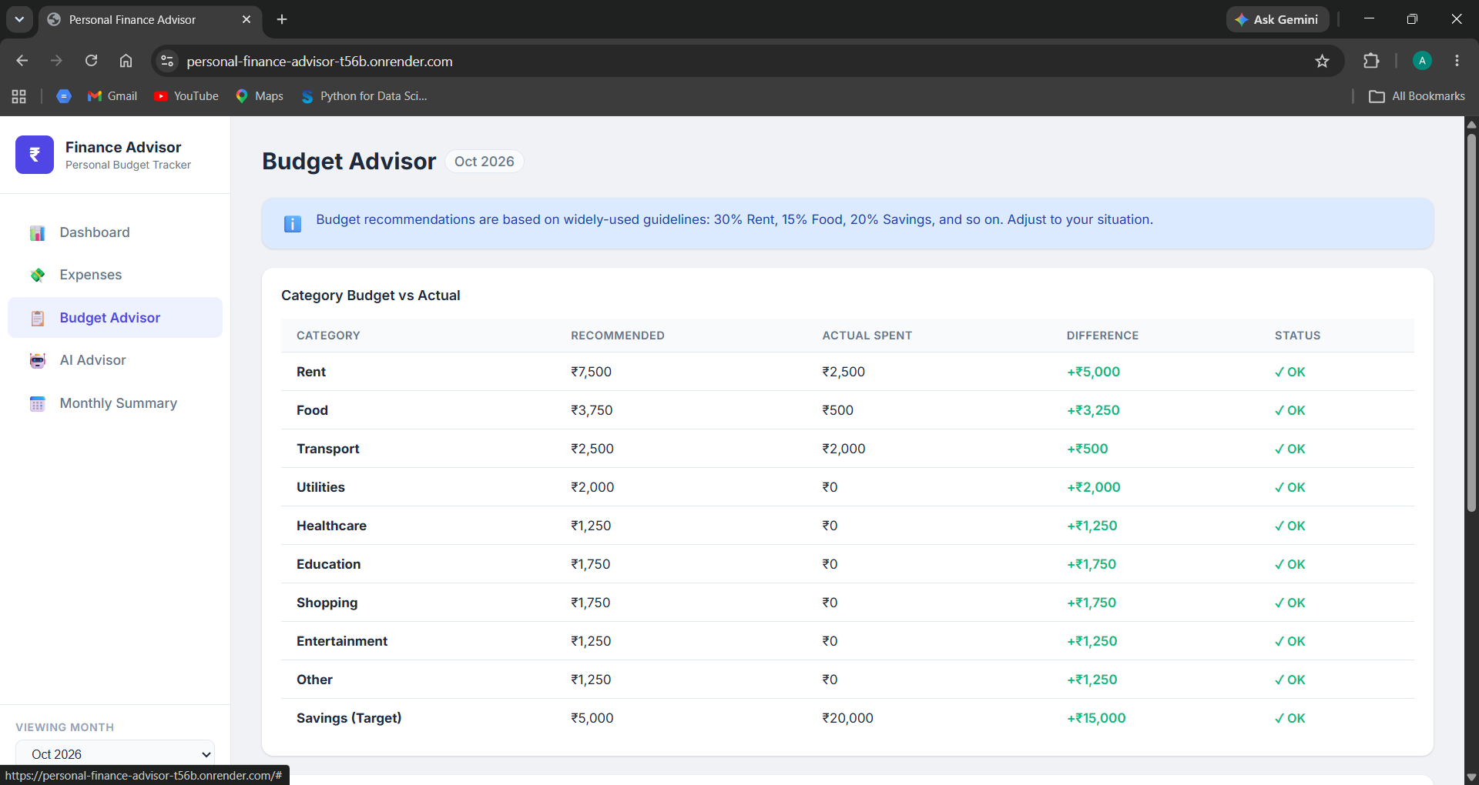
Figure 2. Budget Advisor showing recommended amounts, actual spending, differences and status.
Field | Description
Category | Expense category or savings target.
Recommended | Suggested amount based on budget rules.
Actual Spent | Recorded spending in the selected month.
Difference | Recommended amount minus actual amount.
Status | Indicates whether spending is within the suggested budget.

Budget Allocation Guidelines
Category | Allocation
Rent | 30%
Food | 15%
Transport | 10%
Utilities | 8%
Education | 7%
Shopping | 7%
Healthcare | 5%
Entertainment | 5%
Other | 5%
Savings target | 20%

These are configurable guidelines described in the project documentation, not universal financial rules. A positive difference indicates actual spending is below the recommendation; a negative difference indicates overspending.
In the supplied October 2026 screenshot, Rent, Food and Transport are below their recommended amounts.

Module 4 – AI Financial Advisor
The AI Financial Advisor provides financial tips based on recorded financial information. The project supports rule-based advice and optional Google Gemini integration.
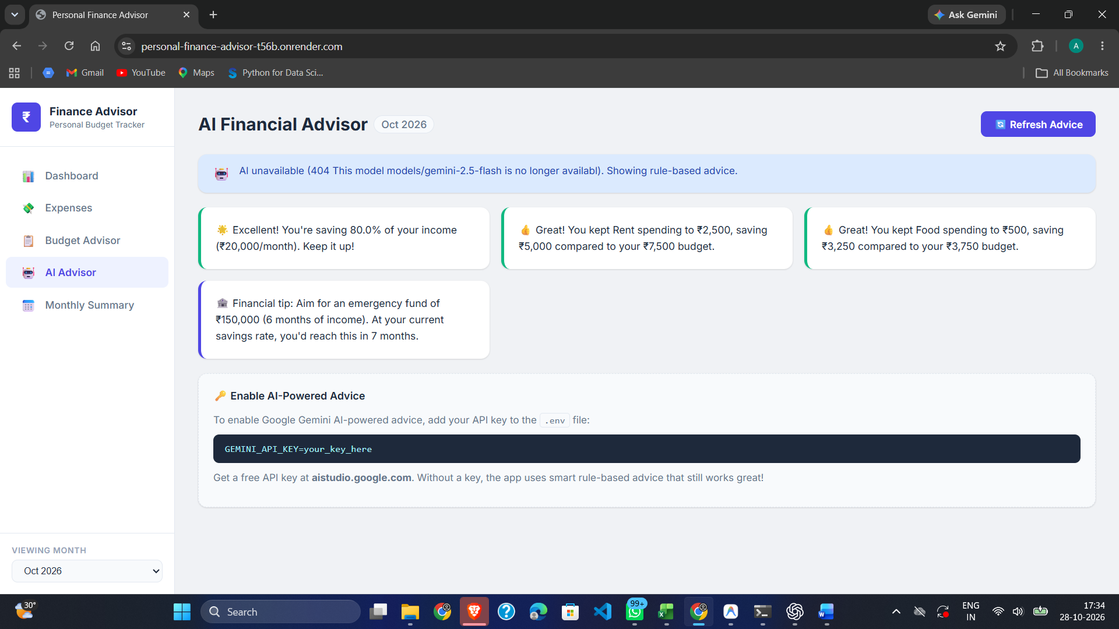
Figure 3. AI Financial Advisor showing rule-based recommendations while Gemini is unavailable.

Advice Examples
- Feedback based on the current savings rate.
- Warnings or positive feedback based on category spending.
- Suggestions to reduce high spending in a category.
- An emergency-fund goal based on income.
- An estimate of the time needed to reach a savings goal.

Operating Modes
Mode | Description
Rule-based | Uses predefined conditions and recorded values; works without an API key.
Gemini AI | Optional integration enabled by configuring GEMINI_API_KEY.
Fallback | If AI is missing or a request fails, rule-based tips can be displayed.

Configuration and Safety
The screenshot reports that the Gemini model endpoint was unavailable and rule-based advice was shown. API keys should be stored as environment variables and never committed to a public repository. Advice is educational and should not replace professional financial guidance.

Module 5 – Monthly Summary
The Monthly Summary consolidates income, expenses, savings and spending patterns. It provides category-level information, key insights and recommendations for the selected month.
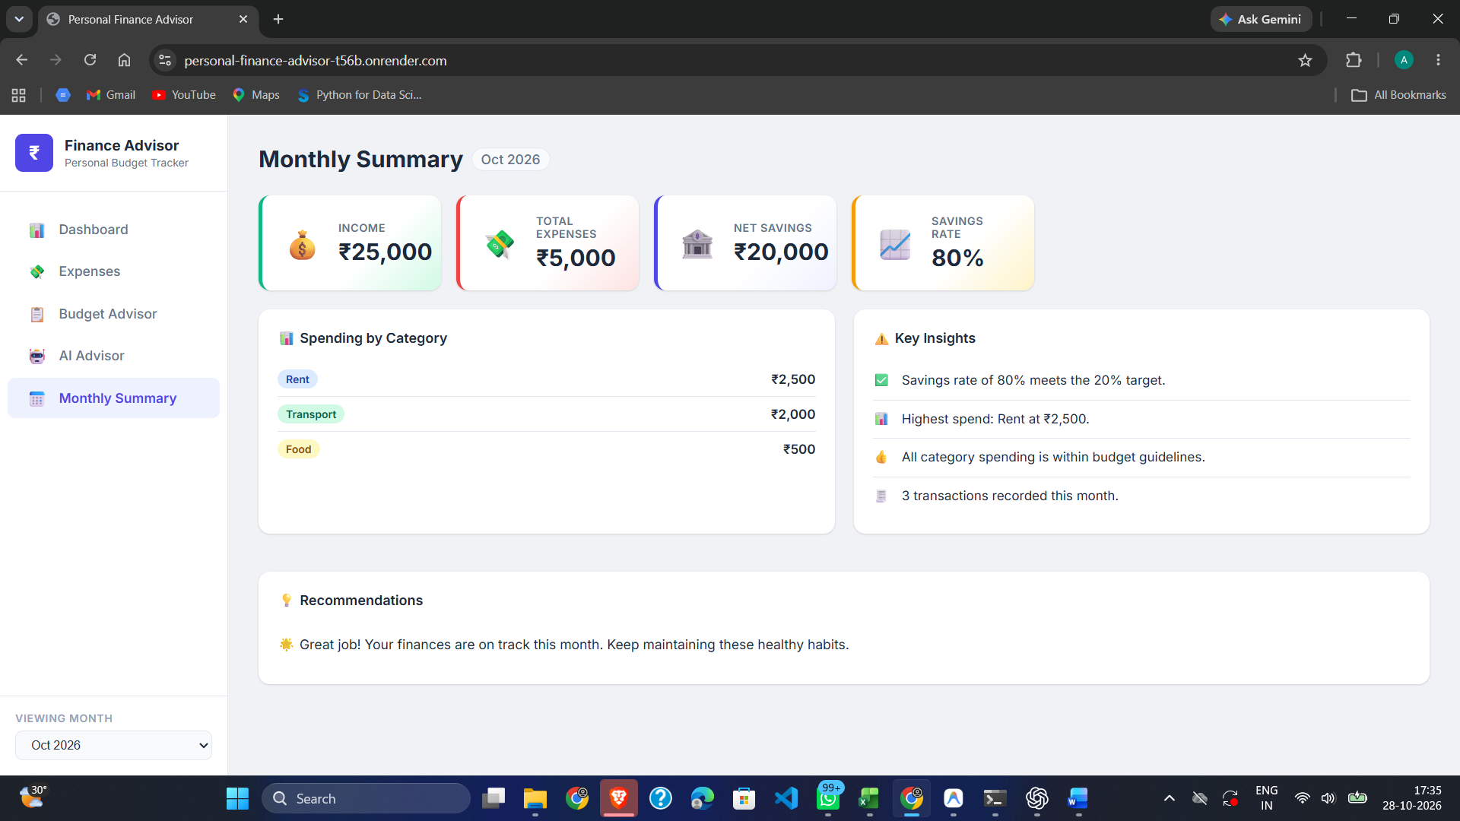
Figure 4. Monthly Summary with financial metrics, category spending, key insights and recommendations.

Summary Metrics
- Income — recorded monthly income.
- Total Expenses — sum of recorded transactions.
- Net Savings — income minus total expenses.
- Savings Rate — net savings as a percentage of income.
- Spending by Category — expenses grouped by category.
- Key Insights — savings rate, highest-spending category and transaction count.
- Recommendations — brief interpretation of the month's financial status.

Formulas
Metric | Formula
Net Savings | Income − Total Expenses
Savings Rate | (Net Savings ÷ Income) × 100, if income > 0
Category Total | Sum of expense amounts assigned to that category in the month.

The supplied screenshot shows October 2026 with ₹25,000 income, ₹5,000 expenses, ₹20,000 net savings and an 80% savings rate. These values describe the screenshot.

Database and API Integration
The repository describes a Flask REST API that exchanges JSON with the frontend. SQLAlchemy provides database access through SQLite.

Database Entities
Entity | Documented Fields | Purpose
Income | id, amount, month, updated_at | One income record per month; setting income again for the month updates the existing record.
Expense | id, amount, category, description, date, month, created_at | Multiple transactions per month; month is derived from the date.

Main API Endpoints
Endpoint | Purpose
GET / | Returns the main single-page application.
GET /api/income | Retrieves monthly income.
POST /api/income | Creates or updates monthly income.
GET /api/expenses | Retrieves expenses with optional filters.
POST /api/expenses | Adds an expense transaction.
DELETE /api/expenses/<id> | Deletes an expense by ID.
GET /api/summary | Returns monthly totals and category totals.
GET /api/budget | Returns recommended-versus-actual budget analysis.
GET /api/ai-advice | Returns rule-based or Gemini advice.
GET /api/categories | Returns supported categories.
GET /api/months | Returns months that contain data.

Technology Stack and Project Structure
Layer | Technology | Role
Backend | Python 3.11+, Flask 3.0.3 | API routes and application logic.
ORM | Flask-SQLAlchemy 3.1.1 | Database access through Python models.
Database | SQLite | Relational storage.
Frontend | HTML5, CSS3, Vanilla JavaScript | Structure, styling and interactions.
Charts | Chart.js 4.4.2 | Dashboard visualizations.
AI (optional) | Google Gemini | AI-generated advice when configured.
Deployment | Gunicorn, Render | Production server and hosting.
Configuration | python-dotenv | Loads environment variables from .env.

Repository Structure
personal-finance-advisor/
├── app.py # Main Flask application
├── requirements.txt # Python dependencies
├── Procfile # Deployment command
├── .env.example # Environment variable template
├── .gitignore # Excluded files
├── README.md # Project overview
├── DOCUMENTATION.md # Technical documentation
├── test_api.py # API test suite
├── templates/
│ └── index.html # Single-page application
├── static/
│ ├── style.css # Styling and responsive layout
│ └── script.js # Client-side logic
└── instance/
└── finance.db # SQLite database created at runtime

Environment Variables
Variable | Purpose
SECRET_KEY | Recommended Flask session signing key.
GEMINI_API_KEY | Optional key for Gemini-powered advice.
FLASK_DEBUG | Should be False in production.
PORT | Optional server port; local default is 5000.

Testing Strategy
The repository documentation describes an automated API test suite in test_api.py and reports 41 tests. The following areas are documented for testing.

Functional Testing
- Create or update monthly income and retrieve it.
- Add, list and delete expense transactions.
- Validate positive amounts, valid categories and date formats.
- Verify monthly summaries and savings calculations.
- Check budget differences and overspending flags.
- Verify rule-based advice and fallback when AI is unavailable.
- Check month and category filters.

Boundary and Error Testing
- Try missing or invalid numeric inputs.
- Try invalid categories and malformed dates.
- Delete an expense ID that does not exist and check the error response.
- Check zero-income handling to avoid division by zero.
- Simulate an unavailable AI service and verify fallback advice.

Non-Functional Checks
- Responsive layout on desktop and mobile.
- Readable charts, labels and table headings.
- API error handling and response time.
- Secret-key protection through environment configuration.
- Data persistence on the selected hosting plan.
The repository documentation states that 41 API tests passed. This report records that documented claim; the test suite has not been independently rerun for this report.

Deployment and Execution

Local Setup
- Clone the repository and open the project directory.
- Create and activate a Python virtual environment.
- Install dependencies with pip install -r requirements.txt.
- Copy .env.example to .env if environment configuration is needed.
- Set a secret key and optionally GEMINI_API_KEY.
- Run python app.py and open http://localhost:5000 in a browser.

Cloud Deployment
The repository documentation describes deployment to Render. Connect the repository as a web service, install dependencies, configure environment variables and use Gunicorn to start the Flask application.
Build command: pip install -r requirements.txt
Start command: gunicorn app:app --bind 0.0.0.0:$PORT

Deployment Considerations
- Store API keys in environment variables, not source code.
- Review hosting logs if dependencies or API calls fail.
- SQLite data may reset after redeployment when storage is ephemeral.
- Use persistent storage or a managed database for long-term data retention.
The screenshots supplied for this report were captured from the deployed application at personal-finance-advisor-t56b.onrender.com.

Conclusion
Personal Finance Advisor Bot combines monthly income tracking, expense recording, budget comparison, financial advice and monthly summaries in one web interface. The Dashboard gives a quick overview, while the Budget Advisor and Monthly Summary provide category-level context to help users review spending.
The project demonstrates integration of a Python Flask backend, SQLAlchemy data access, SQLite storage, HTML/CSS/JavaScript, chart visualizations and optional AI assistance. Rule-based fallback advice helps the advisor screen remain useful when the external AI service is unavailable.
The screenshots document the visible behavior of the deployed application in October 2026. Technical details about routes, data fields, configuration and testing are based on the repository's DOCUMENTATION.md. Production use should include secure secret management, persistent storage and verification of AI settings.

Project Links
GitHub Repository: https://github.com/SheteArnav/personal-finance-advisor
Technical Documentation: https://github.com/SheteArnav/personal-finance-advisor/blob/main/DOCUMENTATION.md
Deployed Application: https://personal-finance-advisor-t56b.onrender.com

