***Name :- Sheth Uday M.***

***Roll no. :- 27***

***Class :- B-6***

***Sem. :- 3***

***Enrollmrnt no. :- 210801320***

**Login Related Command**

1. Which command can list the names of users currently logged in?

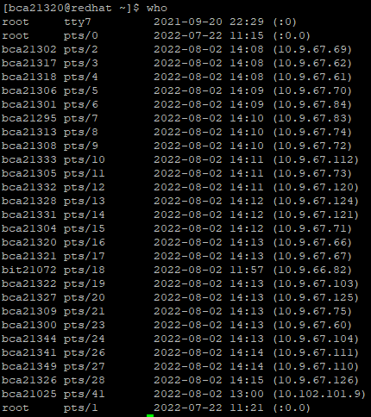

2. Which option is used to print only the usernames and the user count/total no of users logged in?

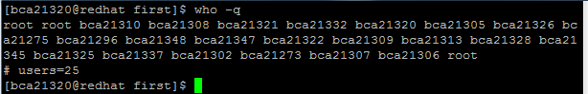

3. Which option is used to display all details of current logged in user?



4. Which option is used to print column headings above the output?

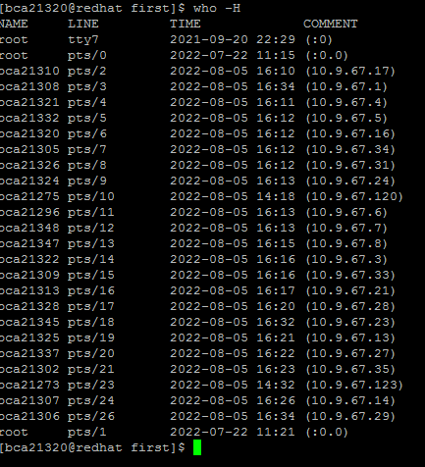

5. Which command is used to print effective userid?



6. Which command is used to clear the screen?

ANS.:- CLEAR

7. Which command is used to logout?

ANS.:- LOGOUT

8. Which command is used to change the password?

ANS.:- PASSWD

**Directory Related Commands**

1. Create the SAMPLE directory under your home directory?

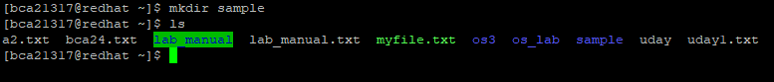

2. Create the TRIAL directory and print the message of created directory?

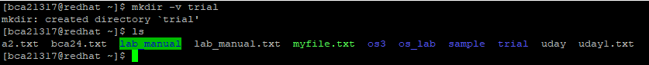

3. Create the UBANTU directory and set all permission to this directory?

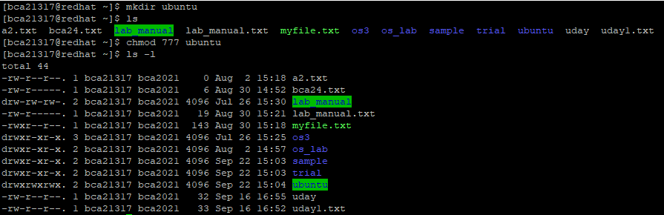

4. Create the sub directory by name EXAM under SAMPLE.



5. Change to UBANTU.

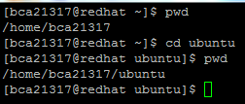

6. Change to your home directory.

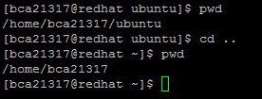

7. Display the name of your home directory.

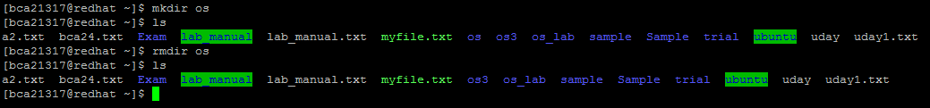

8. Remove directory OS.

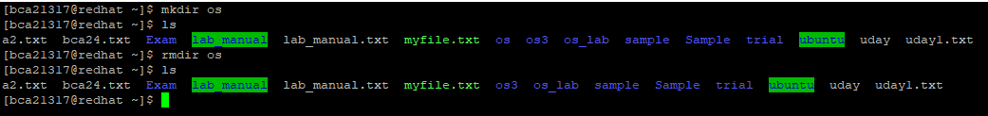

9. Using a single command change from current directory to home directory

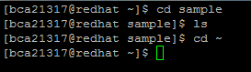

10. Display the all directory name.



11.Display all the hidden files and directory name.



12.Display all the information of directory.

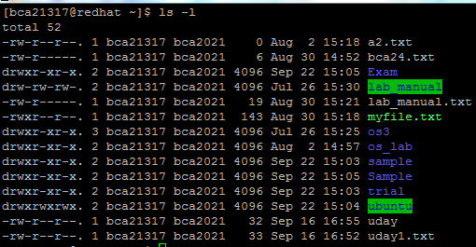

13.Shows all the directory and files in reverse order.



14.Display the slash in front of all directories.



Files Related Command

1. Which command is used to create a new file?



2. How to write in new file?



3. How to read any file?

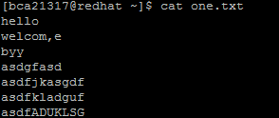

4. How to concatenate in existing file?

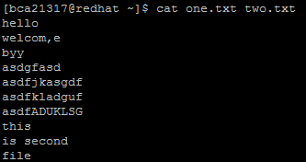

5. Which command is used to omit line numbers for blank space in the output?

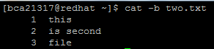

6. Which option is used to line numbers for all output line?

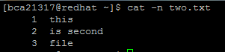

7. Which option is used to display $ at the end of each line?

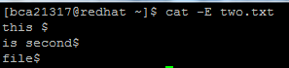

8. Which option is used to if the output has multiple empty lines it replaces it with

one empty line?

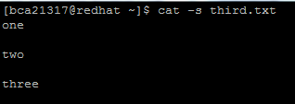

9. Which command is used to rename the file?



10.Which command is used to move file from one directory to another directory?

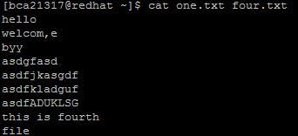

11.Which option is used to prompts before overwriting another file?

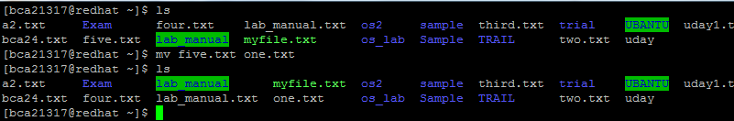

12.Which command is used to copy file from one location to another?



13.Which option is used to ask before overwrite files while copying?



14.Which option is used to give symbolic link while copying?



15.Which command is used to remove the file from the directory?



16.Which option is used to remove directories and their contents?

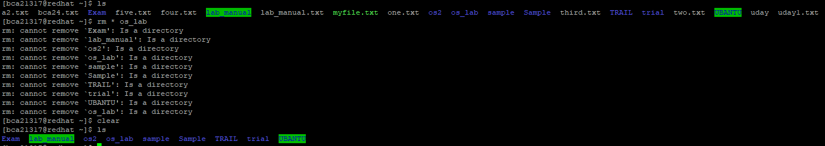

17.Which option is used to prompt before every removal?

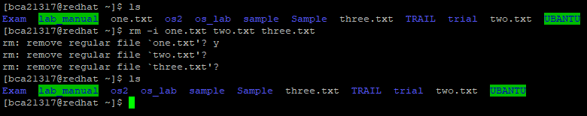

18.Which command use to change access rights to files and directories.



19.Create file DEMO and give only read and write permission.

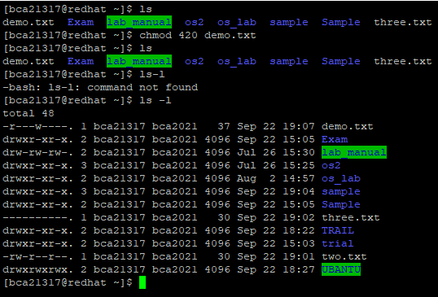

20.Create directory and change all permission.

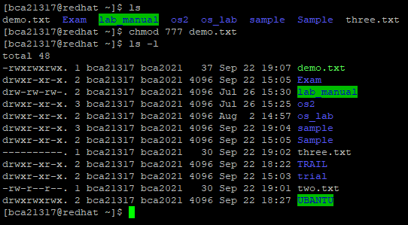

21.Create TEST directory and give only user to read, write, and execute permission.

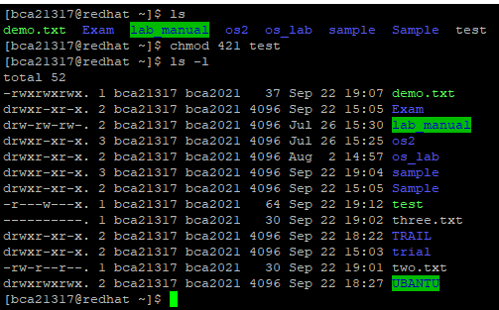

22.Create file and give only group to read and write permission.

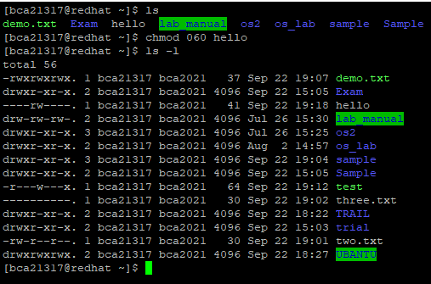

23.Create the PRACTICE file and shows only first 10 lines of this file.

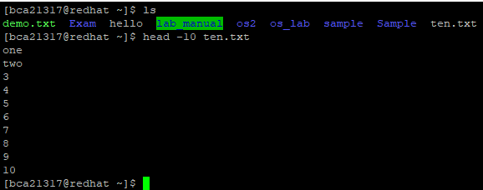

24.Create the DATA file shows only first 4 line of this file.

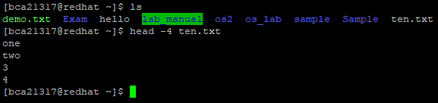

25.In DATA file shows only the last 5 line of this file.

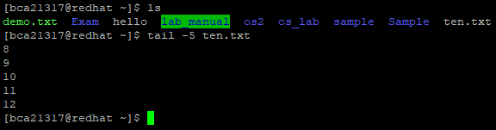

26.Create the TRIAL file and shows the last 10 lines of this file

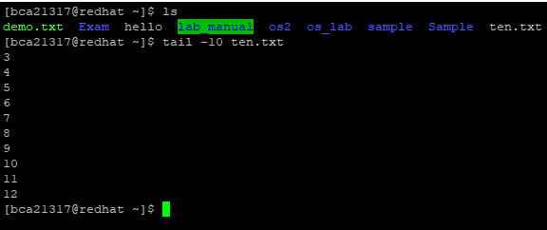

27.In DATA file shows only 11 byte top of the file.

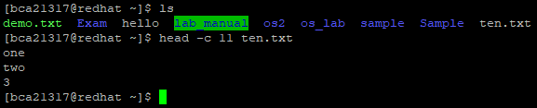

28.In TRIAL file shows only 15 byte bottom of the file.

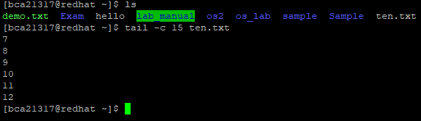

29.Count the number of lines in DATA file.

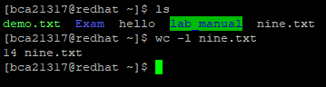

30.Count the number of byte in PRACTICE file.

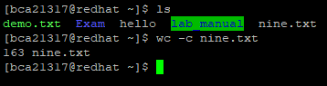

31.Count the number of words in TRIAL file.

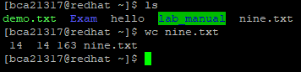

32.Create the EXAM file and find the longest length of line.

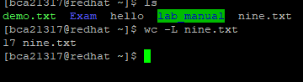

33. Which command is used to create empty file ?

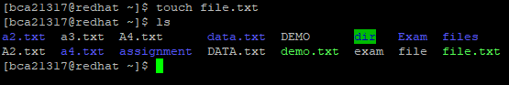

34. Which command is used to create, change and modify timestamps of a file?

**Working with columns and fields**

1. Which command is used to cut out selected fields of each line of a file?

cut

2. Which option is used to display specific fields on each line?

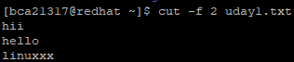

3. Which command is used to paste the content from one file to another file?

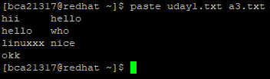

4. Which option is used to paste one file at a time instead of parallel?



5. Which option is used to specify a delimiter while pasting?

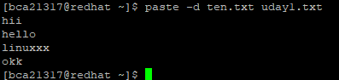

**Comparing Files**

1. Which command is used to compares two files and tells you which line numbers are different?

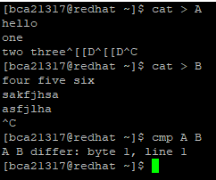

2. Which option is used to print differing bytes while you are comparing?



3. Which command is used to compare two sorted files line by line?

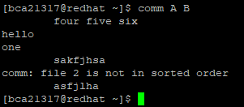

4. Which option is used to suppress lines that appear in both files?

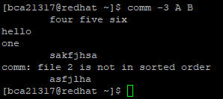

5. Which command is used to find differences between two files?

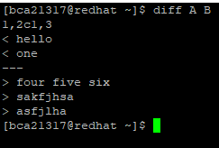

6. Which option is used to ignore blank lines when calculating differences?

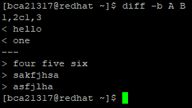

7. Which command is a command line utility for joining lines of two files on a common field?

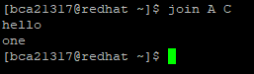

**Tools for sorting**

**datafile1.txt Apple Orange Banana Mango Grapes**

1. Sort data of datafile1.txt

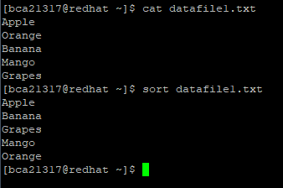

2. How to check whether datafile1.txt is sorted or not

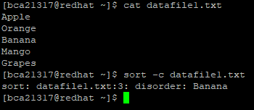

3. Sort data file1.txt in revese order

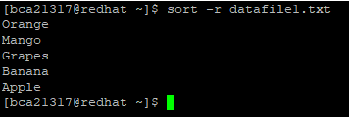

**datauniq1.txt AAA AAA BBB CCC BBB AAA CCC CCC**

4. print uniq data of datauniq1.txt

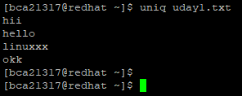

5. find how many times each line occurs in the file datauniq1.txt

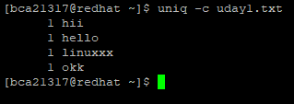

6. print all duplicate lines from datauniq1.txt

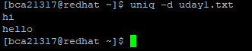

7. print only the lines that occur more than once in a file datauniq1.txt

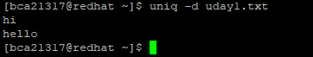

**Tools for mathematical calculations**

1. Create a file for 8*9 and print output with welcome message

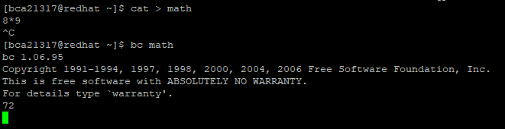

2. Create a file for sum of 1 to 10 and print only output without welcome message

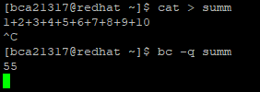

3. Find the factor for 80



4. Find the factor for 13



5. 3 3 7 7 is factor of which number



6. 2 3 3 3 3 19 is factor of which number



**Tools For Displaying Date and Time**

1. Display the calendar for

a. 7th month of the year 7 A.D

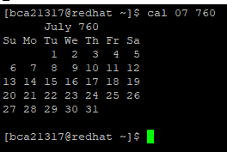

b. Prev/current/next month

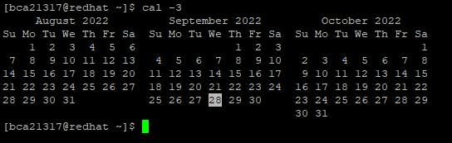

c. SEP 2000

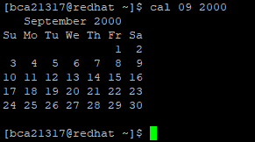

d. Monday as first day of calendar along with Julian dates

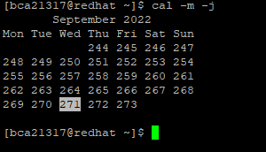

e. Find Julian date for 15-aug-1947

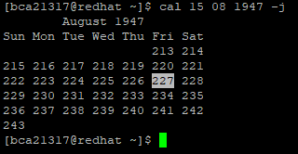

2. Current Date Day Abbreviation , Month Abbreviation along with year

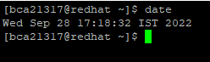

3. Display the time in 12-Hour and 24 Hour Notations.

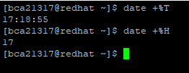

4. Display the Current Date and Current Time

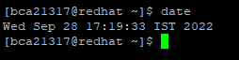

**Monitoring with input and output & redirection and pipeing**

1. Which command is used to store the output of given command in a file?

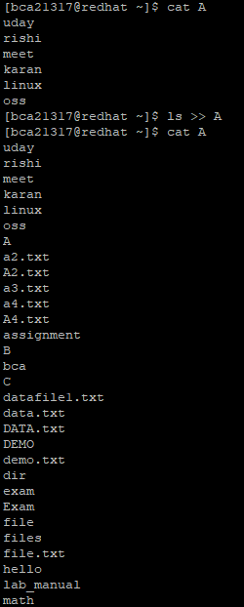

2. Which command is used to record all the terminal activities?

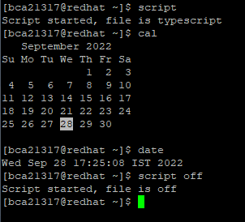

3. Which command is used to combine two or more commands?

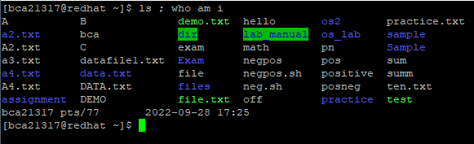

4. Which symbol is used for output redirection?

