**CHMOD COMMAND:-**

**Basic permission :-**

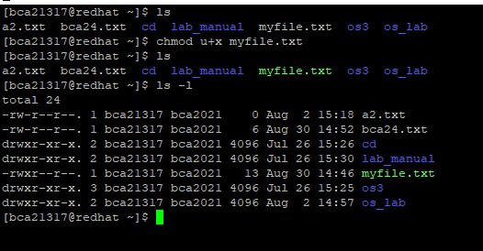

**Choose specific permissions :-**

