1. Write a python program to find the given number is odd or even.

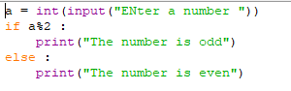

2. Write a python program which take 3 input binary, octal and hexadecimal convert it into decimal.

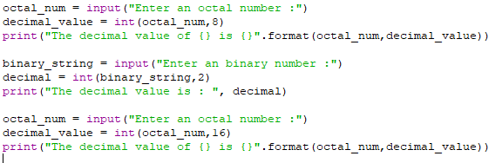

3. Write a python program to take a two numbers & display it's summation, subtraction, multiplication & division.

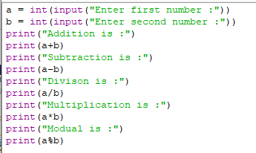

4. Write a python program to find out the min/max from three numbers.

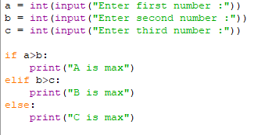

5. Write a python program to enter Number of seconds and display as

Day: ______ Hours :______ Minutes:______ Seconds : ______

6. Write a python program to interchange the value of two numbers with and without third variable.

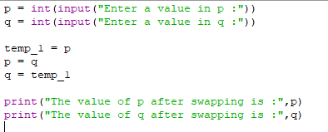

7. Write a python program to find out the number is palindrome or not.

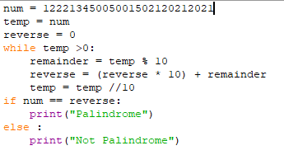

8. Write a python program to find the number is perfect or not.

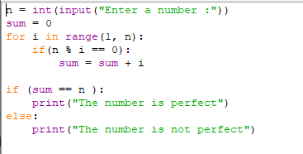

9. Write a python program to find the factorial of given number.

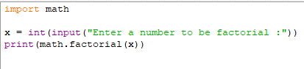

10. Write a python program to find out the sum of digits of a given number.

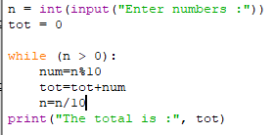

11. Write a python program to find out the sum of odd and even numbers between given range.

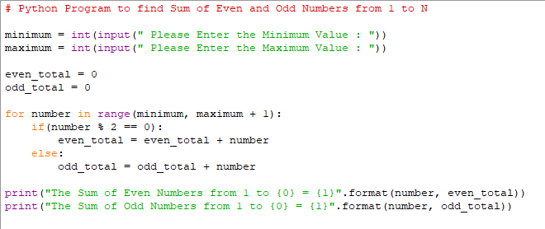

12. Write a python program to find first N prime numbers.

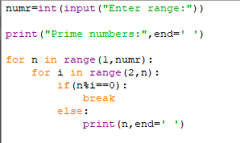

13. Write a python program in which accept the number one by one until user enter 0. Find out total positive numbers, total negative numbers, Maximum number, Minimum number, average of the absolute values of the nos. and total numbers you entered.

14. Write a program that will accept the amount and find how many minimum no of notes you required for that.

(Using the rupee notes of 1, 2, 5, 10, 20 , 50, 100, 200, 500, 2000)

Input: 1238

Output: 500 * 2, 200 * 1, 20*1, 10*1, 5*1, 2*1, 1*13.

15. Write a python program to accept string from the user and print following triangle

Input: ATMIYA

**ATMIYA**

**ATMIY**

**ATMI**

**ATM**

**AT**

**A**