**

**UNIVERSITY-BANGLADESH**

**Faculty of Science and Technology**

**Assignment Cover Page**

|  |  |  |  |  |
| --- | --- | --- | --- | --- |
| Assignment Title: | Final Semester Assignment | | | |
| Assignment No: | 01 | | Date of Submission: | 11 August 2020 |
| Course Title: | OOAD | | | |
| Section | D | |  |  |
| Semester: | Summer | 2019-20 | Course Teacher: | S.A.M MANZUR HOSSAIN KHAN |

|  |  |
| --- | --- |
| Group No: | 12 |

|  |  |  |  |  |  |  |  |
| --- | --- | --- | --- | --- | --- | --- | --- |
| **No** |  | **Name** | **ID** |  | | | **Program** |
| 1 |  | Shethil Ahammed | 19-39698-1 |  | | | BSc CSE |
| 2 |  | MD. Sabbirul Arifin Sayed | 19-39653-1 | |  | | BSc CSE |
| 3 |  | Sabiha Hajera Natasha | 19-39671-1 | | |  | BSc CSE |

HOSPITAL MANAGEMENT SYSTEM

The hospital management system (HMS) handles different directions

of clinical workflows. It manages the smooth healthcare performance

along with administrative, medical, legal and financial control. Hospital

management systems allow us the ability to optimize and digitize all

the processes within the institution, which will help to improve customer service, reduce process costs, streamline the search of medical records, bills, patients, doctors, nurse etc. It supports some of the many job duties of hospital receptionists also. Receptionist schedules patient’s appointments and admission to the hospital, collects information from patient upon patient’s arrival or by phone. For the patient that will stay in the hospital, she or he should have a bed allocated in a ward. Receptionist’s might also receive patient’s payment, record them in a Database and provide receipts, file insurance claims and medical reports. Nurse help doctor at works and operation time. Nurse also treat a patient. The functionality of the system differs with every user needs and operations.

Sequence Diagram 1

Take Appointment to consult a doctor :

:Doctor

:DataBase

:Receptionist

:Patient

1:Request()

2: Checkavailability()

ALT

3: Doctor available

4: Confirm Appointment

5:ConsultWithDoctor()

6:Treats Patient

3:Doctor is not available

4: Return deny

Sequence Diagram 2

Sequence Diagram for Patient Admit :

:Ward

:Patient

:Patient Database

:Receptionist

1:Register()

2:AddNewPatint ()

4:Return

ALT

7: [If available] Return

8:Return(WordNo)

7: [If not available] Return

8:Return(not available )

6:Checkavailability ()

3:Return

5:RequestWard()

Activity Diagram 1

**Activity Diagram for Ward Allocation :**

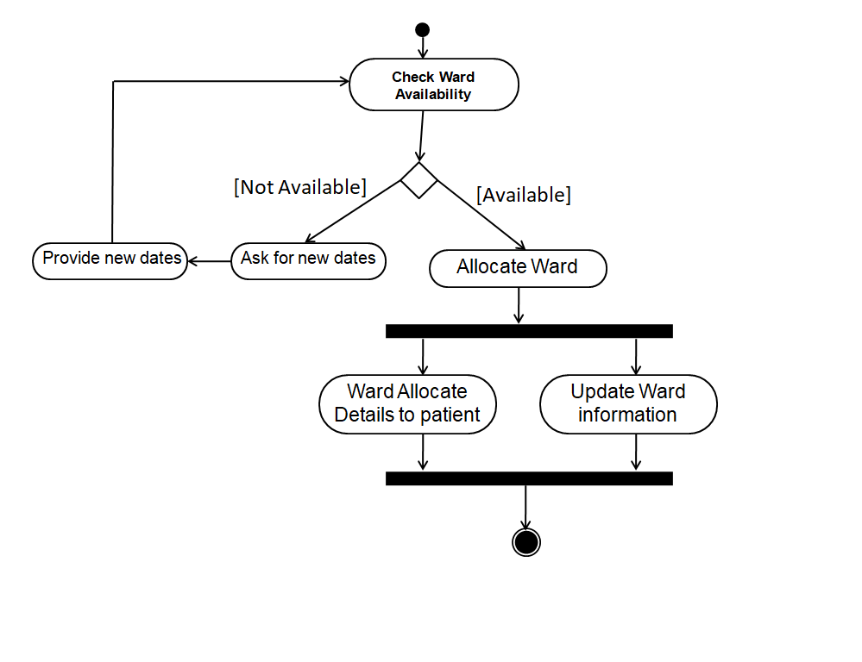

Activity Diagram 2

Activity Diagram for Payment :

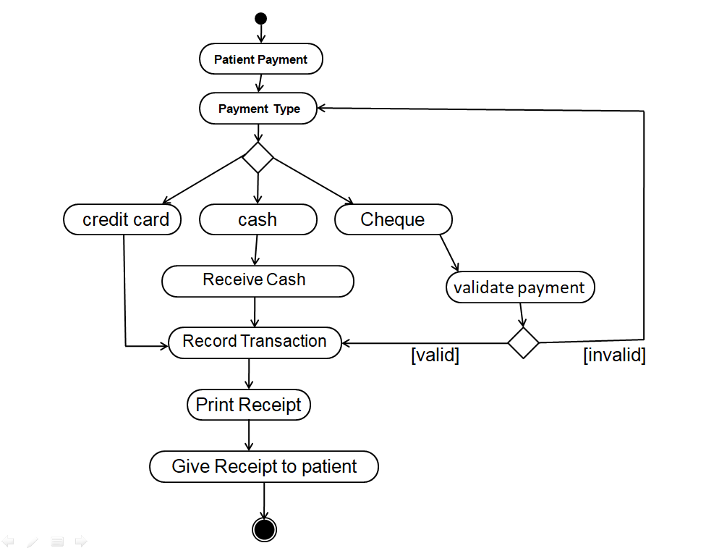

Statechart Diagram 1

Statechart Diagram for Patient:

Doctor visits

Entry / Patient Details()

Exit / Generate Patient ID()

Patient Registere

Undergoing treatment

Do/

Take Medicine ()

Perform Test()

Present Report()

Undergo operation()

Issue of discharge advice

from doctor

Do/ Payment()

Discharged

Statechart Diagram 1

Statechart Diagram for Doctor:

Patient Registerd

Doctor Registere

Undergoing treatment

Do/

Prescribe Medicine ()

Prescribe Test()

Review Report()

Prescribe operation()

Preform operation()

Entry / Accept Details()

Do/ Check Details()

Exit / Issue ID()

Doctor plans to leave

Do/ Doctor ID Released()

Doctor Inactive

We take those two class from our previous Mid tram Class Diagram assignment:

|  |
| --- |
| **Class Department** |
| DepID  DepName  DoctorID |
| AddDepartment (DepID,DepName)  DeletDepartment (DepID)  AddDoctor (DepName,DoctorID)  RemoveDoctor (DoctorID) |

|  |
| --- |
| **Class Patient** |
| PatientName  PatientID  Room |
| SetName(PatientName)  SetID(PatientID)  GetID(PatientID)  PayBill(PatientID, PatientName) |

Calculation of the LCOM value

For department class :

For patient class :