**

**UNIVERSITY-BANGLADESH**

**Faculty of Science and Technology**

**Assignment Cover Page**

|  |  |  |  |  |
| --- | --- | --- | --- | --- |
| Assignment Title: | Mid Semester Assignment | | | |
| Assignment No: | 01 | | Date of Submission: | 11 August 2020 |
| Course Title: | OOAD | | | |
| Section | D | |  |  |
| Semester: | Summer | 2019-20 | Course Teacher: | S.A.M MANZUR HOSSAIN KHAN |

|  |  |
| --- | --- |
| Group Name/No.: | 12 |

|  |  |  |  |  |
| --- | --- | --- | --- | --- |
| **No** | **Name** | **ID** | **Program** |  |
| 1 | Shethil Ahammed | 19-39698-1 | BSc [CSE] |  |
| 2 | MD. Sabbirul Arifin Sayed | 19-39653-1 | BSc [CSE] |  |
| 3 | Sabiha Hajera Natasha | 19-39671-1 | BSc [CSE] |  |

|  |  |  |
| --- | --- | --- |
| ***Faculty use only*** | | |
| FACULTYCOMMENTS | **Marks Obtained** |  |
|  |
|  |
|  | **Total Marks** |  |
|  |
|  |

**HOSPITAL MANAGEMENT SYSTEM**

The hospital management system (HMS) handles different directions

of clinic workflows .It manages the smooth healthcare performance

along with administrative, medical, legal and financial control. Hospital

management systems allows us the ability to optimize and digitize all

the processes within the institution, which will help to improve customer

service, reduce process costs, streamline the search of medical records,

bills, patients, doctors, etc. It supports some of the many job duties of

hospital receptionists also . Receptionist schedules patient’s appointments

and admission to the hospital, collects information from patient upon

patient’s arrival or by phone .For the patient that will stay in the

hospital,she or he should have a bed allocated in a ward. Receptionist’s

might also receive patient’s payment, record them in a Database and

provide recipts, file insurance claims and medical reports. The functionality

of the system differs with every user needs and operations.

Use Case Diagram

Hospital management system

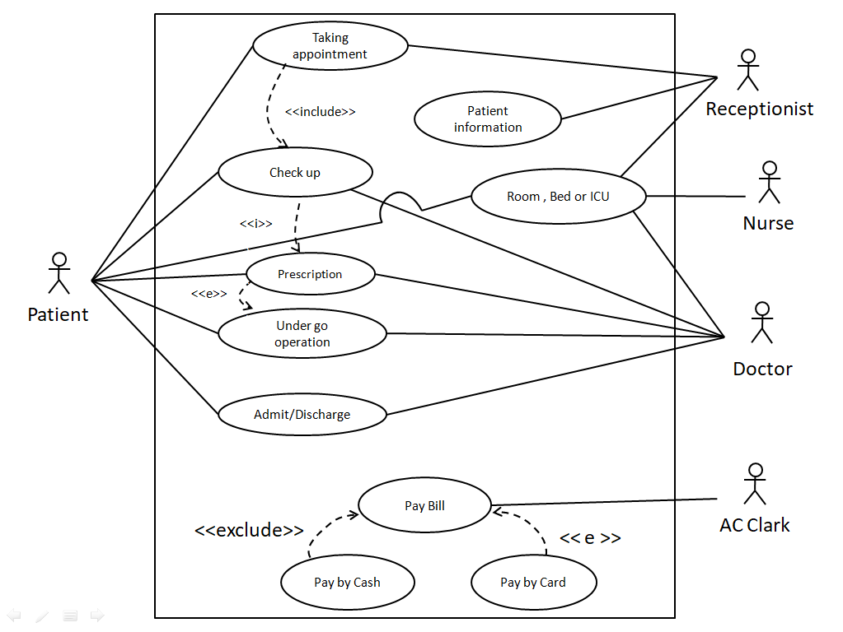

Class Diagram

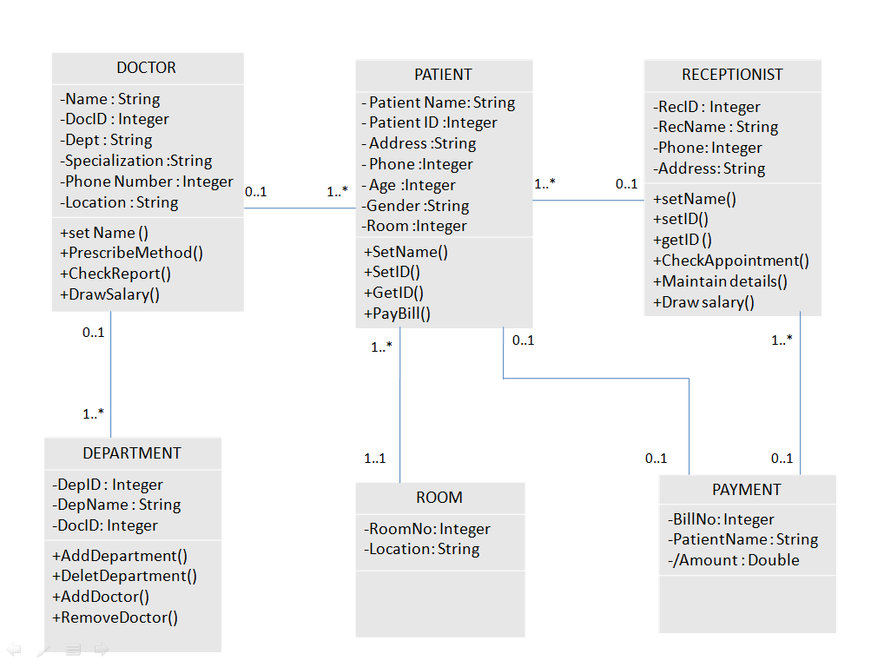

Detail design (name, attributes, operations) of 3 class

Name of the class: Receptionist

Attributes:

|  |  |  |  |
| --- | --- | --- | --- |
| *Name* | *Datetype* | *Visibility* | *Remarks* |
| Rec.Name | String | Private | Maximum 30 characters long. |
| Rec.ID | Integer | Private | Assigned by system. |
| Rec.Phone | Integer | Private |  |
| Address | String | Private |  |

Operations:

|  |  |  |  |  |
| --- | --- | --- | --- | --- |
| *Name* | *Arguments* | *Visibility* | *Return Datatype* | *Remarks* |
| setName() | Name(Datatype: string) | Public |  |  |
| setID() | Id(Datatype: Integer) | Public |  |  |
| getID () |  | Public | Integer |  |
| Check appointment |  | Public |  |  |
| Maintain details |  | Public |  | Static. |
| Draw salary |  | Public | Double |  |

**Name of the class: Patient**

Attributes:

|  |  |  |  |
| --- | --- | --- | --- |
| *Name* | *Datetype* | *Visibility* | *Remarks* |
| Patient Name | String | Private | Maximum 30 characters long. |
| Patient ID | Integer | Private | Assigned by System. |
| Address | String | Private | Static. |
| Phone | Integer | Private | Static. |
| Age | Integer | Private | Maximum 4 numbers store. |
| Gender | String | Private | Maximum 10 characters long. |
| Room | Integer | Private | Static. |

Operations:

|  |  |  |  |  |
| --- | --- | --- | --- | --- |
| *Name* | *Arguments* | *Visibility* | *Return Datatype* | *Remarks* |
| setName () | Name(Datatype: String) | Public |  |  |
| setID () | ID(Datatype: Integer) | Public |  |  |
| getID () |  | Public | Integer |  |
| PayBill () |  | Public | Integer | Static. |

**Name of the class: Doctor**

Attributes:

|  |  |  |  |
| --- | --- | --- | --- |
| *Name* | *Datatype* | *Visibility* | *Remarks* |
| Doctor Name | String | Private | Maximum 30 characters long. |
| Doctor Dept | String | Private | Maximum 30 characters long. |
| Doctor ID | Integer | Private | Assigned by System. |
| Specialization | String | Private | Maximum 40 characters long. |
| Phone No | Integer | Private | Static. |
| Location | String | Private | Static. |

Operations:

|  |  |  |  |  |
| --- | --- | --- | --- | --- |
| *Name* | *Arguments* | *Visibility* | *Return Datatype* | *Remarks* |
| set Name () | Name(Datatype: String) | Public |  |  |
| Check report() |  | Public |  |  |
| PrescribeMethod () |  | Public |  |  |
| Draw salary () |  | Public | Integer |  |

CRC Card

|  |  |
| --- | --- |
| Class name : Patient | |
| Responsibilities | Collaboration |
| Make appointment | Appointment |
| Provide medical history | Medical History |
| Provide information | Reception |
|  |  |
|  |  |

|  |  |
| --- | --- |
| Class name : Receptionist | |
| Responsibilities | Collaboration |
| Fixed appointment | Patient |
| Store data | Patient |
| Provide information | Room ,bed & ICU |
|  |  |
|  |  |

|  |  |
| --- | --- |
| Class name : Doctor | |
| Responsibilities | Collaboration |
| Provide treatment | Patient |
| Prescribe Medicine | Patient |
| Check report | Patient |
| Draw Salary | Payment |
|  |  |

**Use Case Narrative**

|  |  |
| --- | --- |
| *Name:* | Taking Appointment |
| *Short Description:* | Patient take an appointment to consultation doctor |
| *Precondition:* | Have to contact with Reception. |
| *Post condition:* | Have to maintain consulting time. |
| *Error Situation:* | Doctor is not available. |
| *Actor:* | Receptionist , Patient |
| *System state in the event of an error:* | Ranout of appointment |
| *Standard process:* | The patient will ask for information  Receptionist provide information.  Patient chose his/her suitable time.  Receptionist fixed that time. |
| *Alternative process:* | Can cancel appointment  Can change time |

|  |  |
| --- | --- |
| *Name:* | Checkup. |
| *Short description:* | Doctor checks patient physical condition. |
| *Precondition:* | Patient have to take an appointment for checkup. |
| *Postcondition:* | Patient have to complete all test and follow doctor instructions. |
| *Error situations:* | Doctor get late to start checkup the patient. |
| *System state in the event of an error:* | Patient can not consult with doctor. |
| *Actor:* | Patient, Doctor. |
| *Standard process:* | Doctor check physical condition such as  Pressure check  Weight check |
| *Alternative process:* | Doctor can suggested diet |

|  |  |
| --- | --- |
| *Name:* | Prescription. |
| *Short description:* | A physician’s order for the preparation and administration of a drug for a patient . |
| *Precondition:* | Before taking prescription have to consult with doctor . |
| *Postcondition:* | Have to maintain doctor’s advice given in prescription. |
| *Error situations:* | Doctor can prescribe wrong medicine in prescription mistakenly. |
| *System state in the event of an error:* | The condition of the patient can be worse. |
| *Actor:* | Patient, Doctor. |
| *Standard process:* | Doctor will prescribe some medicine  Doctor can suggest Medical text  Example : X-ray, MRI , Blood tests. |
| *Alternative process:* | Doctor can give some advice |