**Document for Proof of concept for Capston Project**

**Table of Content**

1. Objective: 2

2. Walk Through to steps to verify for POC: 2

I. Codes and files related to Task are kept in respective folder along with relevant screenshots: 2

a. Task1 Structure : 2

b. Task2 Structure : 2

c. Task3 Structure : 2

d. Task4 Structure : 2

e. Task 1 Screen Shots 3

I. Cluster nodes created 3

II. HPA Nodes created 3

III. AWS CLI and Terraform Installed 3

f. Task 2 Screen Shots 4

I. Hello world output: 4

g. Task 3 Screen Shots 4

II. redis-volume-persistence: 4

h. Task 4 Screen Shots 5

# Objective:

Objective of the document is to describe the setup done for POC around the setup of a Kubernetes cluster on cloud and managing applications on Kubernetes. The POC will involve the following goals:

* Basic VPC setup for a Kubernetes cluster on AWS
* EKS cluster setup using eksctl
* Stateless & Stateful workload on Kubernetes
* Metrics system for Kubernetes
* Autoscaling nodes & workload on Kubernetes

# Walk Through to steps to verify for POC:

## Codes and files related to Task are kept in respective folder along with relevant screenshots:

These file can be also run manual if any component fails during installation

**Public git repo - https://github.com/Shetty1987/k8_project**

## Task1 Structure :

Following files are available under folder

* 1. **provider.tf** – this file defines initial setup for terraform with AWS provider and tfstate file location
  2. **vpc.tf** – Contains terraform resources /modules for VPC, Subnet, Route Table, IGW, NAT GW, Subnet Association
  3. **cluster.yml** – Cluster deployment yml file
  4. **cluster-autoscale.yml** - Cluster deployment yml file
  5. **metrics-server.txt – Command for metric server**

## Task2 Structure :

Following files are available folder

1. **deployment.yaml –** Kubernetes deployment yml file
2. **Dockerfile.txt -** Docker file to build container
3. **Hello-world.png –** screenshot

## Task3 Structure :

Following files are available folder

1. **Redis.yml** – Redis file
2. **Redis.volume-persistance.png - screenshot**

## Task4 Structure :

Following files are available under folder

Screenshots for Grafana

## Task 1 Screen Shots

### Cluster nodes created

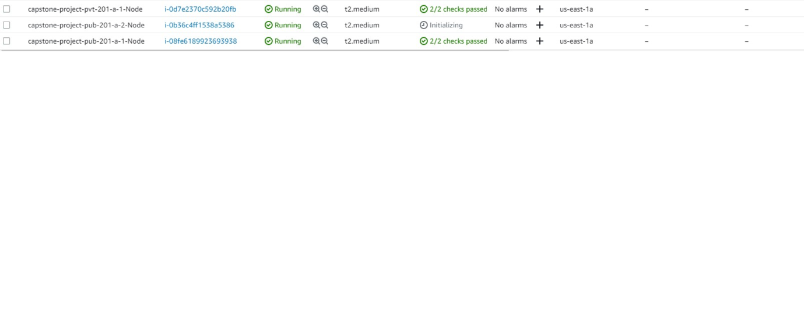

### HPA Nodes created

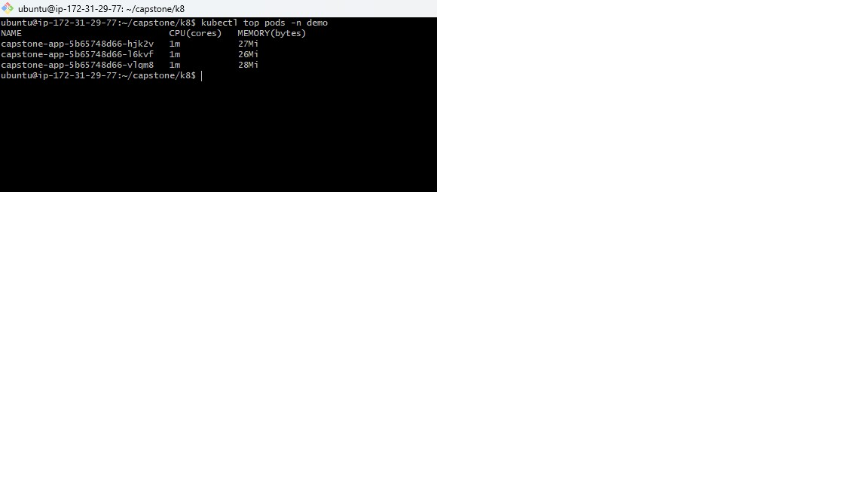

### AWS CLI and Terraform Installed

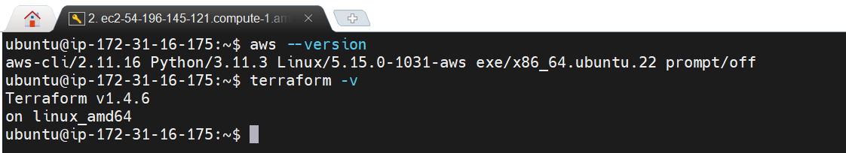

Use following commands to install aws and terraform

sudo apt install unzip

curl "https://awscli.amazonaws.com/awscli-exe-linux-x86_64.zip" -o "awscliv2.zip"

unzip awscliv2.zip

sudo ./aws/install

curl -fsSL https://apt.releases.hashicorp.com/gpg | sudo apt-key add -

sudo apt-add-repository "deb [arch=amd64] https://apt.releases.hashicorp.com $(lsb_release -cs) main"

sudo apt-get update && sudo apt-get install terraform

## Task 2 Screen Shots

### Hello world output:

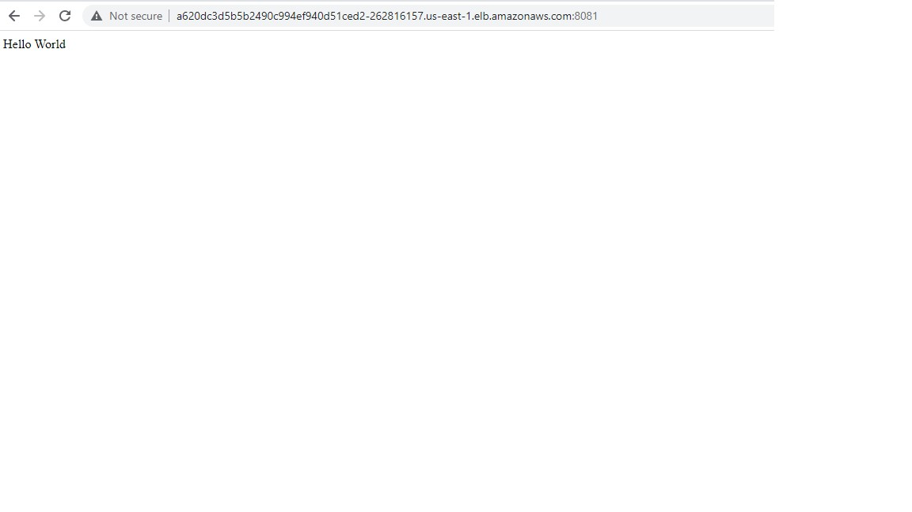

## Task 3 Screen Shots

### redis-volume-persistence:

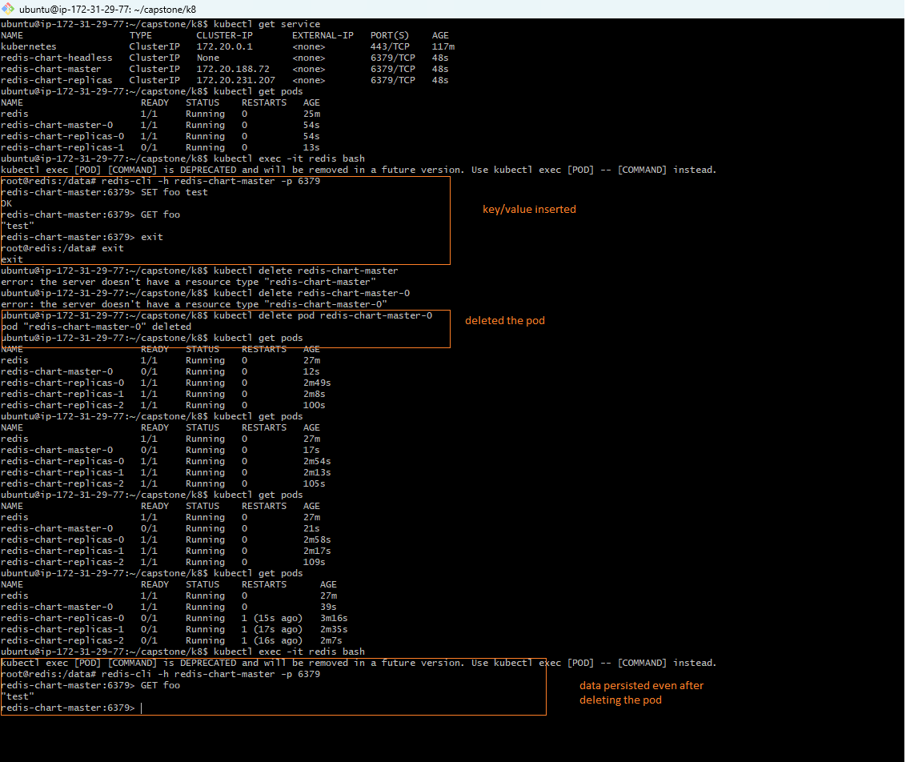

## Task 4 Screen Shots

