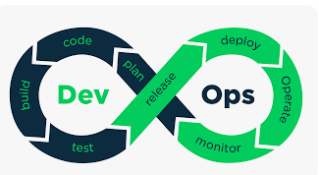

Experiment – 1: Working with Maven: Creating a Maven Project, Understanding the POM File

Experiment – 2: Installing and Setting Up Gradle in IntelliJ IDEA

Experiment – 3: Working with Gradle: Setting Up a Gradle Project, Understanding Build Scripts

Experiment – 4: Gradle Kotlin DSL: Setting Up & Building a Kotlin Project in IntelliJ IDEA

Experiment – 5: Build and Run a Java Application with Maven, Migrate the Same Application to Gradle

Experiment – 6: Understanding and Working with Jenkins

**Experiment - 1**

**Working with Maven: Creating a Maven Project, Understanding the POM File**

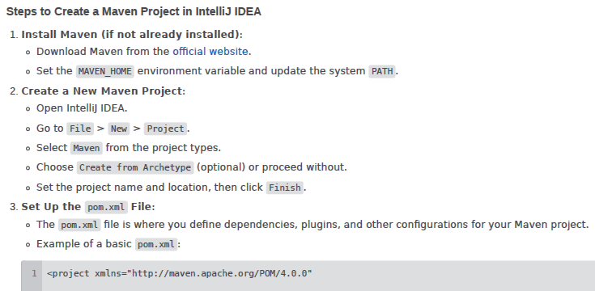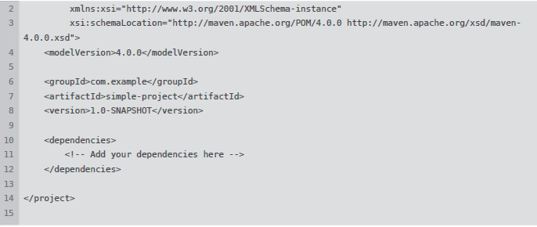

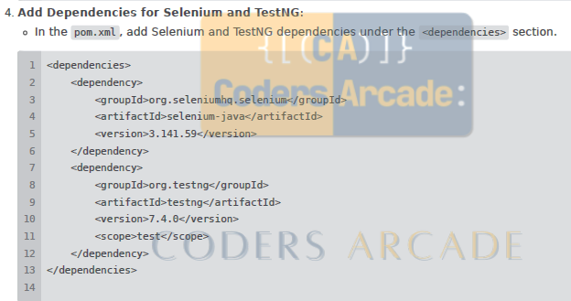

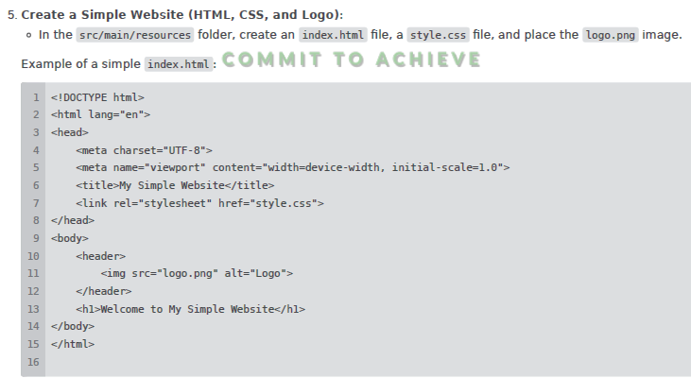

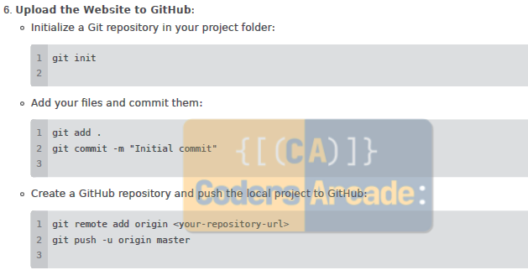

**Experiment - 2**

**Installing and Setting Up Gradle in IntelliJ IDEA**

* **Creating a Gradle Project in IntelliJ IDEA**

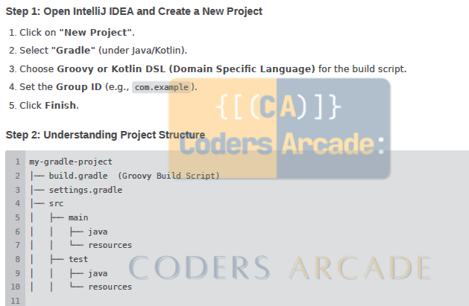

* **Build and Run a Simple Java Application**

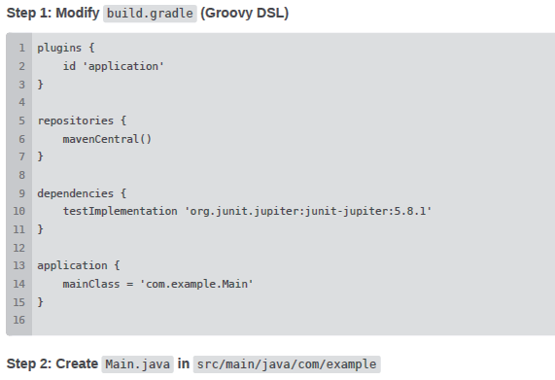

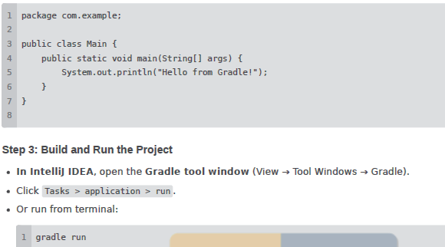

**Hosting a Static Website on GitHub Pages**

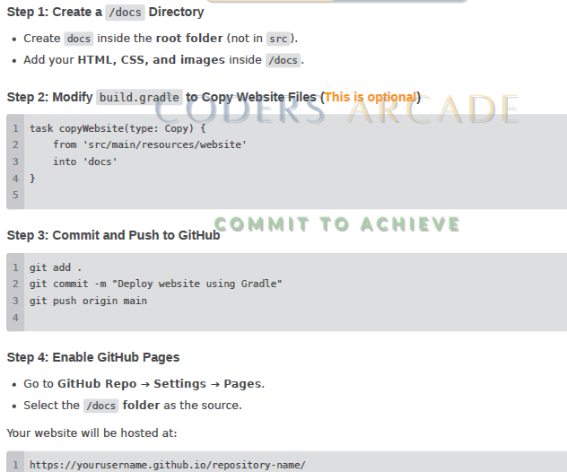

**Experiment - 3**

**Working with Gradle: Setting Up a Gradle Project, Understanding Build Scripts**

**Setting Up the Gradle Project**

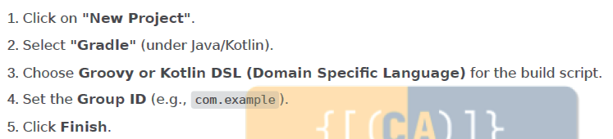

* **Understanding Project Structure**

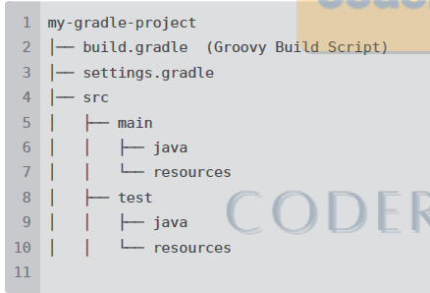

* **Build and Run a Simple Java Application**

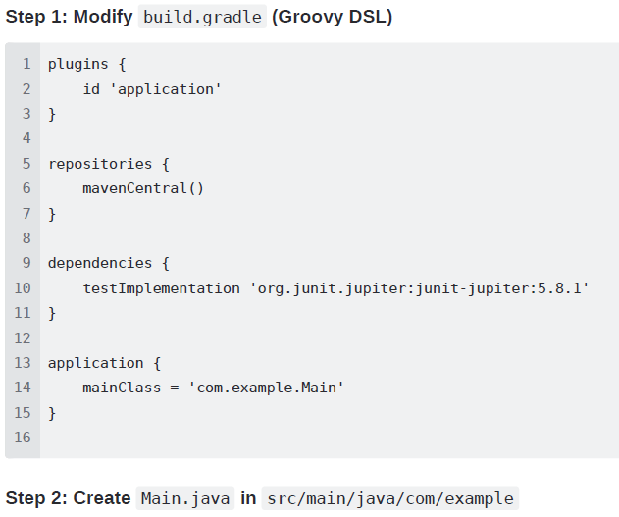

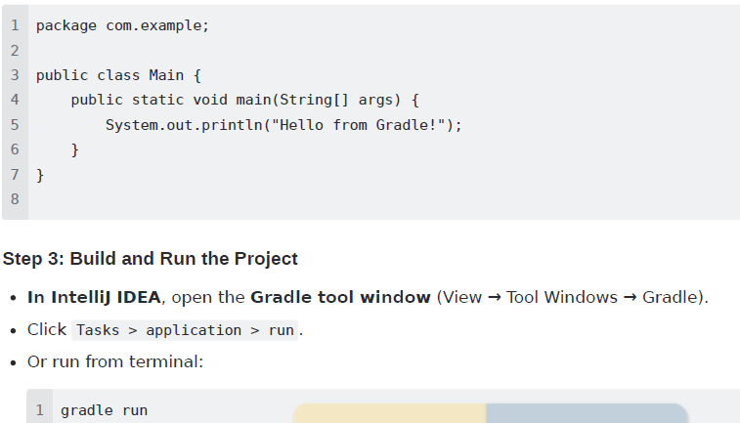

* **Hosting a Static Website on GitHub Pages**

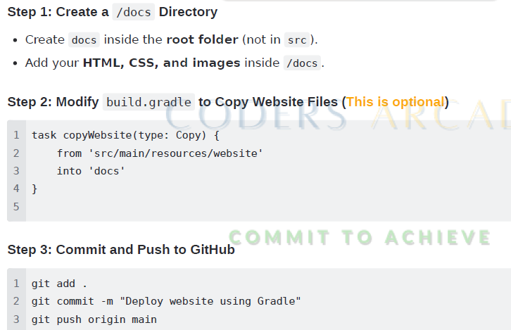

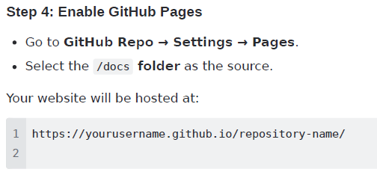

**Experiment - 4**

**Gradle Kotlin DSL: Setting Up & Building a Kotlin Project in IntelliJ IDEA**

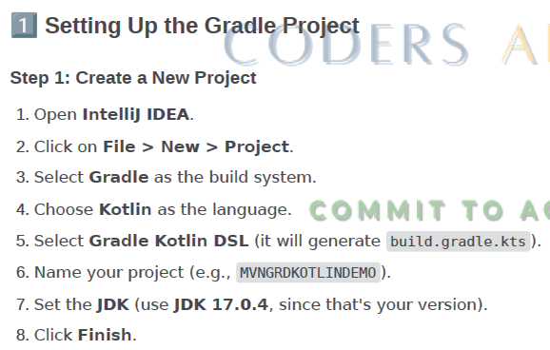

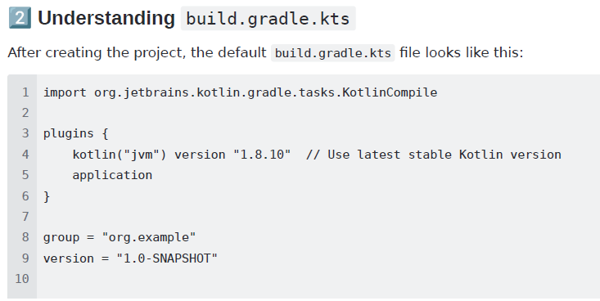

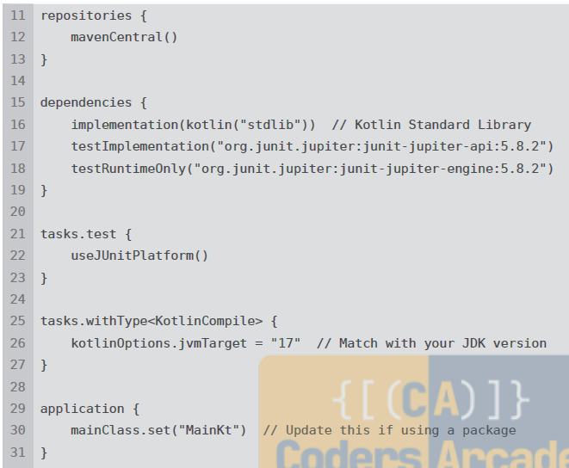

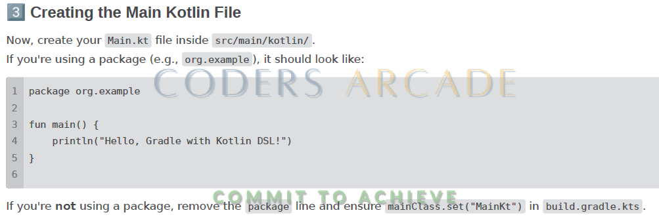

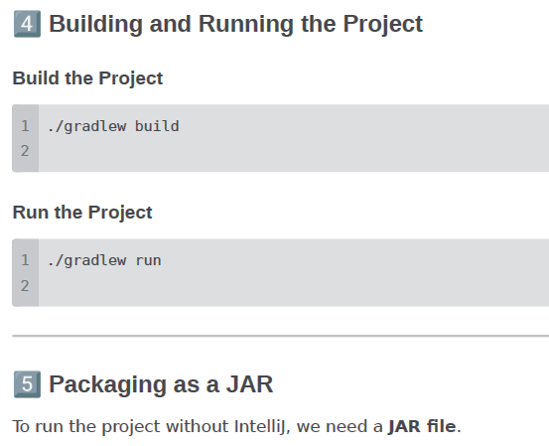

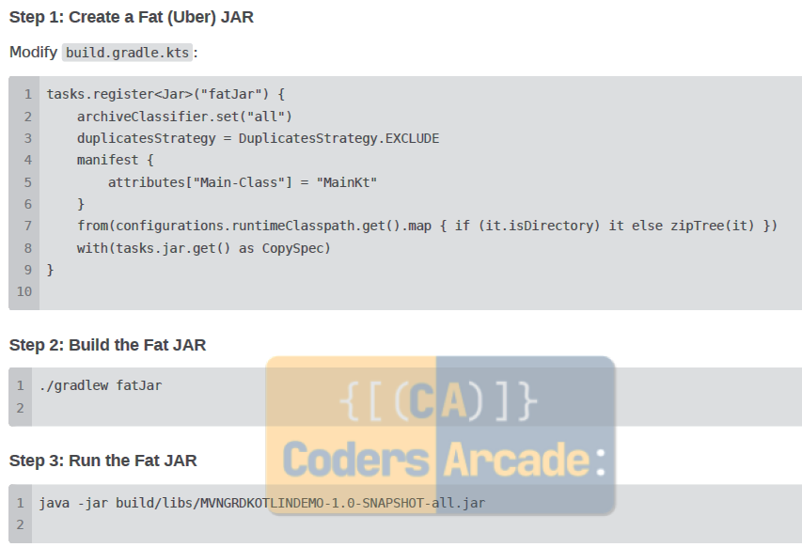

**Experiment - 5**

**Build and Run a Java Application with Maven, Migrate the Same Application to Gradle**

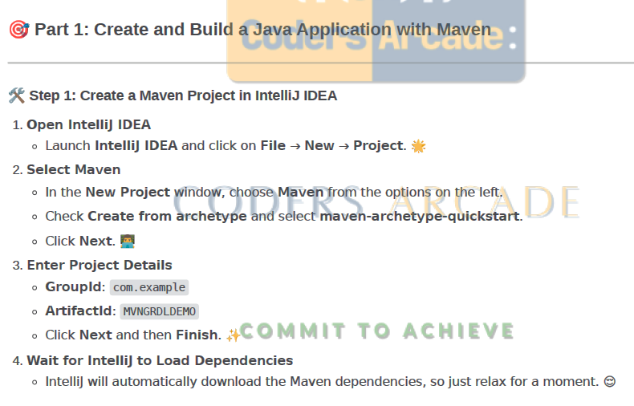

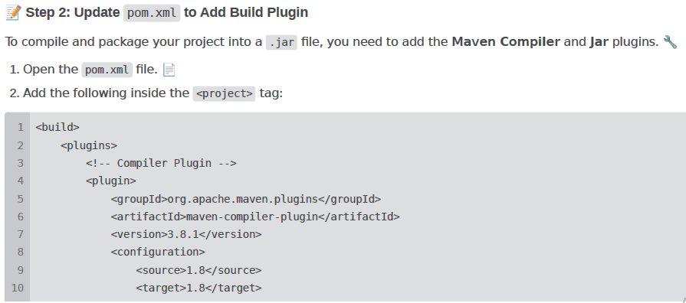

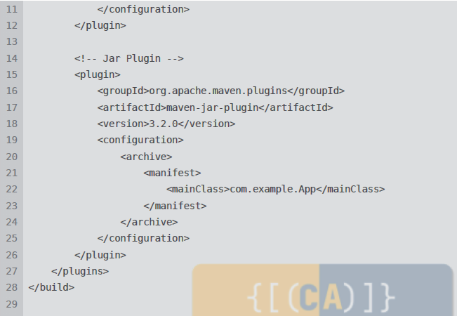

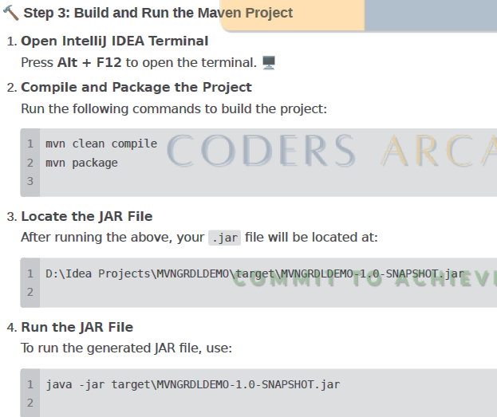

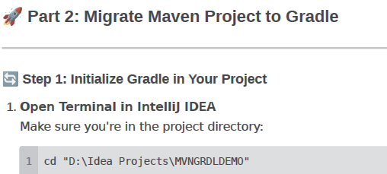

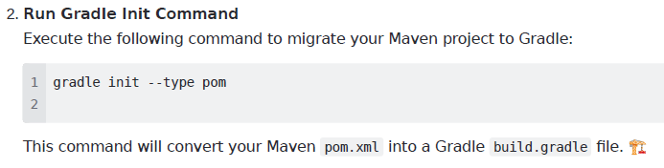

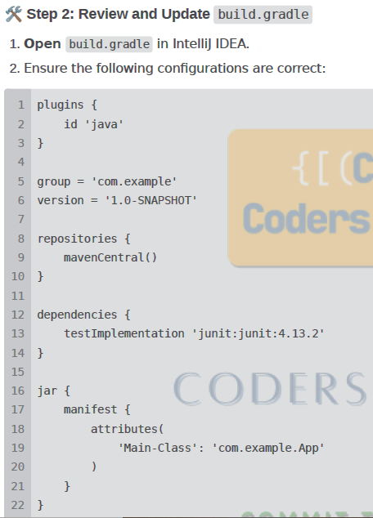

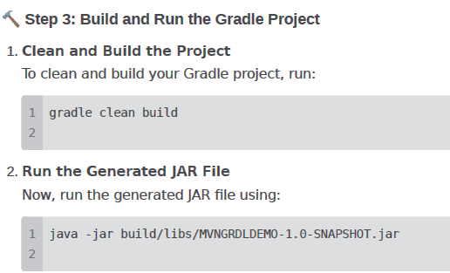

**Experiment - 6**

**Understanding and Working with Jenkins**

**Installation:**

**System Requirements**

**Memory 256 MB of RAM**

**Disk Space Depends on your projects**

**OS Windows, Mac, Ubuntu, Linux**

**Java 8 or 11 (JDK or JRE)**

**Installation on Windows**

**Watch This Video To Seamlessly Install Jenkins** : Jenkins Installation - Step by Step Guide

**Step 1 : Check Java is installed**

**Step 2 : Download Jenkins.war file**

**Step 3 : Goto cmd prompt and run command**

**java -jar jenkins.war --httpPort=8080**

**Step 4 : On browser goto http://localhost:8080**

**Step 5 : Provide admin password and complete the setup**

**Jenkins Configuration**

**How to change Home Directory**

**Step 1: Check your Jenkins Home** ＞ **Manage Jenkins** ＞ **Configure System**

**Step 2 : Create a new folder**

**Step 3 : Copy the data from old folder to new folder**

**Step 4 : Create/Update env variable JENKINS_HOME**

**Step 5 : Restart Jenkins**

**jenkins.xml**

**JENKINS_HOME**

**How to setup Git on Jenkins**

**Step 1 : Goto Manage Jenkins** ＞ **Manage Plugins**

**Step 2 : Check if git is already installed in Installed tab**

**Step 3 : Else goto Available tab and search for git**

**Step 4 : Install Git**

**Step 5 : Check git option is present in Job Configuration**

**Create the first Job on Jenkins**

**How to connect to Git Remote Repository in Jenkins (GitHub)**

**Step 1 : Get the url of the remote repository**

**Step 2 : Add the git credentials on Jenkins**

**Step 3 : In the jobs configuration goto SCM and provide git repo url in git section**

**Step 4 : Add the credentials**

**Step 5 : Run job and check if the repository is cloned**

**How to use Command Line in Jenkins CLI**

**Faster, easier, integration**

**Step 1 : start Jenkins**

**Step 2 : goto Manage Jenkins - Configure Global Security - enable security**

**Step 3 : goto - http://localhost:8080/cli/**

**Step 4 : download jerkins-cli jar. Place at any location.**

**Step 5 : test the jenkins command line is working**

**java -jar jenkins-cli.jar -s http://localhost:8080 /help --username ＜userName＞ --password ＜password＞**

**How to create Users + Manage + Assign Roles**

**Step 1 : Create new users**

**Step 2 : Configure users**

**Step 3 : Create and manage user roles Role Based Authorization Strategy Plugin - download – restart jenkins**

**Step 4 : Manage Jenkins - Configure Global Security - Authorization - Role Based Strategy**

**Step 5 : Create Roles and Assign roles to users**

**Step 6 : Validate authorization and authentication are working properly**

**How to create jenkinsfile**

**Build ＞ Deploy ＞ Test ＞ Release**

**Jenkins file : Pipeline as a code**

**Step 1 : Start Jenkins**

**Step 2 : Install Pipeline Plugin**

**Step 3 : Create a new job**

**Step 4 : Create or get Jenkinsfile in Pipeline section**

**Step 5 : Run and check the output**

**Jenkins Pipeline**

**How to get jenkinsfile from Git SCM**

**Step 1 : Create a new job or use existing job (type : Pipeline)**

**Step 2 : Create a repository or GitHub**

**Step 3 : Add Jenkinsfile in the repo**

**Step 4 : Under Jenkins job ＞ Pipeline section ＞ Select Definition Pipeline script from SCM**

**Step 5 : Add repo and jenkinsfile location in the job under Pipeline section**

**Step 6 : Save & Run**