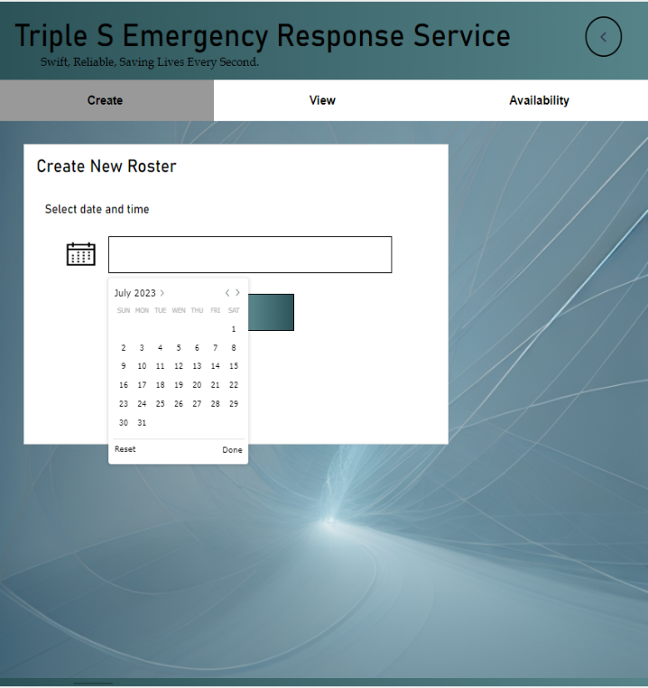
Create New Roster

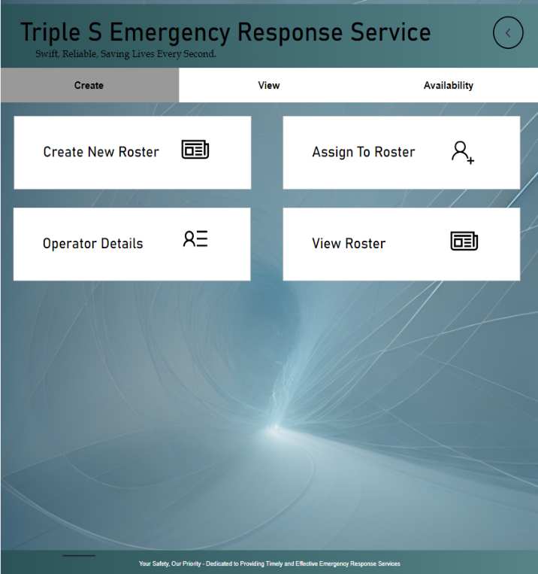

interface 2 Step 2
Then, it will direct to new panel to select the date and time. Once done click OK.
interface 1 Step 1
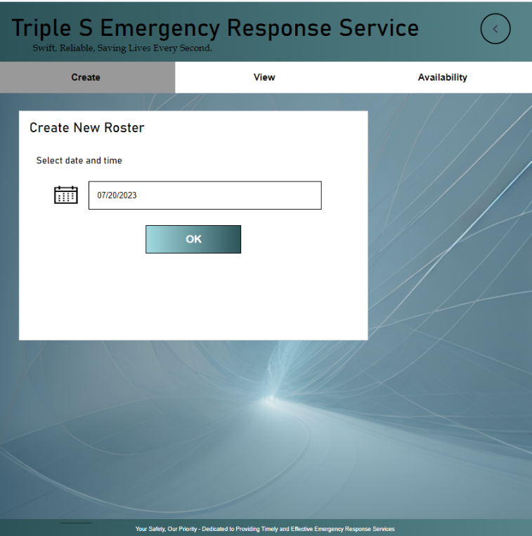
Once the Manager logs into the system with the intention of creating a new roster, he/she will be directed to this interface. Here, the Create tab is being activated with four cards to Create New Roster, Assign To Roster, Operator Details and View Roster.
In order to create a new roster, Manager should start by clicking Create New Roster card.

interface 3 Step 3

Then the Manager will be directed to the Availability information interface.

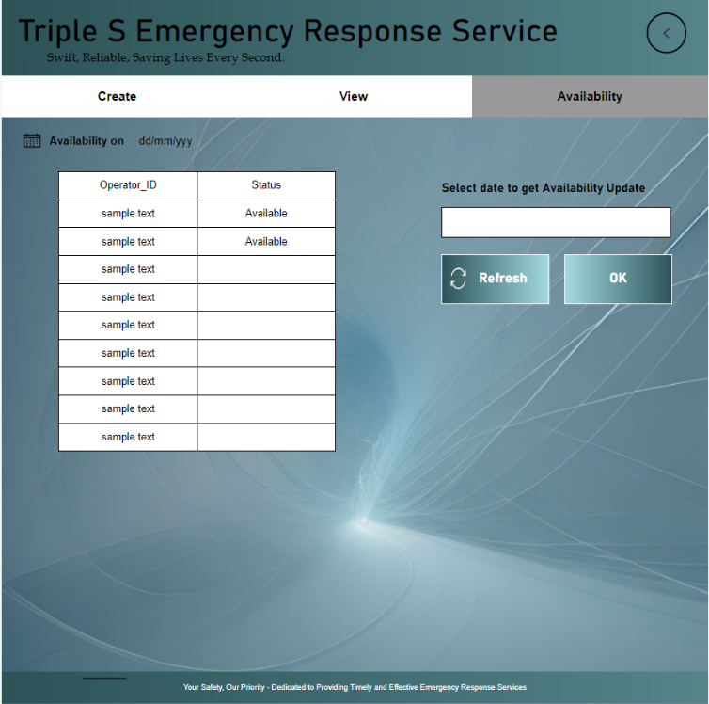
This interface is where, Manager could obtain availability information of the Operators. All available operators on the date which was specified initially are shown in the table with their status.
Note: Manager can also retrieve live update on the availability in a particular date which can be selected in top right corner. (Not applicable to create new roster process)
Next in order to view qualification and experience information of an available operator, Manager should navigate back to Operator detail’s view, which could be obtain by clicking previous arrow in top right corner.

Interface 4 Step 4

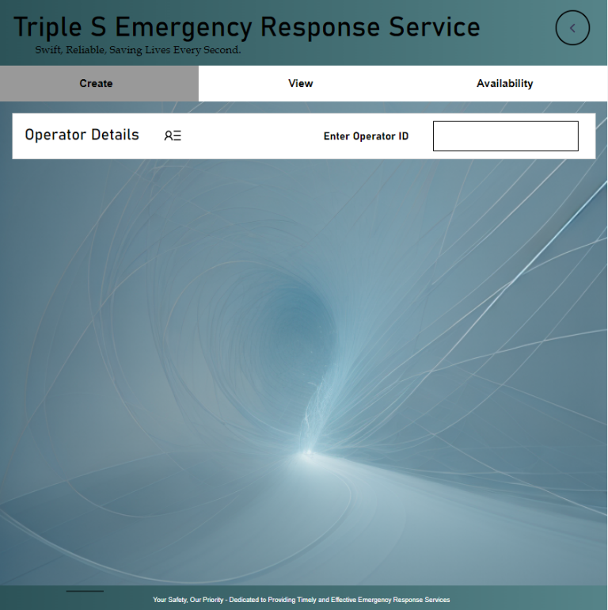
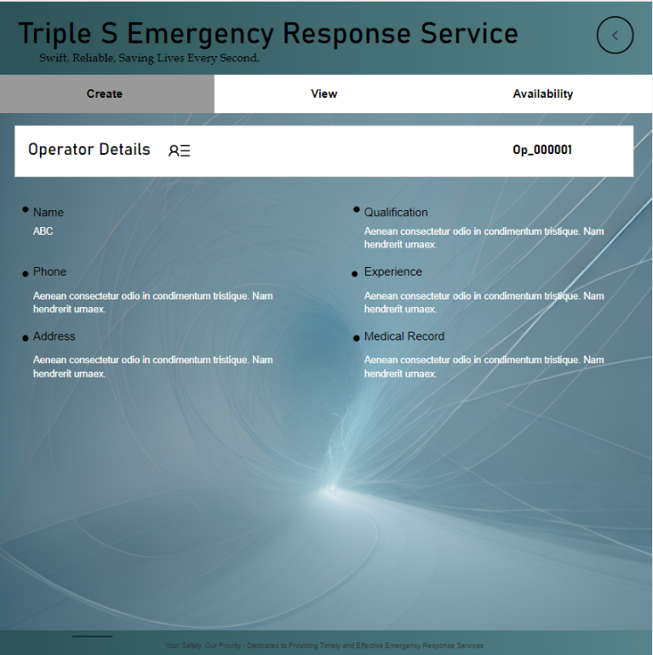

Above is the Operator detail’s view. Once the manger enters the ID of the operator, details of him/ her are displayed in the interface 6.
Next to assign that operator to roster, Manager should navigate back to Create view, which could be obtain by clicking previous arrow in top right corner of the interface 6.

Interface 5 Step 5
Interface 6 Step 6

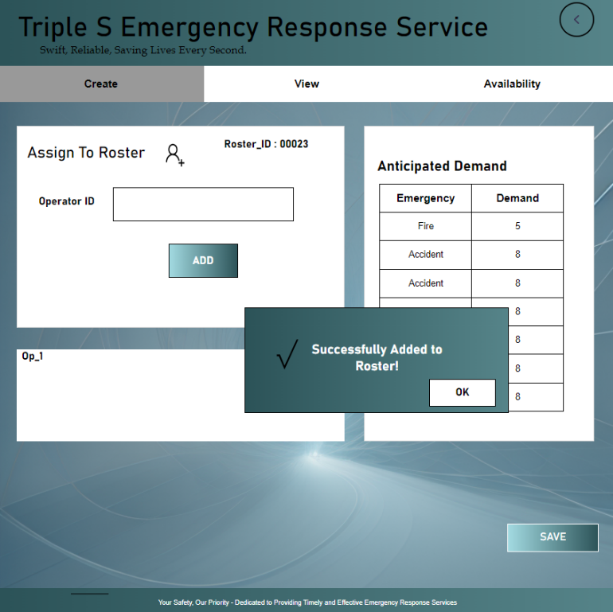
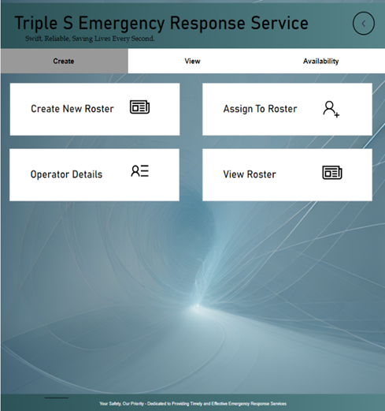
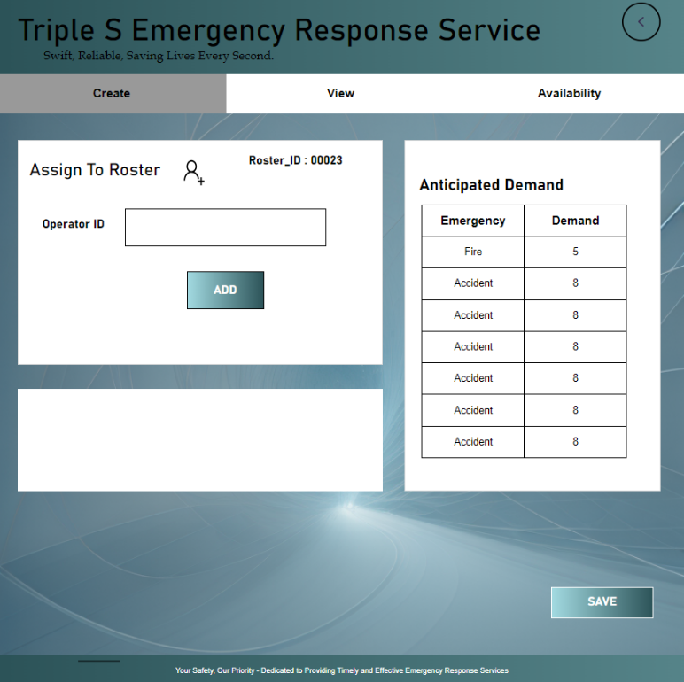
In Create view select Assign To Roster card to add the particular operator to roster.
Interface 7 Step 7
Interface 8 Step 8

Above shows the Assign To Roster view. Manager will type the Id of the operator to be added and click OK. A dialog box will pop up, once the addition was successfully done as in interface 9.

Interface 9 Step 9

The process of assigning each operator to roster will occur repetitively from step 4 to 9, until the demand for the roster satisfied. The anticipated demand which is already stored in the system database is retrieved to the table at right corner.
Finally press SAVE and it will direct to Roster view.

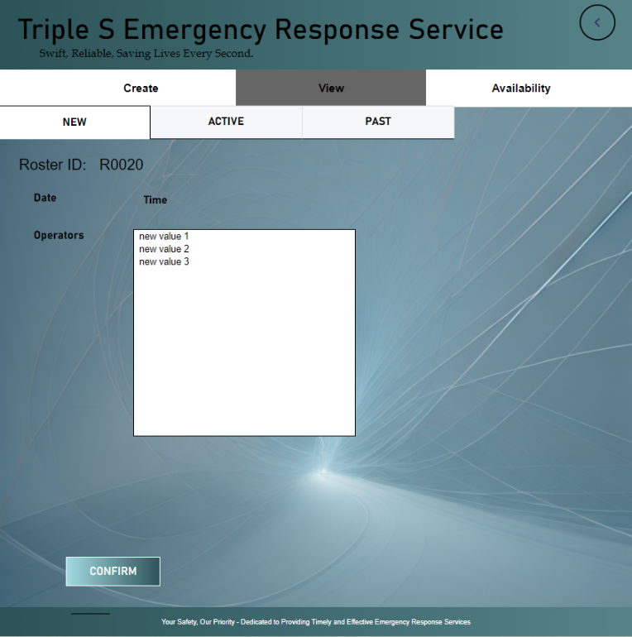
In the given interface, Manager will review for the newly created roster. Then he/she confirm the roster by clicking CONFIRM button.
Interface 10 Step 10

