1.Fetch the transaction id, date and amount of all debit transactions

Select transaction_id, transaction_date, transaction_amount

from Transactions

where credit_debit_flag = 'D';

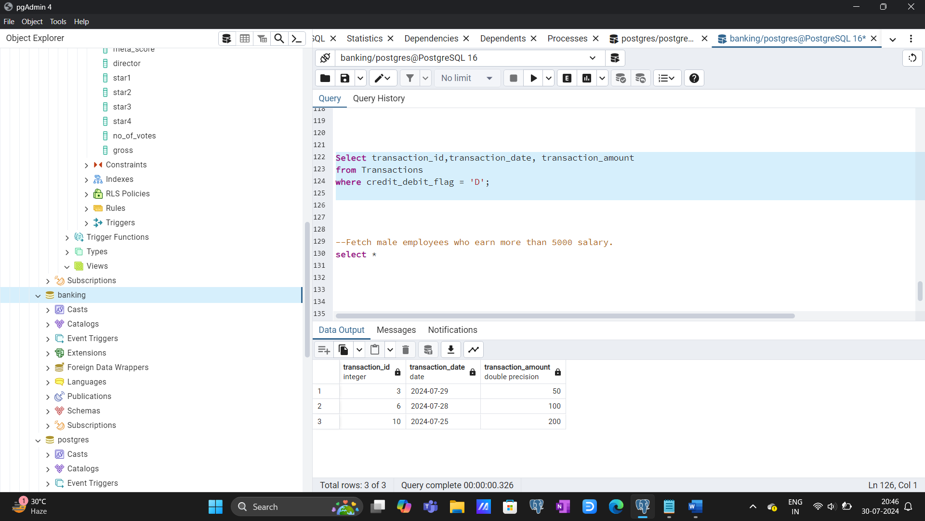

2. Fetch male employees who earn more than 5000 salaries.

select emp_name from employees

where salary > 5000 and gender= 'M';

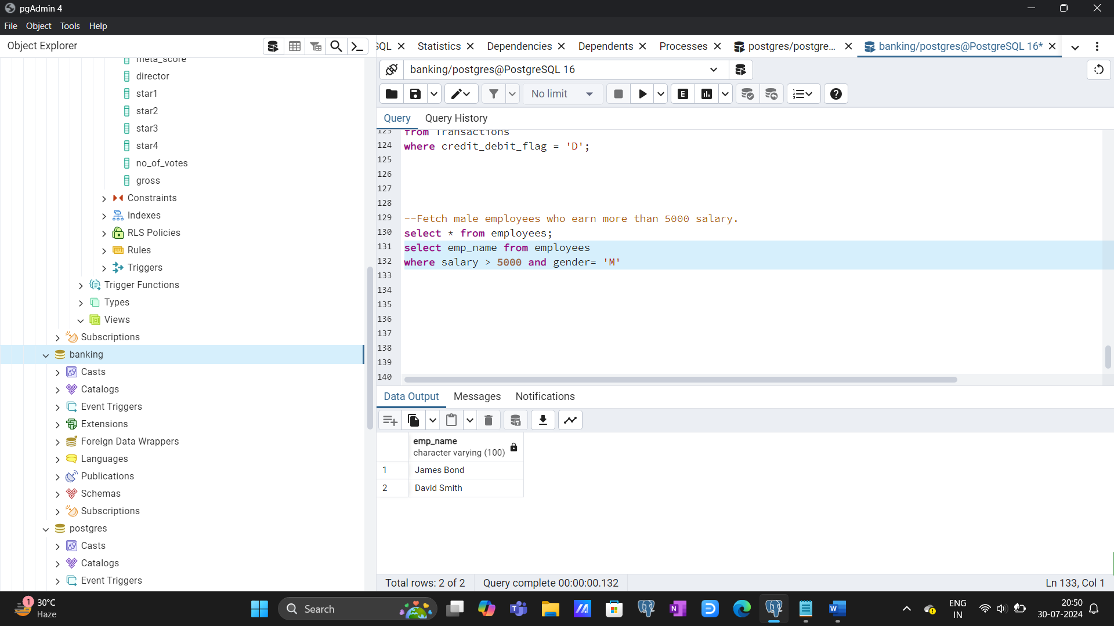

3. Fetch employees whose name starts with J or whose salary is greater than or equal to 70000

select emp_name

from employees

where salary > 70000 or Upper(emp_name) like 'J%’;

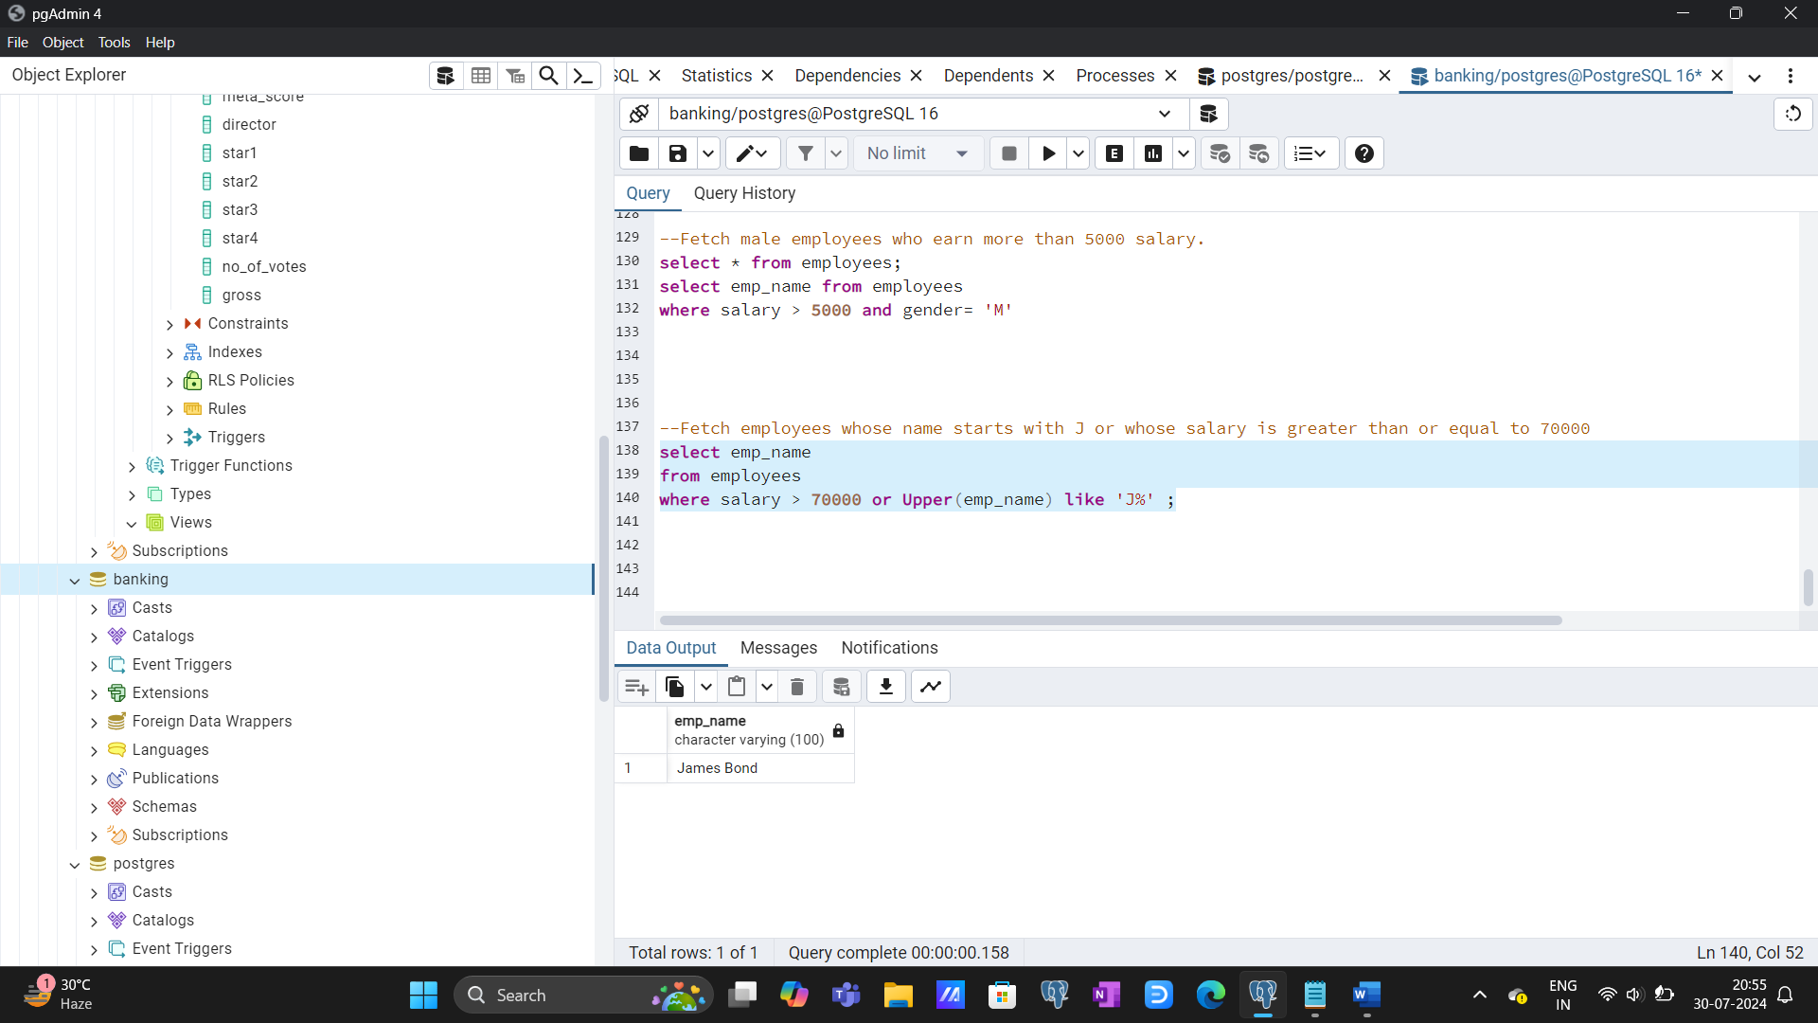

4. Fetch accounts with balance in between 1000 to 3000

select * from accounts

where balance between 1000 and 3000;

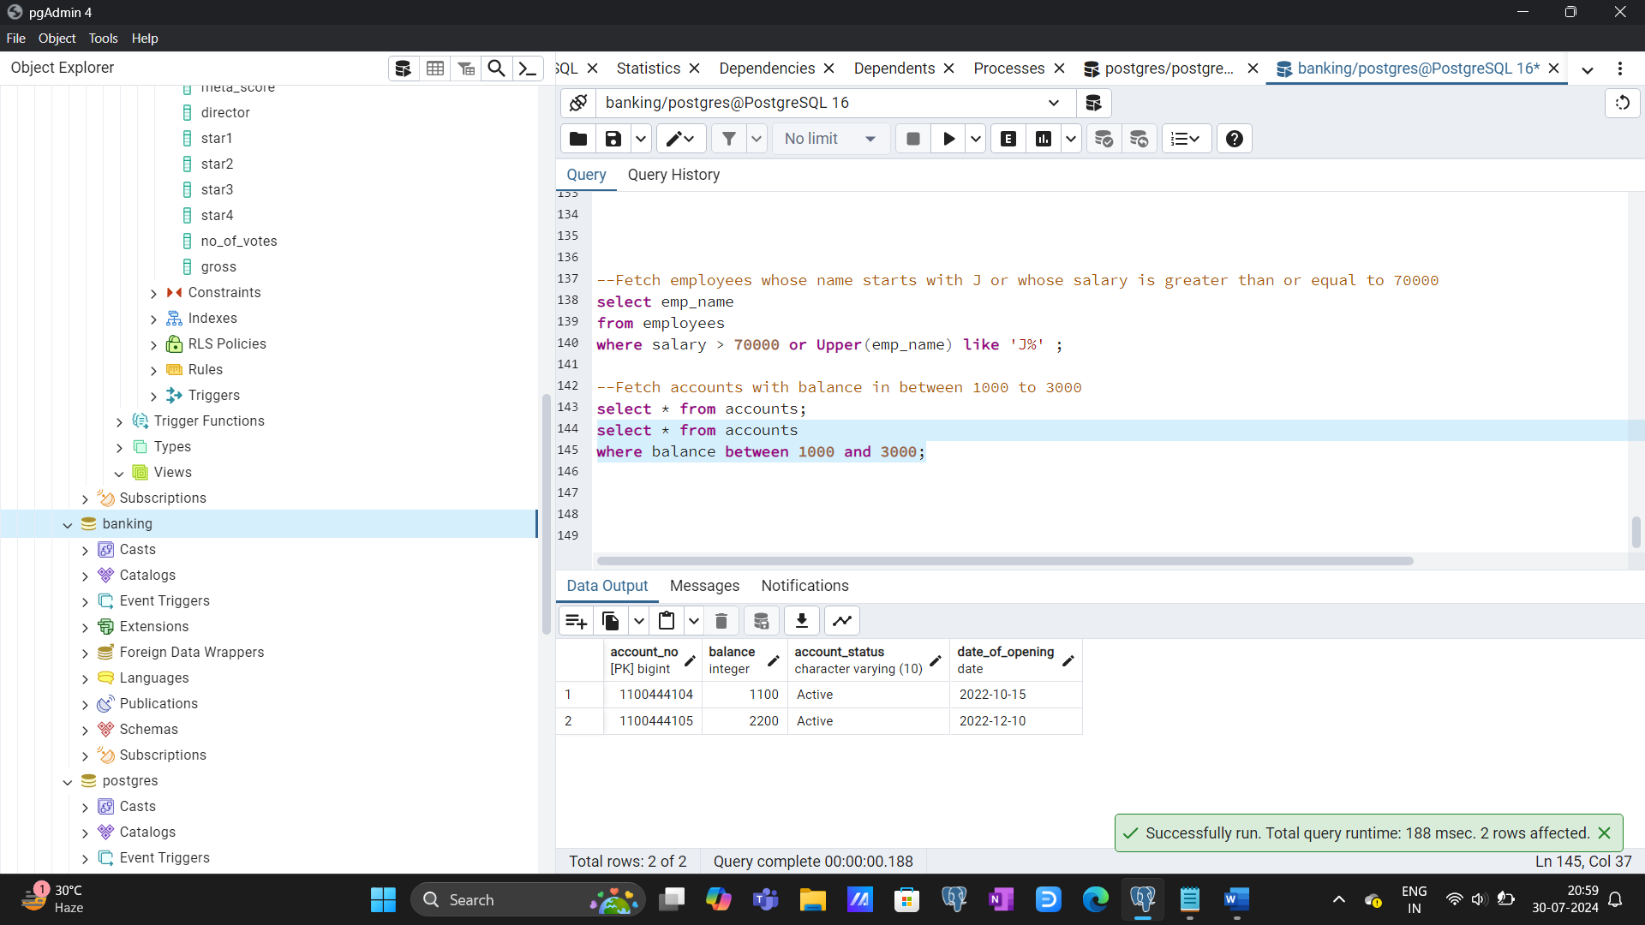

5. Find customers who did not provide a phone no

select * from customers

where phone is Null;

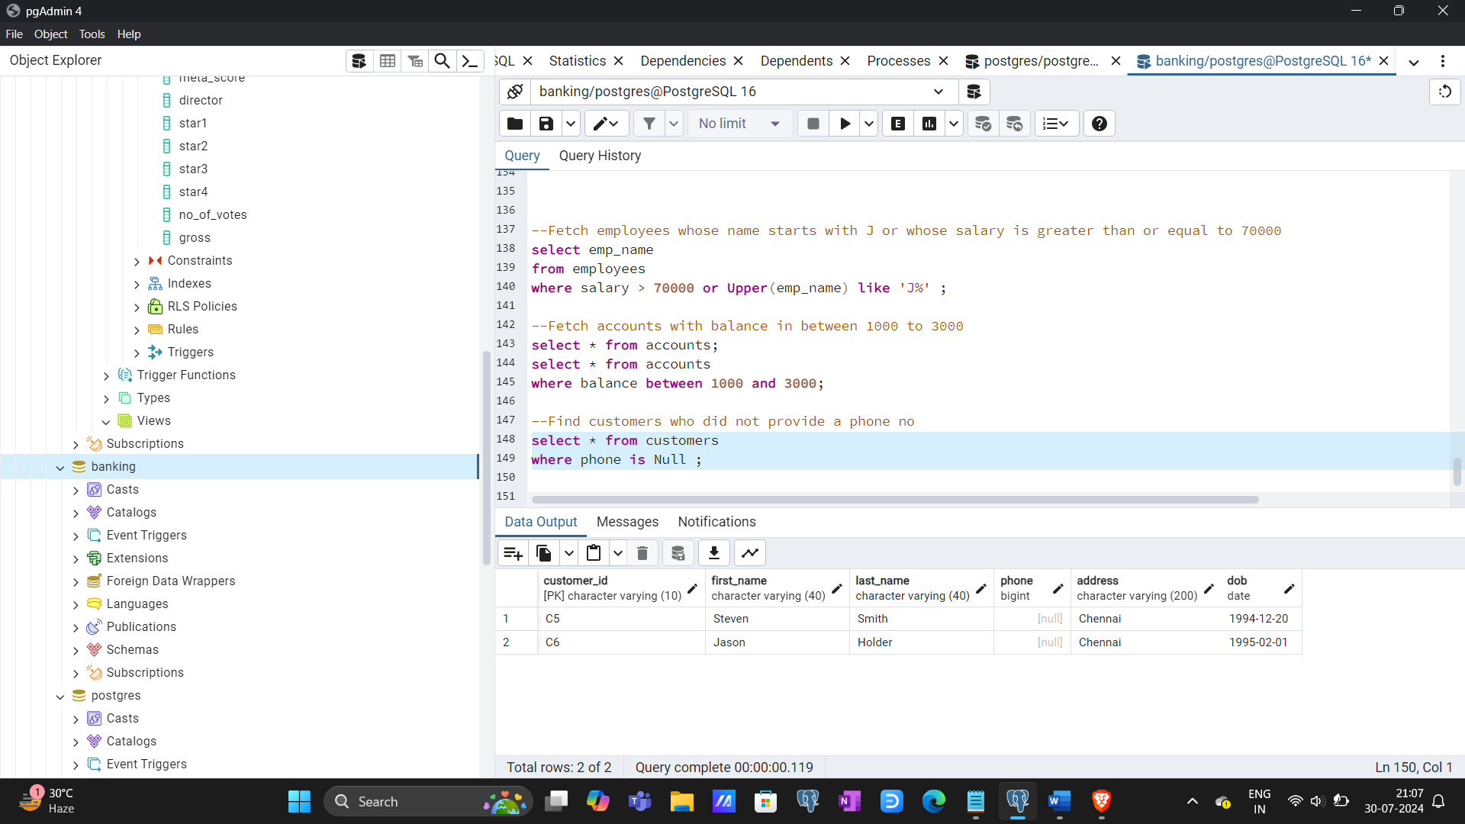

6. Find all the different products purchased by the customers

select ca.customer_id, concat(cs.first_name, ' ' ,cs.last_name) as customer_name, pr.prod_name from customer_accounts ca

join products pr

on ca.prod_id= pr.prod_id

join customers cs

on ca.customer_id=cs.customer_id

group by 1,2,3

order by 1;

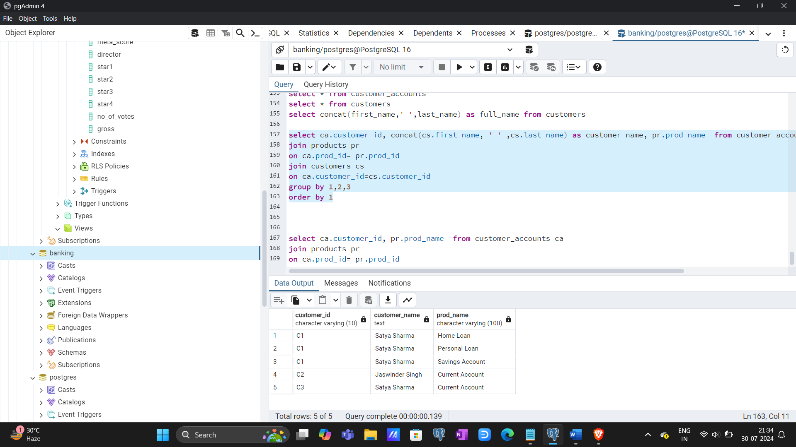

7. Sort all the active accounts with product name, customer_id & customer_name based on highest balance and based on the earliest opening date

select a.account_no, a.balance, a.date_of_opening, pr.prod_name, ca.customer_id,concat(cs.first_name, ' ' ,cs.last_name) as customer_name from accounts a

join customer_accounts ca

on a.account_no = ca.account_no

join customers cs

on ca.customer_id= cs.customer_id

join products pr

on ca.prod_id = pr.prod_id

where lower(account_status) = 'active'

order by balance desc, date_of_opening, customer_id asc;

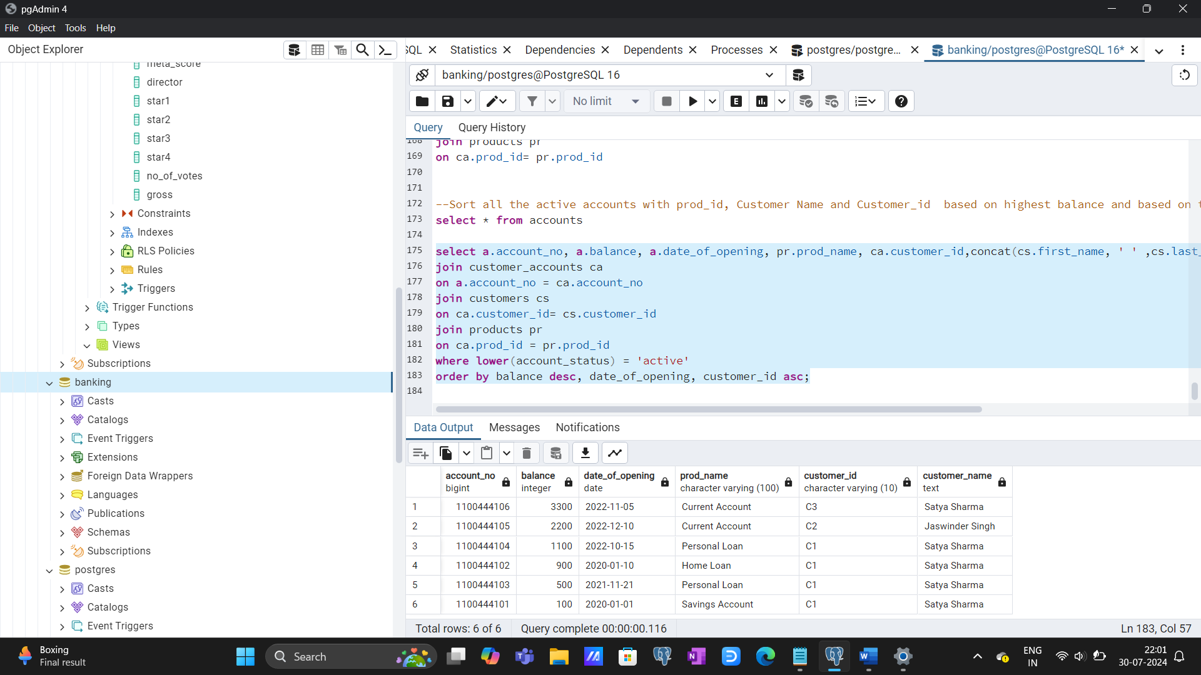

8. Fetch the oldest 5 transactions.

select * from transactions

order by transaction_date asc

limit 5;

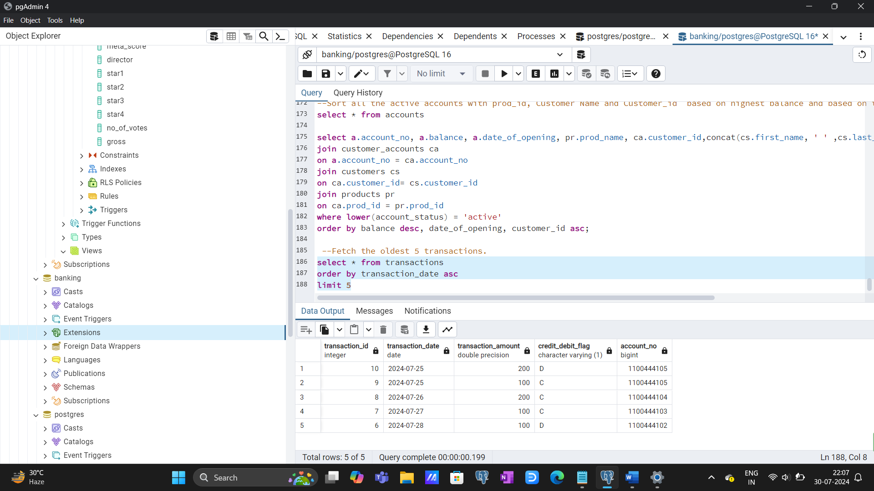

9. Find customers who are either from Bangalore/Chennai and their phone number is available OR those who were born before 1990

select first_name, last_name, phone, address, dob from customers

where address in ('Bangalore', 'Chennai') and phone is not null or extract(year from dob)<1990

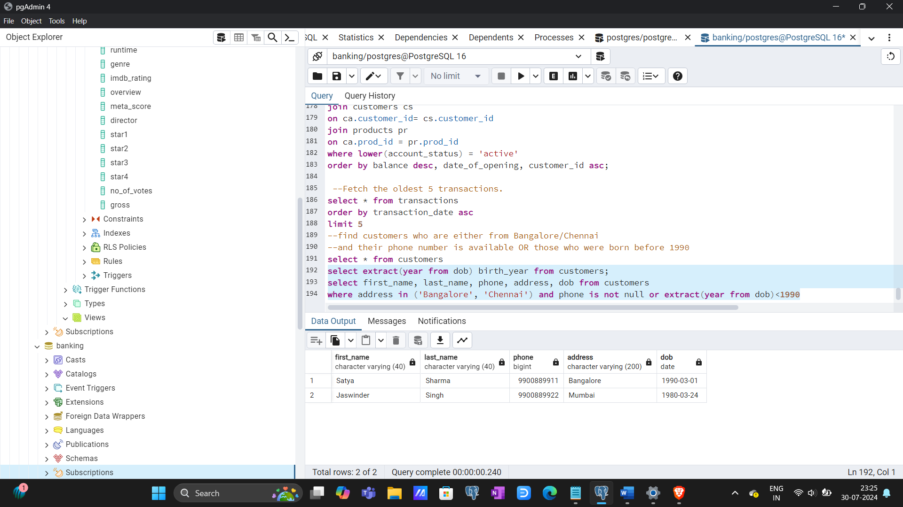

10. Categorise accounts based on their balance.[Below 1k is Low balance, between 1k to 2k is average balance, above 2k is high balance]

select account_no, balance,

case

when balance < 1000 then 'Low'

when balance between 1000 and 2000 then 'Average'

when balance > 2000 then 'High'

end as Category

from accounts

order by balance desc;

