Student Documentation Report
Student Management System

In Partial Fulfillment of the Requirements
For ITEC 105 Information Management
Laguna State Polytechnic University – Sta. Cruz Campus

GROUP 2
Cuala, Christian Mer O.
Rebong, Julian Carl D.
Salazar, Marciano Jr. G.
Sombrano, Mrincess Allisha C.
Tagayun, Janell J.

BSCS 2B
Submitted To: Mr. Edison Templo

Introduction/System Overview

ClassTrack is a teacher-based management system created to help educators handle their daily classroom tasks more easily. In today's educational environment, teachers are responsible for managing many different activities such as tracking student attendance, recording grades, organizing class schedules, and monitoring student performance. These tasks can be time-consuming and difficult to manage, especially when teachers handle multiple classes with many students. ClassTrack aims to solve this problem by bringing together all these important functions into one simple platform. Instead of using different tools or keeping separate records for each task, teachers can access everything they need in one place, which helps them save time and reduces the stress of managing administrative work.

The system is designed to be straightforward and easy to use, so teachers do not need special training or technical skills to operate it effectively. ClassTrack includes basic features for attendance tracking, grade management, class scheduling, and student performance monitoring, all organized in a way that makes sense for everyday classroom use. By keeping all important information in one central location, teachers can quickly check student records, identify students who may be struggling, and keep better track of their classes overall. This approach helps teachers spend less time on paperwork and administrative duties, allowing them to focus more energy on teaching and interacting with their students. ClassTrack provides a practical solution for managing classroom responsibilities in a more organized and efficient manner.

Entity Relationships Diagram (ERD)
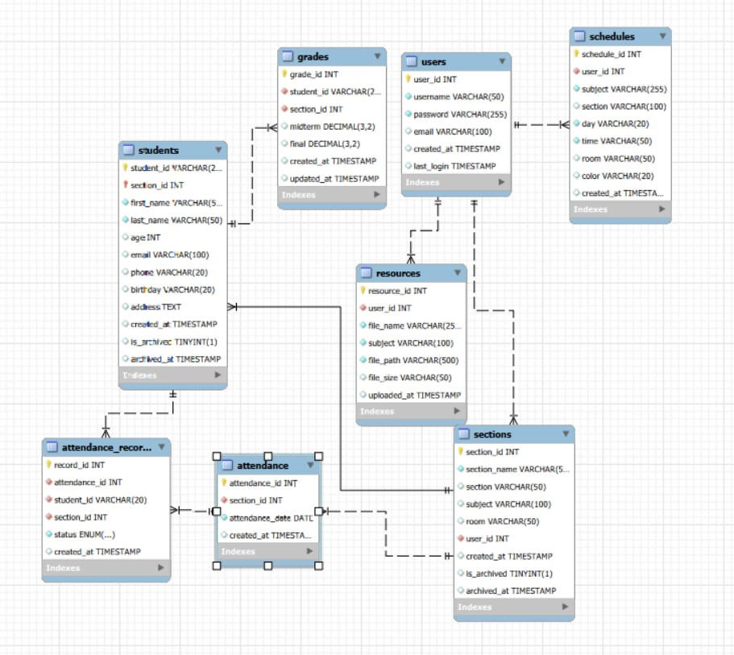

Sample SQL Queries and Outputs

Summary
In Conclusion, ClassTrack provides a helpful solution for teachers who want to manage their classroom tasks in a simpler and more organized way. The system uses a database that connects different parts like student information, grades, attendance records, class schedules, sections, users, and teaching resources, making it easy for teachers to find what they need quickly. By keeping everything in one place and allowing teachers to access important information with just a few clicks, ClassTrack helps reduce the time spent on paperwork and administrative work so they can focus more on teaching their students. As schools continue to deal with more complex requirements and larger class sizes, having a straightforward system like ClassTrack makes a real difference in helping teachers stay organized and do their jobs more effectively.

