Nine Planetary Boundaries
Advanced human societies emerged during an unprecedented period of stability on Earth. During the 12,000 years prior to the Industrial Revolution, our planet’s surface temperature varied by less than 1° Celsius (1.8° Fahrenheit) above or below the average for that entire period. As a result, life — both human and wild — thrived. But "humans in last 50 years, because of ever-increasing population associated with pollution and destruction of natural ecosystems have completely changed the face of the Earth" (Arora 2019).
All life on Earth, and human civilization, are sustained by vital biogeochemical systems, which are in delicate balance. However, our species — due largely to rapid population growth and explosive consumption — is destabilizing these Earth processes, endangering the stability of the “safe operating space for humanity.
Scientists note nine planetary boundaries beyond which we can’t push Earth Systems without putting our societies at risk: climate change, biodiversity loss, ocean acidification, ozone depletion, atmospheric aerosol pollution, freshwater use, biogeochemical flows of nitrogen and phosphorus, land-system change, and release of novel chemicals. The image below (Figure 1) are the Nine Planetary Boundaries at at 2015.

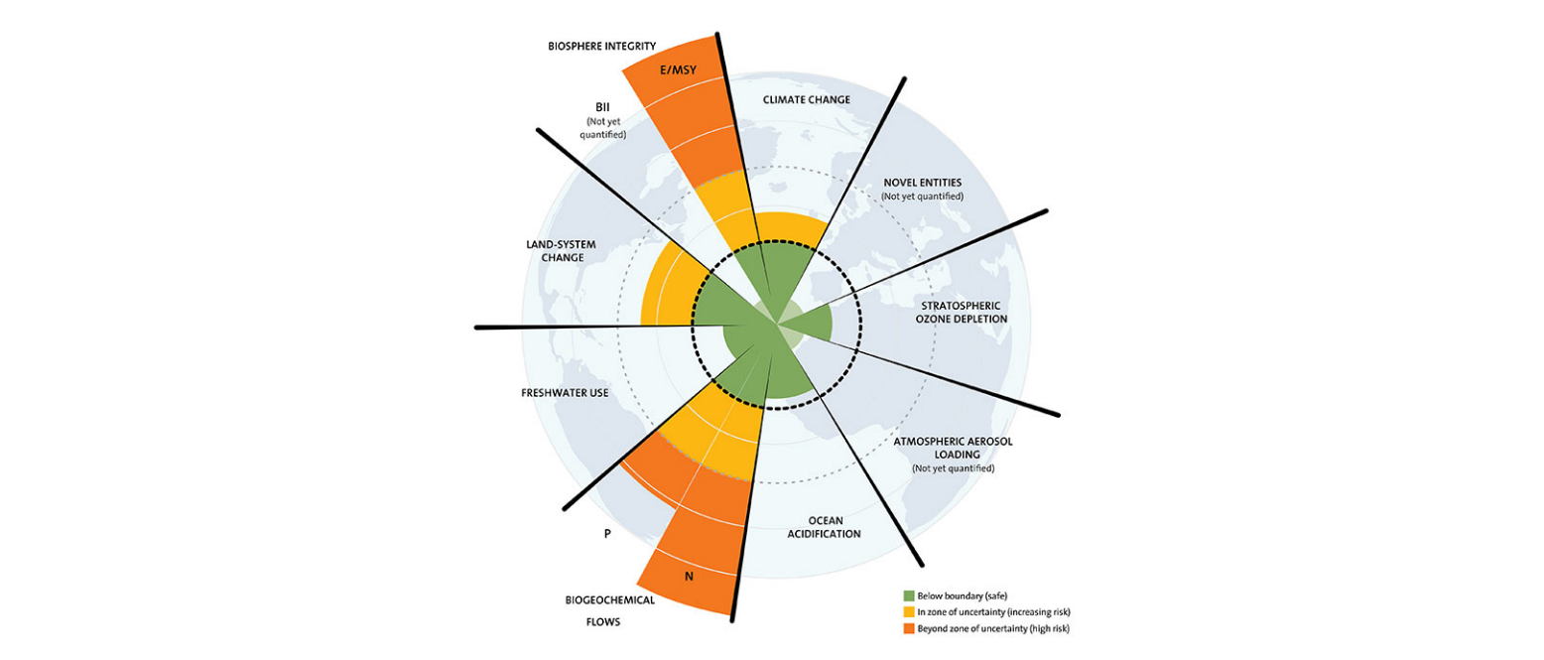
Figure 1: Nine Planetary Boundaries 2015 (Source: Azote for Stockholm Resilience Centre, based on analysis in Steffen et al 2015)
Humanity is already existing outside the safe operating space for at least four of the nine boundaries: climate change, biodiversity, land-system change, and biogeochemical flows (nitrogen and phosphorus imbalance).
In January 2022, catastrophic news fell. Scientists from the Stockholm Resilience Center (SRC) confirmed that we have crossed a 5th planetary boundary : the “chemical pollution” boundary or “introduction of novel entities into the biosphere“. The 5th, on the 9 identified planetary boundaries. The image below (Figure 2) represents the Nine Planetary Boundaries as at 2022.
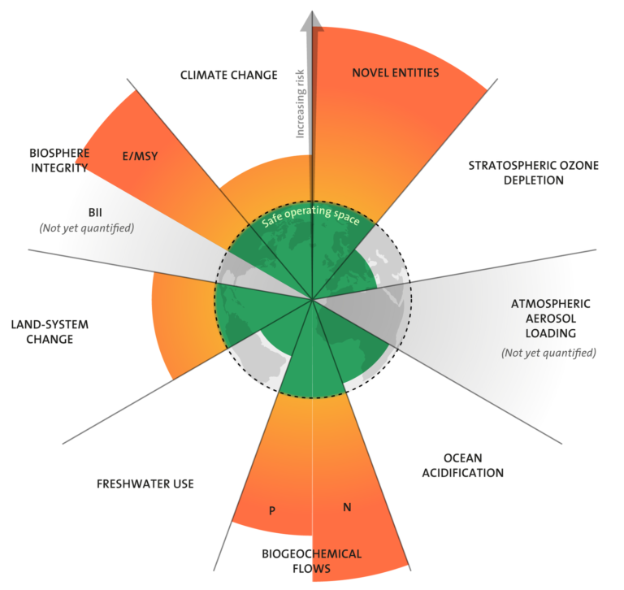
Figure 1: Nine Planetary Boundaries 2022 (Source: Stockholm Resilience Centre, 2022)
Can you notice the difference in the two images?

