SUMMER TRAINING
PROJECT FILE



Name : Shivam
Roll No. : 2337055
Course & Branch : B. Tech. CSE
Training Course : Generative AI
Batch : 1
Semester : V

INDEX OF CONTENTS

S. No. | Title | Page No.
1. | Index | 1
2. | Acknowledgment | 2
3. | Introduction | 3
4. | Project Overview | 4
5. | Objectives | 5
6. | Features | 6
7. | Technologies Used | 7
8. | Project Structure | 8
9. | Setup Instructions | 9
10. | How to Use? | 11
11. | Source Code | 12
12. | Visual Showcase | 15
13. | Customization Options | 17
14. | Future Scope and Improvements | 19
15. | Learning & Outcomes | 20
16. | Conclusion | 21
17. | References | 22

ACKNOWLEDGEMENT
I would like to express my heartfelt gratitude to everyone who supported and guided me throughout my summer training project on “ChatWithWebsite.AI – Gemini-Powered Web Content Chatbot”.
First and foremost, I extend my sincere thanks to my mentor and faculty guide, Mr. Krishna Gupta, for their constant support, valuable insights, and technical guidance during the development of this project. Their expertise in AI applications and project structuring played a crucial role in shaping this solution.
I am thankful to Chandigarh Engineering College (CEC) Mohali (CGC Landran) for offering a platform to apply emerging technologies and complete this training project. Working with tools like LangChain, Gemini 2.5 Flash, and Streamlit provided a real-world glimpse into building intelligent web applications.
I also wish to thank my peers and friends for their feedback, encouragement, and active testing, which helped refine the app and improve its overall experience. Their inputs inspired several key enhancements.
A special acknowledgment goes to the open-source community, whose contributions to frameworks like Streamlit, ChromaDB, and LangChain made this project possible and effective.
Lastly, I am grateful to my family for their unwavering support, patience, and encouragement, which fueled my passion to complete this project successfully.
This training has significantly enriched my practical knowledge and instilled in me the importance of consistency, collaboration, and curiosity in AI-based software development.

INTRODUCTION

In today’s AI-driven digital world, the ability to access, understand, and interact with vast online content is more important than ever. While websites hold a wealth of valuable information, navigating them and extracting meaningful insights quickly can often be time-consuming and inefficient. To address this challenge, the project titled “ChatWithWebsite.AI – Gemini-Powered Web Content Chatbot” was developed as part of my summer training program.
This web-based application enables users to interact directly with the content of one or more websites through a simple chat interface. By pasting URLs, users can ask natural language questions or request summaries, and receive contextually accurate answers powered by Google’s Gemini 2.5 Flash. Whether the user is trying to understand a documentation page, summarize an article, or find specific facts, the chatbot intelligently extracts and delivers the information.
Built using Python and Streamlit, the platform features a responsive and intuitive UI accessible through any browser—no installation required. Under the hood, it leverages LangChain, ChromaDB, and Gemini embeddings to convert website content into vectorized chunks for efficient semantic retrieval. The system also supports multi-URL inputs, chat history logging, theme customization, and local session storage.
The objective of this project is to demonstrate the real-world utility of Retrieval-Augmented Generation (RAG) by creating an AI tool that enhances productivity and learning through conversational web navigation. This introduction marks the beginning of a comprehensive report detailing the project’s development, technology stack, key features, challenges, future potential, and the learning outcomes from this hands-on experience

PROJECT OVERVIEW

The ChatWithWebsite.AI project is a web-based application that allows users to have intelligent conversations with real-world websites, transforming passive web browsing into an interactive and AI-powered experience. Designed for simplicity, versatility, and learning, the application enables users to query one or more website URLs and receive human-like responses in natural language.
Built using Streamlit, the application leverages a modern Python framework to provide a responsive and interactive user interface accessible directly from a browser. At its core is Gemini 2.5 Flash, Google’s advanced generative language model, which powers the chatbot’s contextual understanding and response generation. Using Retrieval-Augmented Generation (RAG), the app fetches content from the provided websites, processes it into embeddings using Gemini's embedding model, and retrieves relevant answers based on user questions.
Users can interact with the app by asking about page content, requesting summaries, or extracting specific details. The system supports multi-page input, chat history logging, local storage of sessions, and dynamic theme switching between dark and light modes. Its use cases include studying documentation, extracting structured insights from blogs or research articles, and simplifying complex content.
The project emphasizes real-world usability and educational value. It is open-source, modular, and easily extendable for various applications such as academic research, technical support, and knowledge discovery. By turning static websites into conversational sources of knowledge, ChatWithWebsite.AI provides an innovative bridge between web data and natural interaction, showcasing the practical power of generative AI and vector-based retrieval in an accessible tool.

OBJECTIVES
The primary objectives of this project were to:
- To develop an AI-based chatbot that allows users to interact with real-world websites using natural language.
- To integrate the Gemini 2.5 Flash API for answering questions and generating summaries based on web content.
- To help users quickly extract meaningful insights from multiple websites through a conversational interface.
- To implement Retrieval-Augmented Generation (RAG) for accurate content-based question answering.
- To provide support for multi-page input, chat history tracking, and summarization features.
- To build a responsive, accessible, and theme-customizable web application using Streamlit.
- To gain hands-on experience in generative AI, vector databases, and web development.
- To explore LangChain's capabilities for document loading, text chunking, and vector retrieval.
- To create an open-source project that can be customized for academic, research, or enterprise use.
- To enhance user engagement by combining AI intelligence with a clean, interactive chat interface.

FEATURES

ChatWithWebsite.AI offers the following features:
- Conversational AI Chatbot: Enables real-time, intelligent interactions with website content using Google’s Gemini 2.5 Flash model.
- Multi-URL Input Support: Allows users to paste and process one or more website links for multi-page summarization and Q&A.
- Website Summarization: Generates simplified, concise summaries of web pages for quick understanding of complex information.
- Contextual Question Answering: Uses Retrieval-Augmented Generation (RAG) to answer user queries based on the actual content of the provided URLs.
- Chat History Tracking: Stores each question-answer exchange during the session for a continuous and coherent chat experience.
- Web-Based UI with Streamlit: Clean, user-friendly interface accessible via browser with no installation required.
- Dark/Light Theme Toggle: Offers a visually adaptive experience by switching between dark and light modes.
- Local Chat Log Saving: Automatically saves chat history in JSON format for future reference or analysis.
- Open-Source and Extensible: Easily customizable codebase to support future integrations like PDFs, authentication, or citation tracking.
- Secure API Key Handling: Utilizes .env or Streamlit secrets to safely manage and access Gemini API credentials.

TECHNOLOGIES USED

- Python 3.11:
Used as the core programming language to implement backend logic, data processing, and LangChain-based integration.
- Streamlit:
A lightweight and reactive framework used to build the web-based user interface with support for input controls, themes, and chat history display.
- Google Gemini 2.5 Flash API:
A state-of-the-art generative AI model used to generate natural and intelligent responses to user queries based on website content.
- LangChain:
A modular framework used for document loading, chunking, embedding generation, retrieval, and chaining large language model operations.
- ChromaDB:
Used as a local vector database for storing and retrieving semantic embeddings of website content.
- python-dotenv / Streamlit Secrets:
Used to securely manage sensitive credentials like the Gemini API key via environment variables or .streamlit/secrets.toml.
- HTML / CSS (via Streamlit):
Used to render custom-styled interface components such as input boxes, buttons, and themes within the Streamlit application.

PROJECT STRUCTURE

Directory structure of ChatWithWebsite.AI application:
chatwithwebsite-ai/
│── .env # Environment file to securely store your Gemini API key
│── app.py # Main Streamlit app that contains the core chatbot logic and UI
│── requirement.txt # List of required Python libraries to install
│
├── chat_logs/ # Folder that stores saved chat history as timestamped JSON files
├── env/ # (Optional) Environment-specific configurations, if used
└── .venv/ # Virtual environment for managing project-specific Python dependencies
Description of Key Files/Folders:
- app.py: This is the main application script. It initializes the Streamlit interface, loads website content using LangChain, runs Gemini-powered queries, and manages chat history, theme toggle, and summarization.
- .env: This file stores your Google Gemini API key securely in development. It is loaded using python-dotenv.
- requirement.txt: Contains all necessary Python packages for the app. Use pip install -r requirement.txt to set up your environment.
- chat_logs/: This folder stores saved conversations in .json format. Each session is timestamped for easy reference.
- env/: Optional folder used to manage additional configurations or files if needed during deployment or development.
- .venv/: Virtual environment that contains project-specific Python interpreter and installed libraries. This ensures your dependencies don’t affect the global Python environment.

SETUP INSTRUCTIONS
1. Install Python
Ensure Python 3.11+ is installed.
python --version
If not installed, download from:
🔗 https://www.python.org/downloads/

2. Clone or Download the Project
Open a terminal or command prompt:
$ git clone https://github.com/your-username/chatwithwebsite-ai.git
$ cd chatwithwebsite-ai
Alternatively, download the .zip and extract it manually.

3. Create a Virtual Environment (Recommended)
$ python -m venv venv
Activate the environment:
- On Windows:
$ venv\Scripts\activate
- On Mac/Linux:
$ source venv/bin/activate

4. Install Required Python Packages
$ pip install -r requirement.txt

5. Set Up Gemini API Key
Get your Gemini API Key from:
🔗 https://aistudio.google.com/app/apikey

Option A – Using .env file:
Create a .env file in the project root:
GOOGLE_API_KEY=your_gemini_api_key_here

Option B – Using .streamlit/secrets.toml:
Create this file:
.streamlit/secrets.toml
[default]
gemini_api_key = "your_gemini_api_key_here"

6. Run the Application
Start the Streamlit app:
$ streamlit run app.py
This will launch the app in your default browser at:
🔗 http://localhost:8501

7. (Optional) Customize or Extend
- Edit app.py to tweak prompts, logic, or UI.
- Add features like file upload, PDF parsing, user authentication, or cloud logging.

HOW TO USE?
Once the app is running at http://localhost:8501 or deployed online :
1. Start a Conversation
In the chatbot input box, paste one or more website URLs and then type your query. Example prompts:
- “What is this website about?”
- “Summarize the content from all the pages.”
- “What does this article say about Python?”
- “Explain the benefits of machine learning from this website.”

2. Receive Intelligent Answers
The chatbot will respond with AI-generated answers such as:
- Clear and concise summaries of website content
- Specific insights pulled from one or more URLs
- Easy-to-understand explanations of technical content
- Direct answers to your natural language questions

3. Explore Web Content Interactively
Ask follow-up queries like:
- “What are the key points of this article?”
- “Give me examples mentioned on this page.”
- “Explain this paragraph in simpler terms.”
- “Compare this with another website’s info.”

4. Use Advanced Features
- 📝 Summarize Website(s): Click to generate a full-page summary of all URLs provided.
- 🌓 Theme Toggle: Choose between light and dark mode for visual comfort.
- 🗑️ Clear Chat: Restart your conversation with a single click.
- 💾 Saved Logs: Find your past chats in the chat_logs/ folder as timestamped JSON files.

SOURCE CODE
$. Requirements.txt
Contains all the required Python libraries for the project:
streamlit
langchain
langchain-community
langchain-core
langchain-google-genai
langchain-text-splitters
chromadb
python-dotenv
requests
beautifulsoup4
html2text
protobuf==3.20.*

$. Secrets.toml :
gemini_api_key = "YOUR_API_KEY"

$. app.py
The core Streamlit application that contains all the logic for:
- Accepting one or more website URLs from the user
- Extracting and chunking website content using LangChain’s WebBaseLoader
- Generating vector embeddings with Gemini’s embedding-001 model
- Storing and retrieving chunks from a ChromaDB vector store
- Using Gemini 2.5 Flash via ChatGoogleGenerativeAI to answer queries
- Displaying responses, chat history, and summaries using Streamlit widgets
- Providing dark/light theme toggle, chat reset, and auto-saving logs

💬 Chat Flow Overview
- User enters URLs and submits a question
- App loads web content and processes it into vectors
- Relevant chunks are retrieved from ChromaDB
- Gemini 2.5 Flash generates answers based on retrieved content
- Chat is displayed with user/assistant roles
- Chat logs are stored as JSON in the /chat_logs directory
import os
import json
from datetime import datetime
import streamlit as st
from dotenv import load_dotenv

from langchain_community.document_loaders import WebBaseLoader
from langchain_text_splitters import RecursiveCharacterTextSplitter
from langchain_community.vectorstores import Chroma
from langchain_google_genai import GoogleGenerativeAIEmbeddings, ChatGoogleGenerativeAI
from langchain.chains import RetrievalQA

# Load environment variables
load_dotenv()
GEMINI_API_KEY = os.getenv("GOOGLE_API_KEY")

# 🌗 Theme toggle
theme = st.radio("🌓 Choose Theme", ["Light", "Dark"], horizontal=True)
if theme == "Dark":
st.markdown("""
<style>
body, .stApp { background-color: #0e1117; color: white; }
.stTextInput input, .stTextArea textarea, .stButton>button {
background-color: #222; color: white; border-radius: 10px;
}
</style>
""", unsafe_allow_html=True)

# 💾 Save chat history locally
def save_chat_log():
os.makedirs("chat_logs", exist_ok=True)
timestamp = datetime.now().strftime("%Y-%m-%d_%H-%M-%S")
filepath = f"chat_logs/chat_{timestamp}.json"
with open(filepath, "w") as f:
json.dump(st.session_state.chat_history, f, indent=4)

# 🔗 Load and embed website content
@st.cache_resource
def get_vectorstore_from_url(urls):
loader = WebBaseLoader(urls)
documents = loader.load()

splitter = RecursiveCharacterTextSplitter(chunk_size=500, chunk_overlap=100)
chunks = splitter.split_documents(documents)

embeddings = GoogleGenerativeAIEmbeddings(
model="models/embedding-001",
google_api_key=GEMINI_API_KEY
)

vectorstore = Chroma.from_documents(chunks, embeddings)
return vectorstore

# 🖼️ Page config
st.set_page_config(page_title="Chat with Website 🤖", layout="centered")

# 🧠 App UI
st.title("💬 Chat with a Website using Gemini AI")
st.markdown("Paste one or more website URLs (not JS-heavy) and ask questions about them!")

# 🔗 Input URLs
url_input = st.text_area("📄 Enter one or more URLs (one per line)", height=150, placeholder="https://realpython.com/\nhttps://geeksforgeeks.org/...")
urls = [u.strip() for u in url_input.split("\n") if u.strip()]

# 🚀 Process URLs
if urls:
with st.spinner("⏳ Loading and processing websites..."):
try:
vectorstore = get_vectorstore_from_url(urls)
except Exception as e:
import traceback
st.error(f"❌ Failed to load website(s): {str(e)}")
st.code(traceback.format_exc(), language='python')
st.stop()

llm = ChatGoogleGenerativeAI(
model="gemini-2.5-flash",
google_api_key=GEMINI_API_KEY,
temperature=0.2
)

retriever = vectorstore.as_retriever()
qa_chain = RetrievalQA.from_chain_type(llm=llm, retriever=retriever)

st.success("✅ Websites loaded and ready!")

# 💬 Chat state
if "chat_history" not in st.session_state:
st.session_state.chat_history = []

# 🧹 Clear history
if st.button("🗑️ Clear Chat History"):
st.session_state.chat_history = []
st.rerun()

# 📝 Summarize
if st.button("📝 Summarize Website(s)"):
with st.spinner("Summarizing..."):
summary = qa_chain.run("Summarize these websites in simple terms.")
st.session_state.chat_history.append(("Summarize these websites in simple terms.", summary))
save_chat_log()
st.markdown("### 📋 Summary")
st.markdown(summary)

# ❓ Ask questions
query = st.text_input("❓ Ask a question", key="user_question")
if query:
with st.spinner("🤖 Thinking..."):
response = qa_chain.run(query)
st.session_state.chat_history.append((query, response))
save_chat_log()

# 📚 Show chat
if st.session_state.chat_history:
st.markdown("---")
st.subheader("🧠 Chat History")
for user, bot in st.session_state.chat_history[::-1]:
st.markdown(f"**🧑‍💻 You:** {user}")
st.markdown(f"**🤖 Gemini:** {bot}")
st.markdown("---")

VISUAL SHOWCASE
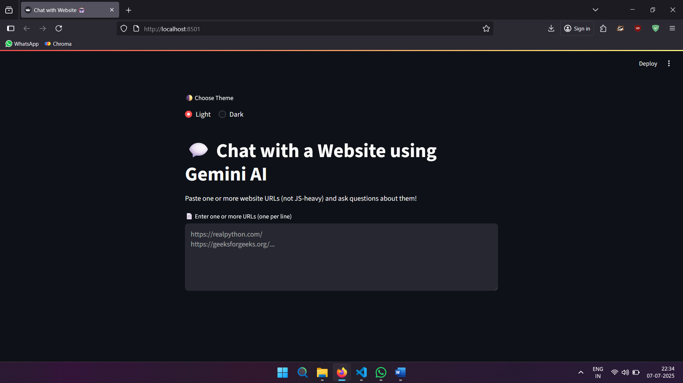

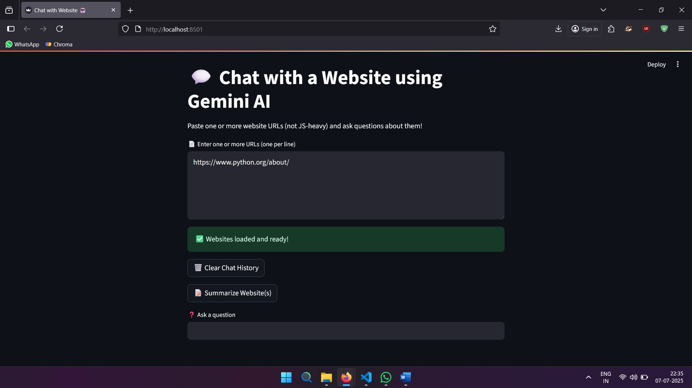
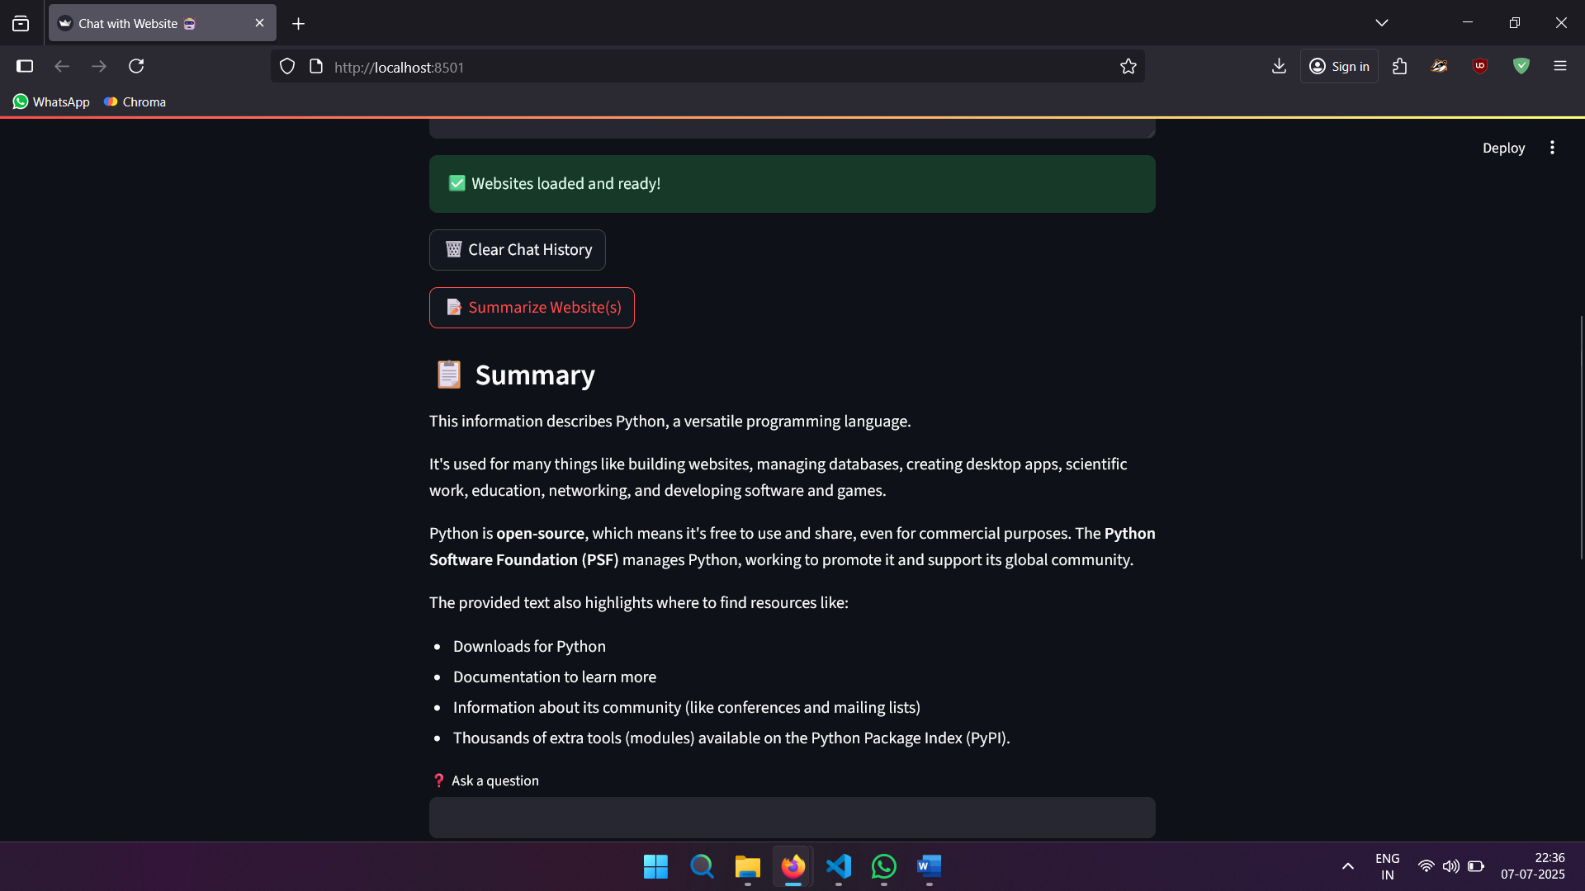

CUSTOMIZATION OPTIONS
ChatWithWebsite.AI is designed to be modular and easily extensible. Below are possible customizations to enhance the application:

🔧 Modify System Behavior
- Adjust the conversational tone, personality, or context by editing prompt logic in app.py.
- You can customize the instructions sent to Gemini to make the chatbot formal, casual, or domain-specific.
system_prompt = "You are a website assistant that summarizes and answers questions clearly and accurately."
📎 Add File Upload Support
- Use st.file_uploader() to allow users to upload .txt, .pdf, or .docx files.
- Parse the files and extract content using LangChain loaders or third-party parsers to enable Q&A over documents.

🗃 Connect a Database
Use SQLite, MySQL, or MongoDB to:
- Store chat logs or user questions
- Save user feedback or favorite answers
- Build user profiles and session history

🤖 Switch to a Different LLM
- Easily replace Gemini 2.5 Flash with OpenAI GPT-4, Claude, or Cohere via LangChain interfaces.
- Ideal if you want more model flexibility, pricing options, or fine-tuned behavior.

🎨 UI Enhancements
- Customize the app visually with icons, logos, or layout changes using st.markdown() and custom CSS.
- Add branding elements, tooltips, and animations for a professional finish.
📚 Add Multi-Page Navigation
Use Streamlit’s native page system or sidebar controls:
st.sidebar.selectbox("Navigate", ["Chat", "Summarize", "Logs", "Settings"])
- Create dedicated pages for:
  - Chat interface
  - Summary dashboard
  - Resource library
  - Session logs

💼 Integrate Job or Knowledge APIs
- Use APIs from LinkedIn, Naukri, RapidAPI, or Wikipedia to supplement web content.
- Fetch live job listings, keyword trends, or industry news.

📱 Build a Mobile Version
- Deploy via Streamlit Cloud and embed in:
  - Flutter WebView
  - React Native wrapper
  - Progressive Web App (PWA) shell

🔐 Add User Authentication
- Implement login/signup with Firebase Auth or streamlit-authenticator.
- Store personalized sessions, bookmarks, and access history.

🎙 Enable Voice Input
- Use SpeechRecognition (Python) or Web Speech API (JavaScript) to accept voice queries.
- Improve accessibility and make the chatbot more interactive.

FUTURE SCOPE & IMPROVEMENTS
The ChatWithWebsite.AI application provides a solid foundation for AI-powered web interaction. However, several enhancements can further expand its capabilities, user experience, and scalability:
- Multi-LLM Support
Enable users to choose between multiple LLMs (Gemini, OpenAI GPT, Claude, etc.) based on use case, accuracy, or cost.
- User Authentication and Profiles
Allow users to log in, save preferences, view chat history, and manage multiple sessions across devices.
- File Upload and Parsing
Support PDF, DOCX, and TXT file uploads to enable Q&A over offline or personal documents.
- Full Website Crawling
Extend from single-page loading to full-site crawling and summarization using sitemap parsing or recursive loaders.
- Citation Highlighting
Display source excerpts alongside answers for transparency and reference.
- Custom Chat Modes
Introduce toggle modes like “Summarizer,” “Technical Explainer,” or “Fact Extractor” to fit different tasks.
- Feedback and Rating System
Allow users to rate responses and fine-tune the LLM pipeline based on feedback.
- Language and Localization Support
Enable multilingual support to query and summarize websites in various languages.
- Mobile App Version
Wrap the app into a PWA or hybrid mobile app using Flutter or React Native.
- Voice Interaction
Add voice input/output to make the chatbot more accessible and conversational.
- Analytics Dashboard
Track user activity, popular questions, and system performance for improvement and insights.
- Cloud Storage Integration
Sync saved chat logs to Google Drive, Dropbox, or AWS S3 for cross-platform access.
- Advanced Search and Filtering
Let users search or filter through previous chat history, URLs, or topic tags.

LEARNINGS & OUTCOMES

During the development of the ChatWithWebsite.AI web application, I gained significant technical and practical experience in building scalable, LLM-powered web tools. The following are the key learnings and outcomes:
- Gained hands-on experience in building interactive web applications using Python and Streamlit.
- Learned to integrate Google’s Gemini 2.5 Flash API for real-time question answering and summarization.
- Understood secure API key handling using .env files and Streamlit’s secrets.toml.
- Explored the use of LangChain for document loading, chunking, embedding, and semantic retrieval.
- Practiced dependency management using requirements.txt and modular code structuring.
- Developed a complete understanding of Retrieval-Augmented Generation (RAG) workflows.
- Improved skills in vector databases by implementing ChromaDB for efficient content storage and retrieval.
- Gained practical exposure to conversational UI design, user experience, and theme-based customization.
- Understood how LLMs can be used to convert static websites into interactive knowledge tools.
- Successfully built a robust, extensible, and user-friendly AI chatbot for summarizing and querying website content.
CONCLUSION
The ChatWithWebsite.AI project showcases the practical application of generative AI and Retrieval-Augmented Generation (RAG) to transform traditional web browsing into an interactive, intelligent experience. By leveraging tools like Streamlit, LangChain, ChromaDB, and Gemini 2.5 Flash, this project successfully demonstrates how large language models can extract, summarize, and answer questions based on real-time website content.
Through this summer training project, I have not only built a functional and user-friendly AI chatbot but also developed a deeper understanding of modern AI pipelines, vector search, prompt engineering, and web-based UI development. The project emphasizes modularity, scalability, and extensibility—making it suitable for real-world use cases such as research assistants, documentation helpers, or educational bots.
Overall, ChatWithWebsite.AI reflects a strong foundation in AI-powered web applications and highlights the value of combining cutting-edge models with thoughtfully designed user interfaces. It has been a fulfilling and enriching experience that enhanced my technical proficiency and broadened my vision for building future-ready AI solutions.

