Neural Network I: Fundamental Theory and Applications (CSA01)

Team Project III

Learning of self-organizing neural network

m5261113 Akihiro Hattori

m5261159 Taisei Shibakura

m5261162 Taisei Shiraishi

m5261176 Yuta Uchida

# 

## 

a) Modify the program, and test the program using the database Iris.

b) Nearest neighbor classifier, Winner-take-all learning

c)

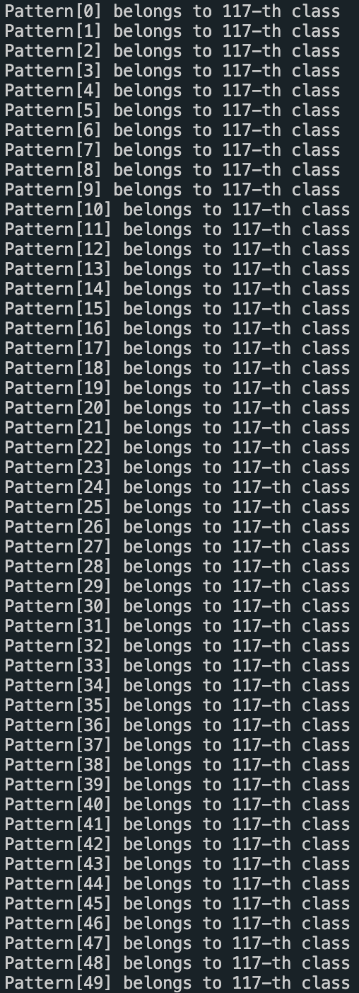

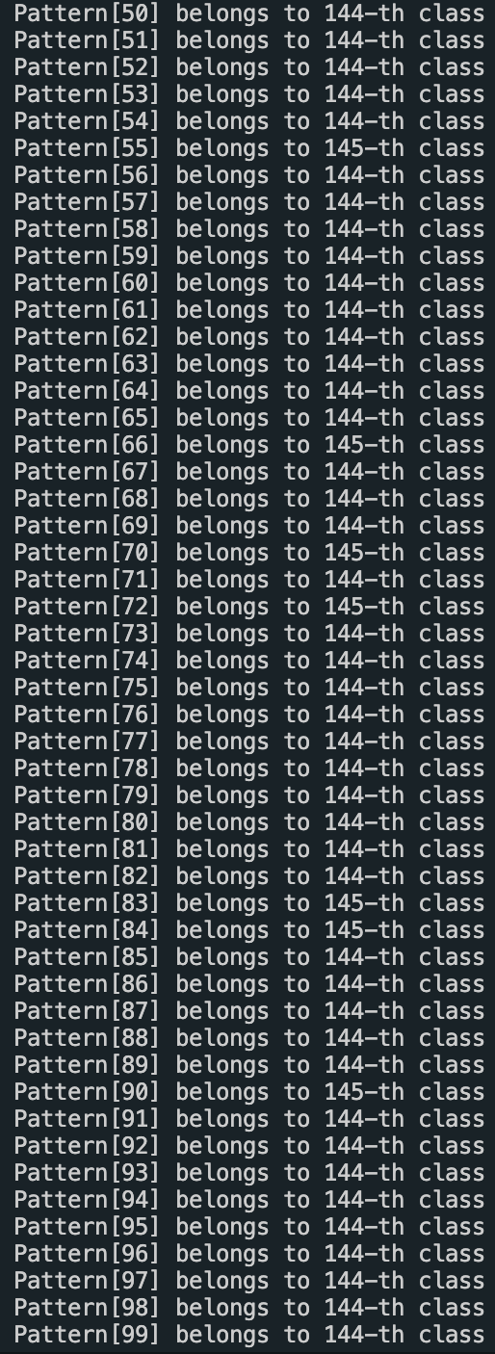

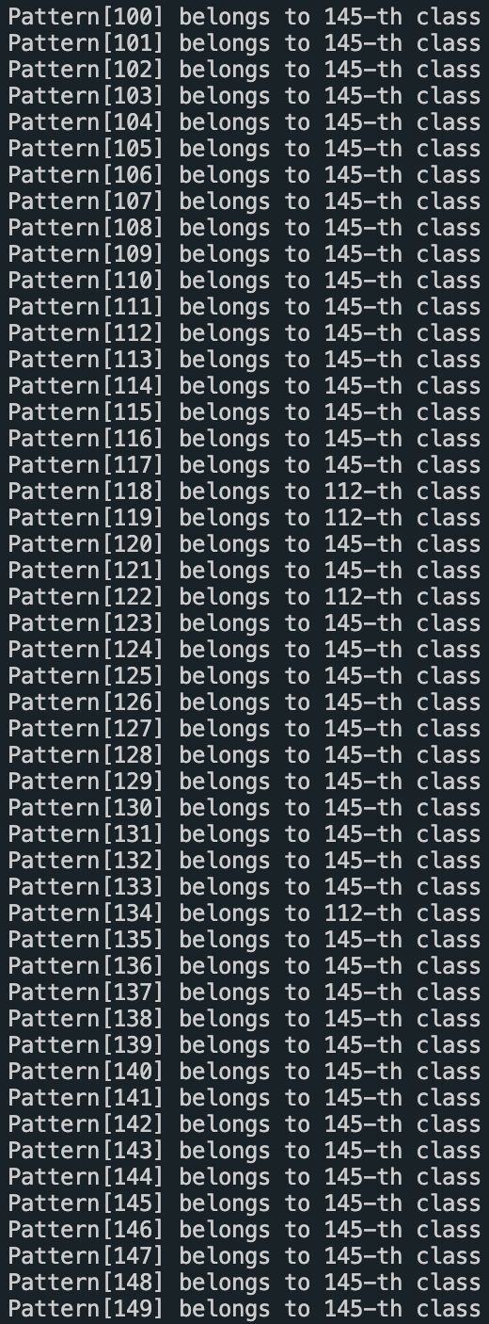

We changed our input data from prepared to iris.data and changed the values of the following constant macros.

According to the results of the program run, the data was classified by class of the data set, although the accuracy was a little rough.

#define I 4

#define M 150

#define P 150

#define alpha 0.1

#define n_update 500

d)What is the behavior of increasing the number of updates?

e)We changed the value of n_upgdate from 500 to 2000

#define n_update 2000

f)The change made it less accurate to distinguish versicolor from virginica.

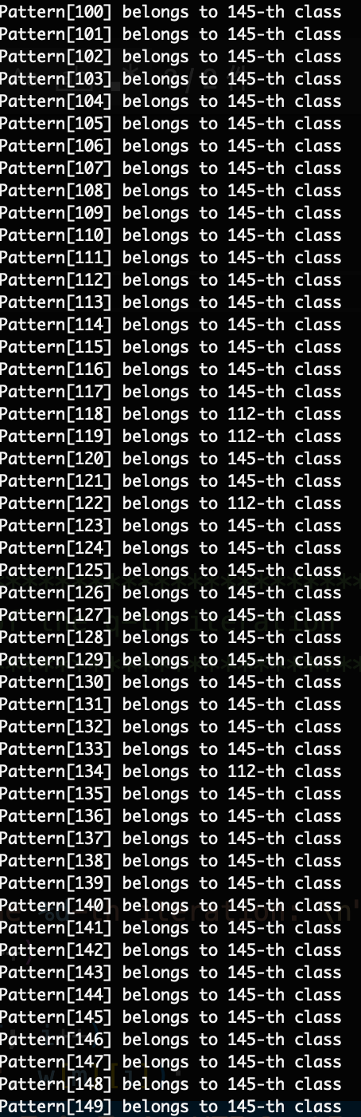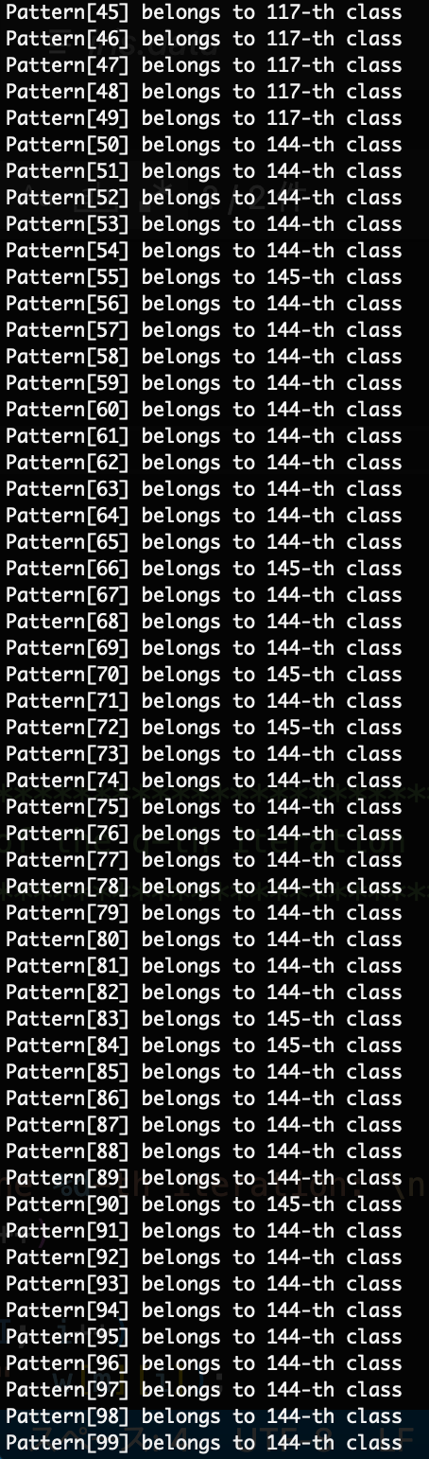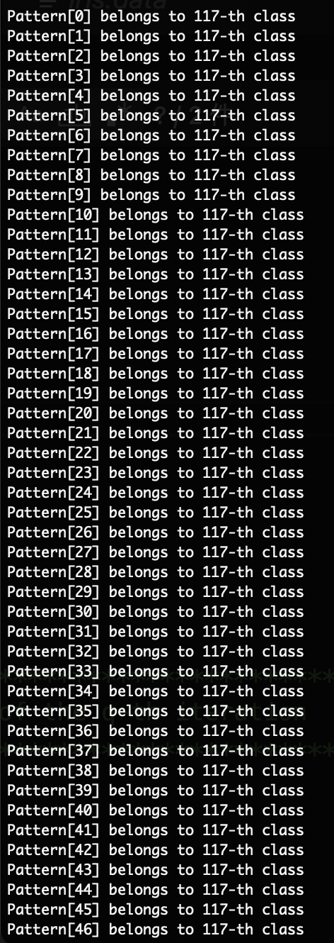

Below is the source code.ーーーーーーーーーーーーーーーーーーーーーーーーーー

/*************************************************************/

/* C-program for self-organized learning of Kohonen network */

/* */

/* The purpose here is to find the representatives of p */

/* clusters in the pattern space. If you can provide the */

/* the training samples x, and speicify the number p, you */

/* can use this program easily */

/* */

/* 1) Number of input : I */

/* 2) Number of neurons: M */

/* 3) Number of training patterns: P */

/* */

/* This program is produced by Qiangfu Zhao. */

/* You are free to use it for educational purpose */

/*************************************************************/

#include <stdio.h>

#include <stdlib.h>

#include <math.h>

#define I 4

#define M 150

#define P 150

#define alpha 0.1

#define n_update 2000

double w[M][I];

double x[P][I];

double y[M];

/*************************************************************/

/* Print out the result of the q-th iteration */

/*************************************************************/

void PrintResult(int q)

{

int m, i;

printf("\n\n");

printf("Results in the %d-th iteration: \n", q);

for (m = 0; m < M; m++)

{

for (i = 0; i < I; i++)

printf("%5f ", w[m][i]);

printf("\n");

}

printf("\n\n");

}

/*************************************************************/

/* The main program */

/*************************************************************/

main()

{

int m, m0, i=0, p, q;

double norm, s, s0;

FILE *fp;

char fname[] = "iris.data";

fp = fopen(fname, "r");

if (fp == NULL)

{

printf("%s file not open!\n", fname);

return -1;

}

else

{

printf("%s file opened!\n", fname);

}

while (fscanf(fp, "%lf,%lf,%lf,%lf", &x[i][0], &x[i][1], &x[i][2], &x[i][3]) != EOF)

{

if (fscanf(fp, "%*999[^0-9]") == 1)

break;

i++;

}

/* Initialization of the connection weights */

for (m = 0; m < M; m++)

{

norm = 0;

for (i = 0; i < I; i++)

{

w[m][i] = (double)(rand() % 10001) / 10000.0 - 0.1;

norm += w[m][i] * w[m][i];

}

norm = sqrt(norm);

for (i = 0; i < I; i++)

w[m][i] /= norm;

}

PrintResult(0);

/* Unsupervised learning */

for (q = 0; q < n_update; q++)

{

for (p = 0; p < P; p++)

{

s0 = 0;

for (m = 0; m < M; m++)

{

s = 0;

for (i = 0; i < I; i++)

s += w[m][i] * x[p][i];

if (s > s0)

{

s0 = s;

m0 = m;

}

}

for (i = 0; i < I; i++)

w[m0][i] += alpha * (x[p][i] - w[m0][i]);

norm = 0;

for (i = 0; i < I; i++)

norm += w[m0][i] * w[m0][i];

norm = sqrt(norm);

for (i = 0; i < I; i++)

w[m0][i] /= norm;

}

PrintResult(q);

}

/* Classify the training patterns */

for (p = 0; p < P; p++)

{

s0 = 0;

for (m = 0; m < M; m++)

{

s = 0;

for (i = 0; i < I; i++){

s += w[m][i] * x[p][i];

}

if (s > s0)

{

s0 = s;

m0 = m;

}

}

printf("Pattern[%d] belongs to %d-th class\n", p, m0);

}

fclose(fp);

return 0;

}

ーーーーーーーーーーーーーーーーーーーーーーーーーーーーーーーーーーーーー