Neural Network I: Fundamental Theory and Applications

Project Ⅲ

Project member:

1. Atsushi Takamiya (s1260013)
2. Tomonori Suzuki (s1260032)
3. Taiki Watanabe (m5251152)
4. Kaito Suzuki (m5251144)
5. Kaito Iwamatsu (m5251115)

• Project Ⅲ: 1

a,b,c) 1

d,e,f) 3

Project Program (Major changes) 3

a,d,c) 3

d,e,f) 3

# Project Ⅲ:

## a,b,c)

a) Noise repair

b) HNN (Hopfield neural network) algorithm

c)

・Pixel weights common between patterns increase.

・Therefore, in the pattern of a unique shape such as 4, it takes time to repair.

noise_rate 0.00 (0% nosie)

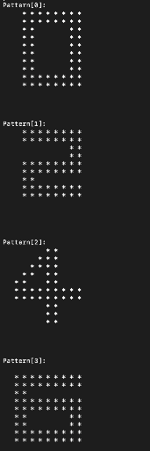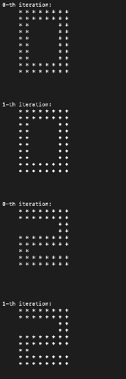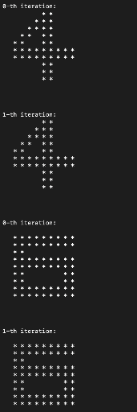

noise_rate 0.10 (10% noise)

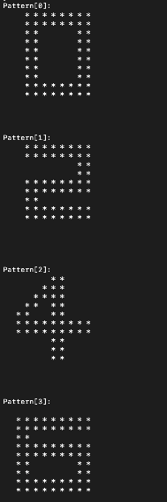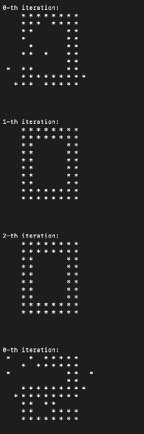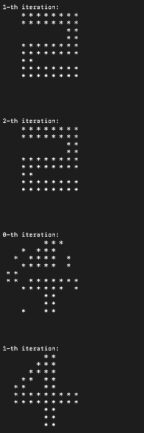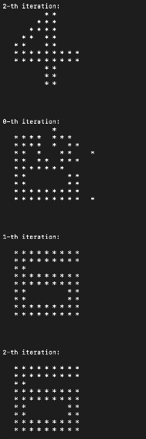

noise_rate 0.15 (15% noise)

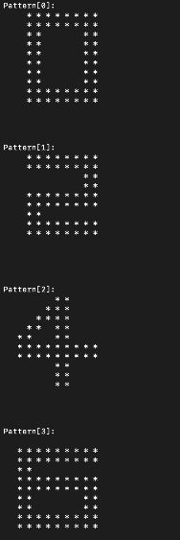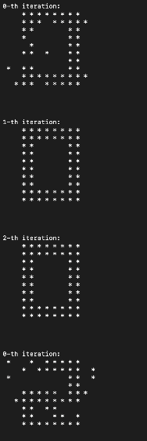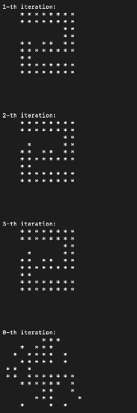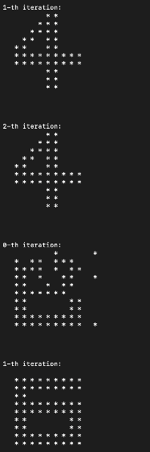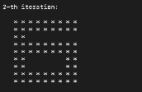

## d,e,f)

d) Difficult to verify various cases of noise.

e) To be easier validations, we made a random value depends on the time.

f) We made the above possible.

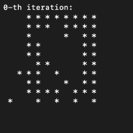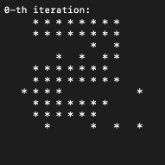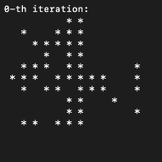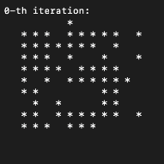

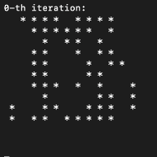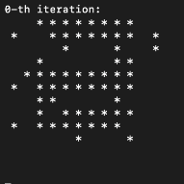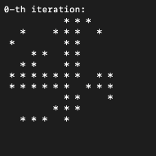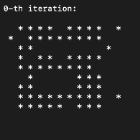

## Project Program (Major changes)

### a,d,c)

// 1st : 0% (0.00) 2nd :10% (0.10) 3rd : 15% (0.15)

#define noise_rate 0.00 (and 0.10 and 0.15)

### d,e,f)

#include <time.h>

int main(){

srand((unsigned int)time(NULL));

・

・

・

}