1.武大
武大遥感院
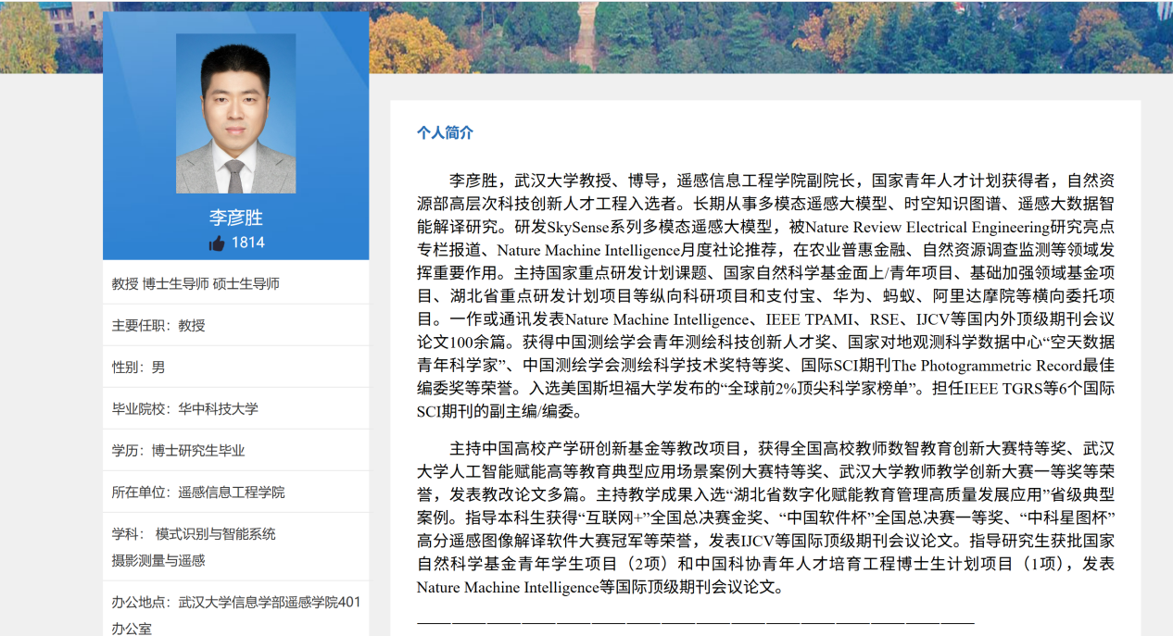
武大国测重
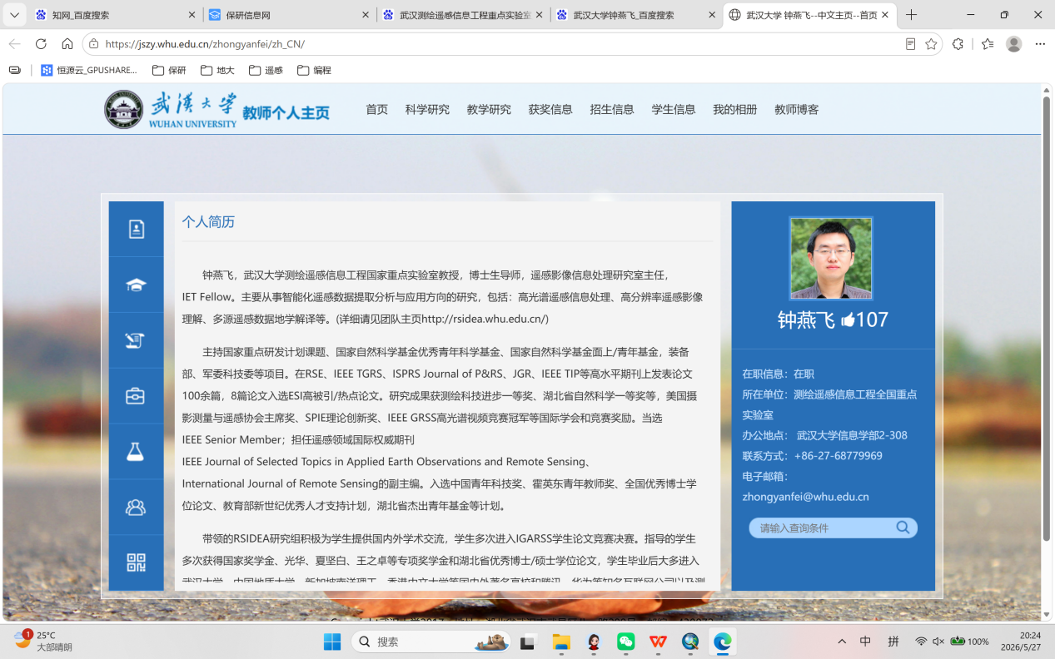
武大资环




北京师范大学

2.1渠瀛

代表论文：
[1]Ying Qu, Hairong Qi and Chiman Kwan. “Unsupervised Sparse Dirichlet-net for Hyperspectral Image Super-Resolution”, Computer Vision and Pattern Recognition, pp. 2511-2520, Salt lake city, USA, June 2018. （CVPR 亮点论文 6.6%）
[2]Ying Qu, Hairong Qi and Chiman Kwan, Naoto Yokoya, Jocelyn Chanussot. “Unsupervised and Unregistered Hyperspectral Image Super-Resolution with Mutual Dirichlet-Net”, in IEEE Transactions on Geoscience and Remote Sensing, doi: 10.1109/TGRS.2021.3079518，May 2021. （TGRS）
Ying Qu, Wei Wang, Rui Guo, Bulent Ayhan, Chiman Kwan, Steven Vance, and Hairong Qi. “Hyperspectral Anomaly Detection through Spectral Unmixing and Dictionary based Low Rank Decomposition”, IEEE Transactions on Geoscience and Remote Sensing vol. 56, no. 8, pp. 4391-4405, Aug.2018. （TGRS, ESI高被引）

2.2赵文智


W Zhao*, R Peng, et al. Life-long learning with continual spectral-spatial feature distillation for hyperspectral image classification. IEEE Transactions on Geoscience and Remote Sensing, 2022.
S Wen, W Zhao*, et al. “Phenology description is all you need!” mapping unknown crop types with remote sensing time-series and LLM generated text alignment, ISPRS Journal of Photogrammetry and Remote Sensing, 2025.

2.3唐宏
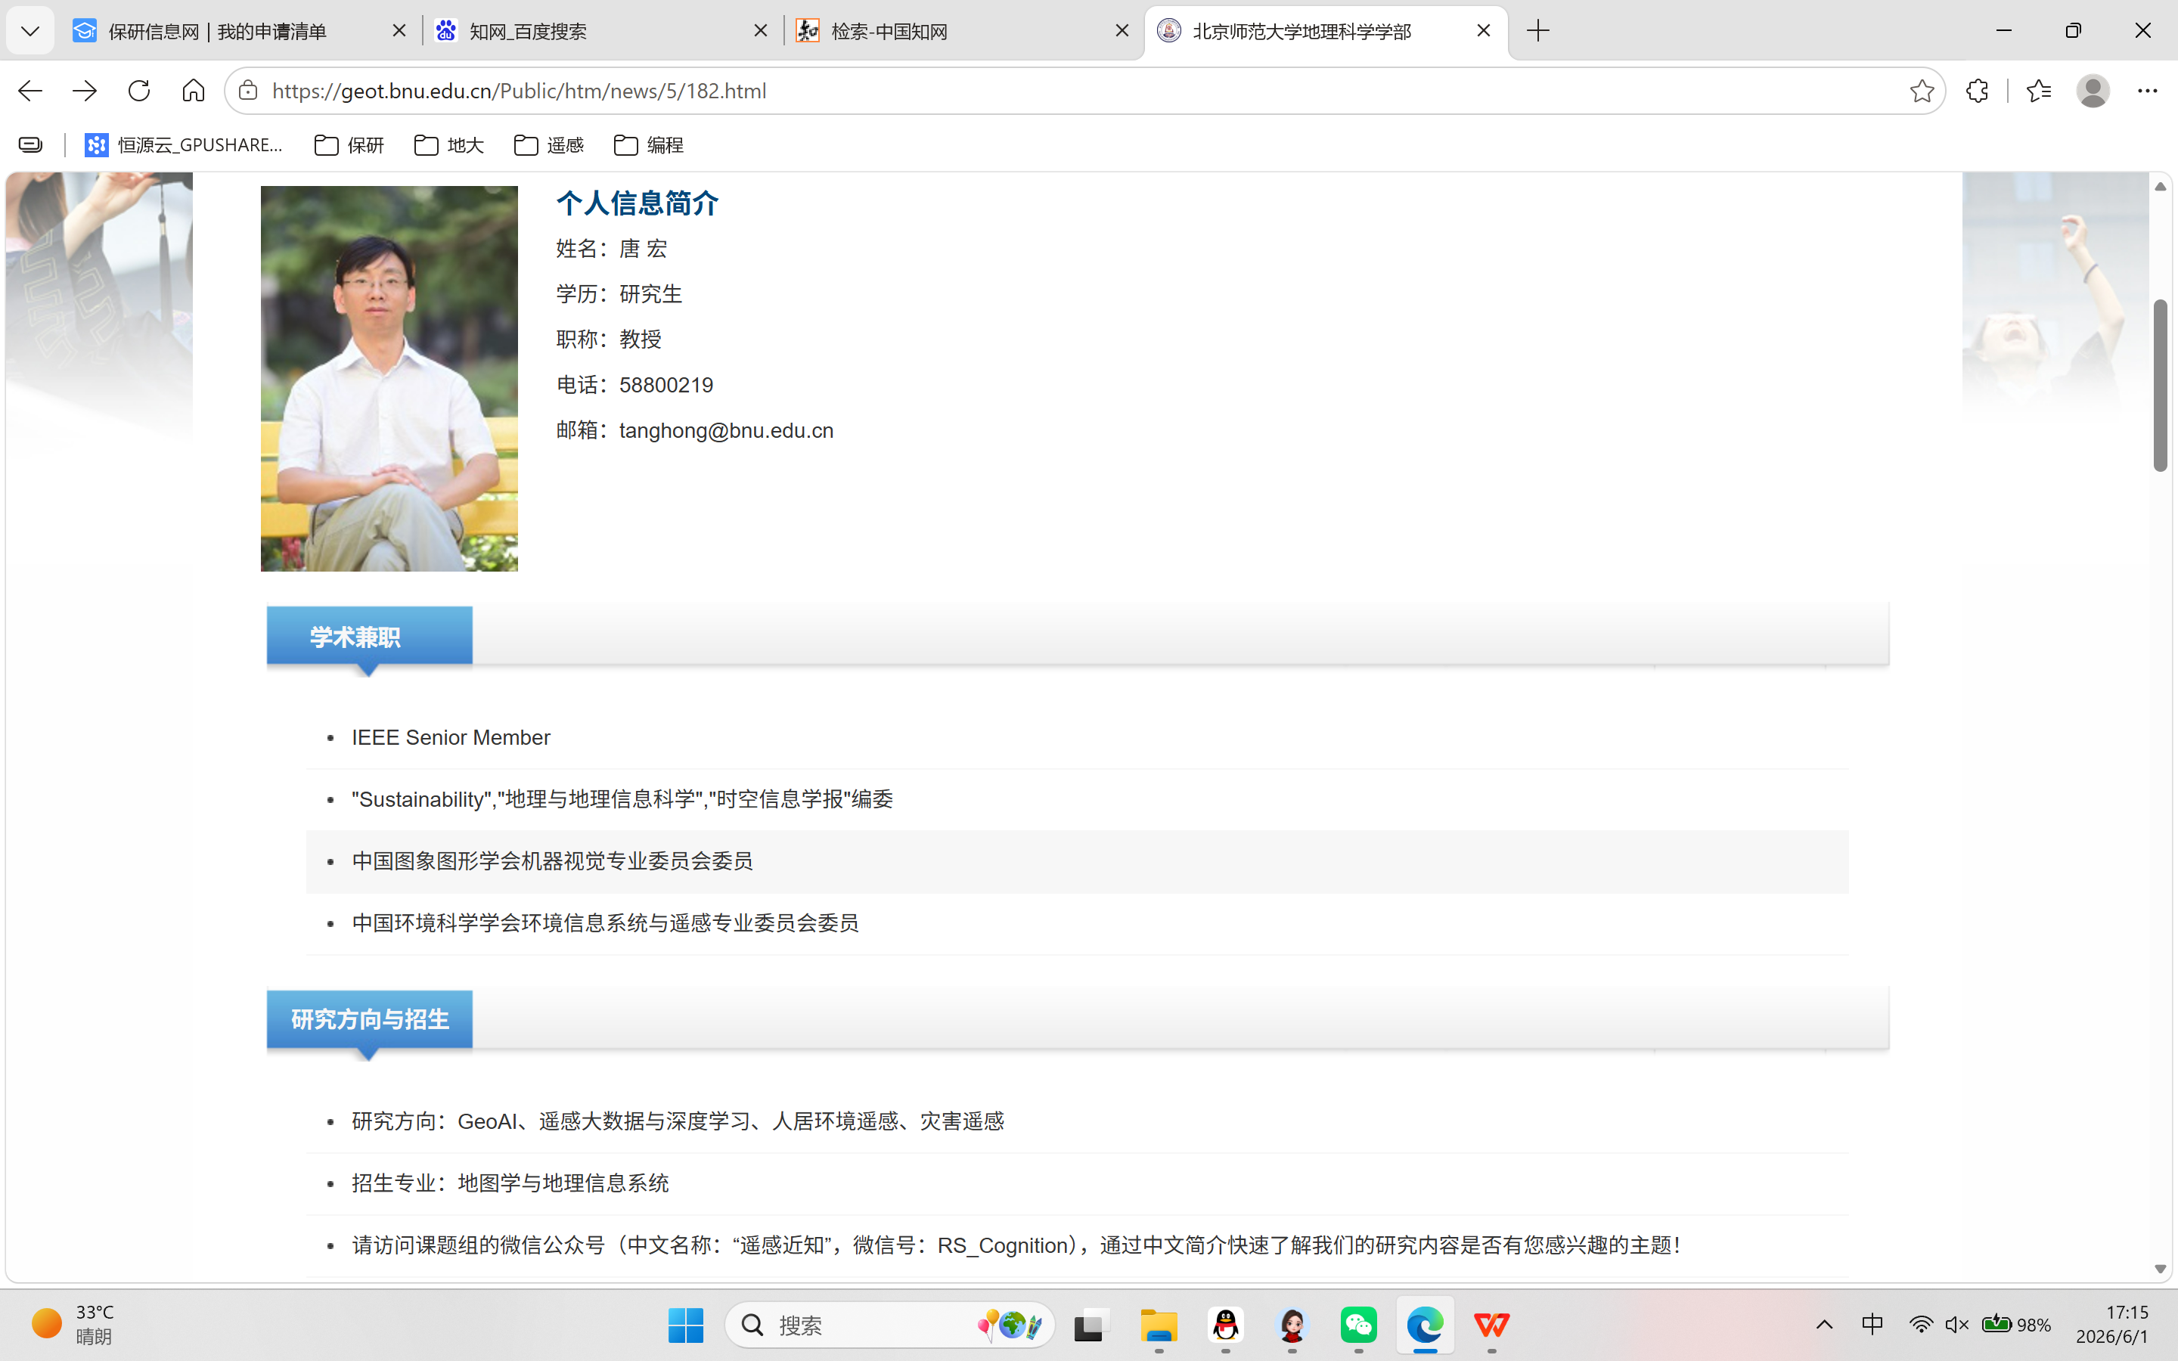

2.4穆望舒

代表论文：
（1）Wang, G., Mu, W.*, Li, C., &Wang, Y. (2026). Quantification and reduction of spatially induced uncertaintyin spatial optimization via deep reinforcement learning. InternationalJournal of Geographical Information Science, Available Online 1-33.
（2）Jia, Q., Zhong, Z., Yang, A., Wu, M.,Mu, W., Liu, F., & Li, P. (2025). HiStory: Methodology and System forGIS‐Based Narrative. Transactions in GIS, 29(7),e70131.
（3）Mu, W.*, & Li, C. (2024). Optimization of urban greenway route using a coverage maximization model for lines. Computers, Environment and Urban Systems, 112, 102155.

