--Q1 Total Revenue

Select Sum(total_price) as Total_Revenue From pizza_sales



--Q2 Average value

Select Sum(total_price)/Count(Distinct order_id) as Average_Order_Value From pizza_sales

--Q3 Total Pizzas Sold

Select Sum(quantity) as Total_Pizzas_Sold From pizza_sales



--Q4 Total Orders

Select Count(Distinct order_id) as Total_Orders From pizza_sales



--Q5 Average Pizza Per Order

Select Count(quantity)/Count( Distinct order_id) as Avg_Pizza_Sale From pizza_sales



--Q6 Daily Trends for Total Orders

Select DATENAME(DW, order_date) as Order_Day, COUNT(Distinct order_id) as Total_Orders

From pizza_sales

Group By DATENAME(DW, order_date)

Order by COUNT(Distinct order_id)

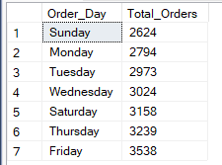

--Q7 Monthly Trends for Total Orders

Select DATENAME(MONTH, order_date) as Month, COUNT(Distinct order_id) as Total_Orders

From pizza_sales

Group By DATENAME(MONTH, order_date)

Order By Total_Orders DESC

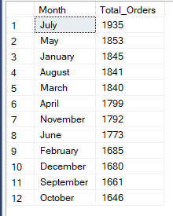

--Q8 Sales Percentage According to Category

Select pizza_category, Sum(total_price)*100 / (Select Sum(total_price) From pizza_sales) as Category_Percent

From pizza_sales

Group By pizza_category

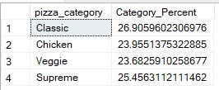

--Q9 Sales Percentage According to Pizza Size

Select pizza_size, Sum(total_price)*100 / (Select Sum(total_price) From pizza_sales) as Category_Percent

From pizza_sales

Group By pizza_size

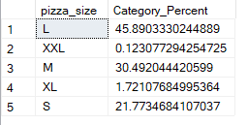

--Q11 Top Best Pizzas Revenue ,Quantity and Orders

Select pizza_name as Pizza_Name, Sum(quantity) as Quantity, Sum(total_price) as Revenue, Count(Distinct order_id) as Orders

From pizza_sales

Group By pizza_name

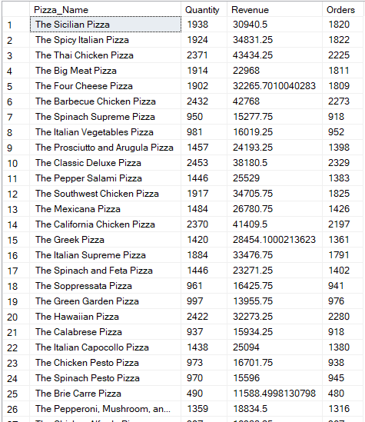

--Q12 Top 5 Best Pizzas Revenue

Select Top 5 pizza_name as Pizza_Name, Sum(total_price) as Revenue

From pizza_sales

Group By pizza_name

Order By Revenue Desc

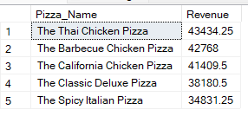

--Q13 Bottom 5 Best Pizzas Revenue

Select Top 5 pizza_name as Pizza_Name, Sum(total_price) as Revenue

From pizza_sales

Group By pizza_name

Order By Revenue

