Chart_1

if (dataset != null) {

return result;

}

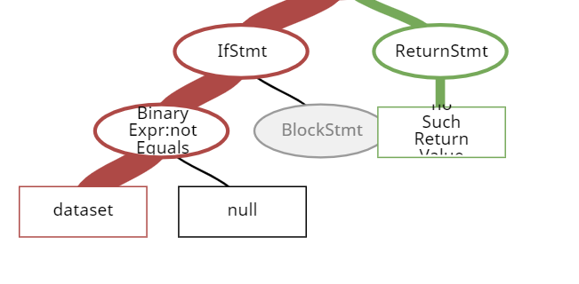

Capgen : 5.89

Sim : 120

Chart_8

Public Week(Date time, TimeZone zone){

prime(time, RegularTimePeriod.DEFAULT_TIME_ZONE, Locale.getDefault());

}

Chart_11

PathIterator iterator2 = p1.getPathIterator(null);

Chart_24

public paint getPaint(double value) {

double v = Math.max(value, this.lowerBound);

v = Math.min(v, this.upperBound);

- int g = (int)((value - this.lowerBound) / (this.upperBound

- this.lowerBound) * 255.0);

return new Color(g, g, g);

}

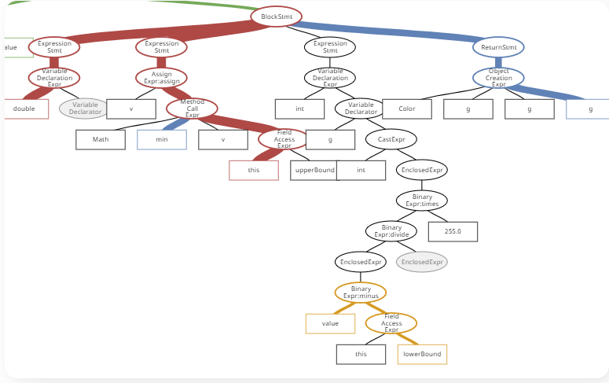

Lang_6

for (int pt = 0; pt <consumed; pt++){

pos += Character.charCount(Character.codePointAt(input, pos));

}

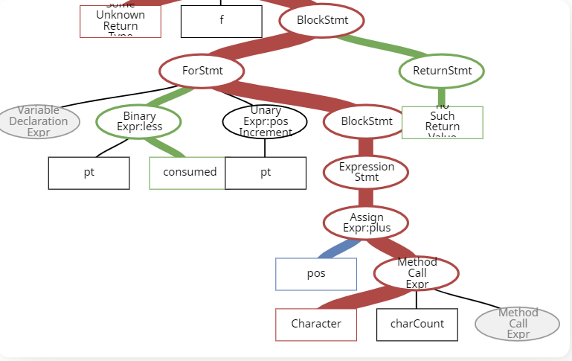

Tbar context : variable expression.

Capgen 11m

SimFix : 6.93m

Lang_26

public String format(Date date){

Calendar c= new GregorianCalendar(mTimeZone);

c.setTime(date);

return applyRules(c, new StringBuffer(mMaxLengthEstimate)).tostring();

}

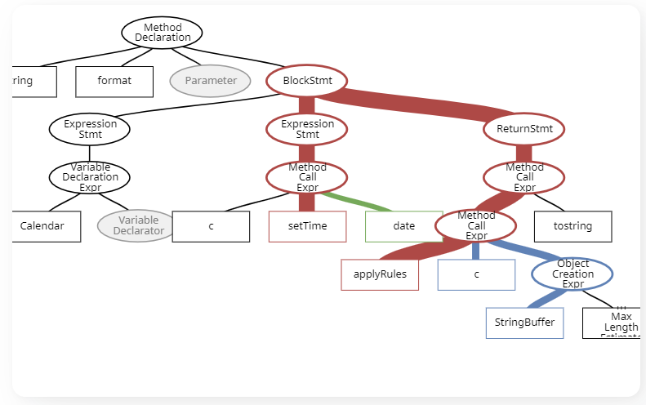

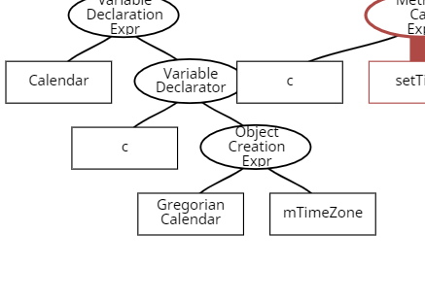

Capgen : 50.32

SimFix : 49.77

Lang_43

int start = pos.getIndex();

char[] c = pattern.toCharArray();

if (escapingOn && c[start] == QUOTE) {

return appendTo == null ? null : appendTo.append(QUOTE);

}

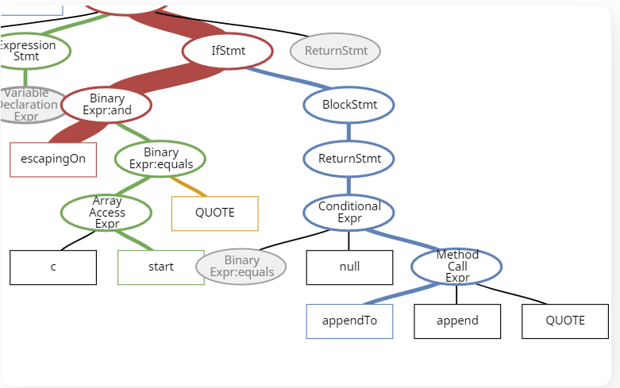

Capgen : 5.96

SimFix : 3.67

Lang_57

public static boolean isAvailableLocale(Locale locale) {

return cAvailableLocaleSet.contains(locale);

}

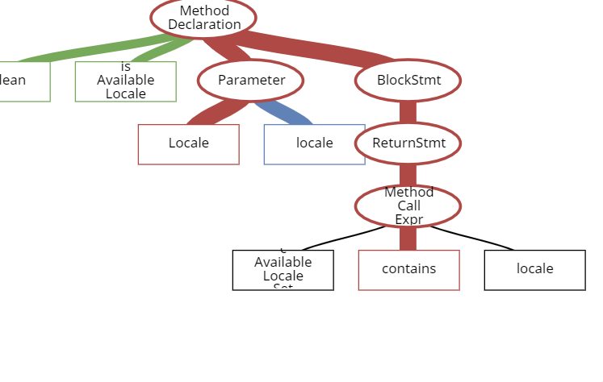

Capgen 5.78

SimFix X

Math_5

if(real==0.0&&imaginary==0.0){

return INF;

}

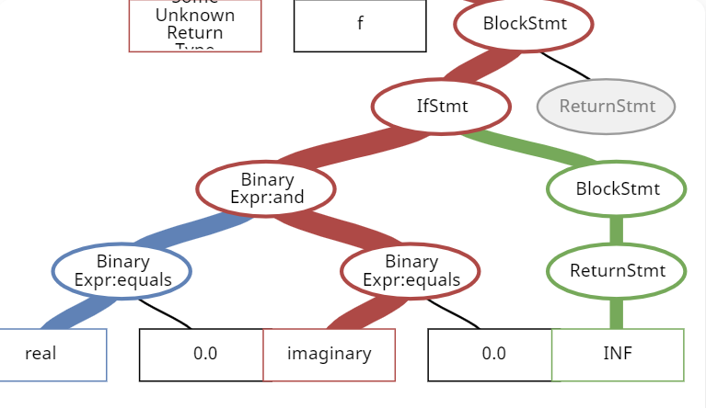Capgen : 5.33

SimFix : 27.87

Math_33

if (Precision.compareTo(entry, 0d, maxUlps) > 0) {

columnsToDrop.add(i);

}

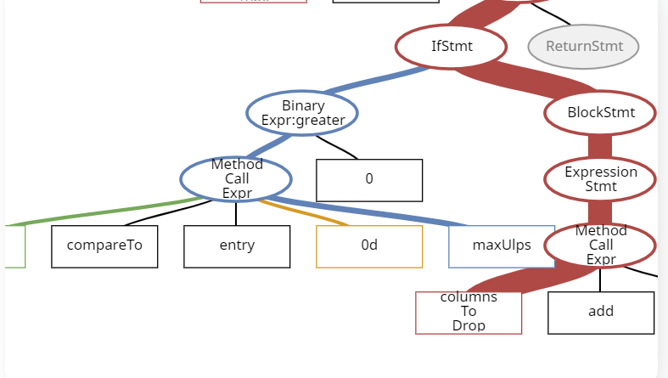

Capgen : 21.51

SimFix : 35.3

Math_53

public Complex add(Complex rhs)

throws NullArgumentException {

MathUtils.checkNotNull(rhs);

return createComplex(real + rhs.getReal(),

imaginary + rhs.getImaginary());

SimFix

MathUtils.checkNotNull(rhs);

return createComplex(real + rhs.getReal(),

imaginary + rhs.getImaginary());

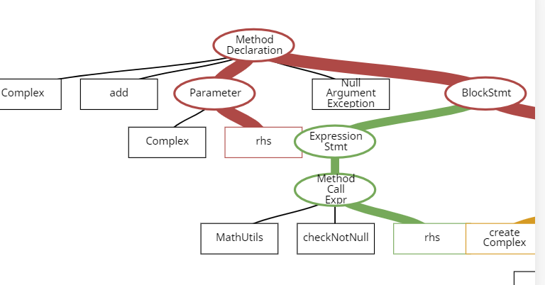

}

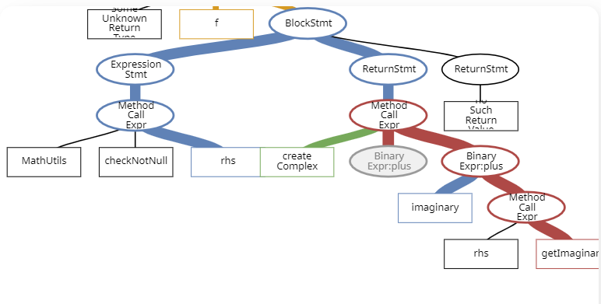

Math_57

while (resultSet.size() < k) {

- int sum = 0;

+ double sum = 0;

for (int i = 0; i < pointSet.size(); i++) {

final T p = pointSet.get(i);

final Cluster<T> nearest = getNearestCluster(resultSet, p);

Math_59

public static float max(final float a, final float b) {

- return (a <= b) ? b : (Float.isNaN(a + b) ? Float.NaN : b);

+ return (a <= b) ? b : (Float.isNaN(a + b) ? Float.NaN : a);

}

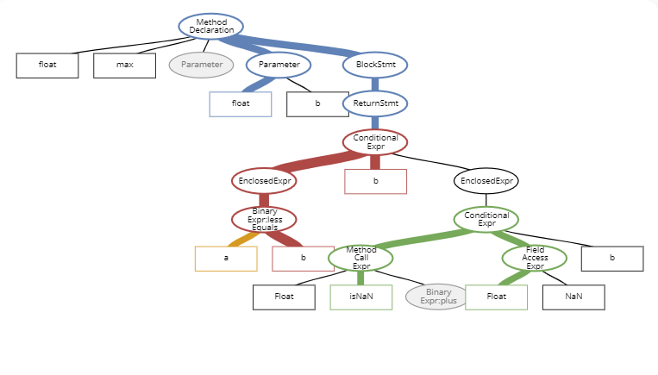

Capgen : 4.61

SimFix : 2.68

Math_63

public static boolean equals(double x, double y) {

return (Double.isNaN(x) && Double.isNaN(y)) || x == y;

}

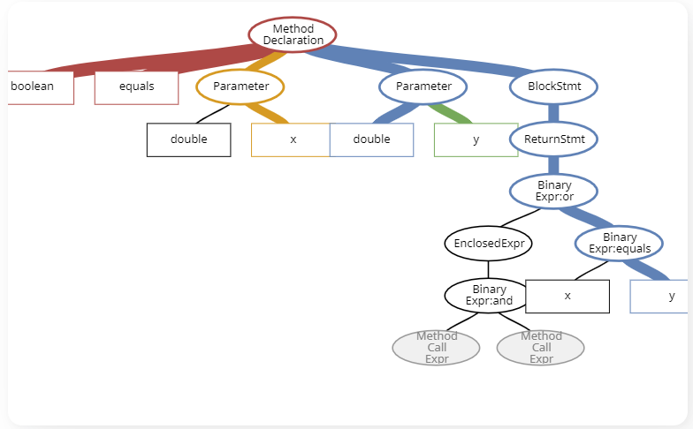

Capgen : 2.17

SimFix : X

Math_70

public double solve(final UnivariateRealFunction f, double min, double max, double initial)

throws MaxIterationsExceededException, FunctionEvaluationException {

return solve(min, max); //bug

}

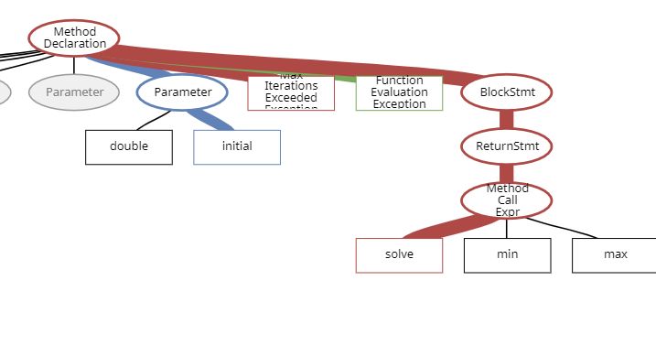

Capgen : 3.02

SimFix : 47.53

Math_75

Math_80

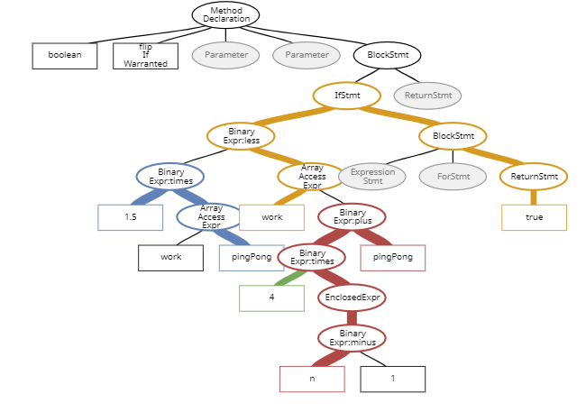

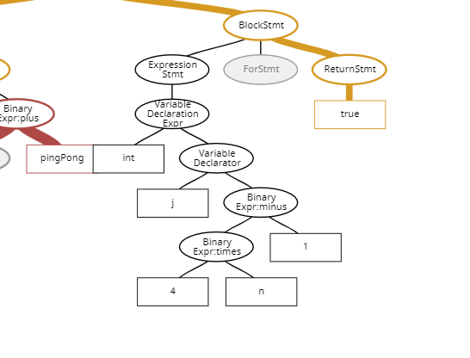

Capgen : 22.86

SimFIx : X (plausible patch)

Math_85

if (fa * fb >= 0.0 ) {

throw new ConvergenceException(

"number of iterations={0}, maximum iterations={1}, " +

"initial={2}, lower bound={3}, upper bound={4}, final a value={5}, " +

"final b value={6}, f(a)={7}, f(b)={8}",

numIterations, maximumIterations, initial,

lowerBound, upperBound, a, b, fa, fb);

}

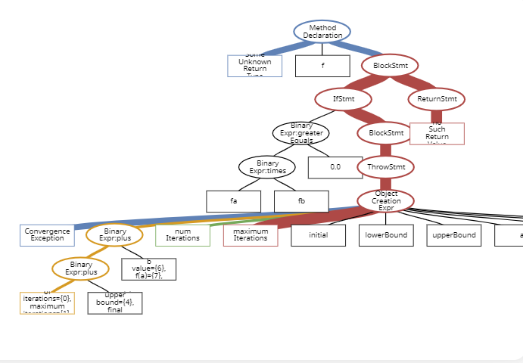

Capgen : 3.42

SimFix : X (plausible)