E-Commerce Sales Analysis
Power BI Assignment 1 – Data Transformation & Data Modeling
Prepared by: Shiam Alex S

- List of Orders – Initial Data

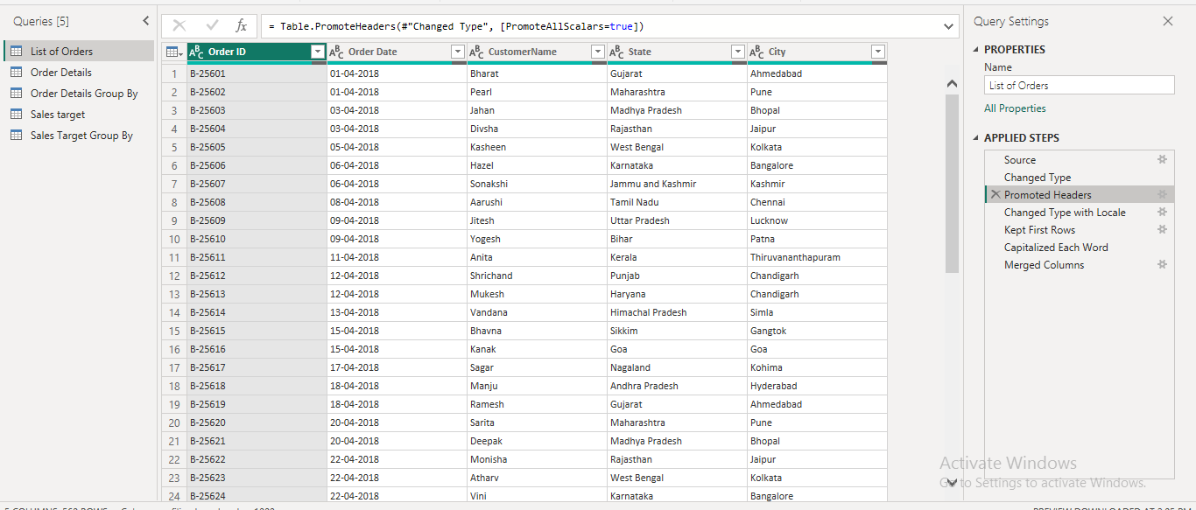

- Location Merge – City, State

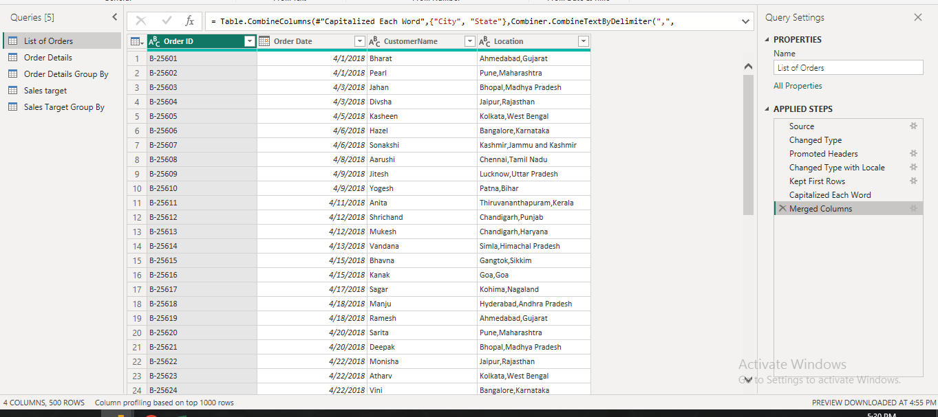

- Profit Margin & Profit Status
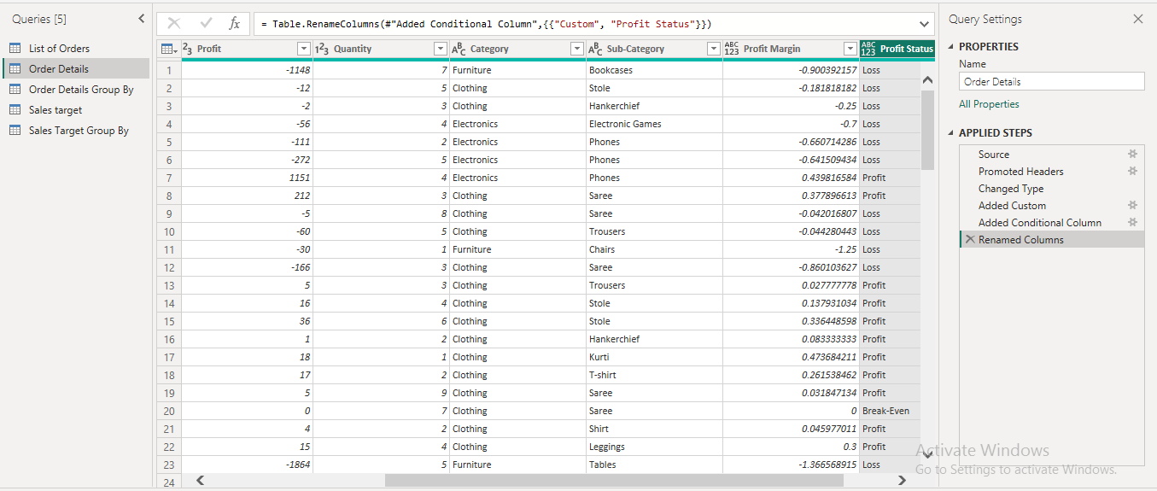

- Orders Data – Merge & Expand

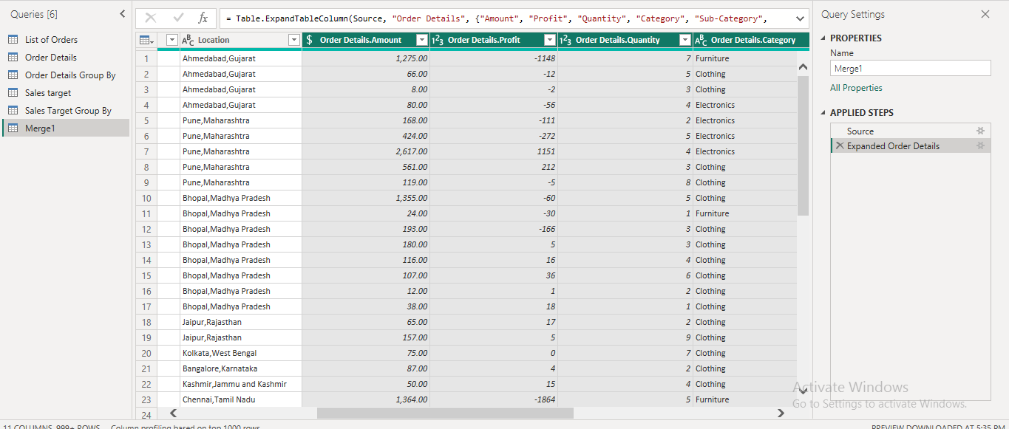

- Missing Values & Duplicate Check

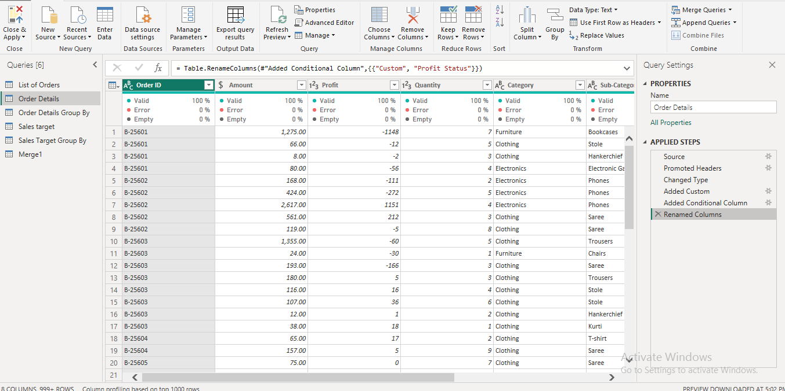

- Sort by Order Date & State Filter

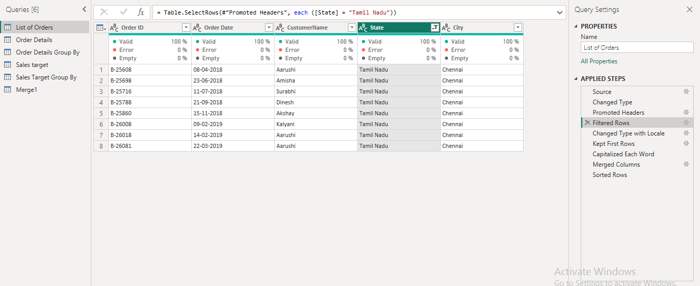

- Order Details – Total Amount by Sub-Category

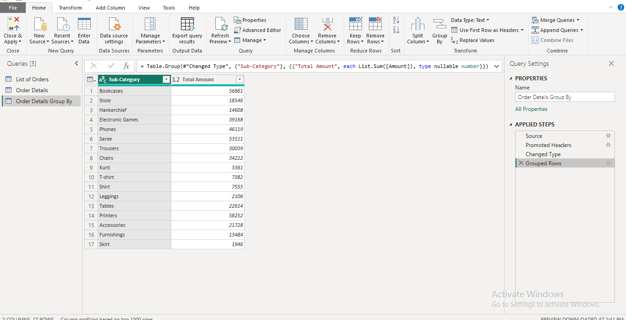

- Sales Target – Total Target by Month

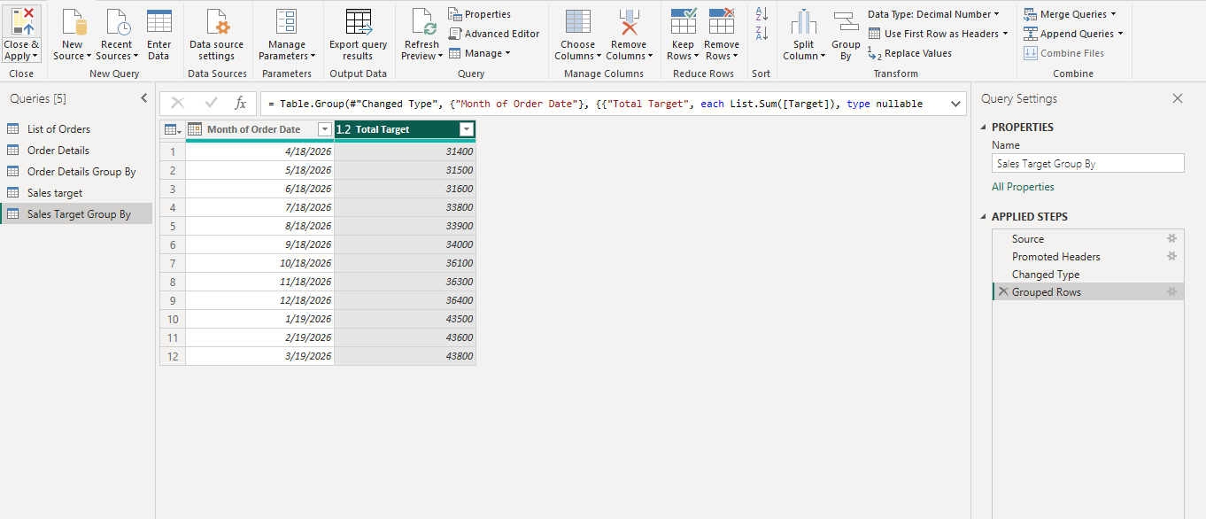

- Data Modeling – Relationships

