公衛三 梁嫚芳

Hw1

Ex 2: In regression analysis, if you observe an F test statistic = 3.2 (right-tailed test), and under the null hypothesis this statistic should follow an F distribution with a numerator d.f. of 3 and a denominator d.f. of 194, please find the p-value? Please plot the pdf and cdf of this F distribution.

p-value = 0.02448583

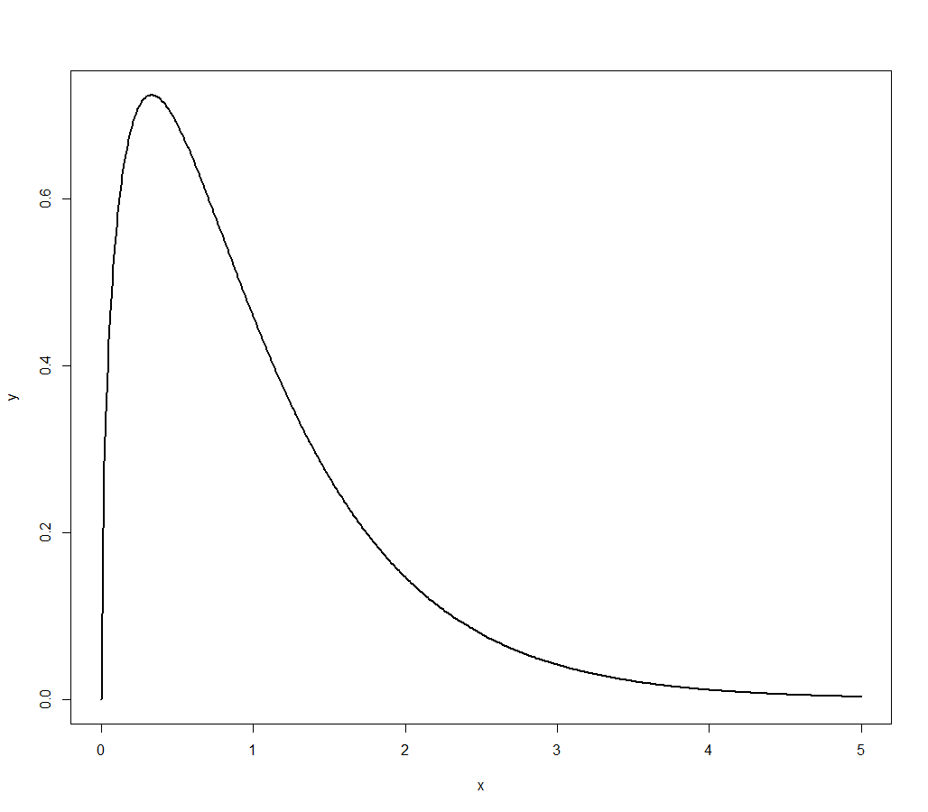

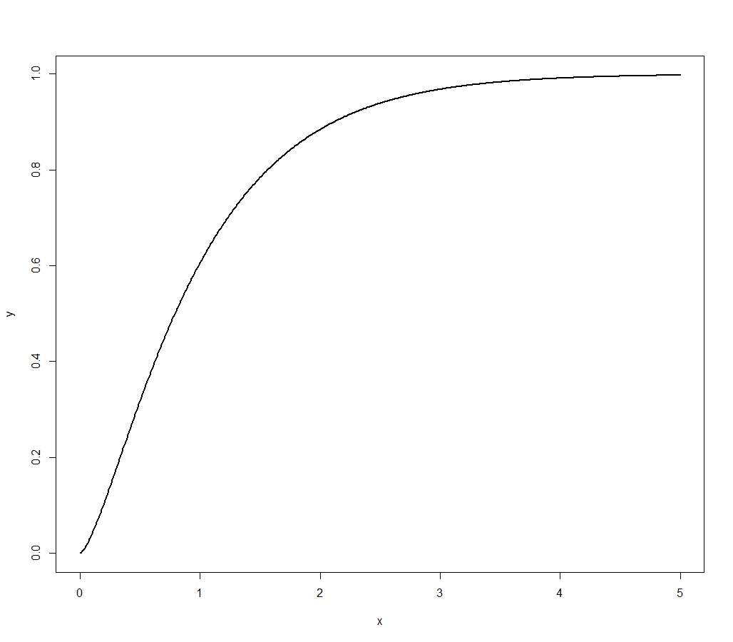

### EX2

## p-value of f-test

pf(3.2, df1=3, df2=194, lower=F)

## plot pdf

x <- seq(0, 5, 0.01)

y <- df(x, 3, 194)

plot(x, y, type="l", lwd=2)

## plot cdf

x <- seq(0, 5, 0.01)

y <- pf(x, 3, 194)

plot(x, y, type="l", lwd=2)

Ex 3: In regression analysis, if you observe a t test statistic = -2.08 (two-tailed test), and under the null hypothesis this statistic should follow a t distribution with a d.f. of 136, please find the p-value? What’s the p-value if you observe a t test statistic = 2.45 (two-tailed test). Please plot the pdf and cdf of this t distribution.

t test statistic = -2.08 → P-value = 0.03940267

t test statistic = 2.45 → P-value = 0.01555642

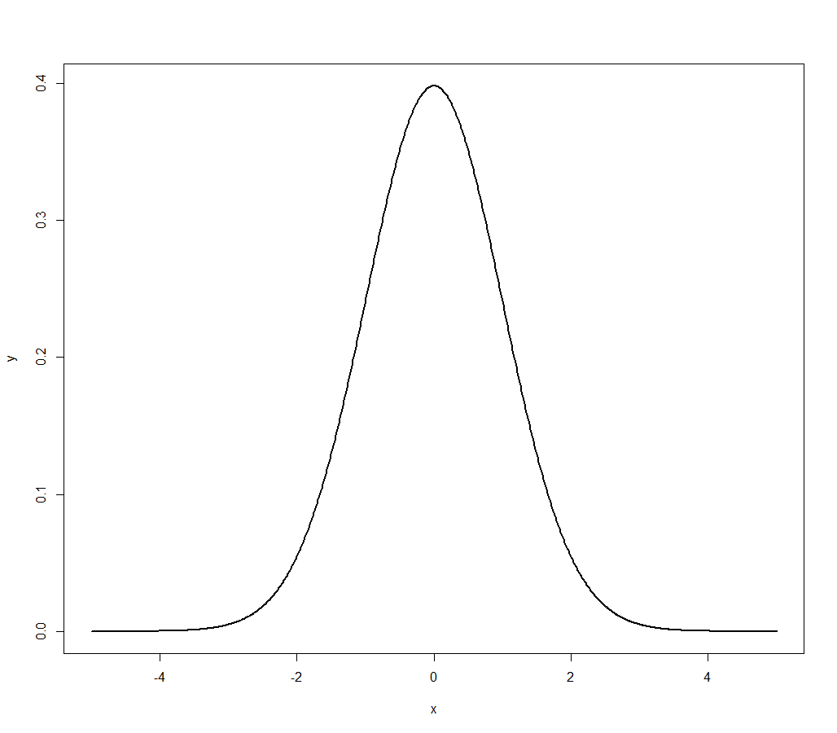

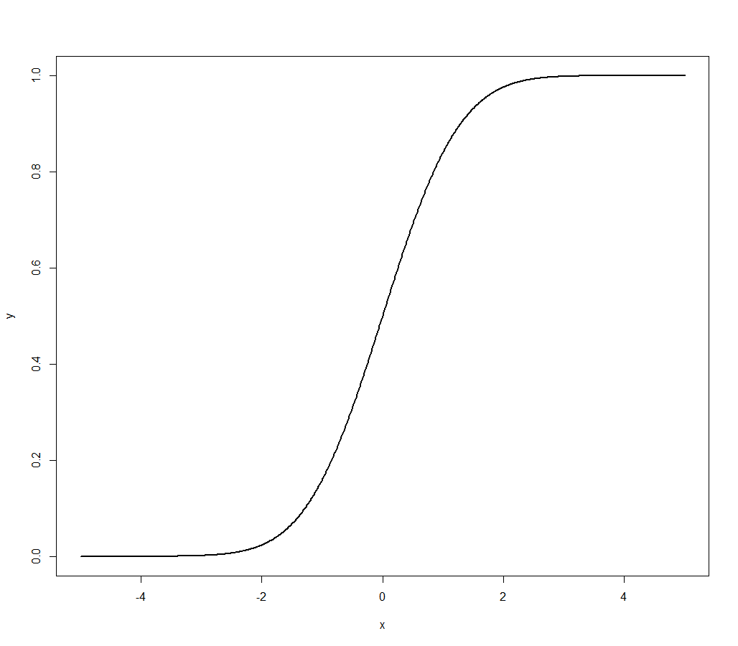

### EX3

## p-value of t-test

(pt(-2.08, df=136)) * 2

(1 - pt(2.45, df=136)) * 2

## plot pdf

x <- seq(-5, 5, 0.01)

y <- dt(x, 136)

plot(x, y, type="l", lwd=2)

## plot cdf

x <- seq(-5, 5, 0.01)

y <- pt(x, 136)

plot(x, y, type="l", lwd=2)