流行病學與生物統計計算HW2

公衛三 梁嫚芳

B07801003

Ex 8: There were 50 students in a class. All odd-numbered students were boys, and all even-numbered students were girls.

There were 7 students passing the midterm exam: 11,16,23,31,36,47,50.

There were 9 students passing the final exam: 3,9,16,20,27,31,36,49,50.

Please use the R commands regarding set operations to answer the following four questions:

1. Please list the boys who passed both the midterm and final exams
2. Please list the girls who passed both the midterm and final exams
3. Please list the boys who passed the midterm exam but failed the final exam
4. Please list the girls who failed the midterm exam but passed the final exam
5. 31
6. 16 36 50
7. 11 23 47
8. 20

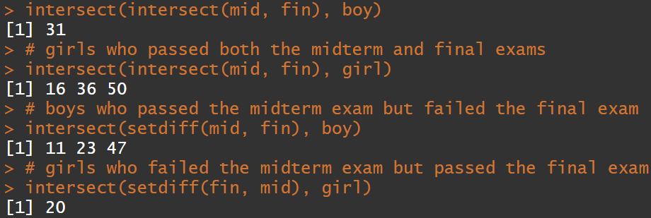

Code:

## EX8

# pass

mid <- c(11,16,23,31,36,47,50)

fin <- c(3,9,16,20,27,31,36,49,50)

# odd

boy <- seq(1,50,2)

# even

girl <- seq(2,50,2)

# boys who passed both the midterm and final exams

intersect(intersect(mid, fin), boy)

# girls who passed both the midterm and final exams

intersect(intersect(mid, fin), girl)

# boys who passed the midterm exam but failed the final exam

intersect(setdiff(mid, fin), boy)

# girls who failed the midterm exam but passed the final exam

intersect(setdiff(fin, mid), girl)

Ex 9: Please write a function on your own to estimate the regression coefficients of a simple linear regression, where the response variable is “y” from “seizure.csv” (data set on ceiba 9/17 course materials) and the predictor variable is “ltime” from “seizure.csv”. (Hint: the regression coefficients should include an intercept term and a slope term)

intercept term: -3.922414

slope term: 15.906957

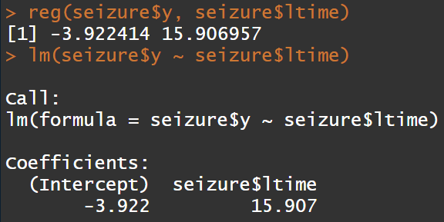

Code:

## EX9

seizure <- read.csv(file.choose())

reg <- function(y, x){

b1 <- sum((x - mean(x)) * (y - mean(y))) / (sum((x - mean(x)) ^ 2))

b0 <- mean(y) - b1 * mean(x)

return(c(b0, b1))

}

reg(seizure$y, seizure$ltime)

lm(seizure$y ~ seizure$ltime)