流行病學與生物統計計算hw4

公衛三 梁嫚芳b07801003

Ex S1: Please calculate “factorial(10)” by using a “for” loop and a “while” loop, respectively. (4 points)



Code:

## EX S1

# for loops

factorial <- function(x){

f <- 1

for(i in 1:x){

f <- f * i

}

return(f)

}

factorial(10)

# while loops

factorial <- function(x){

f <- 1

i <- 1

done <- F

while(!done){

if(i == x){

done = T

}

f <- f * i

i <- i + 1

}

return(f)

}

factorial(10)

Revisit Ex 12: x <- c(3600, 5000, 12000, NA, 1000, 2000, 600, 7500, 1800, 9000), please end the loop once you meet the missing value, and please tell me which observation is the missing value. (2 points)

Requirements:

1. Please use “while” to build a “do…until…loop”.
2. Please use “cat” and the output should be

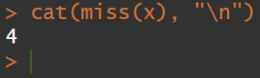

Code:

## EX 12

miss <- function(x){

done <- F

i <- 1

while(!done){

if(i == length(x)){

done <- T

}

if(is.na(x[i]) == T){

done <- T

output <- i

}

i <- i + 1

}

return(output)

}

x <- c(3600, 5000, 12000, NA, 1000, 2000, 600, 7500, 1800, 9000)

cat(miss(x), "\n")

Ex 15: Please plot the BMI curves for ID51-ID60, to the right of ID1-ID10. Please put a title as “Drug group” and make a legend. (please see page 3 of this handout) (2 points)

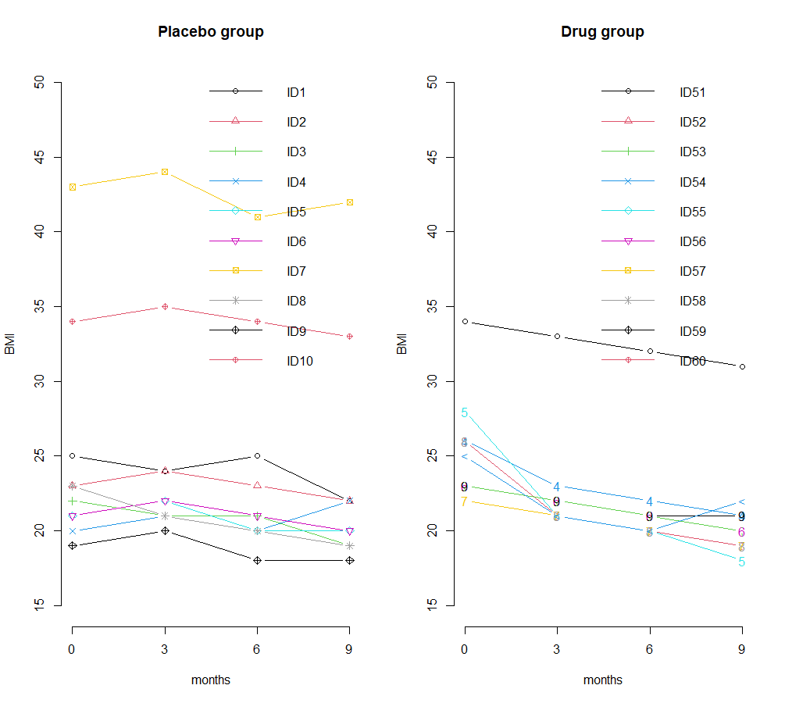

Code:

## EX 15

bmi <- read.csv(file.choose())

x <- seq(0,9,3)

y <- cbind(bmi$BMI0, bmi$BMI1, bmi$BMI2, bmi$BMI3)

par(mfrow = c(1,2))

# plot 1

plot(x,y[1,],type="b",lwd=1,col=1,lty=1,pch=1,ylim=c(15,50),axes = F,xlab="months",ylab="BMI",main="Placebo group")

axis(1, at = x, labels = seq(0,9,3))

axis(2)

for(subj in 2:10){

lines(x,y[subj,],lty=1,lwd=1,col=subj,type="b",pch=subj)

}

legend("topright",bty="n", c("ID1","ID2","ID3","ID4","ID5","ID6","ID7","ID8","ID9","ID10"),lty=1,col=(1:10),lwd=1,pch=(1:10))

# plot 2

plot(x,y[51,],type="b",lwd=1,col=1,lty=1,pch=1,ylim=c(15,50),axes = F,xlab="months",ylab="BMI",main="Drug group")

axis(1, at = x, labels = seq(0,9,3))

axis(2)

for(subj in 52:60){

lines(x,y[subj,],lty=1,lwd=1,col=subj,type="b",pch=subj)

}

legend("topright",bty="n", c("ID51","ID52","ID53","ID54","ID55","ID56","ID57","ID58","ID59","ID60"),lty=1,col=(1:10),lwd=1,pch=(1:10))

Ex S2: Please add percentages to the 3D pie chart on page 4 of this handout. (2 points)

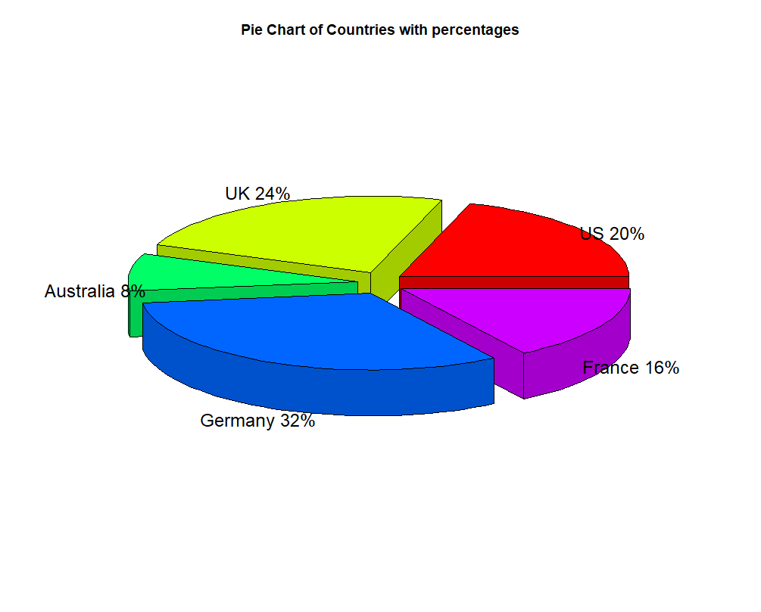

Code:

## EX S2

install.packages("plotrix")

library(plotrix)

subject <- c(10, 12, 4, 16, 8)

lbls <- c("US", "UK", "Australia", "Germany", "France")

pct <- round(subject/sum(subject)*100)

lbls <- paste(lbls, pct) # add percentages to labels

lbls <- paste(lbls,"%",sep="") # ad % to labels

pie3D(subject,labels=lbls,explode=0.1,main="Pie Chart of Countries with percentages")