# Ex S2: There are three rods (rod A, rod B, and rod C) and 20 disks of different sizes, which can slide onto any rod. The 20 disks are placed in ascending order of size on rod A, while the smallest at the top, and the largest at the bottom. Question: Please calculate the minimum number of steps required to move the 20 disks from rod A to rod C, obeying the following rules:

1. Only one disk can be moved in a step.
2. No larger disk can be placed on top of a smaller disk.
3. Please answer this question with a recursive function.

│ │ │

┌┴┐ │ │

┌┴─┴┐ │ │

┌┴───┴┐ │ │

───┴─────┴─────┴───────┴──────

rod A rod B rod C

1048575



Code:

hanoi <- function(n, A, B, C){

if(n == 1){

return(c(A, C))

}else{

return(c(hanoi(n - 1, A, C, B), hanoi(1, A, B, C), hanoi(n - 1, B, A, C)))

}

}

n <- 20

length(hanoi(n, 'A', 'B', 'C')) / 2

# Ex S3: Please use the “apply” command to calculate the medians, maximums, and minimums, of each row and each column. Missing values could be ignored.

x <- matrix(c(3600, 5000, 12000, NA, 1000, 2000, 600, 7500, 1800, 9000,

3600, 4500, 10000, 8500, 3000, 10000, 1000, NA, 1200, 10000,

3800, 5500, 9000, 6000, 6600, 3000, 9600, 6500, 8200, 8000,

5000, 6600, 13000, 4500, 5000, NA, 10600, 9500, 7600, 6000,

6600, 8000, 17000, 3000, 7000, 1000, 12600, 8500, 6000, NA),5,10, byrow = TRUE)

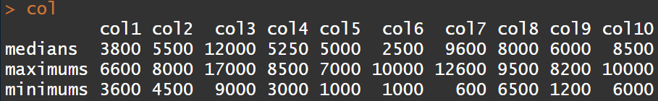

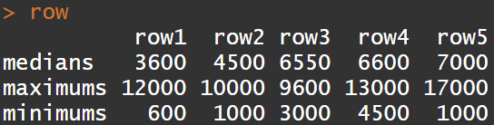

Code:

x <- matrix(c(3600, 5000, 12000, NA, 1000, 2000, 600, 7500, 1800, 9000,

3600, 4500, 10000, 8500, 3000, 10000, 1000, NA, 1200, 10000,

3800, 5500, 9000, 6000, 6600, 3000, 9600, 6500, 8200, 8000,

5000, 6600, 13000, 4500, 5000, NA, 10600, 9500, 7600, 6000,

6600, 8000, 17000, 3000, 7000, 1000, 12600, 8500, 6000, NA),5,10, byrow = TRUE)

col <- apply(x, 2, function(y){c(median(y, na.rm=T), max(y, na.rm=T), min(y, na.rm=T))})

row.names(col) <- c("medians", "maximums", "minimums")

colnames(col) <- c("col1", "col2", "col3", "col4", "col5", "col6", "col7", "col8", "col9", "col10")

col

row <- apply(x, 1, function(y){c(median(y, na.rm=T), max(y, na.rm=T), min(y, na.rm=T))})

row.names(row) <-c("medians", "maximums", "minimums")

colnames(row) <- c("row1", "row2", "row3", "row4", "row5")

row

Ex S8: Please find x, y, and z to satisfy . Please first build a matrix and use the “solve” command.

x=3, y=0, z=1

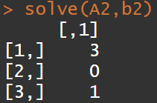

Code:

A2 <- matrix(c(1,1,1,-3,-2,-1,1,3,1),3,3)

b2 <- matrix(c(4,6,4),3,1)

solve(A2,b2)