Ex 17-1：Consider a class with 100 students, if the probability of passing the final exam is *p* and we observe 20 students passing the final exam.

1. Please find the 95% exact confidence interval for *p*.

Requirements: please start from making plots to decide the initial values (2 points), and then define your functions and use our newtonraphson (ftn7, ftn8, etc) (4 points)

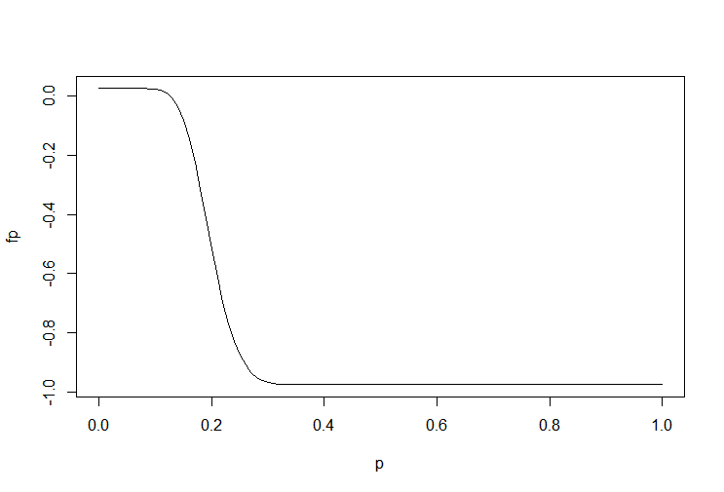initial: 0.1 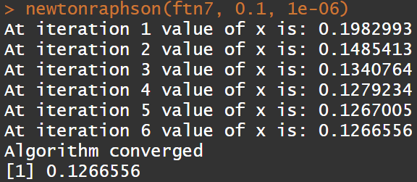

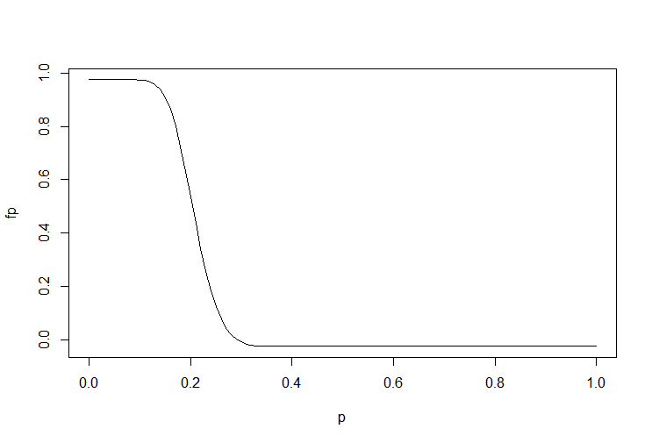initial: 0.2 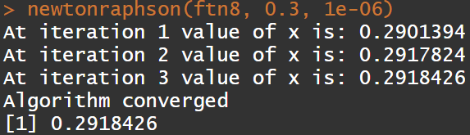

0.1266556

0.2918426

Code:

p <- seq(0, 1, 0.01)

fp <- (-0.975)

for(k in 0:19){

fp <- fp + choose(100,k)*(p^k)*((1-p)^(100-k))

}

plot(p, fp, type="l")

ftn7 <- function(x) {

fx <- (- 0.975)

dfx <- 0

for(i in 0:19){

fx <- fx + choose(100, i) * (x ^ i) * ((1 - x) ^ (100 - i))

dfx <- dfx + choose(100, i) * (i * (x ^ (i - 1)) * ((1 - x) ^ (100 - i)) - (x ^ i)*(100 - i) * ((1 - x) ^ (99 - i)))

}

return(c(fx, dfx))

}

newtonraphson(ftn7, 0.1, 1e-06)

p <- seq(0, 1, 0.01)

fp <- (-0.025)

for(k in 0:20){

fp <- fp + choose(100,k)*(p^k)*((1-p)^(100-k))

}

plot(p, fp, type="l")

ftn8 <- function(x) {

fx <- (-0.025)

dfx <- 0

for(i in 0:20){

fx <- fx + choose(100, i) * (x ^ i) * ((1 - x) ^ (100 - i))

dfx <- dfx + choose(100, i) * (i * (x ^ (i - 1)) * ((1 - x) ^ (100 - i)) - (x ^ i) * (100 - i) * ((1 - x) ^ (99 - i)))

}

return(c(fx, dfx))

}

newtonraphson(ftn8, 0.3, 1e-06)

1. Please find the 95% asymptotic confidence interval for *p*. (2 points)

(asymptotic: based on the central limit theorem)

Requirements: please calculate 95% asymptotic confidence interval based on .





0.1216014

0.2783986

Code:

(20 / 100) - qnorm(0.975) * sqrt((20 / 100) * (1 - (20 / 100)) / 100)

(20 / 100) + qnorm(0.975) * sqrt((20 / 100) * (1 - (20 / 100)) / 100)

**Please note: Using the “binom” package to answer this homework will be scored as 0, although you may use that package to check your own answers.**