**Homework:** (10 points, please pay attention to all the words in this orange box):

Ex 18_1 (5 points in total)：There are 12 complicated crossroads in this city. The numbers of car accidents at the 12 crossroads within 1 month are as follows: 5, 5, 6, 0, 1, 2, 4, 4, 3, 5, 7, 10.

1. Please plot the log-likelihood function for mean number of car accidents within 1 month, . (2 points) (Hint: )

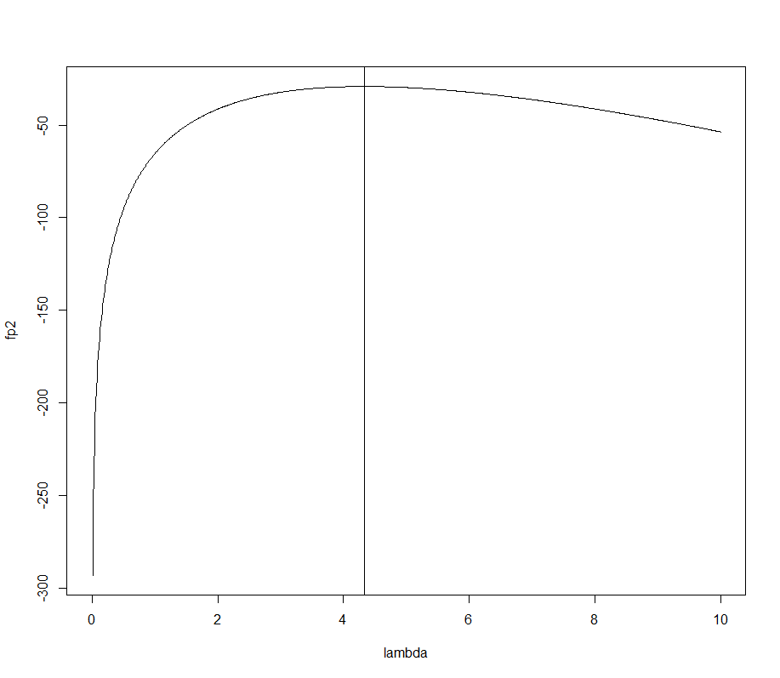

Code:

# loglikelihood function

logLik <- function(X, lambda){

loglikelihood <- 0

for(i in 1:length(X)){

loglikelihood <- loglikelihood + log(exp(- lambda) * (lambda ^ X[i]) / factorial(X[i]))

}

return(loglikelihood)

}

X <- c(5, 5, 6, 0, 1, 2, 4, 4, 3, 5, 7, 10)

lambda <- seq(0, 10, 0.01)

fp2 <- logLik(X, lambda)

plot(lambda, fp2, col=1, type="l")

lambdahat <- sum(X) / length(X) # mean(X)

abline(v=lambdahat)

1. Please solve the maximum likelihood estimate (MLE) of  by the Newton-Raphson method. And mark the MLE on the above plot.

Requirements: please start from making a plot to decide an initial value (1 point), and then define your function and use our newtonraphson (2 points)

initial value =2

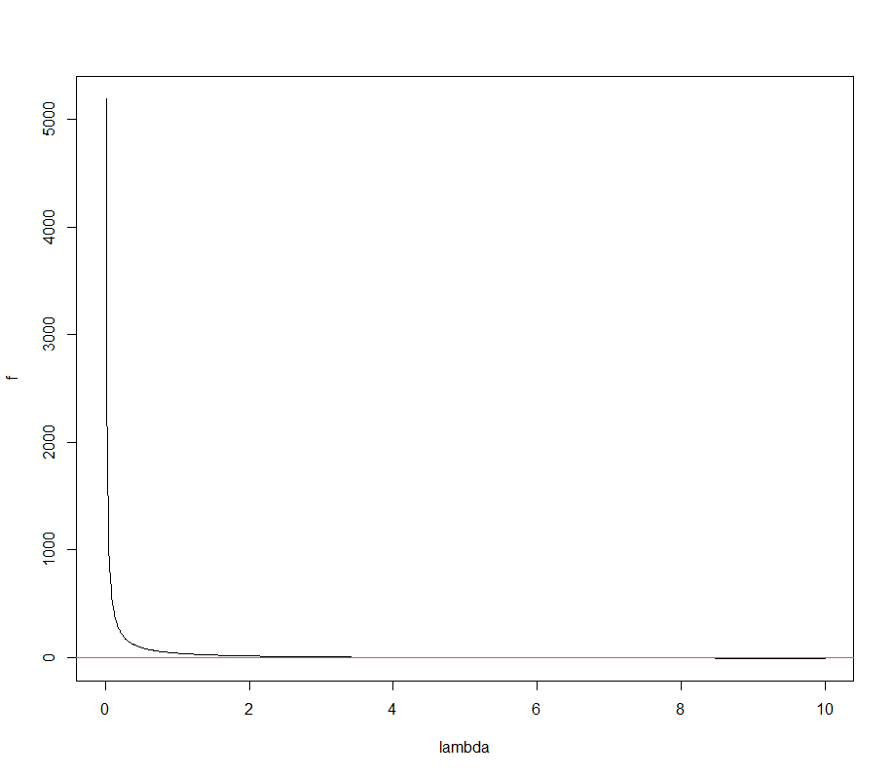 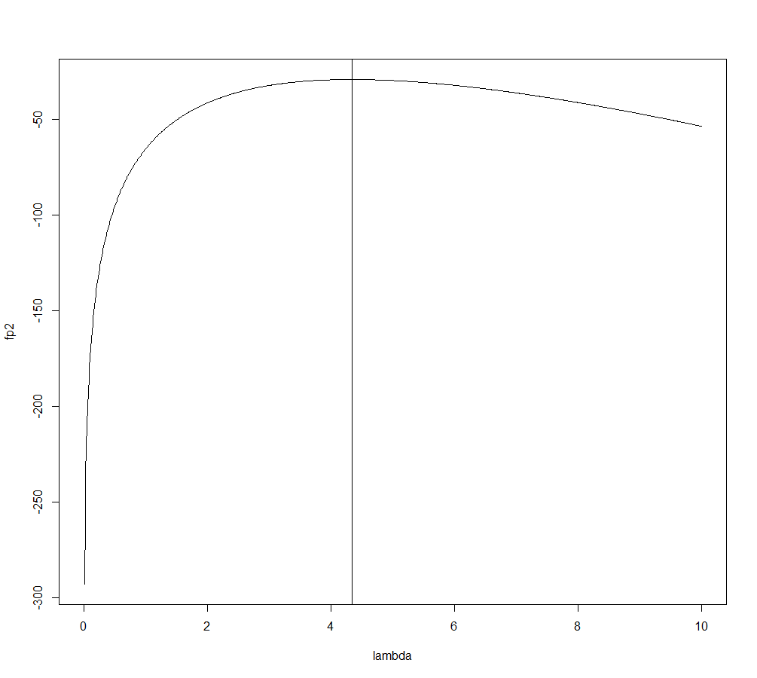

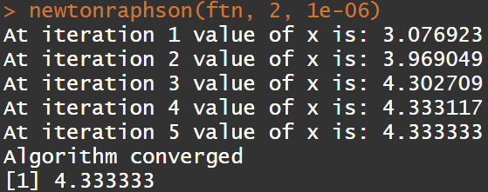

MLE of =4.333333

Code:

newtonraphson <- function(ftn, x0, tol = 1e-9, max.iter = 100) {

x <- x0 # x0: the initial value

fx <- ftn(x)

iter <- 0

while ((abs(fx[1]) > tol) & (iter < max.iter)) {

x <- x - fx[1]/fx[2]

fx <- ftn(x)

iter <- iter + 1

cat("At iteration", iter, "value of x is:", x, "\n")

}

if (abs(fx[1]) > tol) {

cat("Algorithm failed to converge\n")

return(NULL)

} else { # abs(fx[1]) <= tol

cat("Algorithm converged\n")

return(x)

}

}

ftn <- function(lambda){

f <- (-length(X)) + sum(X) / lambda

df <- -(lambda ^ (-2)) * sum(X)

return(c(f, df))

}

X <- c(5, 5, 6, 0, 1, 2, 4, 4, 3, 5, 7, 10)

lambda <- seq(0, 10, 0.01)

f <- (-length(X)) + sum(X) /lambda

plot(lambda, f, type="l")

abline(h=0, col=2)

newtonraphson(ftn, 2, 1e-06)

# plot

X <- c(5, 5, 6, 0, 1, 2, 4, 4, 3, 5, 7, 10)

lambda <- seq(0, 10, 0.01)

fp2 <- logLik(X, lambda)

plot(lambda, fp2, col=1, type="l")

abline(v=4.333333)

Ex S5_1 (5 points in total): Data: BMIrepeated.csv on ceiba (Oct, 15 class material). Please use “SEX”, “AGE”, “Treatment” as predictors, “BMI3” as response variable, to calculate the log likelihood of this model.

**Requirement:** Please start from constructing design matrix (1 point), calculating regression coefficients (1 point), calculating residuals (1 point), estimating  (1 point), and then using this formula:  (1 point).

**Please note:** Using the R built-in function “logLik(model)” to answer this homework will be scored as 0, although you may use it to check your own answer.

Matrix regression coefficients residuals 

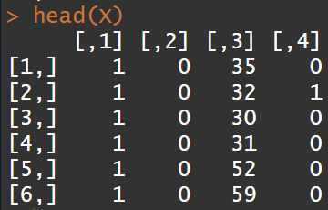 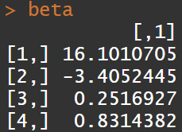 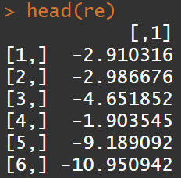 



Code:

data <- read.csv(file.choose())

data$SEX <- ifelse(data$SEX=="M", 1, 0)

X <- cbind(rep(1, length(data$BMI3)), data$Treatment, data$AGE, data$SEX)

head(X)

beta <- solve(t(X) %*% X) %*% t(X) %*% matrix(data$BMI3, ncol=1)

beta

re <- data$BMI3 - X %*% beta

head(re)

sigma2 <- sum(re^2) / length(data$BMI3)

sigma2

-(length(data$BMI3) / 2) * (log(2 * pi) + log(sigma2) + 1)