**Homework:** (8 points, please pay attention to all the words in this orange box):

Ex 20-4：Continue Ex 20-3, because log(Death rate per 100,000 person years) is not linear in Age, it will be more reasonable to recode Age as 11 dummy variables.

rate$Age.f <- factor(rate$Age)

1. Please use the Newton-Raphson method to find the maximum likelihood estimate (MLE) of the regression coefficients of Poisson regression () (4 points)

**Please note:** No need to make a plot for the initial value. Using the R built-in function “glm(Death~Age.f+sex, offset=log(PY/100000), data=rate, family=poisson)” to answer this homework will be scored as 0, although you may use it to check your own answer.

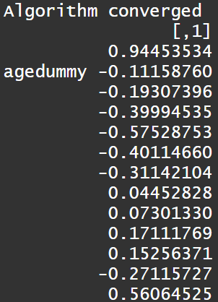

Code:

newtonraphson <- function(ftn, x0, tol = 1e-9, max.iter = 100) {

x <- x0 # x0: the initial value

fx <- ftn(x)

iter <- 0

while ((max(abs(fx[[1]])) > tol) & (iter < max.iter)) {

x <- x - solve(fx[[2]]) %*% fx[[1]]

fx <- ftn(x)

iter <- iter + 1

}

if (max(abs(fx[[1]])) > tol) {

cat('Algorithm failed to converge\n')

return(NULL)

} else { # max(abs(fx[[1]])) <= tol

cat("Algorithm converged\n")

return(x)

}

}

rate <- read.csv(file.choose())

rate$Age.f <- factor(rate$Age)

# dummy

agedummy <- ifelse(rate$Age==2, 1, 0)

for(i in 3:12){

agedummy <- cbind(agedummy, ifelse(rate$Age==i, 1, 0))

}

Y <- rate$Death

X <- cbind(rep(1,length(Y)),agedummy,ifelse(rate$sex=="m",1,0))

ftn <- function(betacoef){

mu <- exp(X %*% betacoef + log(rate$PY / 100000))

gradient <- t(X) %*% (Y - mu)

Hessian <- -t(X) %*% diag(c(mu),length(Y)) %*% X

logL <- sum(-mu + Y * log(mu) - log(factorial(Y)))

return(list(gradient, Hessian,logL))

}

newtonraphson(ftn,c(0,0,0,0,0,0,0,0,0,0,0,0,0))

1. Please find the variance-covariance matrix for  (2 points)

**Please note:** Using the R built-in function “vcov(model)” to answer this homework will be scored as 0, although you may use it to check your own answer.

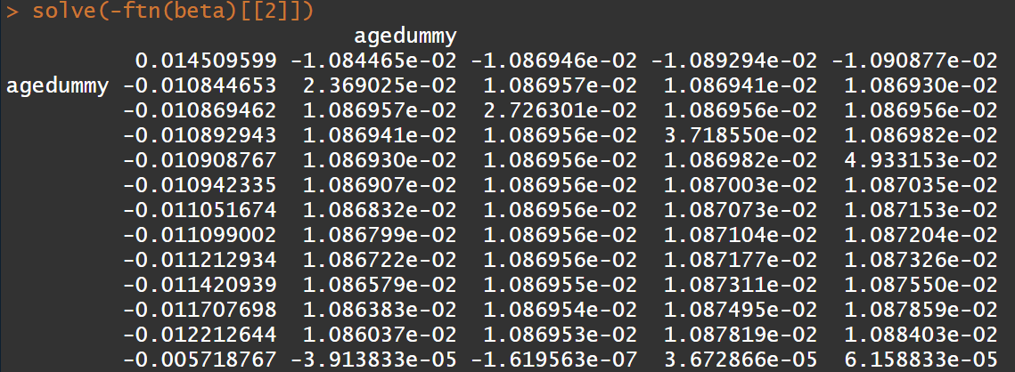

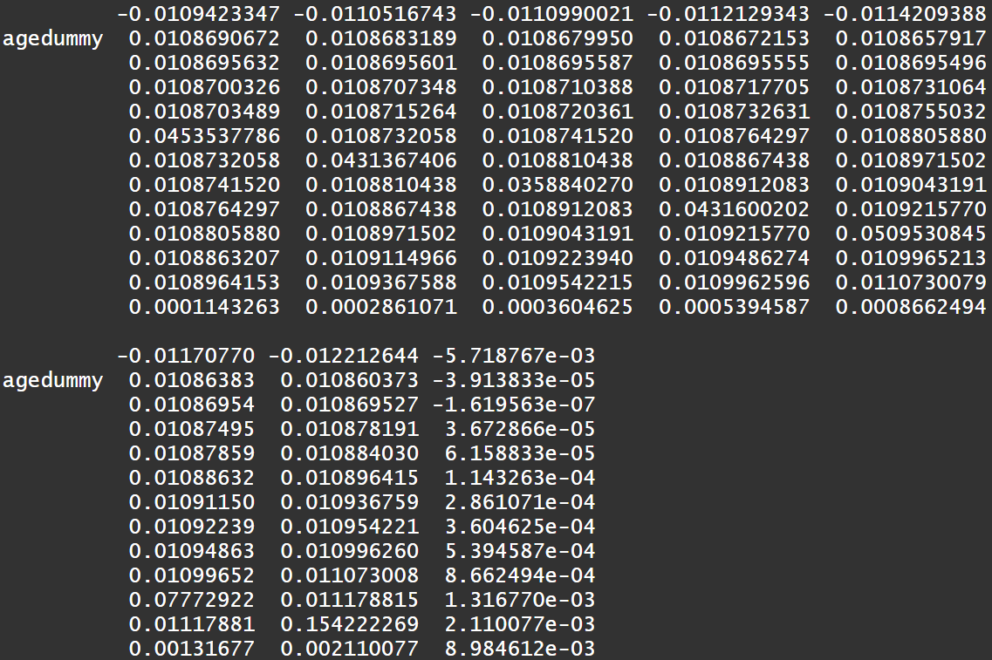

Code:

beta <- newtonraphson(ftn,c(0,0,0,0,0,0,0,0,0,0,0,0,0))

solve(-ftn(beta)[[2]])

1. Please find the log likelihood at  (2 points)

**Please note:** Using the R built-in function “logLik(model)” to answer this homework will be scored as 0, although you may use it to check your own answer.



Code:

ftn(beta)[[3]]