**74 位疑似咽喉部胃酸逆流(laryngopharyngeal reflux; LPR)患者接受氫離子幫浦阻斷劑治療的資料**

|  |  |
| --- | --- |
| 治療前的資料 | Proton pump inhibitor 治療後兩個月 |

RSI score ≥13 and RFS ≥7 were indicated to be positive for LPR.

Age

Gender

BMI

Reflux symptoms index (病人自評)

RSI- 9題 (each item 0-5)

Maximal 45, normal <13

Reflux symptoms index (病人自評)

RSI- 9題 (each item 0-5)

Reflux Finding Score (內視鏡檢查第一位醫師評分)

RFS- 8題 maximal score =26, normal<7 (paper)

Reflux Finding Score (內視鏡檢查第一位醫師評分)

RFS- 8題 maximal score =26, normal<7 (paper)

Reflux Finding Score (內視鏡檢查第二位醫師評分)

RFS- 8題 maximal score =26, normal<7 (paper)

Reflux Finding Score (內視鏡檢查第二位醫師評分)

RFS- 8題 maximal score =26, normal<7 (paper)

如何以治療前初診的資料建立一個model predicting proton pump inhibitor treatment response (以RSI進步為主) ?

RFS 的 interrater reliability如何?

Reflux Symptoms Index



Belafsky, P.C., G.N. Postma, and J.A. Koufman,

Validity and reliability of the reflux symptom index (RSI).

J Voice, 2002. 16(2): p. 274-7

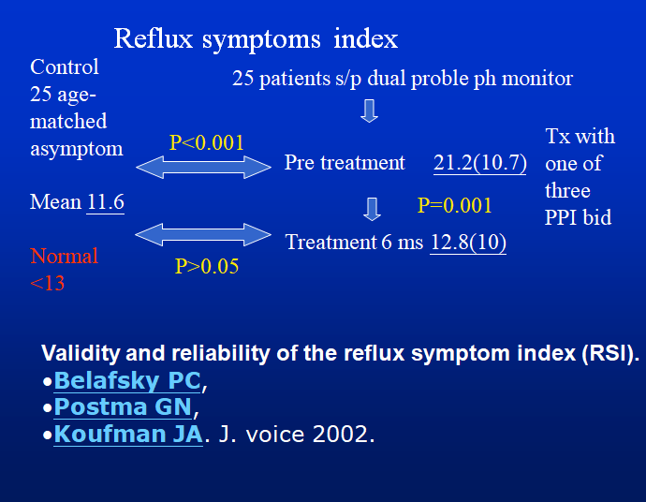

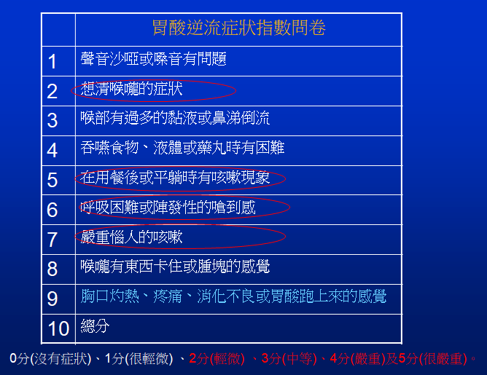

Reflux finding score

Subglottic edema = SE (0,2)

Ventricular = V (0,2,4)

Erythema/hyperemia = E/H (0,2,4)

Vocal fold edema = VFE (1,2,3,4)

Diffuse laryngeal edema = DLE (1,2,3,4)

Posterior commissure hypertrophy = PCH (1,2,3,4)

Granuloma/granulation tissue = G/GT (0,2)

Thick endolaryngeal mucus = TEM (0,2)

