SKYRECON
AI Powered Drone Intelligence Platform
â”€â”€â”€â”€â”€â”€â”€â”€â”€â”€â”€â”€â”€â”€â”€â”€â”€â”€â”€â”€â”€â”€â”€â”€â”€â”€â”€â”€â”€â”€â”€â”€â”€â”€â”€â”€â”€â”€â”€â”€â”€â”€â”€â”€â”€â”€â”€â”€â”€â”€â”€â”€â”€â”€â”€â”€â”€â”€â”€â”€â”€â”€â”€â”€â”€â”€â”€â”€â”€â”€â”€â”€â”€â”€â”€â”€â”€â”€â”€â”€

Mapping & Survey Report

Project Information
Project Name | trees
Location | 22.2531°N, 84.9011°E
Drone Model | DJI Mavic 3 Pro
Detection Mode | STANDARD
Analysis Date | 04 Jun 2026, 12:05
Processing Time | 1817.0 seconds
Status | COMPLETED
Description | Aerial monitoring of campus green cover, infrastructure & roadways.||PROGRESS||98

Detection Summary
Unique Objects Tracked: 149 | Categories: 1 | Area Covered: 17282.4 mÂ² | Coverage: 100.0%

Category Breakdown
Category | Count | % of Total
Trees | 149 | 100.0%

Top Detections (by Confidence)
Label | Category | Confidence | Timestamp
tree (93%) first seen T=37.0s | Trees | 93% | 37.0s
tree (93%) first seen T=42.0s | Trees | 93% | 42.0s
tree (93%) first seen T=40.0s | Trees | 93% | 40.0s
tree (93%) first seen T=25.0s | Trees | 93% | 25.0s
tree (93%) first seen T=38.0s | Trees | 93% | 38.0s
tree (93%) first seen T=59.0s | Trees | 93% | 59.0s
tree (93%) first seen T=23.0s | Trees | 93% | 23.0s
tree (93%) first seen T=39.0s | Trees | 93% | 39.0s
tree (93%) first seen T=38.0s | Trees | 93% | 38.0s
tree (93%) first seen T=26.0s | Trees | 93% | 26.0s
tree (92%) first seen T=21.0s | Trees | 92% | 21.0s
tree (90%) first seen T=10.0s | Trees | 90% | 10.0s
tree (89%) first seen T=27.0s | Trees | 89% | 27.0s
tree (86%) first seen T=18.0s | Trees | 86% | 18.0s
tree (85%) first seen T=8.0s | Trees | 85% | 8.0s
tree (84%) first seen T=31.0s | Trees | 84% | 31.0s
tree (84%) first seen T=19.0s | Trees | 84% | 19.0s
tree (83%) first seen T=76.0s | Trees | 83% | 76.0s
tree (82%) first seen T=20.0s | Trees | 82% | 20.0s
tree (82%) first seen T=29.0s | Trees | 82% | 29.0s

AI Planning Recommendations
Analysis detected 149 objects across 1 categories. Total covered area: 17282.4 mÂ² (100.0%). Available area: 0.0 mÂ² (0.0%). Vegetation: 149 plant/tree instances detected. Recommend planting in 0.0 mÂ² of open soil.

Detection Screenshots
Annotated frames captured during AI analysis. Timestamp on each image indicates exact position in the video.
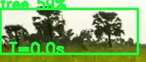
tree (59%) first seen T=0.0s | Confidence: 59% | Timestamp: T=0.0s

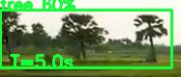
tree (60%) first seen T=5.0s | Confidence: 60% | Timestamp: T=5.0s

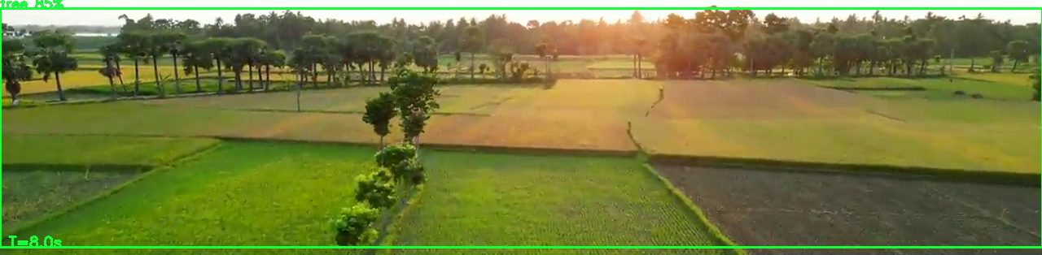
tree (85%) first seen T=8.0s | Confidence: 85% | Timestamp: T=8.0s

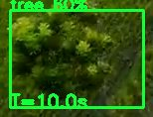
tree (60%) first seen T=10.0s | Confidence: 60% | Timestamp: T=10.0s

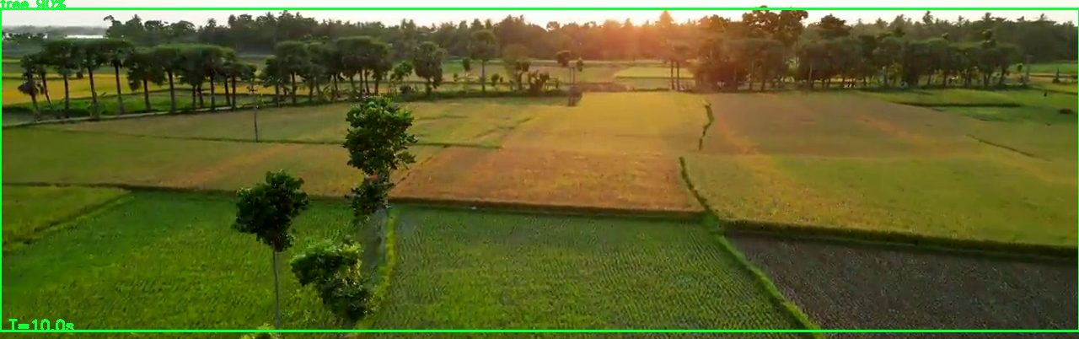
tree (90%) first seen T=10.0s | Confidence: 90% | Timestamp: T=10.0s

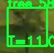
tree (58%) first seen T=11.0s | Confidence: 58% | Timestamp: T=11.0s

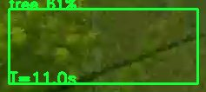
tree (61%) first seen T=11.0s | Confidence: 61% | Timestamp: T=11.0s

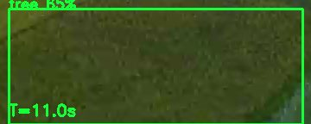
tree (65%) first seen T=11.0s | Confidence: 65% | Timestamp: T=11.0s


tree (59%) first seen T=11.0s | Confidence: 59% | Timestamp: T=11.0s

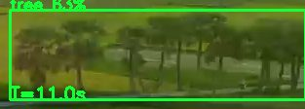
tree (63%) first seen T=11.0s | Confidence: 63% | Timestamp: T=11.0s

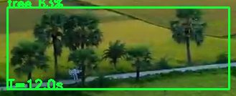
tree (63%) first seen T=12.0s | Confidence: 63% | Timestamp: T=12.0s

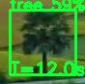
tree (59%) first seen T=12.0s | Confidence: 59% | Timestamp: T=12.0s


tree (59%) first seen T=12.0s | Confidence: 59% | Timestamp: T=12.0s


tree (63%) first seen T=12.0s | Confidence: 63% | Timestamp: T=12.0s

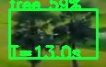
tree (59%) first seen T=13.0s | Confidence: 59% | Timestamp: T=13.0s

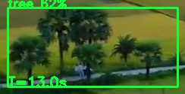
tree (62%) first seen T=13.0s | Confidence: 62% | Timestamp: T=13.0s


tree (62%) first seen T=13.0s | Confidence: 62% | Timestamp: T=13.0s


tree (59%) first seen T=13.0s | Confidence: 59% | Timestamp: T=13.0s

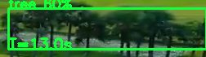
tree (60%) first seen T=13.0s | Confidence: 60% | Timestamp: T=13.0s

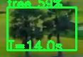
tree (59%) first seen T=14.0s | Confidence: 59% | Timestamp: T=14.0s

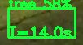
tree (58%) first seen T=14.0s | Confidence: 58% | Timestamp: T=14.0s

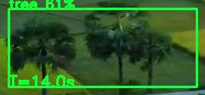
tree (61%) first seen T=14.0s | Confidence: 61% | Timestamp: T=14.0s

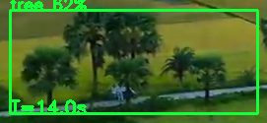
tree (62%) first seen T=14.0s | Confidence: 62% | Timestamp: T=14.0s


tree (59%) first seen T=14.0s | Confidence: 59% | Timestamp: T=14.0s


tree (59%) first seen T=14.0s | Confidence: 59% | Timestamp: T=14.0s

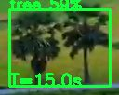
tree (59%) first seen T=15.0s | Confidence: 59% | Timestamp: T=15.0s

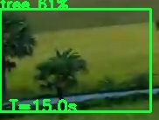
tree (61%) first seen T=15.0s | Confidence: 61% | Timestamp: T=15.0s

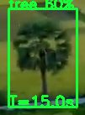
tree (60%) first seen T=15.0s | Confidence: 60% | Timestamp: T=15.0s


tree (59%) first seen T=15.0s | Confidence: 59% | Timestamp: T=15.0s


tree (59%) first seen T=15.0s | Confidence: 59% | Timestamp: T=15.0s

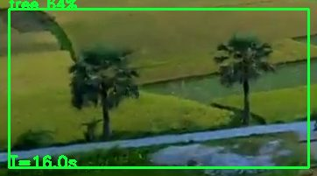
tree (64%) first seen T=16.0s | Confidence: 64% | Timestamp: T=16.0s

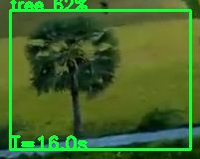
tree (62%) first seen T=16.0s | Confidence: 62% | Timestamp: T=16.0s

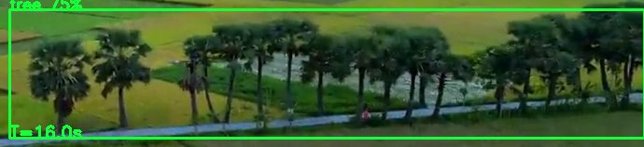
tree (75%) first seen T=16.0s | Confidence: 75% | Timestamp: T=16.0s

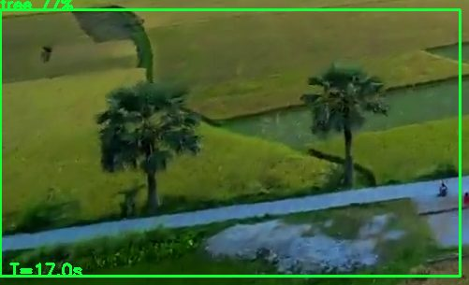
tree (77%) first seen T=17.0s | Confidence: 77% | Timestamp: T=17.0s

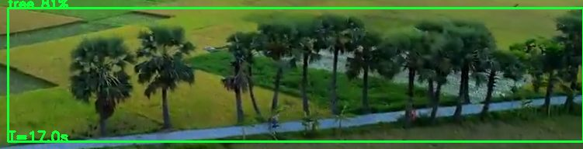
tree (81%) first seen T=17.0s | Confidence: 81% | Timestamp: T=17.0s

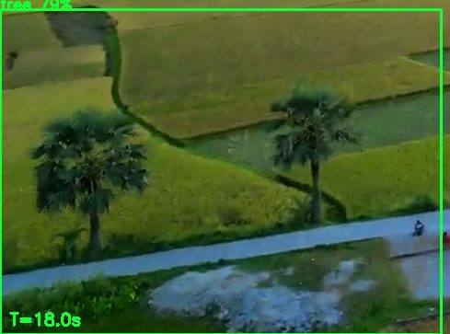
tree (79%) first seen T=18.0s | Confidence: 79% | Timestamp: T=18.0s

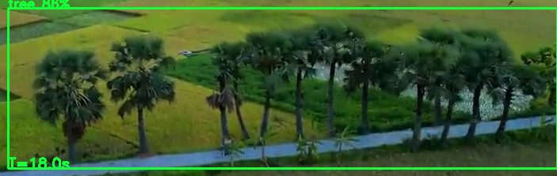
tree (86%) first seen T=18.0s | Confidence: 86% | Timestamp: T=18.0s

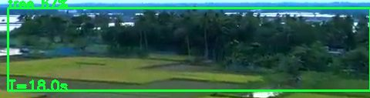
tree (67%) first seen T=18.0s | Confidence: 67% | Timestamp: T=18.0s

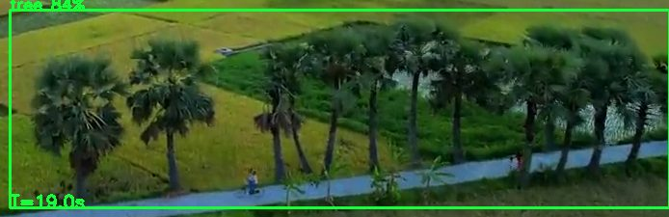
tree (84%) first seen T=19.0s | Confidence: 84% | Timestamp: T=19.0s


tree (59%) first seen T=19.0s | Confidence: 59% | Timestamp: T=19.0s

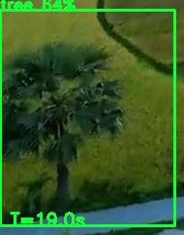
tree (64%) first seen T=19.0s | Confidence: 64% | Timestamp: T=19.0s

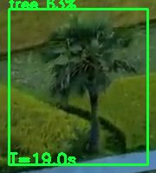
tree (63%) first seen T=19.0s | Confidence: 63% | Timestamp: T=19.0s

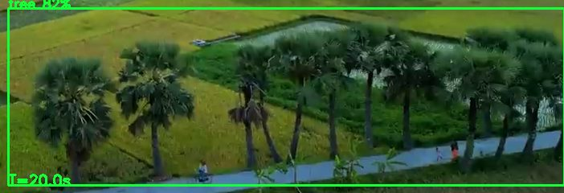
tree (82%) first seen T=20.0s | Confidence: 82% | Timestamp: T=20.0s

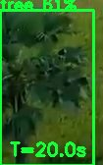
tree (61%) first seen T=20.0s | Confidence: 61% | Timestamp: T=20.0s

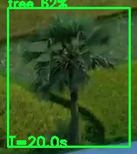
tree (62%) first seen T=20.0s | Confidence: 62% | Timestamp: T=20.0s

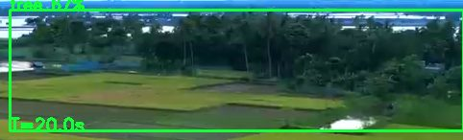
tree (67%) first seen T=20.0s | Confidence: 67% | Timestamp: T=20.0s

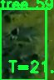
tree (59%) first seen T=21.0s | Confidence: 59% | Timestamp: T=21.0s

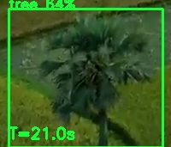
tree (64%) first seen T=21.0s | Confidence: 64% | Timestamp: T=21.0s


tree (58%) first seen T=21.0s | Confidence: 58% | Timestamp: T=21.0s

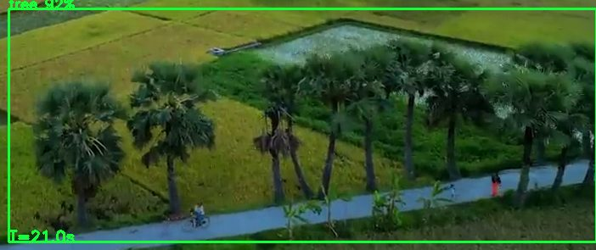
tree (92%) first seen T=21.0s | Confidence: 92% | Timestamp: T=21.0s

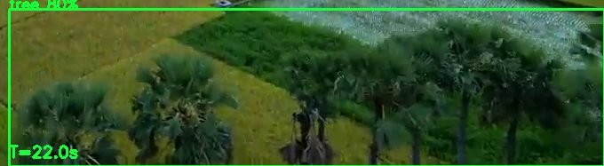
tree (80%) first seen T=22.0s | Confidence: 80% | Timestamp: T=22.0s

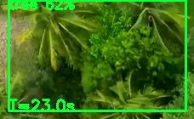
tree (62%) first seen T=23.0s | Confidence: 62% | Timestamp: T=23.0s

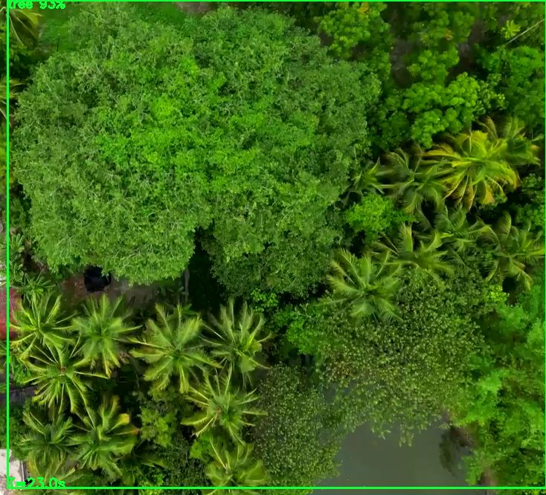
tree (93%) first seen T=23.0s | Confidence: 93% | Timestamp: T=23.0s


tree (62%) first seen T=23.0s | Confidence: 62% | Timestamp: T=23.0s

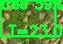
tree (59%) first seen T=23.0s | Confidence: 59% | Timestamp: T=23.0s


tree (59%) first seen T=23.0s | Confidence: 59% | Timestamp: T=23.0s


tree (58%) first seen T=24.0s | Confidence: 58% | Timestamp: T=24.0s

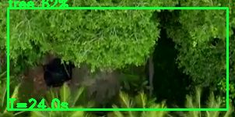
tree (62%) first seen T=24.0s | Confidence: 62% | Timestamp: T=24.0s

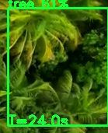
tree (61%) first seen T=24.0s | Confidence: 61% | Timestamp: T=24.0s


tree (59%) first seen T=24.0s | Confidence: 59% | Timestamp: T=24.0s


tree (58%) first seen T=25.0s | Confidence: 58% | Timestamp: T=25.0s

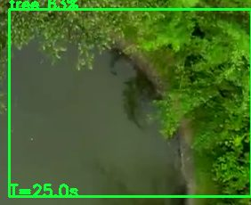
tree (63%) first seen T=25.0s | Confidence: 63% | Timestamp: T=25.0s


tree (93%) first seen T=25.0s | Confidence: 93% | Timestamp: T=25.0s

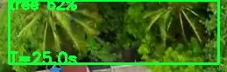
tree (62%) first seen T=25.0s | Confidence: 62% | Timestamp: T=25.0s

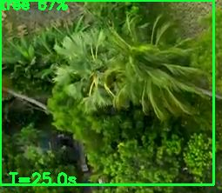
tree (67%) first seen T=25.0s | Confidence: 67% | Timestamp: T=25.0s

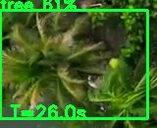
tree (61%) first seen T=26.0s | Confidence: 61% | Timestamp: T=26.0s

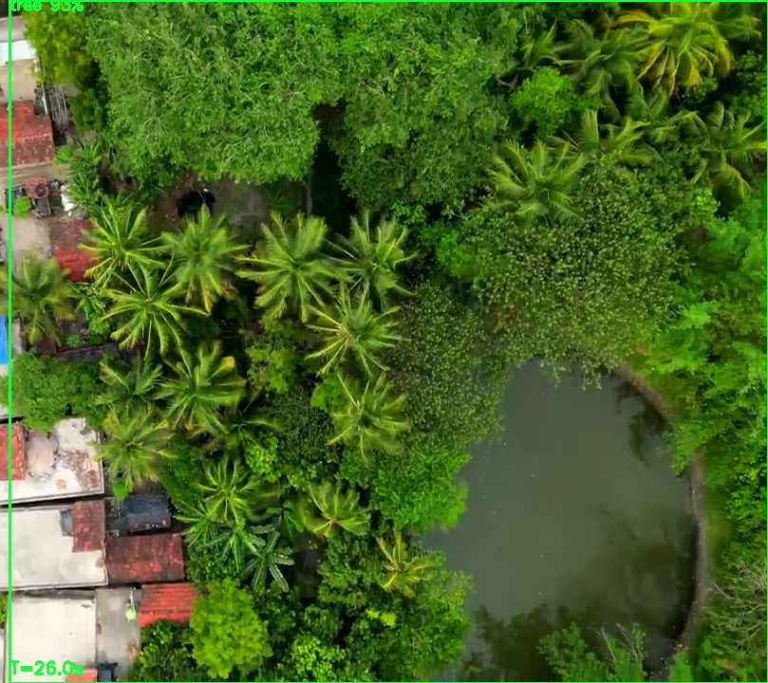
tree (93%) first seen T=26.0s | Confidence: 93% | Timestamp: T=26.0s


tree (59%) first seen T=26.0s | Confidence: 59% | Timestamp: T=26.0s

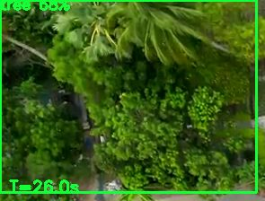
tree (68%) first seen T=26.0s | Confidence: 68% | Timestamp: T=26.0s

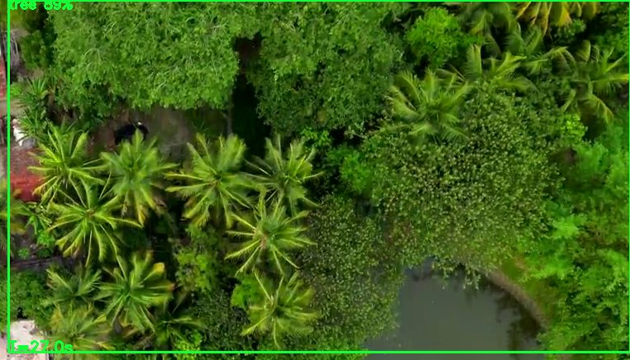
tree (89%) first seen T=27.0s | Confidence: 89% | Timestamp: T=27.0s

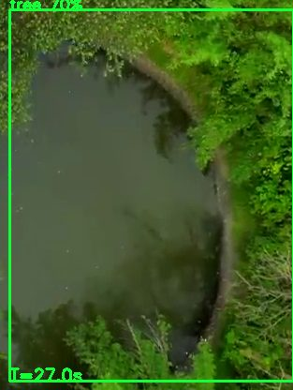
tree (70%) first seen T=27.0s | Confidence: 70% | Timestamp: T=27.0s


tree (58%) first seen T=27.0s | Confidence: 58% | Timestamp: T=27.0s


tree (60%) first seen T=27.0s | Confidence: 60% | Timestamp: T=27.0s

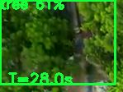
tree (61%) first seen T=28.0s | Confidence: 61% | Timestamp: T=28.0s


tree (59%) first seen T=28.0s | Confidence: 59% | Timestamp: T=28.0s

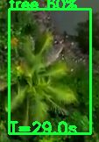
tree (60%) first seen T=29.0s | Confidence: 60% | Timestamp: T=29.0s

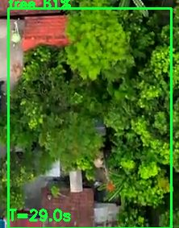
tree (61%) first seen T=29.0s | Confidence: 61% | Timestamp: T=29.0s

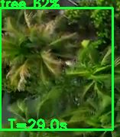
tree (62%) first seen T=29.0s | Confidence: 62% | Timestamp: T=29.0s

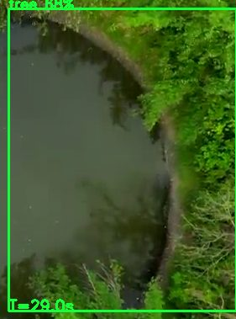
tree (68%) first seen T=29.0s | Confidence: 68% | Timestamp: T=29.0s

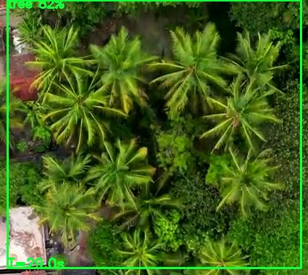
tree (82%) first seen T=29.0s | Confidence: 82% | Timestamp: T=29.0s


tree (58%) first seen T=30.0s | Confidence: 58% | Timestamp: T=30.0s

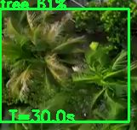
tree (61%) first seen T=30.0s | Confidence: 61% | Timestamp: T=30.0s


tree (61%) first seen T=30.0s | Confidence: 61% | Timestamp: T=30.0s

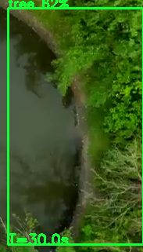
tree (62%) first seen T=30.0s | Confidence: 62% | Timestamp: T=30.0s

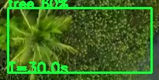
tree (60%) first seen T=30.0s | Confidence: 60% | Timestamp: T=30.0s

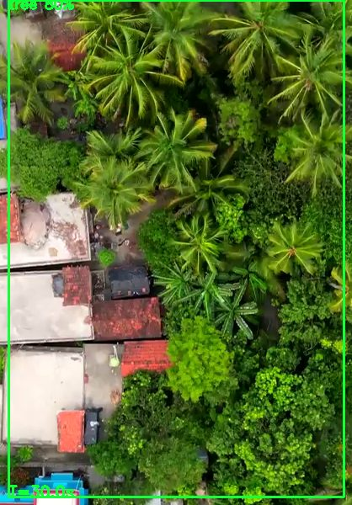
tree (80%) first seen T=30.0s | Confidence: 80% | Timestamp: T=30.0s

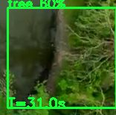
tree (60%) first seen T=31.0s | Confidence: 60% | Timestamp: T=31.0s


tree (60%) first seen T=31.0s | Confidence: 60% | Timestamp: T=31.0s

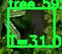
tree (59%) first seen T=31.0s | Confidence: 59% | Timestamp: T=31.0s


tree (58%) first seen T=31.0s | Confidence: 58% | Timestamp: T=31.0s


tree (58%) first seen T=31.0s | Confidence: 58% | Timestamp: T=31.0s

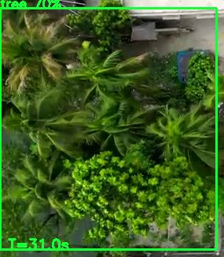
tree (70%) first seen T=31.0s | Confidence: 70% | Timestamp: T=31.0s

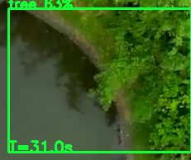
tree (63%) first seen T=31.0s | Confidence: 63% | Timestamp: T=31.0s

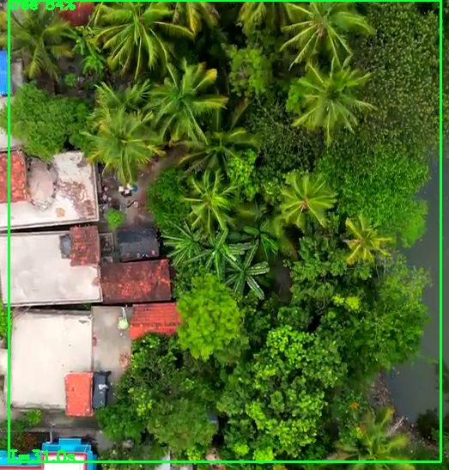
tree (84%) first seen T=31.0s | Confidence: 84% | Timestamp: T=31.0s

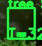
tree (58%) first seen T=32.0s | Confidence: 58% | Timestamp: T=32.0s

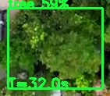
tree (59%) first seen T=32.0s | Confidence: 59% | Timestamp: T=32.0s


tree (59%) first seen T=32.0s | Confidence: 59% | Timestamp: T=32.0s


tree (59%) first seen T=32.0s | Confidence: 59% | Timestamp: T=32.0s

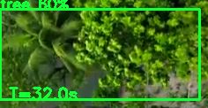
tree (60%) first seen T=32.0s | Confidence: 60% | Timestamp: T=32.0s

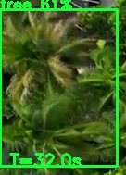
tree (61%) first seen T=32.0s | Confidence: 61% | Timestamp: T=32.0s

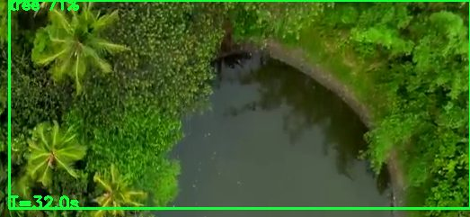
tree (71%) first seen T=32.0s | Confidence: 71% | Timestamp: T=32.0s


tree (68%) first seen T=32.0s | Confidence: 68% | Timestamp: T=32.0s

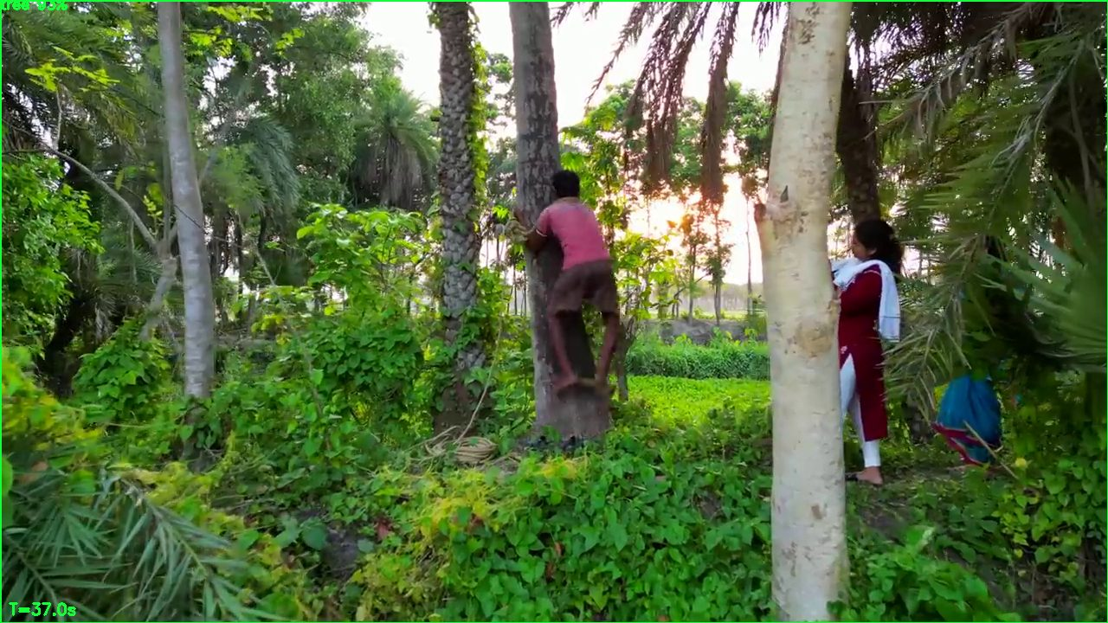
tree (93%) first seen T=37.0s | Confidence: 93% | Timestamp: T=37.0s

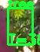
tree (58%) first seen T=38.0s | Confidence: 58% | Timestamp: T=38.0s

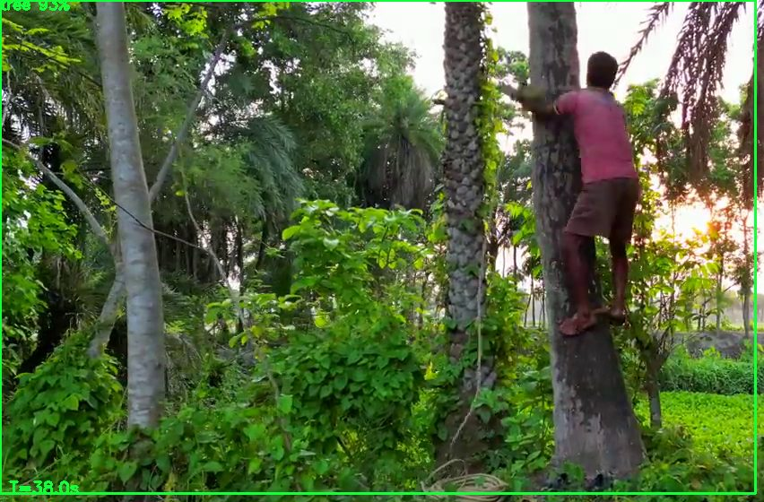
tree (93%) first seen T=38.0s | Confidence: 93% | Timestamp: T=38.0s


tree (93%) first seen T=38.0s | Confidence: 93% | Timestamp: T=38.0s


tree (58%) first seen T=39.0s | Confidence: 58% | Timestamp: T=39.0s

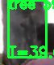
tree (59%) first seen T=39.0s | Confidence: 59% | Timestamp: T=39.0s

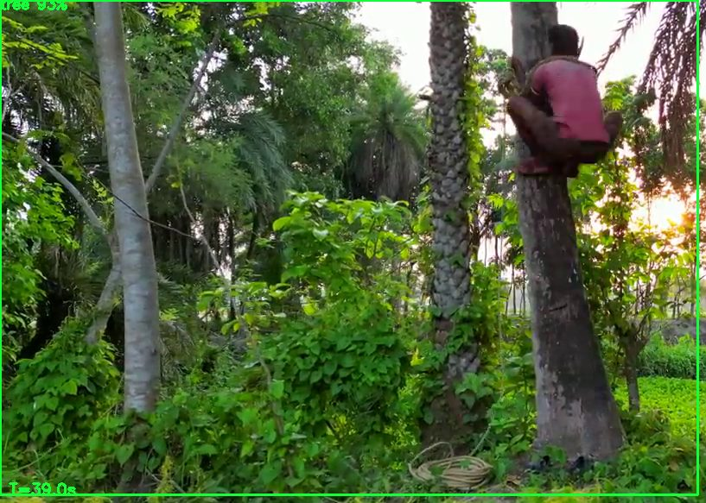
tree (93%) first seen T=39.0s | Confidence: 93% | Timestamp: T=39.0s

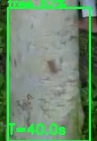
tree (62%) first seen T=40.0s | Confidence: 62% | Timestamp: T=40.0s

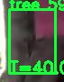
tree (59%) first seen T=40.0s | Confidence: 59% | Timestamp: T=40.0s

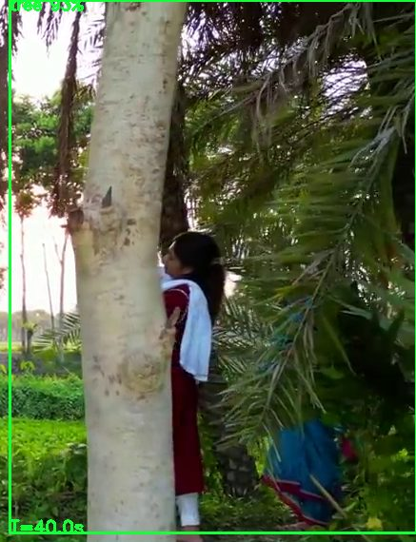
tree (93%) first seen T=40.0s | Confidence: 93% | Timestamp: T=40.0s

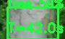
tree (59%) first seen T=42.0s | Confidence: 59% | Timestamp: T=42.0s

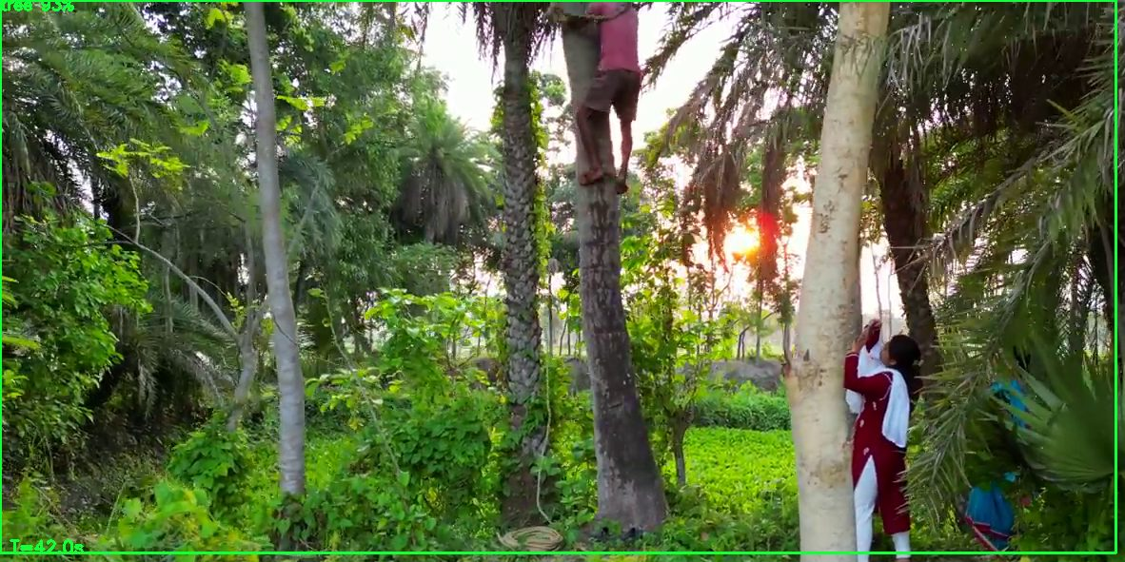
tree (93%) first seen T=42.0s | Confidence: 93% | Timestamp: T=42.0s

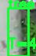
tree (58%) first seen T=44.0s | Confidence: 58% | Timestamp: T=44.0s


tree (58%) first seen T=45.0s | Confidence: 58% | Timestamp: T=45.0s

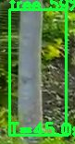
tree (59%) first seen T=45.0s | Confidence: 59% | Timestamp: T=45.0s

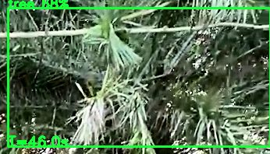
tree (68%) first seen T=46.0s | Confidence: 68% | Timestamp: T=46.0s

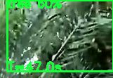
tree (60%) first seen T=47.0s | Confidence: 60% | Timestamp: T=47.0s


tree (58%) first seen T=48.0s | Confidence: 58% | Timestamp: T=48.0s

tree (58%) first seen T=50.0s | Confidence: 58% | Timestamp: T=50.0s

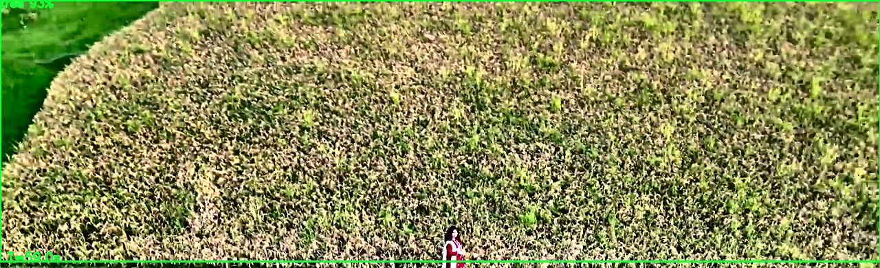
tree (93%) first seen T=59.0s | Confidence: 93% | Timestamp: T=59.0s

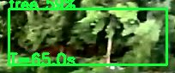
tree (59%) first seen T=65.0s | Confidence: 59% | Timestamp: T=65.0s


tree (58%) first seen T=66.0s | Confidence: 58% | Timestamp: T=66.0s


tree (59%) first seen T=67.0s | Confidence: 59% | Timestamp: T=67.0s


tree (58%) first seen T=68.0s | Confidence: 58% | Timestamp: T=68.0s

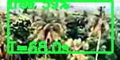
tree (59%) first seen T=68.0s | Confidence: 59% | Timestamp: T=68.0s

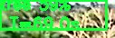
tree (59%) first seen T=69.0s | Confidence: 59% | Timestamp: T=69.0s

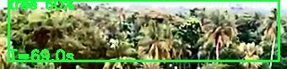
tree (60%) first seen T=69.0s | Confidence: 60% | Timestamp: T=69.0s

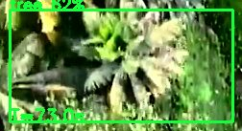
tree (62%) first seen T=73.0s | Confidence: 62% | Timestamp: T=73.0s


tree (59%) first seen T=73.0s | Confidence: 59% | Timestamp: T=73.0s


tree (59%) first seen T=73.0s | Confidence: 59% | Timestamp: T=73.0s


tree (59%) first seen T=76.0s | Confidence: 59% | Timestamp: T=76.0s

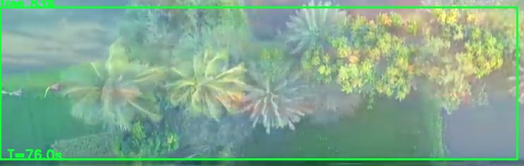
tree (83%) first seen T=76.0s | Confidence: 83% | Timestamp: T=76.0s

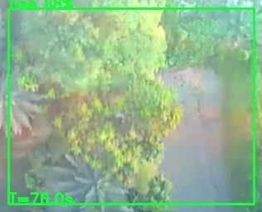
tree (68%) first seen T=76.0s | Confidence: 68% | Timestamp: T=76.0s


tree (59%) first seen T=76.0s | Confidence: 59% | Timestamp: T=76.0s


tree (59%) first seen T=80.0s | Confidence: 59% | Timestamp: T=80.0s

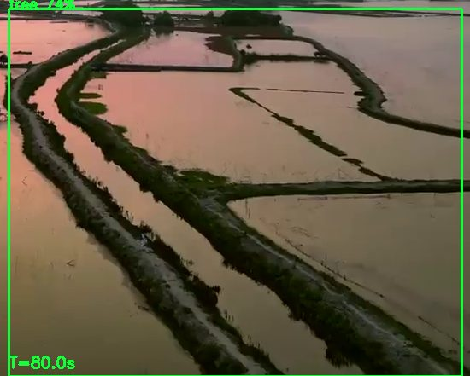
tree (74%) first seen T=80.0s | Confidence: 74% | Timestamp: T=80.0s


tree (59%) first seen T=80.0s | Confidence: 59% | Timestamp: T=80.0s


tree (59%) first seen T=80.0s | Confidence: 59% | Timestamp: T=80.0s

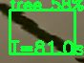
tree (58%) first seen T=81.0s | Confidence: 58% | Timestamp: T=81.0s

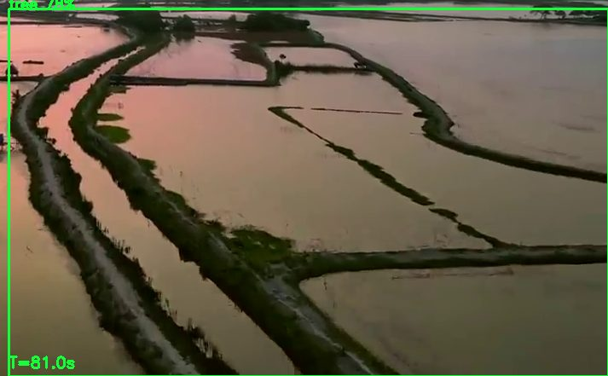
tree (78%) first seen T=81.0s | Confidence: 78% | Timestamp: T=81.0s

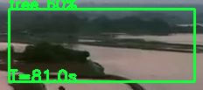
tree (60%) first seen T=81.0s | Confidence: 60% | Timestamp: T=81.0s


tree (59%) first seen T=81.0s | Confidence: 59% | Timestamp: T=81.0s


tree (59%) first seen T=81.0s | Confidence: 59% | Timestamp: T=81.0s

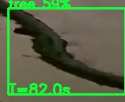
tree (59%) first seen T=82.0s | Confidence: 59% | Timestamp: T=82.0s

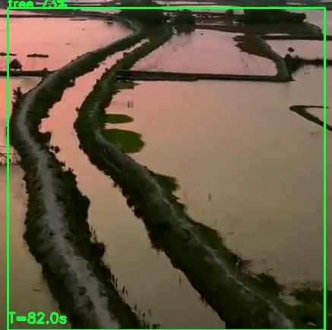
tree (73%) first seen T=82.0s | Confidence: 73% | Timestamp: T=82.0s


tree (58%) first seen T=82.0s | Confidence: 58% | Timestamp: T=82.0s


tree (58%) first seen T=82.0s | Confidence: 58% | Timestamp: T=82.0s

â”€â”€â”€â”€â”€â”€â”€â”€â”€â”€â”€â”€â”€â”€â”€â”€â”€â”€â”€â”€â”€â”€â”€â”€â”€â”€â”€â”€â”€â”€â”€â”€â”€â”€â”€â”€â”€â”€â”€â”€â”€â”€â”€â”€â”€â”€â”€â”€â”€â”€â”€â”€â”€â”€â”€â”€â”€â”€â”€â”€â”€â”€â”€â”€â”€â”€â”€â”€â”€â”€â”€â”€â”€â”€â”€â”€â”€â”€â”€â”€
Generated by SkyRecon AI Drone Intelligence Platform â€¢ 04 Jun 2026 12:40

