**Project**: **ATLIQ Hardware Sales Insights**

**Problem Statement**: Our case study is based on a computer hardware business which is facing challenges in a dynamically changing market. The sales director decides to invest in a data analysis project, where he would like to build a power BI dashboard that can give him real time sales insights to assist in tracking sales and performance in all regions where the business operates.

**Project Planning**: Project has been planned and brainstormed using AIMS Grid

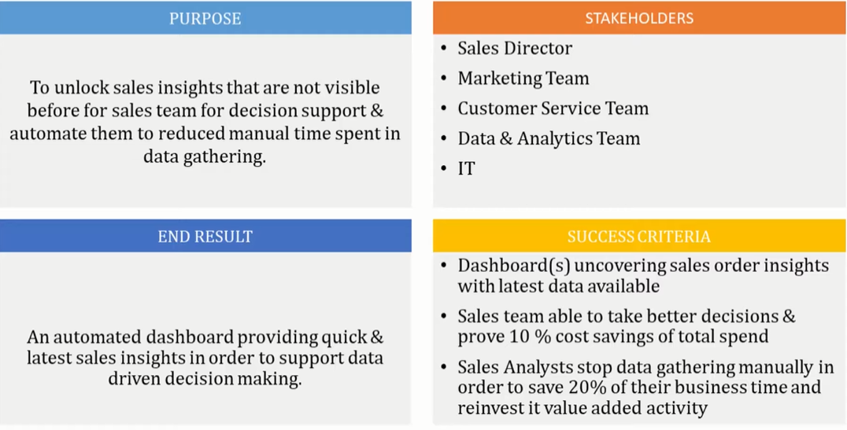

**Methodology:**

Import Sales data into MySQL for explorative analysis

Explored the data using:

* SELECT
* FROM
* WHERE
* COUNT
* DISTINCT
* INNER JOIN
* SUM
* ON

Connected to the MySQL database from PowerBI and imported the Sales data to perform data modelling, cleaning/wrangling, transformation, and visualization.

* Applied filtering to remove outliers
* Created conditional column to convert and standardize currencies

Generated a Dashboard as per project objectives

* Verified figures and data by cross checking the MySQL database using queries