# Profile



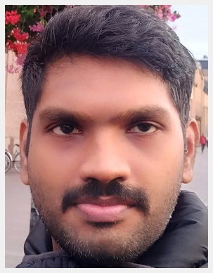

**Shibi Sasidharan**

Technical Architect

**Details**

**Skills**

Angular

JavaScript

HTML & CSS

React JS

Node.js

Docker

Git

SQL

C#

ASP.net

MongoDB

MySql

WPF

AWS

Azure

**Languages**

English

Malayalam

Hindi

**Hobbies**

Driving, Travelling

+91 – 9446451717

+

shibisasidharan@gmail.com

An energetic individual who cherish an ambition to add value to the organization with focus on the client and quality of work delivered. Having 11.5 years of web application development experience with React / Angular, Node JS, C# and ASP.NET. I ensure proficiency in the complete Web development life cycle development & maintenance in agile (Scrum & Kanban).

**Employment History**

## Technical Architect, Tata Consultancy Services, India

+91 – 8848197288

+

December 2019 — PRESENT

* Worked as an onsite lead (Helsinki, Finland) for a digital transformation program.
* Working in one of top insurance company in Finland.
* Working on MEAN Stack (Mongo DB, Express, Node JS and Angular).
* Used Azure Kubernetes Services(AKS) for an integrated continuous integration and continuous delivery (CI/CD) and governance.
* Now working as an offshore Technical architect for another digital transformation program for the same organization.

## Technical Lead, Tata Consultancy Services, India

DECEMBER 2015 — DECEMBER 2019

* Working well in a fast-paced and rapidly changing environment.
* Worked on various domains/technologies given below during this stint.
  + - * + Banking and Financial service | Angular JS, HTML & CSS
        + Manufacturing |Angular 2, ASP.NET, C#. .NET core, MS SQL
        + Travel and Tourism| React JS, React-Redux, Redux-Saga
        + Oil and Gas | React JS, React-Redux, Redux-Saga
* Working as an offshore technical lead, team coordinator and mentored junior resources.
* Worked as onsite technical lead and proposed solutions to customer for better user experience

**Senior Software Engineer, QuEST Global, India**

SEPTEMBER 2010 — DECEMBER 2015 (5 YEARS)

* Worked well independently and on a team to solve problems.
* Worked as a senior developer and team coordinator.
* Worked as a full stack developer with good exposure in Angular and React,ASP.NET and C #
* Worked on developing Web APIs using ASP.NET, C# and .Net Core
* Organized and prioritized work to complete assignments in a timely, efficient manner.

## Software Engineer, C-DIT, India

JANUARY 2010 — SEPTEMBER 2010 (8 MONTHS)

* Organized and prioritized work to complete assignments in a timely, efficient manner.
* Worked on service domain in C# and ASP.net for developing official websites for Government of Kerala.
* Prioritize Delivery quality control & ensuring coding standard for bug free delivery.

# Education

## Batchelor of Technology, Muslim Association College Of Engineering, Venjarammoodu

July 2005 — JUNE 2009

Completed full time engineering degree in Computer Science & Engineering (CSE)

## Certification

Azure Az-900 Certified