**Water Quality Analysis Project Design and Innovation**

|  |  |
| --- | --- |
| **Date** | **04-10-2023** |
| **Team ID** | **3933** |
| **Project Name** | **Water Quality Analysis** |

**Table of Contents**

|  |  |
| --- | --- |
| 1 | Introduction |
| 2 | Water Quality Parameters |
| 2.1 | Types of water quality parameters |
| 3 | Anomaly Detection Techniques |
| 3.1 | Statistical Methods |
| 3.2 | Machine Learning Approaches |
| 4 | Anomaly Detection Implementation |
| 4.1 | Algorithm Selection |
| 4.2 | Model Training |
| 4.3 | Evaluation Metrics |
| 5 | Conclusion |

**1. Introduction**

Anomaly detection techniques play a pivotal role in safeguarding the quality of our water resources by identifying abnormal patterns or deviations in water quality parameters. These methods utilize statistical, machine learning, and domain-specific approaches to scrutinize data from various sensors and instruments, aiming to detect outliers that may signal contamination events, equipment failures, or other anomalies.

**2.Water Quality Parameters**

Water quality parameters are fundamental measures used to assess the physical, chemical, and biological characteristics of water bodies, such as rivers, lakes, and reservoirs. These parameters provide valuable insights into the health and safety of aquatic ecosystems, as well as the suitability of water for various purposes, including drinking, recreation, and industrial use.

**2.1 Types of Water Quality Parameters**

**1.Physical Parameters**:

* **Temperature**: The measure of the water's warmth or coldness, which affects the solubility of gases and the metabolic processes of aquatic organisms.
* **Turbidity**: A measure of water clarity or cloudiness, often related to the presence of suspended particles and sediments.

**2.Chemical Parameters**:

* **pH**: A measure of the acidity or alkalinity of the water, which can impact chemical reactions and aquatic life.
* **Dissolved Oxygen (DO)**: The amount of oxygen dissolved in water, vital for aquatic organisms' respiration.
* **Chemical Oxygen Demand (COD)**: A measure of the amount of oxygen required to oxidize organic and inorganic matter in water, reflecting pollution levels.

**3.Biological Parameters**:

* **Bacteria and Pathogens**: Including coliform bacteria, E. coli, and other microorganisms that can indicate fecal contamination and waterborne diseases.
* **Algal Blooms**: The presence of excessive algae, including harmful algal blooms (HABs) that produce toxins detrimental to ecosystems and water quality.
* **Biotic Index**: Assessments of aquatic life diversity and health, often using indicator species to gauge pollution levels.

**4.Radiological Parameters**:

* **Radionuclides**: Radioactive elements and isotopes that may enter water sources through natural or anthropogenic processes, necessitating monitoring for public health and safety.

**5.Organic Compounds**:

* **Pesticides**: Chemicals used in agriculture that can contaminate water and harm aquatic life.
* **Volatile Organic Compounds (VOCs)**: Organic chemicals that can leach into groundwater from industrial and commercial activities.

**3. Anomaly Detection Techniques**

Anomaly detection techniques are a crucial set of methods employed in data analysis and machine learning to identify unusual or abnormal patterns within datasets. These anomalies, often referred to as outliers, deviate significantly from the expected behaviour of most data points. Anomalies can represent critical events or errors in various domains, including finance, cybersecurity, manufacturing, and environmental monitoring.

**3.1. Statistical Methods**

Statistical methods for anomaly detection involve using various statistical techniques and models to identify anomalies in data. These methods are often straightforward and can be effective when applied to well-understood datasets. Here are some common statistical methods used for anomaly detection:

**1.Z-Score or Standard Score:**

* The Z-score measures how many standard deviations a data point is away from the mean of the dataset.
* Data points with a Z-score significantly higher or lower than a threshold are considered anomalies.

**2.Modified Z-Score:**

* Similar to the standard Z-score but robust to outliers.
* It uses the median and median absolute deviation (MAD) instead of the mean and standard deviation.

**3.Percentile Ranks:**

* Identifies anomalies based on data points that fall outside a certain percentile range.
* For example, values in the top or bottom 5% of the dataset may be considered anomalies.

**4.Grubbs' Test:**

* Used for univariate outlier detection.
* Detects a single data point that significantly deviates from the mean of the dataset.

These statistical methods are valuable for identifying anomalies in various datasets, including water quality parameters. However, their effectiveness may vary depending on the characteristics of the data and the specific requirements of the application.

**3.2. Machine Learning Approaches**

Machine learning approaches for anomaly detection techniques leverage computational models to automatically identify unusual patterns in data. These methods are particularly useful when dealing with complex, high-dimensional datasets. Here are some common machine learning-based approaches for anomaly detection:

**1.Isolation Forest:**

* A tree-based algorithm that isolates anomalies by recursively partitioning the data space.
* Anomalies are typically isolated in fewer partitions, making them easier to detect.

**2.One-Class SVM (Support Vector Machine):**

* Trains a model on the "normal" data and tries to find a hyperplane that best separates it from potential anomalies.
* Data points located on the wrong side of the hyperplane are considered anomalies.

**3.Autoencoders:**

* A type of neural network that learns to encode and decode data.
* Anomalies are detected by comparing the reconstruction error (difference between input and output) for each data point.

These machine learning-based approaches offer flexibility and can adapt to different data types and structures.

**4. Anomaly Detection Implementation**

**4.1 Algorithm Selection**

Selecting the appropriate algorithm for anomaly detection is a crucial decision in the implementation process. The choice of algorithm depends on various factors, including the nature of the data, the specific problem, and the available resources.

Considerations for algorithm selection should also include the following:

* The size of your dataset and its dimensionality.
* Whether anomalies are expected to be rare or more prevalent.
* The computational resources available for training and deploying the model.
* The interpretability of the selected algorithm and the need for explainability in your application.

It's often a good practice to experiment with multiple algorithms and evaluate their performance using appropriate metrics before finalizing the choice for your specific anomaly detection implementation.

**4.2. Model Training**

Model training is a critical step in the implementation of an anomaly detection system. During this phase, you teach the selected algorithm or model to recognize normal patterns within your data. The specific training process can vary depending on the chosen algorithm, but here are general steps:

**1.Data Preparation:**

* **Data Splitting:** Divide your dataset into training and testing sets. The training set is used to teach the model, while the testing set is used to evaluate its performance.
* **Feature Selection/Engineering:** Carefully select relevant features or engineer new ones that capture the characteristics of your data effectively.

**2.Choose a Training Algorithm:**

* Depending on your selected algorithm (e.g., Isolation Forest, One-Class SVM, Autoencoder), you may need to set hyperparameters and configure the model accordingly.

**3.Model Training:**

* Train the model using only normal, non-anomalous data. This is a key principle in anomaly detection—teach the model what "normal" looks like.
* If using supervised learning techniques, ensure that your training dataset contains labelled examples of normal and anomalous data.
* For unsupervised methods, provide the algorithm with clean, normal data without labels.

**4.Hyperparameter Tuning:**

* Depending on the algorithm, you may need to fine-tune hyperparameters such as the contamination factor, kernel type, or the number of neighbours.
* Use techniques like cross-validation to find optimal hyperparameters that yield the best results on your validation set.

**4.3. Evaluation Metrices**

Evaluating the performance of an anomaly detection implementation is crucial to assess its effectiveness in identifying anomalies while minimizing false alarms. The choice of evaluation metrics depends on the nature of your data and the specific goals of your application.

**1.Confusion Matrix:**

* Provides a comprehensive view of the model's performance by comparing predicted labels to true labels.
* Components of the confusion matrix include True Positives (TP), True Negatives (TN), False Positives (FP), and False Negatives (FN).

**2.Precision:**

* Precision measures the accuracy of positive predictions made by the model.
* It is calculated as TP / (TP + FP) and indicates the fraction of predicted anomalies that are true anomalies.

**3.Recall (Sensitivity or True Positive Rate):**

* Recall measures the ability of the model to identify all true anomalies.
* It is calculated as TP / (TP + FN) and indicates the fraction of true anomalies that were correctly detected.

**4.F1-Score:**

* The F1-Score is the harmonic mean of precision and recall and provides a balance between the two.
* It is calculated as 2 * (Precision * Recall) / (Precision + Recall).

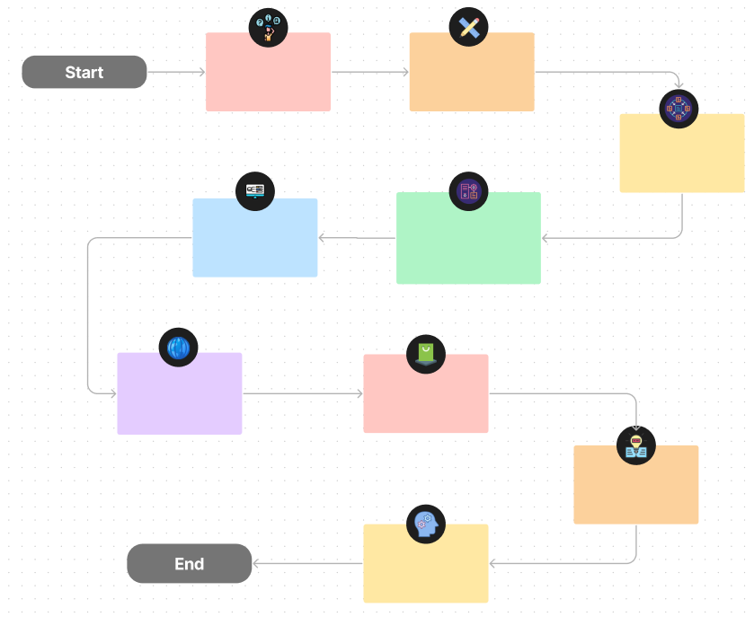

**Types of water quality** paramater

**Water quality Parameter**

**Anomaly detection techniques**

**Evaluation Metrics**



**Model Training**



**Algorithm Selection**



**Anomaly Detection** **Implementation**



**Machine Learning** **Approaches**

**Statistical methods**

**5.Conclusion**

In conclusion, anomaly detection techniques are indispensable tools across a wide range of industries and applications. These methods, whether based on statistics, machine learning, or domain-specific knowledge, play a vital role in identifying rare and unexpected patterns within data. By enabling the early detection of anomalies, these techniques help mitigate risks, enhance security, and improve the quality and reliability of systems. As data continues to grow in complexity and volume, the importance of effective anomaly detection only continues to rise, making it an essential component of modern data-driven decision-making processes.