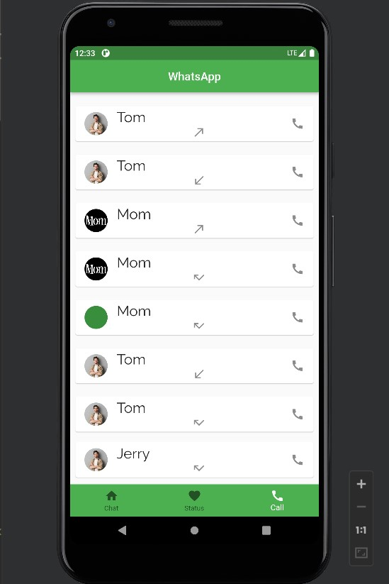

import 'package:flutter/material.dart';  
  
class WCall extends StatelessWidget {  
 const WCall({super.key});  
  
  
  
 @override  
 Widget build(BuildContext context) {  
 return Container(  
 child: Column(  
 children: [  
 InkWell(  
 onTap: () {},  
 child: Container(  
 margin: EdgeInsets.all(5),  
 child: Column(  
 children: const [  
 SizedBox(height:15),  
 Card(  
 child: ListTile(  
 title: Text(  
 'Tom',  
 style: TextStyle(fontSize: 25, fontFamily: 'Raleway'),  
 ),  
 subtitle: Icon(Icons.*call_made_outlined*),  
 leading: CircleAvatar(  
 backgroundImage: NetworkImage(  
 "https://t4.ftcdn.net/jpg/02/14/74/61/360_F_214746128_31JkeaP6rU0NzzzdFC4khGkmqc8noe6h.jpg"),  
 ),  
 trailing: Icon(Icons.*call*)),  
 ),  
 SizedBox(height:15),  
 Card(  
 child: ListTile(  
 title: Text(  
 'Tom',  
 style: TextStyle(fontSize: 25, fontFamily: 'Raleway'),  
 ),  
 subtitle: Icon(Icons.*call_received*),  
 leading: CircleAvatar(  
 backgroundImage: NetworkImage(  
 "https://t4.ftcdn.net/jpg/02/14/74/61/360_F_214746128_31JkeaP6rU0NzzzdFC4khGkmqc8noe6h.jpg"),  
 ),  
 trailing: Icon(Icons.*call*)),  
 ),  
 SizedBox(height:15),  
 Card(  
 child: ListTile(  
 title: Text(  
 'Mom',  
 style: TextStyle(fontSize: 25, fontFamily: 'Raleway'),  
 ),  
 subtitle: Icon(Icons.*call_made*),  
 leading: CircleAvatar(  
 backgroundImage: NetworkImage(  
 "https://www.emmys.com/sites/default/files/shows/mom-2016-600x600.jpg"),  
 ),  
 trailing: Icon(Icons.*call*)),  
 ),  
 SizedBox(height:15),  
 Card(  
 child: ListTile(  
 title: Text(  
 'Mom',  
 style: TextStyle(fontSize: 25, fontFamily: 'Raleway'),  
 ),  
 subtitle: Icon(Icons.*call_missed*),  
 leading: CircleAvatar(  
 backgroundImage: NetworkImage(  
 "https://www.emmys.com/sites/default/files/shows/mom-2016-600x600.jpg"),  
 ),  
 trailing: Icon(Icons.*call*)),  
 ),  
 SizedBox(height:15),  
 Card(  
 child: ListTile(  
 title: Text(  
 'Mom',  
 style: TextStyle(fontSize: 25, fontFamily: 'Raleway'),  
 ),  
 subtitle: Icon(Icons.*call_missed*),  
 leading: CircleAvatar(  
 backgroundImage: NetworkImage(  
 " https://www.emmys.com/sites/default/files/shows/mom-2016-600x600.jpg"),  
 ),  
 trailing: Icon(Icons.*call*)),  
 ),  
 SizedBox(height:15),  
 Card(  
 child: ListTile(  
 title: Text(  
 'Tom',  
 style: TextStyle(fontSize: 25, fontFamily: 'Raleway'),  
 ),  
 subtitle: Icon(Icons.*call_received*),  
 leading: CircleAvatar(  
 backgroundImage: NetworkImage(  
 "https://t4.ftcdn.net/jpg/02/14/74/61/360_F_214746128_31JkeaP6rU0NzzzdFC4khGkmqc8noe6h.jpg"),  
 ),  
 trailing: Icon(Icons.*call*)),  
 ),  
 SizedBox(height:15),  
 Card(  
 child: ListTile(  
 title: Text(  
 'Tom',  
 style: TextStyle(fontSize: 25, fontFamily: 'Raleway'),  
 ),  
 subtitle: Icon(Icons.*call_missed*),  
 leading: CircleAvatar(  
 backgroundImage: NetworkImage(  
 "https://t4.ftcdn.net/jpg/02/14/74/61/360_F_214746128_31JkeaP6rU0NzzzdFC4khGkmqc8noe6h.jpg"),  
 ),  
 trailing: Icon(Icons.*call*)),  
 ),  
 SizedBox(height:10),  
 Card(  
 child: ListTile(  
 title: Text(  
 'Jerry',  
 style: TextStyle(fontSize: 25, fontFamily: 'Raleway'),  
 ),  
 subtitle: Icon(Icons.*call_missed*),  
 leading: CircleAvatar(  
 backgroundImage: NetworkImage(  
 "https://t4.ftcdn.net/jpg/02/14/74/61/360_F_214746128_31JkeaP6rU0NzzzdFC4khGkmqc8noe6h.jpg"),  
 ),  
 trailing: Icon(Icons.*call*)),  
 ),  
  
  
  
 ],  
 ),  
 ),  
 )  
 ],  
 ));  
 }  
}