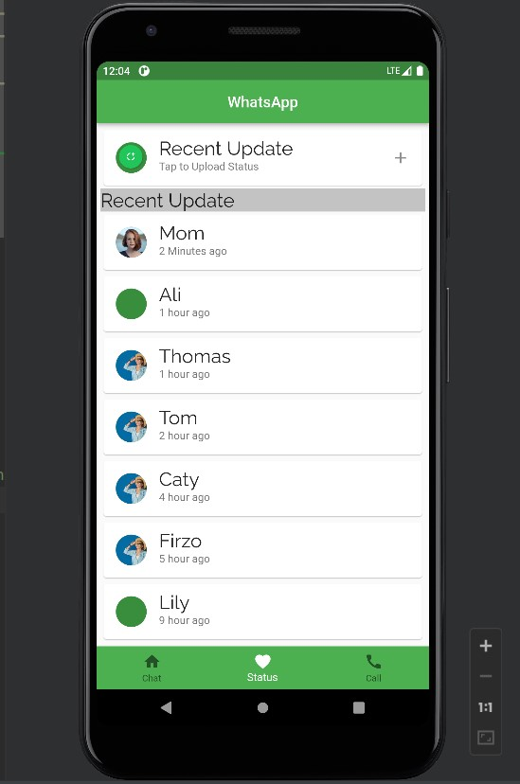

import 'package:flutter/material.dart';  
  
class WStatus extends StatelessWidget{  
 @override  
 Widget build(BuildContext context) {  
 return Container(  
 child:Column(  
 children: [  
 InkWell(  
 onTap: (){},  
 child: Container(  
 margin: EdgeInsets.all(5),  
 child: Column(  
 children: [  
  
 const Card(  
 child: ListTile(title: Text('Recent Update', style: TextStyle(  
 fontSize: 25,fontFamily: 'Raleway'),),  
 subtitle: Text('Tap to Upload Status '),  
 leading: CircleAvatar(backgroundImage: NetworkImage("https://files.seniorweb.nl/uploadedimages/wwwseniorwebnl/thema/tabletsmartphone/apps/tip(8)(1).png" ),),  
 trailing:Icon(Icons.*add*) ),  
 ),  
*/// recent update* Container(  
 height: 30,  
 width: 500,  
 color: Colors.*grey*.withOpacity(0.6),  
 child: const Text('Recent Update', style: TextStyle(  
 fontSize: 25,fontFamily: 'Raleway'),),  
 ),  
  
 const Card(  
 child: ListTile(title: Text('Mom', style: TextStyle(  
 fontSize: 25,fontFamily: 'Raleway'),),  
 subtitle: Text('2 Minutes ago'),  
 leading: CircleAvatar(backgroundImage: NetworkImage("https://images.unsplash.com/photo-1438761681033-6461ffad8d80?ixlib=rb-4.0.3&ixid=MnwxMjA3fDB8MHxzZWFyY2h8Mnx8cGVyc29ufGVufDB8fDB8fA%3D%3D&w=1000&q=80"  
 ),),  
 ),  
 ),  
 const Card(  
 child: ListTile(title: Text('Ali', style: TextStyle(  
 fontSize: 25,fontFamily: 'Raleway'),),  
 subtitle: Text('1 hour ago'),  
 leading: CircleAvatar(backgroundImage: NetworkImage(""),),  
 ),  
 ),  
 const Card(  
 child: ListTile(title: Text('Thomas', style: TextStyle(  
 fontSize: 25,fontFamily: 'Raleway'),),  
 subtitle: Text('1 hour ago'),  
 leading: CircleAvatar(backgroundImage: NetworkImage("https://static.vecteezy.com/system/resources/thumbnails/003/823/495/small/image-of-beautiful-cute-young-girls-smiling-and-happy-isolated-over-blue-background-space-to-copy-the-text-free-photo.jpg"),),  
 ),  
 ),  
 const Card(  
 child: ListTile(title: Text('Tom', style: TextStyle(  
 fontSize: 25,fontFamily: 'Raleway'),),  
 subtitle: Text('2 hour ago'),  
 leading: CircleAvatar(backgroundImage: NetworkImage("https://static.vecteezy.com/system/resources/thumbnails/003/823/495/small/image-of-beautiful-cute-young-girls-smiling-and-happy-isolated-over-blue-background-space-to-copy-the-text-free-photo.jpg"),),  
 ),  
 ),  
 const Card(  
 child: ListTile(title: Text('Caty', style: TextStyle(  
 fontSize: 25,fontFamily: 'Raleway'),),  
 subtitle: Text('4 hour ago'),  
 leading: CircleAvatar(backgroundImage: NetworkImage("https://static.vecteezy.com/system/resources/thumbnails/003/823/495/small/image-of-beautiful-cute-young-girls-smiling-and-happy-isolated-over-blue-background-space-to-copy-the-text-free-photo.jpg"),),  
 ),  
 ),  
 const Card(  
 child: ListTile(title: Text('Firzo', style: TextStyle(  
 fontSize: 25,fontFamily: 'Raleway'),),  
 subtitle: Text('5 hour ago'),  
 leading: CircleAvatar(backgroundImage: NetworkImage("https://static.vecteezy.com/system/resources/thumbnails/003/823/495/small/image-of-beautiful-cute-young-girls-smiling-and-happy-isolated-over-blue-background-space-to-copy-the-text-free-photo.jpg"),),  
 ),  
 ),  
 const Card(  
 child: ListTile(title: Text('Lily', style: TextStyle(  
 fontSize: 25,fontFamily: 'Raleway'),),  
 subtitle: Text('9 hour ago'),  
 leading: CircleAvatar(backgroundImage: NetworkImage(""),  
 ),  
 ),  
 ),  
  
  
 ],  
 ),  
 ),  
 )  
 ],  
 )  
 );  
 }  
   
}