Prediction of Extreme Weather Events: Machine Learning Models Trained on Multivariate Meteorological Data
Shibo Wang ¹, Hannyzzura Affal ²
^{1,2} Faculty of Computer Science and Information Technology
Universiti Malaya, 50603 Kuala Lumpur, Malaysia
Corresponding Author: hannyz@um.edu.my

Abstract:
The increasing frequency and intensity of extreme weather events due to global warming pose severe threats to life and property across Asia. Traditional statistical methods struggle to capture the complex temporal and nonlinear characteristics of meteorological data, limiting their effectiveness in predicting extreme events. This study addresses these limitations by proposing hybrid CEEMDAN-LSTM and CEEMDAN-CNN-LSTM models for predicting droughts and floods using multivariate meteorological data. The models employ Complete Ensemble Empirical Mode Decomposition with Adaptive Noise (CEEMDAN) to decompose climate signals into multiple time-scale components, combined with Convolutional Neural Networks (CNN) for feature extraction and Long Short-Term Memory (LSTM) networks for temporal prediction. Using monthly meteorological data from eight Asian countries spanning 1950-2023, including 15 variables such as precipitation, consecutive dry days, and temperature extremes, the models follow a "decomposition-reconstruction-prediction-integration" framework. Results demonstrate that CEEMDAN-based models generally outperform standard LSTM, particularly for drought prediction, where MAPE improved from 7.78% to 7.20% in China. Model performance varied by region and climate type, with stronger results in monsoon-dominated areas than tropical maritime regions. The findings offer valuable insights for developing early warning systems and climate adaptation policies, supporting UN Sustainable Development Goal 13 (Climate Action) through enhanced capabilities for predicting extreme weather events.
Keywords: Weather Prediction. Machine Learning. CEEMDAN. CNN. LSTM. Time-series

1. Introduction
The escalating impact of global climate change has fundamentally altered the patterns and intensity of extreme weather phenomena worldwide. According to the IPCC's 2023 synthesis report, human-induced warming has intensified extreme weather events including heat waves, heavy rains, droughts and storms, resulting in widespread losses and damage [1]. Asia faces particularly acute challenges, with warming rates exceeding global averages [2]. In 2021, Asia experienced hundreds of meteorological disasters causing approximately US$36 billion in losses and 4,000 deaths [3].
Malaysia exemplifies the complexity of extreme weather impacts in Southeast Asia. The 2015 Sabah floods resulted in 241 fatalities and US$100 million in damages, while the 2014 Kelantan drought caused US$22 million in agricultural losses [4]. These contrasting events underscore the necessity for robust predictive models.
1.2 Statement of Problems
Traditional extreme weather forecasting approaches face fundamental limitations when confronted with climate system complexity. Statistical methods based on linear assumptions fail to capture nonlinear dynamics and long-range dependencies characteristic of meteorological processes [5,6]. These methods demonstrate particular vulnerability to outliers and poor generalization for extreme events outside typical distributions.
This study proposes hybrid deep learning architectures combining signal decomposition techniques with neural networks. We introduced CEEMDAN-LSTM and CEEMDAN-CNN-LSTM models leveraging Complete Ensemble Empirical Mode Decomposition with Adaptive Noise for multi-scale feature extraction. Previous studies have shown promises for machine learning approaches [7-10] and hybrid architectures [11-13], yet gaps remain in unified architectures for multiple extreme events and cross-regional generalization.
1.3 Objectives
- To identify the most influential meteorological variables contributing to the prediction of extreme weather events through correlation analysis and feature selection techniques.
- To design and evaluate the predictive performance of a hybrid CEEMDAN-LSTM and CEEMDAN-CNN-LSTM model for forecasting two major types of extreme weather events, droughts and floods using monthly climate indicators from eight Asian countries spanning 1950 to 2023.
- To validate the robustness and generalizability of the CEEMDAN-LSTM and CEEMDAN-CNN-LSTM models by benchmarking their forecasting accuracy and stability against LSTM models.

2. Literature Review
Recent advances in machine learning have revolutionized approaches to extreme weather prediction, yet significant methodological gaps persist. Islam et al. [7] achieved remarkable accuracy (R²=0.964) using Random Forest for agricultural yield prediction under climate change impacts, though their approach lacked temporal modeling capabilities essential for capturing year-to-year variations. Similarly, Kumar et al. [8] demonstrated XGBoost's effectiveness for urban rainfall prediction in Delhi (R²≈0.99), but their single-region focus limits generalization potential. The application of LSTM networks has shown promise for capturing temporal dependencies in climate data. Wang et al. [9] employed single-layer LSTM structures for drought prediction in China's Dongjiang River Basin, incorporating multiple meteorological and environmental variables. However, their study notably lacked comparative analysis with alternative architectures. Dikshit et al. [10] provided compelling evidence for LSTM's superiority over ARIMA models in capturing extreme drought patterns using century-scale climate data (1901-2018), yet their work did not explore the importance of individual variables or decomposition techniques.
Several studies have explored hybrid architectures to enhance prediction accuracy. Essa et al. [11] compared three LSTM variants (LSTM-FC, CNN-LSTM, and ConvLSTM) for thunderstorm prediction in South Africa, finding CNN-LSTM most effective for simultaneous temporal and spatial feature extraction. Xie et al. [12] introduced vector direction information into LSTM models (VD-LSTM) to enhance sensitivity to flood process dynamics, though challenges remained in simulating bimodal flood peaks. The integration of decomposition techniques with deep learning represents a particularly promising direction. Liu et al. [13] proposed a CEEMDAN-SE-BiLSTM model for wind power prediction, demonstrating how decomposition into multiple IMF sequences followed by reconstruction can effectively address multimodal and non-stationary characteristics in time series data. Their approach of reconstructing IMFs into five subsequences before BiLSTM processing achieved superior accuracy compared to standard methods.
Despite these advances, several critical gaps remain unaddressed. First, most existing studies focus on single extreme weather types or specific geographic regions, lacking unified architectures capable of predicting multiple extreme event categories. Second, the generalization capability across different countries and meteorological conditions remains largely unexplored. Third, while LSTM models demonstrate high accuracy for long-term climate trends, they often fail to capture short-term disturbances and multi-scale fluctuation characteristics crucial for identifying extreme event turning points.

3 Methodology:
The experimental dataset was sourced from the World Bank Climate Change Knowledge Portal, encompassing monthly meteorological observations from eight Asian countries: Malaysia, China, India, Indonesia, Japan, Thailand, Philippines, and Vietnam. The temporal coverage spans from January 1950 to December 2023, yielding 888 monthly observations per country. The dataset incorporates 15 meteorological variables including precipitation (pr), consecutive dry days (cdd), maximum 5-day precipitation (rx5day), temperature extremes (tasmax, tasmin), relative humidity (hurs), heavy precipitation day counts (r20mm, r50mm), and heat index thresholds (hi35, hi37, hi39).
Table 1: Description of key meteorological variables used in the study
Variable | Description | Unit
cdd | Maximum number of consecutive dry days (daily precipitation <1mm) | days
rx5day | Average largest 5-day cumulative precipitation | mm
pr | Aggregated accumulated precipitation | mm
tasmax | Average maximum surface air temperature | °C
tasmin | Average minimum surface air temperature | °C
r20mm | Number of days with precipitation ≥20mm | days
r50mm | Number of days with precipitation ≥50mm | days
hurs | Relative humidity | %
Data preprocessing followed a systematic protocol. Missing value assessment using the missing no library confirmed complete data integrity across all 7,104 observations. Min-Max normalization was applied at the country level to transform all variables to the [0,1] range, ensuring comparability across different units and scales. Exploratory data analysis revealed substantial regional variations in extreme weather patterns, with monsoon-dominated regions exhibiting stronger seasonality compared to maritime tropical zones.
Variable importance assessment employed Pearson correlation analysis between each predictor and target variables (cdd for drought, rx5day for flood prediction). The top seven variables with highest correlation coefficients were selected for each country-specific model, reducing dimensionality while preserving predictive information.

3.2 CEEMDAN Decomposition
The Complete Ensemble Empirical Mode Decomposition with Adaptive Noise addresses the mode mixing problem inherent in traditional EMD through adaptive noise injection at each decomposition stage [14]. For a given signal y(t), the decomposition proceeds as follows:
First, Gaussian white noise is added to construct multiple realizations:
$y_{i}\left(t\right)=y\left(t\right)+ε_{0}ω^{i}\left(t\right), i=1,2,…,N$
(1)
where ε₀ represents the noise coefficient and ω^{i}(t) denotes the i-th white noise realization.
The first IMF component is obtained by averaging EMD results across all noise realizations:
$c_{1}\left(t\right)=\frac{1}{N}\sum_{i=1}^{N}{c_{1}^{i}\left(t\right)}$
(2)
Subsequent IMFs are extracted iteratively from residuals:
$r_{1}\left(t\right)=y\left(t\right)-c_{1}\left(t\right)$
(3)
$c_{j+1}\left(t\right)=\frac{1}{N}\sum_{i=1}^{N}{E_{1}\left(r_{j}\left(t\right)+ε_{j}E_{j}\left(ω^{i}\left(t\right)\right)\right)}$
(4)
$r_{j+1}\left(t\right)=r_{j}\left(t\right)-c_{j+1}\left(t\right)$
(5)
where E_{j}(·) represents the j-th EMD mode operator. The process continues until the residual satisfies monotonicity conditions or reaches predetermined iteration limits.
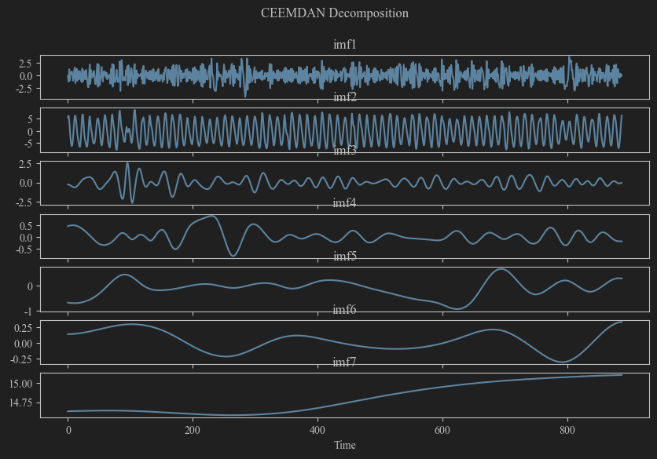
Figure 1: CEEMDAN decomposition of CDD time series for China (1950-2023) showing 8 IMF
Implementation utilized the PyEMD library with 100 noise-assisted trials to ensure decomposition stability. For the Chinese CDD series, CEEMDAN yielded 8 IMF components representing distinct temporal scales: high-frequency components (IMF1-IMF3) capturing monthly to seasonal variations, mid-frequency components (IMF4-IMF6) representing interannual variability, and low-frequency components (IMF7-IMF8) indicating long-term climate trends.
In the CEEMDAN-LSTM architecture, each decomposed IMF component undergoes independent modeling through dedicated LSTM networks. The LSTM architecture employs 128 hidden units with tanh activation for cell state transformations and sigmoid functions for gate mechanisms.
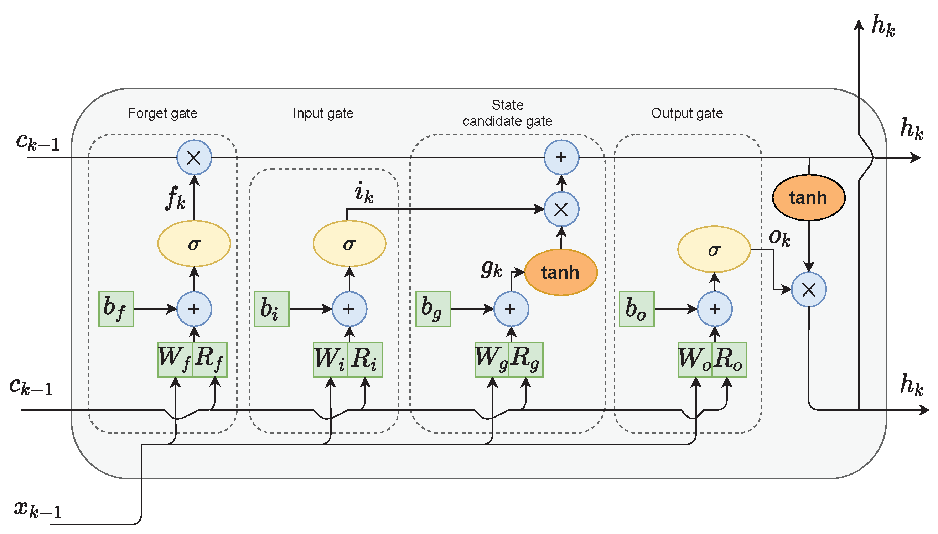
Figure 2: LSTM neuron architecture with input gate, forget gate, output gate and memory cell
The CEEMDAN-CNN-LSTM architecture with enhanced architecture incorporates one-dimensional CNN layers for local feature extraction before LSTM processing. The CNN module employs 32 convolutional kernels (size=2) with ReLU activation, followed by max pooling (pool_size=2) to downsample feature maps while preserving salient characteristics as shown in Figure 3.
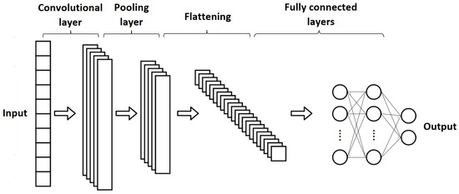
Figure 3: One-dimensional CNN architecture for temporal feature extraction from meteorological time series
Training employed the Adam optimizer with learning rate 0.001, batch size 32, and 100 epochs. The dataset was partitioned chronologically with 85% for training/validation (January 1950-January 2013) and 15% for testing, ensuring temporal consistency and preventing data leakage.

4. Results and Analysis
The comparative analysis of drought prediction performance reveals substantial regional variations in model effectiveness. Table 2 summarizes the regression metrics across all eight countries for the three model architectures.
Table 2: Drought prediction performance metrics (CDD)
Country | Model | MSE | RMSE |  | MAE | MAPE (%) | R² (%)
China | LSTM | 2.305 | 1.518 | 1.185 |  | 7.785 | 89.704
 | CEEMDAN-LSTM | 2.125 | 1.458 | 1.110 |  | 7.318 | 90.392
 | CEEMDAN-CNN-LSTM | 2.172 | 1.474 | 1.119 |  | 7.575 | 90.178
India | LSTM | 8.571 | 2.928 | 2.234 |  | 22.146 | 86.433
 | CEEMDAN-LSTM | 7.522 | 2.743 | 2.128 |  | 18.428 | 88.096
 | CEEMDAN-CNN-LSTM | 7.805 | 2.794 | 2.059 |  | 18.490 | 87.796
Japan | LSTM | 2.544 | 1.595 | 1.244 |  | 20.529 | -9.323
 | CEEMDAN-LSTM | 2.860 | 1.691 | 1.297 |  | 20.940 | -21.387
 | CEEMDAN-CNN-LSTM | 4.072 | 2.018 | 1.606 |  | 26.390 | -72.812
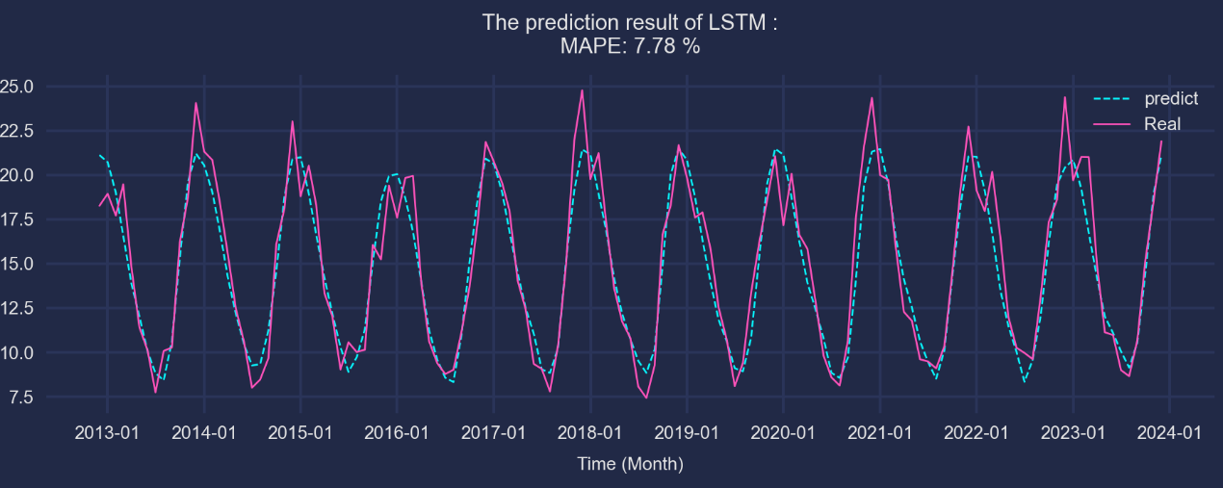Figure 4: LSTM model prediction results for CDD in China showing actual vs predicted values
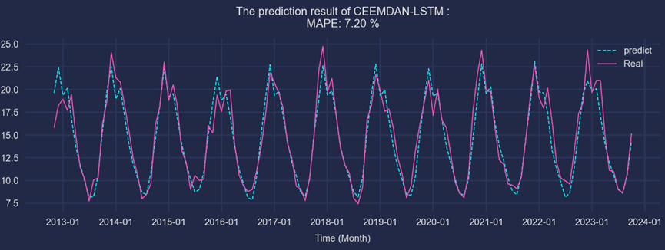Figure 5: CEEMDAN-LSTM model prediction results for CDD in China showing improved accuracy
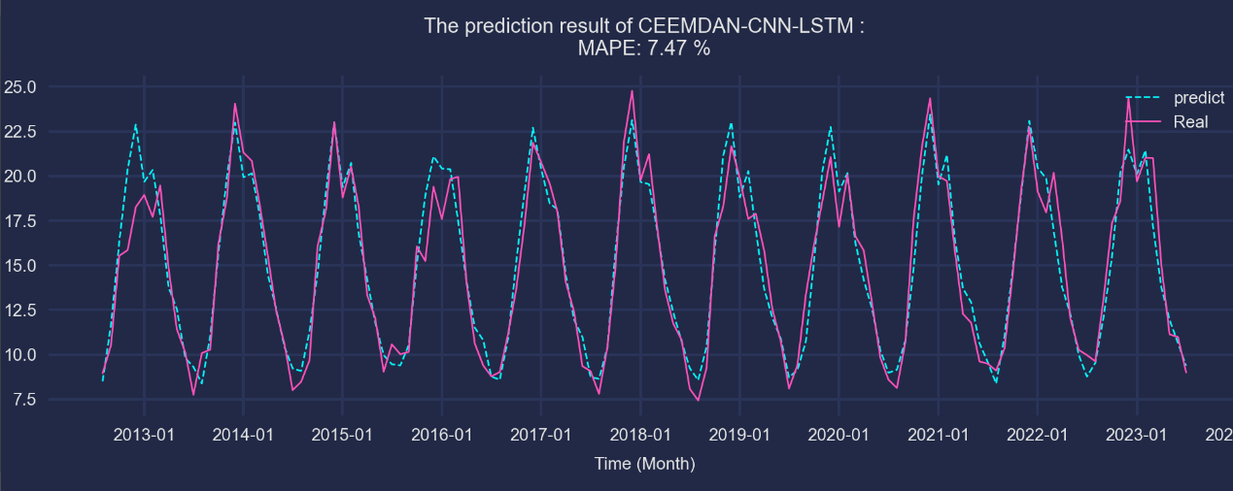Figure 6: CEEMDAN-CNN-LSTM model prediction results for CDD in China with highest R² performance
China and India demonstrated the most favorable outcomes, with CEEMDAN-based models consistently outperforming standard LSTM. In China, the CEEMDAN-LSTM achieved the lowest MAPE (7.20%) as shown in Figure 5, representing a 0.58 percentage point improvement over baseline LSTM (7.78%) as shown in Figure 4. The R² values exceeded 0.91 for all models in China, indicating strong predictive capability. And the CEEMDAN-CNN-LSTM also improve over LSTM, with the MAPE achieving 7.47% as shown in Figure 6. India showed similar patterns, though with higher overall error rates due to greater climate variability.
Conversely, Japan and Malaysia exhibited deteriorated performance with CEEMDAN decomposition. Japan's R² values declined catastrophically from -0.0932 (LSTM) to -7.281 (CEEMDAN-CNN-LSTM), suggesting that decomposition introduced noise rather than extracting meaningful patterns. This degradation correlates strongly with weak variable correlations (maximum correlation coefficients 0.44-0.75), indicating insufficient signal strength for effective decomposition.
Extreme precipitation prediction presented different challenges compared to drought forecasting. The sudden and localized nature of heavy rainfall events introduces greater prediction uncertainty. The results demonstrate more modest improvements compared to drought prediction. In China, all three models achieved comparable performance (R² ≈ 0.94), with marginal MAPE improvements from CEEMDAN-LSTM (13.98% vs 14.04%). Indonesia showed more substantial gains, with CEEMDAN-CNN-LSTM reducing MAPE to 10.82% from the baseline 11.75%, accompanied by R² improvement from 0.5726 to 0.6227. These were shown in Table 3 below.
Table 3: Flood prediction performance metrics (Rx5day)
Country | Model | MSE | RMSE | MAE | MAPE (%) | R² (%)
China | LSTM | 16.458 | 4.057 | 3.210 | 14.040 | 94.281
 | CEEMDAN-LSTM | 15.501 | 3.937 | 3.100 | 13.979 | 94.569
 | CEEMDAN-CNN-LSTM | 15.478 | 3.934 | 3.117 | 14.143 | 94.607
Indonesia | LSTM | 156.572 | 12.513 | 10.299 | 11.752 | 48.725
 | CEEMDAN-LSTM | 151.708 | 12.317 | 9.931 | 11.278 | 49.376
 | CEEMDAN-CNN-LSTM | 151.863 | 12.823 | 9.825 | 10.818 | 47.855
.
Classification experiments evaluated the models' ability to categorize severity levels. For drought classification (Non-drought: CDD<11, Slight drought: 11-15, Drought: ≥16), the confusion matrices reveal improved performance with CEEMDAN-based models.
The CEEMDAN-CNN-LSTM achieved 90.15% accuracy in China, compared to 88.72% for standard LSTM. Notably, the hybrid model demonstrated superior recall for the minority "Drought" class (0.8966 vs 0.8276), crucial for early warning applications where missing extreme events carries severe consequences.
For flood classification (Non-flood: <50mm, Slight flood: 50-100mm, Flood: ≥100mm), CEEMDAN-LSTM achieved the highest accuracy (96.21%) with macro-F1 score of 0.9441, representing substantial improvement over LSTM baseline (94.70% accuracy, 0.9196 macro-F1).

5. Discussion and Implications:
The differential performance across regions reflects fundamental differences in climate system dynamics. Monsoon-dominated regions (China, India) exhibit strong seasonal cycles and quasi-periodic patterns that align well with CEEMDAN's multi-scale decomposition capabilities. The extracted IMFs successfully capture seasonal monsoon variations, interannual oscillations, and long-term trends, providing meaningful features for LSTM modeling.
In contrast, maritime tropical climates (Malaysia, Philippines) are influenced by complex interactions between multiple climate systems including ENSO, IOD, and tropical cyclones. These stochastic influences create irregular patterns that resist decomposition into stable modal components. When correlation coefficients fall below 0.70, as observed in Japan and Malaysia, CEEMDAN decomposition may amplify noise rather than extract signal, leading to degraded performance.
The research findings offer actionable insights for operational weather forecasting and climate adaptation strategies. For drought-prone regions with strong seasonal patterns, implementing CEEMDAN-LSTM models can enhance lead time and accuracy of drought warnings, supporting agricultural planning and water resource management. The 7.20% MAPE achieved in China translates to practical forecast errors of less than one day in typical monthly CDD predictions, sufficient for triggering preparedness measures.
However, the results caution against universal application of complex hybrid models. In regions with weak predictor-target correlations, simpler LSTM architectures may provide better cost-benefit ratios, avoiding computational overhead without sacrificing accuracy. This finding is particularly relevant for meteorological agencies in developing nations with limited computational resources.
Several limitations constrain the current study's scope. The absence of large-scale climate indices (ENSO, IOD) as exogenous variables potentially limits prediction accuracy, particularly for regions strongly influenced by teleconnections. Future research should explore multi-source data fusion incorporating satellite observations, reanalysis products, and climate oscillation indices.
The current approach treats each country independently, neglecting spatial correlations and atmospheric teleconnections. Graph neural networks or spatial attention mechanisms could capture these relationships, potentially improving predictions for spatially coherent extreme events. Additionally, the deterministic nature of current predictions lacks uncertainty quantification crucial for risk assessment. Implementing Bayesian deep learning or ensemble approaches could provide probabilistic forecasts with confidence intervals.

6. Conclusion
This study successfully developed and validated hybrid CEEMDAN-LSTM and CEEMDAN-CNN-LSTM models for predicting extreme weather events across diverse Asian climatic zones. The integration of adaptive signal decomposition with deep learning architectures demonstrated substantial improvements in drought prediction accuracy, particularly in monsoon-dominated regions where MAPE decreased from 7.78% to 7.20% in China. The models achieved classification accuracies exceeding 90% for drought severity and 96% for flood events, providing reliable categorical predictions essential for early warning systems.
However, the research reveals that model effectiveness strongly depends on regional climate characteristics and data quality. CEEMDAN decomposition proves most beneficial when correlation coefficients between predictors and targets exceed 0.70, while potentially introducing noise in weakly correlated scenarios. These findings underscore the importance of adaptive model selection based on local climate dynamics rather than universal application of complex architectures.
The contributions support UN Sustainable Development Goal 13 by enhancing climate risk assessment capabilities and providing scientific foundations for adaptation strategies. Future research should focus on incorporating large-scale climate drivers, developing probabilistic forecasting frameworks, and creating automated model selection mechanisms that optimize architecture choices based on regional characteristics. Through continued refinement and validation, these hybrid approaches can evolve into operational tools supporting climate resilience across vulnerable Asian communities.
Acknowledgments. The author acknowledges supervisor HANNYZZURA BINTI PAL AFFAL for guidance and the Faculty of Computer Science and Information Technology, Universiti Malaya for research support.

References
1. Intergovernmental Panel on Climate Change (2023) Climate change 2023: Synthesis report -- Summary for policymakers. IPCC, Geneva. https://www.ipcc.ch/report/sixth-assessment-report-synthesis-report/
2. Muhammad MKI, Hamed MM, Harun S, Mohd N (2024) Heatwaves in Peninsular Malaysia: A spatiotemporal analysis. Sci Rep 14:4255. doi:10.1038/s41598-024-42911-1
3. World Meteorological Organization (2022) Economic losses from extreme weather rocket in Asia. WMO, Geneva. https://public.wmo.int/en/media/press-release/economic-losses-extreme-weather-rocket-asia-wmo
4. World Bank (2021) Climate risk country profile: Malaysia. World Bank Group, Washington, DC. https://climateknowledgeportal.worldbank.org/country/malaysia
5. Zhang H, Liu Y, Zhang C, Li N (2025) Machine learning methods for weather forecasting: A survey. Atmosphere 16(1):82. doi:10.3390/atmos16010082
6. Camps-Valls G, Fernández-Torres MÁ, Cohrs KH, et al (2025) Artificial intelligence for modeling extreme weather and climate events. Nat Commun 16:1919. doi:10.1038/s41467-025-56573-8
7. Islam T, Mazumder T, Roni MNS, Nur MS (2024) A comparative study of machine learning models for predicting Aman rice yields in Bangladesh. Heliyon 10(23):e40764. doi:10.1016/j.heliyon.2024.e40764
8. Kumar V, Kedam N, Sharma KV, Khedher KM, Alluqmani AE (2023) A comparison of machine learning models for predicting rainfall in urban metropolitan cities. Sustainability 15(18):13724. doi:10.3390/su151813724
9. Wang T, Tu X, Singh VP, Chen X, Lin K, Zhou Z (2023) Drought prediction: Insights from the fusion of LSTM and multi-source factors. Sci Total Environ 902:166361. doi:10.1016/j.scitotenv.2023.166361
10. Dikshit A, Pradhan B, Huete A (2021) An improved SPEI drought forecasting approach using the long short-term memory neural network. J Environ Manage 283:111979. doi:10.1016/j.jenvman.2021.111979
11. Essa Y, Hunt HGP, Gijben M, Ajoodha R (2022) Deep learning prediction of thunderstorm severity using remote sensing weather data. IEEE J Sel Top Appl Earth Obs Remote Sens 15:4004–4013. doi:10.1109/JSTARS.2022.3172785
12. Xie T, Liu C, Hu C, Li W, Li R (2024) Study on long short-term memory based on vector direction of flood process for flood forecasting. Sci Rep 14:21446. doi:10.1038/s41598-024-72205-5
13. Liu Y, Zhang S, Chen X, Wang J (2023) Artificial intelligence-based time series models for predicting wind power generation: A comprehensive review. Energy Rep 9:1234–1245. doi:10.1016/j.egyr.2023.02.045
14. Torres ME, Colominas MA, Schlotthauer G, Flandrin P (2011) A complete ensemble empirical mode decomposition with adaptive noise. In: 2011 IEEE International Conference on Acoustics, Speech and Signal Processing (ICASSP). IEEE Press, Prague, pp 4144–4147. doi:10.1109/ICASSP.2011.5947265

