Japyonary
An SRS with a built-in Japanese dictionary and community-built decks.
The best part? You'll never have to deal with duplicate cards ever again.
Simone Bondi @ UNIMORE 2022-2023

Project draft

A Japanese dictionary / SRS (Spaced Repetition System) combo website which aims to extract, combine and improve on what, for me, are the best ideas of jisho.org, jpdb.io and kanji.koohii.com.
The website, in its most basic form, can be used as a dictionary - all users (both registered and anonymous) can query kanji, readings and meanings to find dictionary entries, which will appear in a list just like in jisho.org (with a much more rudimentary search engine).
A "Deck" is a group of dictionary entries and might represent, for example, the vocabulary used in a certain movie. Decks can be public or private, they have a name, a description and a cover image, in addition to the vocabulary list. Both registered and anonymous users can see the list of public decks created by other users from the deck search page, in which they can also filter by name, author or description.
Registered users can create new empty decks, create a copy of another user's deck, or import a list of vocabulary entries from a text file. They can then modify a deck by adding new entries from the dictionary, by removing an entry. Moreover, they can "heart" a deck and add comments. Comments allow a deck creator to receive feedback from other users, while decks with the most hearts are displayed first in the deck search page, which allow any user to search decks by deck name or author username.
Every registered user has their "Spaced Repetition System", or SRS for short: any dictionary entry added to it becomes a "flashcard" (card, for short) of the user's SRS. Every day, the user can start a review, during which for each "expired" card, the website will show to the user the front of the card, consisting of the vocabulary in Kanji. The user will then be able to flip the card, displaying its back which consists of the reading, the meaning in english, and two buttons "Yes" and "No" which allow the user to express whether he remembered the card or not.

The user should be able to interrupt a review at any point and for any reason (e.g. blackout) without noticing any loss of progress when he eventually reconnects to the website. This should hold true even when reconnecting from another device.

Answered cards are then re-scheduled by assigning a new expiration date according to what button the user pressed. The scheduling is implemented with the Leitner system, which consists of a series of "Leitner boxes" numbered 0 to n. Each card in the SRS deck is contained in one and only one box, and is rescheduled at increasing intervals based on the box it is in. New cards are put into Box 0. When an user responds "Yes", the card advances to the next box, but when he responds "No", the card returns to box 0. Rescheduling should also have some randomness (e.g. ±20% of the scheduling interval) to avoid having lots of cards with the same schedule. In practice, if the interval of box i is labeled Ti, a card in box i is rescheduled with a formula similar to "new_expiration_date = today + Ti + Ti * randf(-0.2, 0.2)".

In summary, the website will have, at the very least, the following views:
- an homepage, in which registered users see the pending reviews for the day and can start a new review. All users see the dictionary search box and a list of top-rated decks.
- a review page, accessible only by registered users, through which they can use the SRS.
- a dictionary page, in which all users see the dictionary search box and the search results. Registered users can add single entries to decks from here.
- a decks page, in which all users see a deck search box and the search results, including the cover image, name, author and heart count. In this page, registered users can only click on decks to navigate to the single deck display page.
- a single deck display page - here, all users can see any detail pertaining to the deck: the vocabulary list, description, comments... Registered users can heart and add comments from this page. The deck owner can enter the deck edit page.
- deck edit page, which allows the owner of a deck to edit description, comments and cover image of a deck, remove vocabulary from a deck and delete the entire deck.

In addition, admins will be able by design to delete comments, edit any deck metadata (title/description/image) directly in the interface where the deck owner could do the same.

Use case
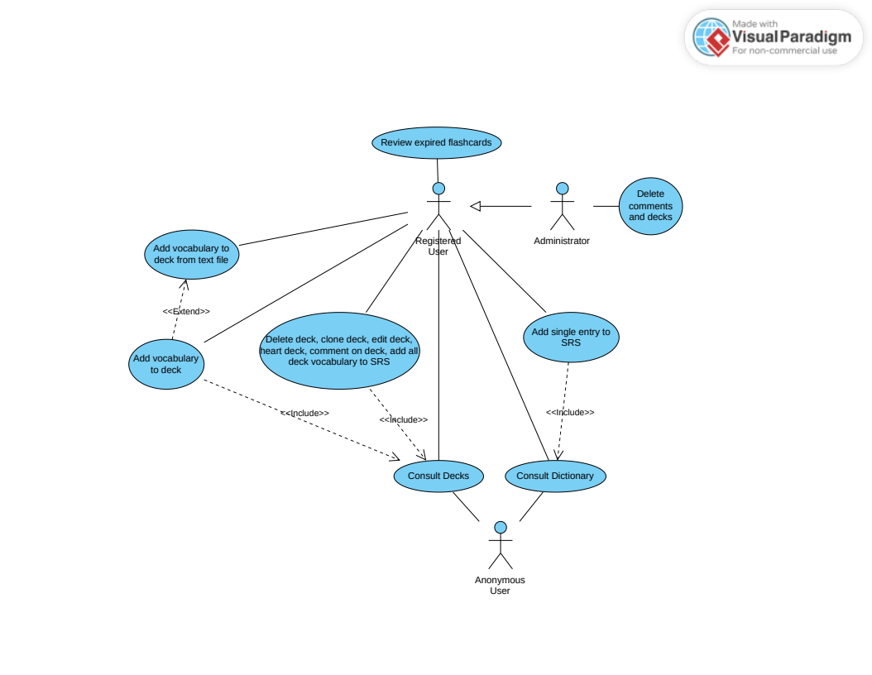Dictionary Use Case

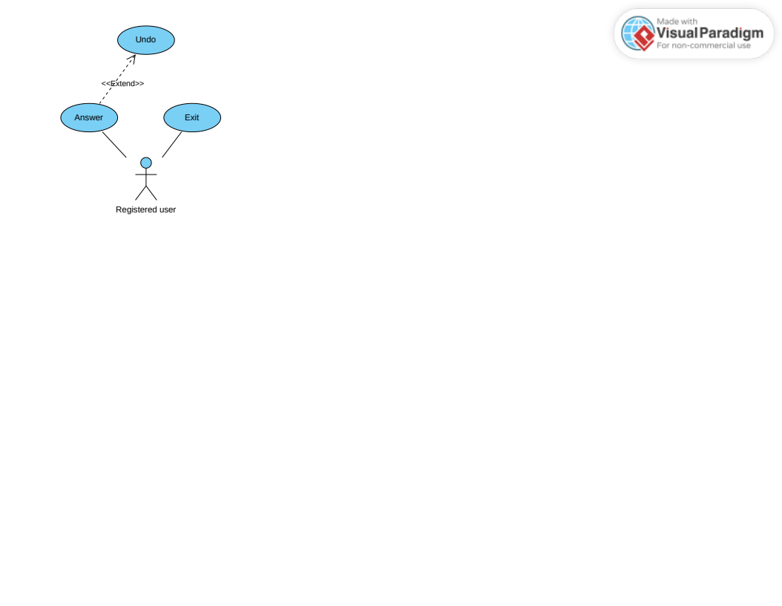SRS Use Case

The main objective for Anonymous Users is get them to register: showing them the top decks in the homepage entices them to register, by letting them look at what the community has to offer.

Registered users can then participate in the community by creating and managing their own decks, and also by hearting and commenting on other users decks.

The focus, however, is on the SRS. Everything on the site is only supposed to be an helper to the SRS system: decks, for example, group cards that an user can just pop into their SRS. Hearts and comments play the important role of highlighting the best decks and authors, to allow users to “filter” out the bad decks which may contain grammar points instead of just vocabulary, verbs, and adjectives.

Administrators only have the role of moderating the community by removing inappropriate content.

Class diagrams
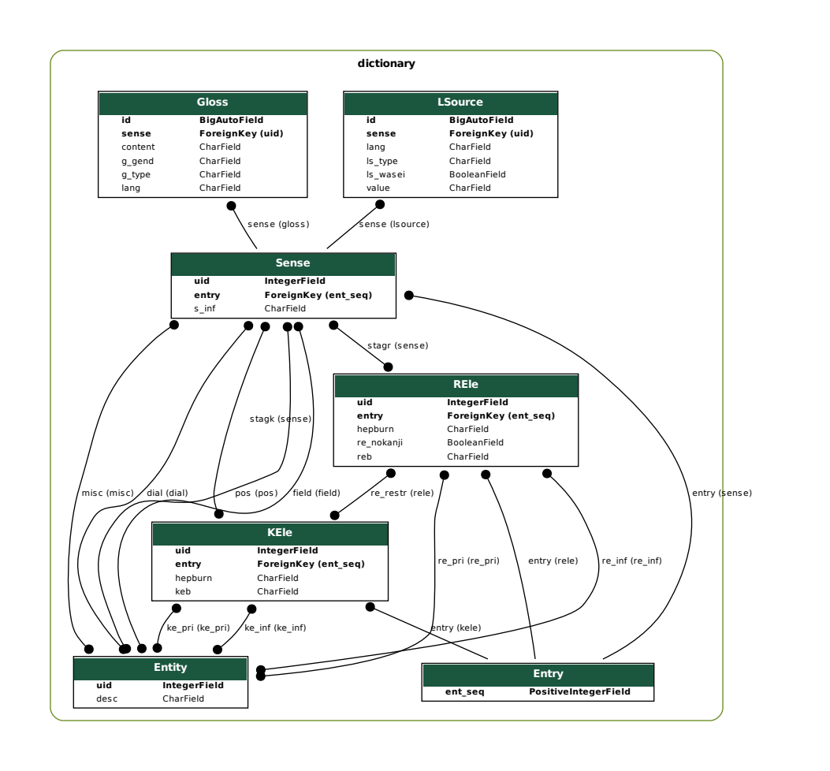ORM class diagram for Dictionary.
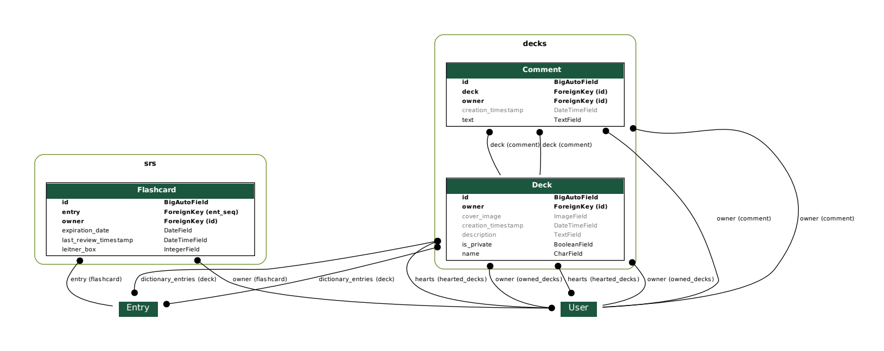ORM class diagram for everything but Dictionary.

Technologies used, problems and motivations

Dictionary source data: the structure and data of the Jmdict project were used for the dictionary. This is the de-facto standard for many free online dictionaries - additionally, Tatoeba, which is the most comprehensive example sentence repository available for free, is part of the same project and provides links to the vocabulary entries used in the sentences. This means that, in the future, adding example sentences will be straightforward. The Jmdict file is in XML format, and Japyonary uses the xsdata package to parse it. Xsdata allows generating python code of dataclasses definitions that represent XML elements from an XML DTD. Then, Xsdata is able to parse the XML document into instances of these dataclasses. This is all handled by the management command dictionary.management.commands.load_dictionary, which is also executed upon running the setup.sh script provided with the project.

Database: the dictionary data is a “constant” in the sense that neither users nor admins are supposed to change it, so the switch from one mode of storage to another should be straightforward.
The most obvious choice to make at this point is to keep it simple (instead of attempting an in-memory configuration) and use one of the many available DBs. The Jmdict data is well structured and transfers well to a relational database; these are well supported by Django and are highly compatible with one another, so a relational database was chosen. For development purposes, the choice fell on SQLite, but if the project ever went in production it would require the switch to a RDBMS like PostgreSQL, as SQLite has no support for parallelism and poorly supports concurrency.

Importing entries from unstructured text: this requires a tokenizer and a lemmatizer. The sudachipy project provides both in one package, although it uses its own dictionary – this means, unfortunately, that we have two copies: one for this library and the other on the database, each weighing around 60MB. The result of the lemmatization is then matched to Jmdict entries to create the Flashcards.

SRS review: as per requirements, if the user has his review interrupted for any reason (e.g. blackout, loss of connection…) he should experience no data loss whatsoever and should be able to continue even from another device. This requires every answer to be recorded on the server ASAP, and imposes a high frequency of interactions between client and server. AJAX wasn’t chosen in order to avoid frequently creating and destroying TCP connections – instead, Websocket is used, which keeps a single connection open during the whole review. However, most of the time is spent waiting for user interaction, and WSGI allows a limited number of concurrent requests on a single thread. ASGI was chosen to overcome this limitation, which required the use of Asynchronous programming, the Daphne ASGI server and the Websocket module from Django Channels. A custom JSON-based messaging protocol is used: each JSON object contains a “message” field (the message name) and a “payload” field (the message parameters). Unfortunately, a design choice was made to make the server render the flashcards, send the HTML to the client which would then replace an element’s content with that HTML: but when templates access Django ORM objects foreign-key and many-to-many relationships, synchronous queries are performed on the DB, which cannot be executed in an asynchronous context. This could be solved by prefetching all the data related to an entry, but I could not find a clean solution in time for the deadline as the subject is poorly documented except for the simplest of cases; the card rendering was therefore offloaded to a thread with asgiref.sync.sync_to_async. Fortunately the rendering phase takes little time and the thread is immediately freed and hopefully reused (I didn’t investigate, but I’d expect it to be part of a thread pool – otherwise I don’t see why it would be reccomended by the Django official documentation itself).

The add-entry-to-SRS button, available in the Dictionary and Deck Vocabulary views, and the Heart button, available in the Deck List and Deck Detail views: instead of reloading the page on user interaction, which would worsen the UX, these buttons use AJAX to post a request in background. This uses the same message-payload protocol used for the SRS, albeit in the form of HTTP POST request and response. Django REST Framework was not used to build this API – I had never used either at the time and I decided to invest the time into studying how a widespread technology like AJAX worked instead of yet another Django-specific library. Then once again, the deadline did not allow the switch to Django REST Framework, which could be done in the future.

Status bar: this reports errors and success messages to the user - it is built with Django Messages and Javascript. When responding to POST requests, right before redirecting the user to another page, a Django Message containing the status bar message is added (in the form of cookies). After the redirect, when the client makes a request to the view it will load the Django Message which, if present, will be added to the Django template context. The base template will then inject a Javascript line into the HTML that makes the status bar appear with the stored message.

Testing: unittests was used as it is the standard with Django. The unittests.mock module was used to mock dependencies. The channels.testing.WebsocketCommunicator was used to perform an integration test.

Forms: The search-bar form was developed as a single reusable form, as it is used both in the Deck Search and Dictionary Search views. Django Crispy Forms is used as reusing standard Django forms is not straightforward. For the rest of the forms, which are really simple, Crispy Forms spared me from developing the front-end altogether.

Styling: Bootstrap 5 is used to speed up front-end development.

The rest of the functionalities are implemented as standard Django views. The only noteworthy characteristic is that all views are implemented as Class Based Views. When possible, views inherit from django.views.generic.*.

Software Architecture

The project is divided in 5 logical units, four of which have their own apps and one, Japyonary, which lives under the Django project folder. The four apps: Dictionary, Decks, SRS and Users.

However, this is not to say that each app is an indipendent black box; each of them has a dependency on the models of some other app. Yet, this division is natural and it resulted in hassle-free development.

Japyonary contains the reusable Search Bar form, the paginator widgets, the Homepage and two base templates (one of which is minimalistic and is used for the SRS review page). Additionally, it contains some common helper logic in the utils module: most noteworthy, the common AJAX logic and the Mixins containing the Status Bar messaging logic.

The Dictionary app contains all logic related to the dictionary: the Dictionary view, the Jmdict database model, the management command to load the Jmdict, and the business logic used to import vocabulary from text.

The Decks app contains the logic required to search, clone, delete, modify, heart, comment etc. on decks. The clone, delete, heart and comment POST-request handlers are in their own view.

The SRS app contains all logic pertaining to SRS and the Flashcard model. The SRS business logic is contained in the SrsReview class, which is independent from the communication medium used. SrsException class is used to “gracefully” disconnect with errors and an SrsBridge interface (implemented as a python ABC), which is passed to the constructor, is used for communicating to the underlying communication medium.
The SrsConsumer is instead concerned with the latter and consists of a few layers of abstraction, bottom to top (see also UML in next page):
- channels.generic.websocket.JsonWebsocketConsumer: this is provided by Channels and abstracts the websocket to receive and send single JSON objects.
- AsyncMessageWebsocketConsumer: this abstracts JSON towards a message-payload protocol: each JSON object will contain a message field containing the message name (e.g. “answer” a flashcard), and a payload field containing the parameters (e.g. with “YES”).
- AsyncMessageDispatchingWebsocketConsumer, this dispatches messages (by message field) to handlers declared in the message_handlers field.
- SrsConsumer implements SrsBridge and calls the appropriate SrsReview methods when receiving messages. It also unpacks and validates the payloads.

The Users app contains the User model and the login/signup/signout forms.

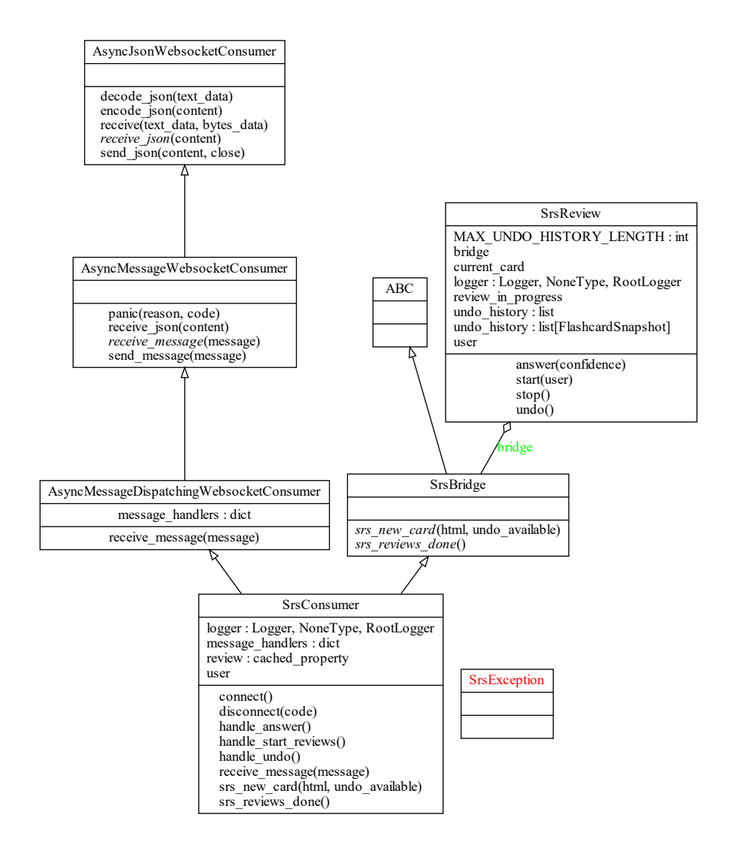UML of the SRS module.
Testing methodology

The SRS module was developed with the TDD (Test Driven Development) methodology – I wanted to experiment with it as I had never tried it out before. This resulted in multiple layers of abstractions, each with a single, simple and clear goal. Using channels.testing.WebsocketCommunicator breaks the principle of unit testing, so the unittest.mock module was used extensively.
Tests, from the bottom up:

AsyncMessageWebsocketConsumer is tested for correctly sending an error message and disconnecting when “panicking”, for panicking on malformed messages (missing the “message” field or “message” field not being a string) and for correctly calling the message_received method on valid inputs (complete messages, missing the optional “payload” field). The AsyncJsonWebsocketConsumer methods were patched to decouple it from AsyncMessageWebsocketConsumer.

AsyncMessageDispatchingWebsocketConsumer is tested for panicking on unknown messages and for calling the correct handler upon reception of a known message. This time, the AsyncMessageWebsocketConsumer methods were patched.

SrsConsumer is tested for correctly disconnecting when SrsReview throws SrsException, or when the user is not authenticated. It is not instead tested for correctly calling SrsReview methods upon reception of messages. This would mean creating a test for each message to validate, but the logic is already extremely simple, consisting only a matter of parsing the payload parameters and calling a function. Here too the AsyncMessageWebsocketConsumer methods were patched.

SrsReview is tested for raising SrsException when it is interacted with without having been started; for correctly and gracefully disconnecting when starting a review with no pending flashcards; for correctly identifying pending flashcards and communicating with the client until the flashcards are finished, and then disconnecting; for correctly raising SrsException when undo is called with no available undos; for displaying undid cards in the same order they were undid; for correctly updating flashcards upon answers and for correctly restoring flashcards upon undos.
This time, because SrsReview takes the bridge as constructor parameter (like in the Dependency Injection design pattern) no patching was needed – instead, passing a Mock instead of an SrsBridge to the constructor suffices. Unfortunately these tests make heavy use of the Flashcard model and, due to the time constraints, I was not able to mock out the Database which effectively remains an external dependency breaking the unit testing principles.

In the end, an integration test was implemented, where the websocket connection is tested using channels.testing.WebsocketCommunicator (akin to Django’s Client). A short review consisting of a few expired cards is tested by answering until the expired cards are finished.
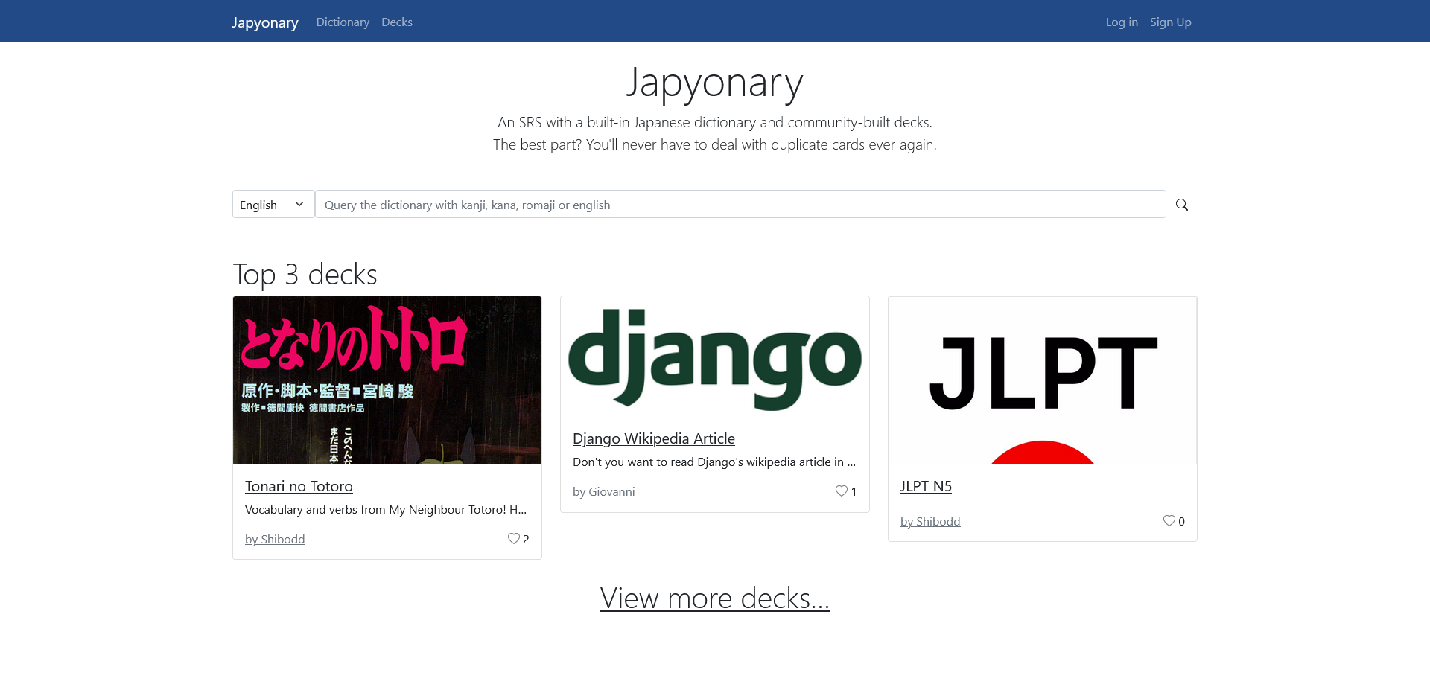Homepage as shown to an anonymous user

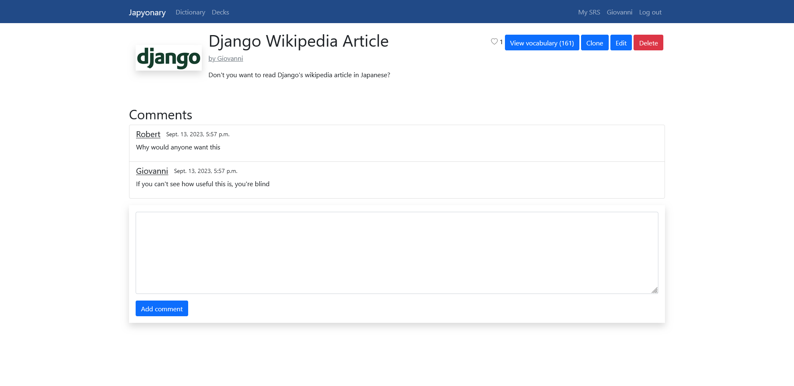The deck detail view

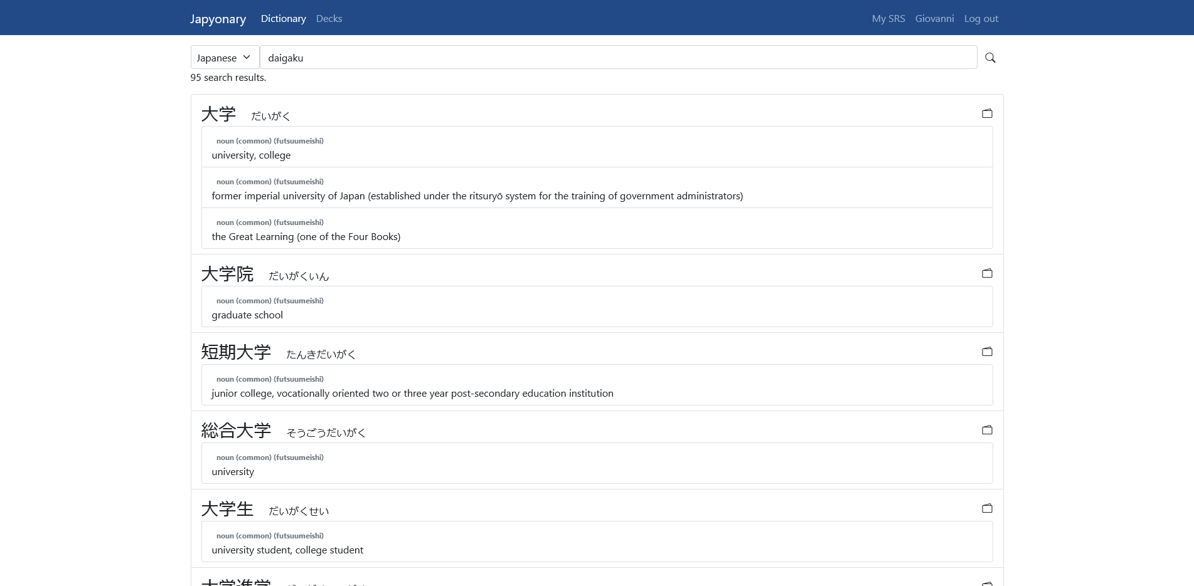The dictionary view.
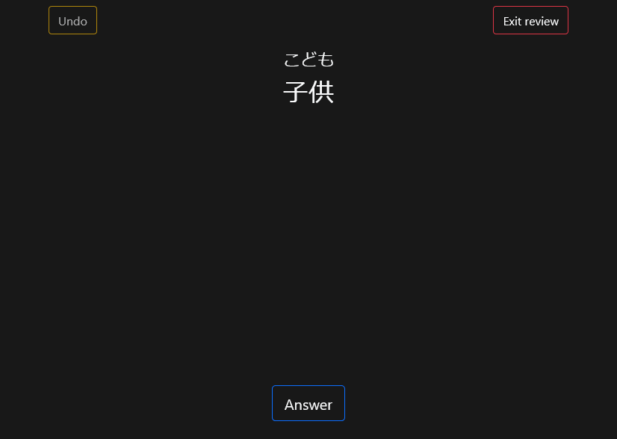The SRS review page (front of the card)

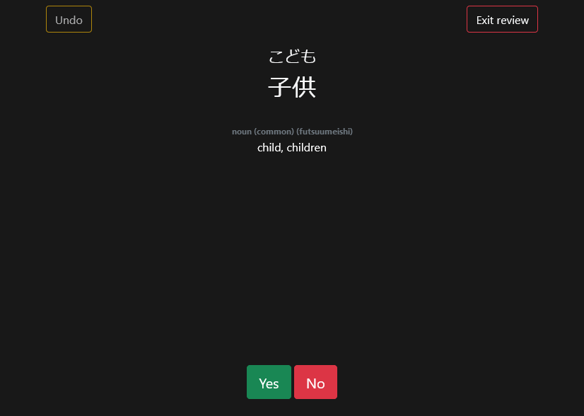The SRS review page (back of the card)

