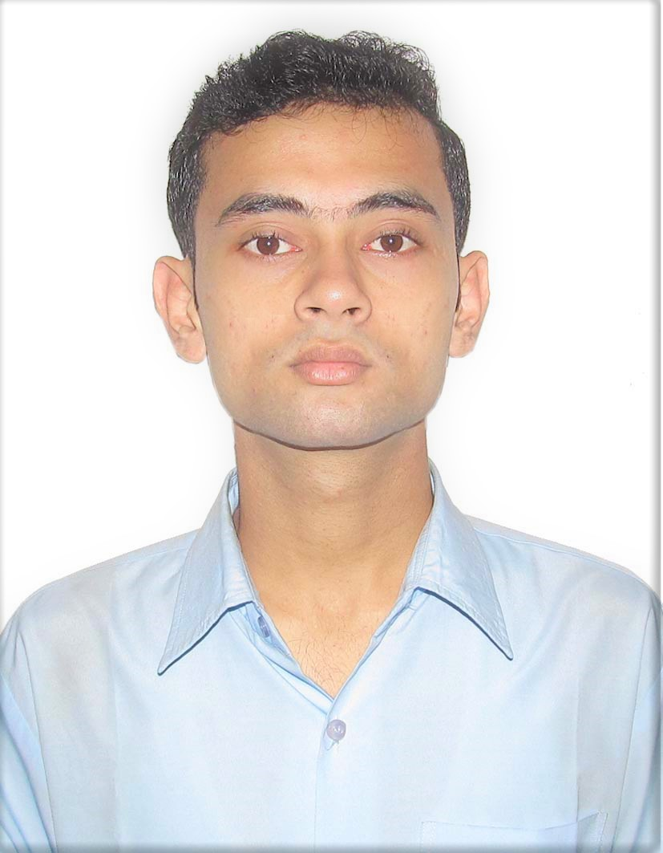

**SHIBSHANKAR MITRA**

Chaksadi, Kuthikonarpur, Ghatal, Paschim Medinipur, West Bengal. PIN – 700136

**Mobile No**: **(+91)** **983516859**, **7908221517**

**Email-Id:** shibu.rkmv@gmail.com

**CAREER OBJECTIVE:** To work in a very productive environment where I can contribute

significantly to my organisation simultaneously developing my technical skills as well.

**EDUCATIONAL QUALIFICATIONS**:

|  |  |  |  |  |
| --- | --- | --- | --- | --- |
| **COURSE** | **UNIVERSITY/**  **BOARD** | **COLLAGE/INSTITUTION** | **PERCENTAGE/**  **CGPA** | **YEAR OF**  **PASSING** |
| B.TECH. in Computer Science and Engineering | MAKAUT | B. P. Poddar Institute of Management & Technology | 7.6 CGPA up to 6th semester | 2019 |
| Higher Secondary Examination | WBCHSE | Ramakrishna Mission Vidyapith, Purulia | 92 | 2015 |
| Madhyamik Examination | WBSE | Ramakrishna Mission Vidyapith, Purulia | 92.6 | 2013 |

**SUBJECT PROFICIENCY**: C programming Language, Java, Database Management Systems.

**TRAININGS UNDERTAKEN:**

|  |  |  |  |  |
| --- | --- | --- | --- | --- |
| **Training name** | **Provider** | **Description** | **Date** | **Duration (Hours)** |
| Big Data Analytics Hadoop and Apache hive | Ardent Computech private Ltd | A training to learn the basics of Big Data and the uses of Hadoop and hive. | 11th June 2018 to 4th July 2018 | 45 |

**PROJECTS UNDERTAKEN**:

* **Armed Conflict Event Data Analysis**:

Built an analysis on A dataset of armed conflicts among the nations all around the world to determine most war affected nations of the world.

**Technologies:** Apache hive, Apache Hadoop, Map Reduce Programs.

**Duration:** June 2018 – July 2018.

**ACHIEVEMENTS/ EXTRA-CURRICULAR ACTIVITIES:**

* (Runners up) Inter college Football tournament 2015-2016.
* (Champions) Inter college Football tournament 2017-2018.
* Man of the Match, Inter college Football tournament 2017-2018.
* (Runners up) Intra college Carrom tournament (Anakhronos, Techno India) 2017-2018.

**PERSONAL DETAILS:**

**Nationality**: India

**Date of Birth:** 27/05/1997

**Languages:** Bengali, Hindi, English

**Hobbies:** Football, Music, Reading Story Book

**Signature: _____________________**

**Date:**