ENTERPRISE DATA ACQUISITION & PREPROCESSING STRATEGY
A Technical Roadmap for Data Sourcing, Quality Auditing, Outlier Detection, Imputation, and Feature Transformation in Python Analytics
AUTHOR: Senior Data Lead / Analytics Engineer | VERSION: 1.0 | TARGET TIMELINE: 30–35 Hours Execution
📌 EXECUTIVE STRATEGY SUMMARY: In modern data analytics, raw data is rarely directly consumable. Garbage in yields garbage out. This document presents a strategic framework for acquiring data from public APIs, databases, and web sources, enforcing 6-dimension data quality controls, addressing missingness (MCAR/MAR/MNAR) and anomalies (IQR/Z-Score/Isolation Forest), and performing optimal feature scaling and encoding in Python for maximum downstream analytical fidelity.

1. Strategic Vision & Project Objectives
Data acquisition and preprocessing form the foundational bedrock of any quantitative analytics endeavor. A rigorous preprocessing strategy ensures that real-world noise, structural irregularities, missing values, and distribution anomalies are systematically triaged before data enters exploratory, statistical, or machine learning pipelines.
Key Project Objectives:
1. Standardize Multi-Source Ingestion: Integrate diverse external data streams (REST APIs, Web Scrapes, Database Extracts) seamlessly.
2. Automate Quality Auditing: Implement a repeatable 6-dimension schema validation matrix.
3. Mitigate Information Loss: Employ state-of-the-art imputation algorithms (MICE, KNN) customized to missingness types.
4. Prevent Distortions: Apply robust anomaly detection (Isolation Forest, IQR) to safeguard analytical modeling.
5. Optimize Analytical Fit: Tailor feature scaling and encoding to specific downstream algorithmic requirements.
2. Public Data Sources & Selection Framework
Selecting appropriate data sources is a multi-dimensional optimization task. To balance data richness, licensing constraints, and computational feasibility, public datasets are evaluated across a 7-point assessment matrix.
2.1 Data Selection Criteria Matrix
Evaluation Criterion | Threshold / Metric | Strategic Rationale & Target Objective
1. Freshness & Cadence | Daily / Real-time API | Ensures models reflect current macro trends without temporal lag.
2. Licensing & Governance | CC-BY 4.0 / Open Government | Prevents legal liabilities and guarantees commercial/academic reuse.
3. Schema Stability | Semantic Versioned API | Minimizes breaking structural shifts during automated ingestion runs.
4. Missingness Ratio | Unrecoverable Nulls < 15% | Limits bias introduced by aggressive row/column truncation.
5. Spatial/Temporal Coverage | 5+ Years Longitudinal Data | Provides sufficient sample size for statistical power and time-series trends.
6. Granularity | Transaction / Event Level | Enables flexible aggregation at daily, weekly, or regional levels.
7. API Throttling Limits | >= 1,000 requests/min | Guarantees high-throughput batch extraction within project schedule.

2.2 Identified Public Benchmark Sources
For this project, three benchmark public datasets have been prioritized:
• World Bank Data API: Global macroeconomic metrics, development indicators, and trade volumes.
• NYC OpenData Portal: High-density urban mobility, service requests, and transaction logs.
• Kaggle Global E-Commerce & Financial Transactions Benchmark: Granular consumer behavior and pricing telemetry.
3. Data Extraction Methods & Technical Challenge Mitigation
Data extraction bridges public repositories and local analytics memory spaces. Each extraction pattern introduces distinct operational failure modes.
3.1 Extraction Challenges & Technical Countermeasures
Extraction Vector | Anticipated Challenge | Technical Mitigation Strategy
RESTful APIs | HTTP 429 Rate Limiting & Throttling | Exponential backoff retry policy (tenacity library) with persistent API key rotation.
Web Scraping | Anti-Bot Captchas & Dynamic JS Rendering | Headless Playwright rendering with user-agent randomization and polite delay intervals (1-3s).
Bulk Databases | Memory Overflow on High-Volume CSVs | Chunked streaming with pandas read_csv(chunksize=50000) and PyArrow Parquet memory mapping.
Heterogeneous Data | Character Encoding Mismatch (Latin-1/UTF-8) | Chardet automatic encoding detection and forced UTF-8 byte stream coercion upon download.
Network Connections | Socket Timeouts & Dropped Packets | Atomic partial downloads stored in staging buckets with SHA-256 integrity checksum verification.

4. Data Quality Assurance, Validation & Cleaning Strategy
Data quality auditing is executed across six foundational dimensions: Completeness, Accuracy, Consistency, Timeliness, Validity, and Uniqueness. Violations are isolated before downstream transformation.
4.1 Missing Data Taxonomy & Imputation Framework
Handling missing values requires diagnosing the statistical mechanism underlying the missingness:
📌 MISSINGNESS MECHANISM TAXONOMY: 1. MCAR (Missing Completely at Random): Missingness is independent of observed and unobserved data. Action: Mean/Median Imputation or Listwise Deletion if < 3%.
2. MAR (Missing at Random): Missingness depends on observed features (e.g., income missingness correlated with age). Action: KNN Imputation or MICE (Multivariate Imputation by Chained Equations).
3. MNAR (Missing Not at Random): Missingness relates to unobserved true values. Action: Add binary missing indicator columns (is_missing=1) and domain-specific modeling.

4.2 Outlier Detection & Treatment Methodologies
Outliers represent either legitimate extreme events or measurement errors. Three complementary techniques are utilized:
• Z-Score (Parametric): Flags data points where |Z| > 3.0. Assumes underlying normal distribution.
Formula: Z = (X - μ) / σ
• Interquartile Range (IQR - Non-Parametric): Resilient to existing heavy skewness. Flags points outside [Q1 - 1.5×IQR, Q3 + 1.5×IQR].
Formula: IQR = Q3 - Q1
• Isolation Forest (Multivariate ML): Constructs isolation trees to partition high-dimensional feature spaces. Anomaly scores identify complex multivariate outliers.
4.3 Outlier Treatment Rationale
Rather than blanket row deletion (which destroys sample size), extreme values undergo Winsorization (capping at 1st and 99th percentiles) or log transformation to preserve sample density while bounding leverage.
5. Python Toolchain Justification & Transformation Rationale
The selection of Python libraries is tailored to maximize execution efficiency, memory management, and algorithmic rigor.
5.1 Technical Toolchain Rationale Matrix
Library / Framework | Primary Preprocessing Functions | Technical Justification & Advantages
Pandas 2.x | Dataframe operations, time-series alignment, group aggregations | C-optimized Arrow backend support, intuitive index alignment, rich I/O connectors.
NumPy 1.26+ | Vectorized array math, matrix transformations, log transforms | BLAS/LAPACK hardware acceleration, minimal memory overhead for numerical computations.
Scikit-Learn 1.4+ | StandardScaler, RobustScaler, OneHotEncoder, IterativeImputer | Production-tested API, pipelining capabilities, prevention of data leakage via fit/transform splits.
SciPy 1.12+ | Shapiro-Wilk normality tests, Box-Cox transforms, Z-scores | Extensive statistical distribution modeling and formal hypothesis testing utilities.
Polars / Dask | Out-of-core evaluation, multi-threaded parallel file reads | Used as high-scale fallback for datasets exceeding RAM limits (> 10GB).

5.2 Data Transformation Methodology
• Scaling Strategy: Continuous numeric features are transformed using RobustScaler (subtracts median, scales by IQR) when outliers exist, or StandardScaler (Z-scoring) for normally distributed metrics.
• Categorical Encoding: Low-cardinality nominal values (< 10 levels) undergo One-Hot Encoding. High-cardinality nominals use Target / Frequency Encoding.
• Skewness Correction: Features with skewness |S| > 1.0 are log-transformed (np.log1p) or Box-Cox transformed.
6. Preprocessing Workflow Architecture & Pseudo-code
The end-to-end data acquisition and preprocessing workflow is operationalized into an object-oriented Python pipeline architecture.
6.1 Visual Pipeline Architecture Flowchart

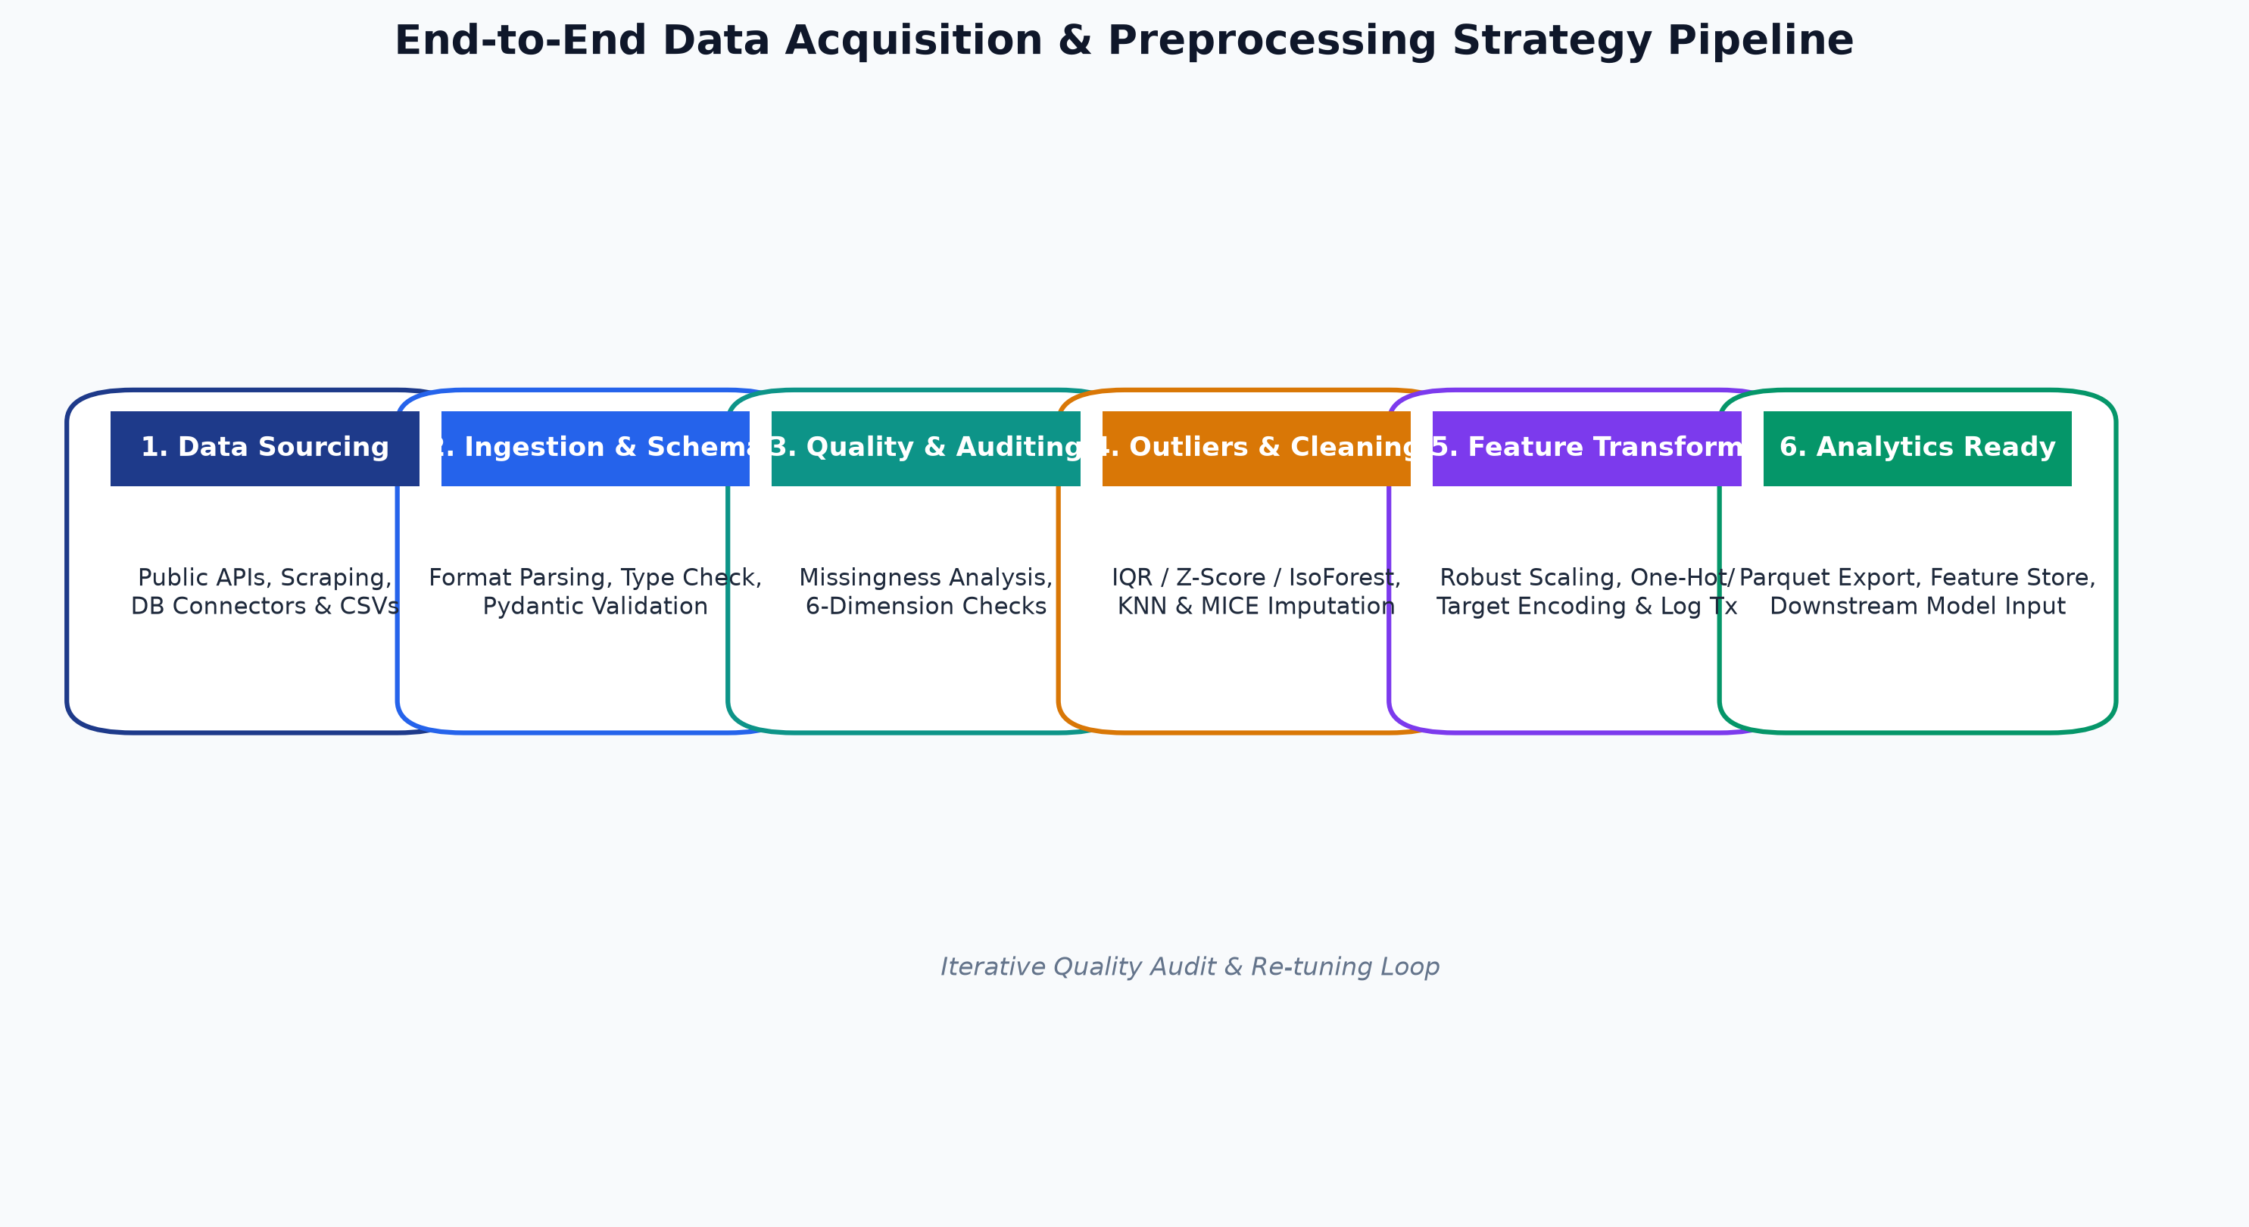
Figure 1: End-to-End Modular Data Preprocessing Workflow Diagram
6.2 Modular Python Preprocessing Pseudo-code
import pandas as pd
import numpy as np
from sklearn.base import BaseEstimator, TransformerMixin
from sklearn.preprocessing import RobustScaler, OneHotEncoder
from sklearn.impute import KNNImputer
from sklearn.ensemble import IsolationForest
class ProductionDataPipeline(BaseEstimator, TransformerMixin):
def __init__(self, numeric_cols, categorical_cols, outlier_contamination=0.03):
self.numeric_cols = numeric_cols
self.categorical_cols = categorical_cols
self.contamination = outlier_contamination
self.imputer = KNNImputer(n_neighbors=5)
self.scaler = RobustScaler()
self.encoder = OneHotEncoder(sparse_output=False, handle_unknown='ignore')
self.iso_forest = IsolationForest(contamination=self.contamination, random_state=42)
def fit(self, X, y=None):
# 1. Fit Missingness Imputer on Numerics
self.imputer.fit(X[self.numeric_cols])
imputed_num = self.imputer.transform(X[self.numeric_cols])
# 2. Fit Robust Scaler
self.scaler.fit(imputed_num)
# 3. Fit Categorical Encoder
self.encoder.fit(X[self.categorical_cols].fillna("MISSING"))
# 4. Fit Anomaly Detector
self.iso_forest.fit(imputed_num)
return self
def transform(self, X):
X_clean = X.copy()
# 1. Impute Numerics
imputed_num = self.imputer.transform(X_clean[self.numeric_cols])
# 2. Flag Outliers
outlier_flags = self.iso_forest.predict(imputed_num)
X_clean['is_outlier'] = np.where(outlier_flags == -1, 1, 0)
# 3. Scale Numerics
scaled_num = self.scaler.transform(imputed_num)
df_scaled = pd.DataFrame(scaled_num, columns=[f"{c}_scaled" for c in self.numeric_cols], index=X_clean.index)
# 4. Encode Categoricals
encoded_cat = self.encoder.transform(X_clean[self.categorical_cols].fillna("MISSING"))
cat_feature_names = self.encoder.get_feature_names_out(self.categorical_cols)
df_encoded = pd.DataFrame(encoded_cat, columns=cat_feature_names, index=X_clean.index)
# 5. Assemble Analytics-Ready Matrix
final_df = pd.concat([df_scaled, df_encoded, X_clean[['is_outlier']]], axis=1)
return final_df

7. Coherence & Linkage to Downstream Analytics
Every preprocessing decision directly influences the mathematical assumptions and performance of downstream analytical algorithms.
7.1 Preprocessing Action to Analytics Outcome Matrix
Preprocessing Action | Downstream Analytics Task | Direct Analytical Outcome & Impact
IQR Winsorization | Multiple Linear Regression | Prevents high-leverage extreme values from skewing regression coefficients and inflating Standard Error.
Robust Scaling | K-Means / KNN Clustering | Ensures Euclidean distance metrics are not dominated by high-magnitude scales, equalizing feature weights.
MICE / KNN Imputation | Random Forest / Feature Importance | Preserves multi-variable co-variance structure required for accurate Gini impurity variance reduction.
Log Transformation | Parametric ANOVA / t-Tests | Normalizes right-skewed residuals to satisfy homoscedasticity and normality assumptions.
Deduplication & Timestamp Alignment | Executive Dashboard / Time Series | Eliminates double-counting in revenue KPIs and prevents irregular spacing in ARIMA/Prophet models.

8. Phased Execution Timeline & Project Milestones (30–35 Hours)
The project execution is structured into five sequential phases spanning 30 to 35 labor hours.
8.1 Visual Gantt Roadmap Chart
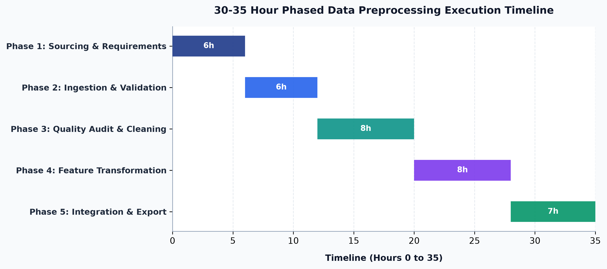
Figure 2: 30-35 Hour Phased Preprocessing Execution Timeline
8.2 Detailed Phase Deliverables Table
Project Phase | Hours Allocated | Core Activities | Phase Deliverable
Phase 1: Sourcing & Setup | 6 Hours | API credentials setup, source selection evaluation, raw data ingestion scripts. | Data Selection Matrix & Ingestion Scripts
Phase 2: Ingestion & Validation | 6 Hours | Schema enforcement, data type casting, Pydantic contract verification. | Schema Contract & Raw Staging Table
Phase 3: Quality Audit & Cleaning | 8 Hours | Missingness diagnostics, KNN/MICE imputation, IQR/Z-score/Isolation Forest outlier capping. | Data Quality Report & Cleaned Dataset
Phase 4: Feature Transformation | 8 Hours | Robust/Standard scaling, One-Hot/Target encoding, skewness log transforms. | Engineered Feature Store (Parquet)
Phase 5: Integration & Docs | 7 Hours | Pipeline modularization, unit testing, documentation, README.md and .DOC finalization. | Final Strategy DOC & Modular Code

