Introduction to Materials Molecular Dynamics Modelling:

1. Modelling structural change with temperature

1. Aims and Objectives

The aim of this task is to introduce molecular dynamics for atomistic simulation. We will start with some generated structures for simple materials, and then carry out molecular dynamics (MD) simulations using a package called DL_POLY, developed at Daresbury Laboratory, which is an important flagship code for CCP5 – do have a look at what else is available: https://www.ccp5.ac.uk/.

There are two versions, DL_POLY_Classic and DL_POLY4. A detailed manual for DL_POLY_Classic and the source code is contained on the website https://ccpforge.cse.rl.ac.uk/gf/project/dl_poly_classic/ and the manual is essential reading for those intending to use the package seriously. We will mainly be adjusting the DL_POLY CONTROL file to adjust the simulation conditions and analysing the output obtained from MD simulations using a package called VMD. Once this task is complete we will explore the structural changes in different materials.

By the end of this task you will be able to:

1. Perform molecular dynamics simulations at different temperatures.

2. Manipulate the input files.

3. Adjust the ensemble for the simulation.

4. Examine the volume and energy of different simulations.

5. Apply VMD to visualize the simulation cell and evaluate radial distribution coefficients.

1. Molecular dynamics calculations using DL_POLY

DL_POLY is a general purpose parallel molecular dynamics package that was written by Daresbury Laboratory, primarily to support CCP5. The code is available free of charge and was written to be sufficiently flexible that it can be applied to many different condensed matter materials. There are two versions of the code, DL_POLY_Classic and DL_POLY4. DL_POLY Classic currently has a little more functionality, while DL_POLY4 is more focussed on systems with more than 30,000 atoms. Although with the PLUMED add-inhttp://www.plumed.org/ DL_POLY4 is able to calculate free energies.

* 1. *Modifying CONTROL input file for DL_POLY to find the Solid-Liquid Phase Transition for Argon.*

When running a DL_POLY simulation you need to have at least 3 files in your folder, CONTROL, FIELD and CONFIG.

Copy the folder W1 from the public folder onto your desktop. In W1 you will find 3 files: CONTROL, FIELD and CONFIG. The subfolder called extensions relates to Section 3 in this document, which are further exercises for you to later.

1. CONTROL

Specifies the controlss for a run of the program e.g. number of steps, timestep, temperature, pressure, ensemble etc.

1. FIELD

Specifies the force field for the simulation. It is also important to appreciate that it defines the order in which atoms will appear in the configuration. For example, if there were 25 W and 75 O atoms, this file will give the order of atoms in the simulation cell.

1. CONFIG

Specifies the dimensions of the simulation cell and then positions of all the atoms (in Å ). If it is generated from a previous run, it may also contain the atomic velocities and forces for each atom.

Note: if restarting the simulation, there may be another file, REVOLD, which is a list of data used in the analysis.

A useful first check that the atom positions are not chemically sensible is to open the CONFIG file with VESTA

Open the CONFIG with VESTA, which should open displaying the Ar crystal. *If you are not sure what the structure should look like, ask a demonstrator to check your results.*

Experiment with using the viewer to manipulate the cell.

For example you might try to change the display type or grow the crystal.

Open the file CONTROL in Notepad++. This file, as its name suggests, contains all the control variables for the simulation, i.e. it tells the program what to do. We have generateda template file with some standard values for a typical simulation; however for the simulation we are going to perform we will need to change a few of these values.

1. Check that the time step is set at 0.001 ps (1 fs)

2. Check the number of ‘steps’ is set to 20000

3. Change the values traj 1 250 0 to traj 0 100 0. This changes how often the program writes out to the HISTORY file (more on this later)

4. Select a *temperature* to run: first try 85. This is the temperature in Kelvin.

Once you have made these changes save the file as CONTROL. (again, all capitals with *no suffix –* ignore any warnings about changing suffix type).

NOTE: The reliability of the result will depend on the number of steps as this improves the statistics. Thus, if the computer is fast enough, or you are leaving it running etc, try increasing the number of steps, but be careful or you may spend too much time waiting.

All DL_POLY simulations should be run in separate folders.

To run DL POLY, copy the dlpoly “app” or exe file into your folder and then double-click on it to launch DL_POLY (no need to drag-and-drop files).

The DL_POLY jobs will take just under 10 minutes to run – if you find that yours is terminating immediately, or lasting for significantly longer than 15 minutes, *please inform a demonstrator*. Once the job has finished, you should find a number of new output files in the working directory: HISTORY, OUTPUT, RDFDAT, REVCON, REVIVE and STATIS.

The output files are as follows:

1. OUTPUT

Contains a summary of the simulation, including the input data, simulation progress report and summary of final system averages.

1. REVCON

This contains the positions, velocities and forces of all the atoms in the system at the end of the simulation. When renamed CONFIG is used as the restart configuration for a continuation run. It is written at the same time as the REVIVE file. As with the CONFIG file, it is always worth checking that the atoms are at sensible positions.

1. STATIS

Contains a number of system variables at regular (user-specified) intervals throughout a simulation. It can be used for later statistical analysis. Note the file grows every time DL_POLY is run and is not overwritten. It should be removed from the execute subdirectory if a new simulation is to be started.

1. HISTORY

This details the atomic positions, (although can be made to contain velocities and forces) at selected intervals in the simulation. It forms the basis for much of the later analysis of the system. This file can become extremely large (beware) and is appended to, not overwritten, by later runs. It should always be removed from the execute subdirectory if a new simulation is to be started.

Note: if restarting the simulation, the output file: REVIVE should be renamed REVOLD, as it then continues to save the list of data used in the analysis.

Open the OUTPUT file in WordPad or Note Pad and search for the word “final averages”. Under this line, you should find a table of properties and their fluctuations.

Properties we particularly consider are temp_tot, eng_cfg, volume and press (Temperature, Potential Energy, Volume and Pressure). As this is run in the NVE ensemble, clearly the volume will stay fixed.

Check that the temperature is close to your chosen value, if not, increase the number of equilibration steps (e.g. from 1000 to 10000) and increase the total number of steps by 10000.

Increase the total number of steps and see if the properties remain reasonably constant, i.e. checking that the results are not dependent on the number of timesteps.

Repeat the simulation in a separate folder but at 110K. Is there a phase change from solid to liquid based on the properties?

*3.2 Arrhenius plot for ionic diffusion in CaF2*

By simulating the CaF2 structure at a range of different temperatures, the change in rate of ionic diffusion (as measured by the diffusion coefficient) as a function of temperature can be

used to determine the thermal activation barrier for the ionic transport. This value may be compared directly with the defect formation energies, to shed some light on the mechanisms of diffusion at finite temperature.

A widely-used classification of phase transitions is the Ehrenfest classification, which describes phase transitions as nth order, where n is the nth order temperature derivative of an intrinsic quantity where a discontinuity occurs (see Figure 2). For instance, the liquid-gas phase transition is described as a 1st order phase transition as there is a discontinuity in a number of properties:

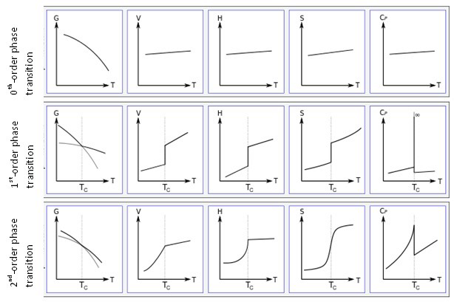Figure 1: Gibbs Free Energy, G, volume, V, enthalpy, H, entropy, S, and heat capacity at constant pressure, Cp graphs against temperature for 0th, 1st and 2nd order Ehrenfest phase transitions..

*2.2 Structural analysis and visualization using VMD*

In order to look in more detail at structure we can visualize the trajectories directly using a package called VMD (Visual Molecular Dynamics). As well as visualization, VMD can also calculate radial distribution functions g(r) to enable a more quantitative structural analysis, which can easily distinguish between a solid and liquid, based on the structure

Launch VMD from the shortcut. After a few seconds, you should see three windows appear, the top-most being the ‘VMD Main’ window. From the ‘File’ menu of the main window, select ‘New Molecule’ and ‘Browse’ to the directory in which you carried out your DL_POLY simulation in 3.2 above. Then, select HISTORY file and change the setting of ‘Determine file type’ drop-down menu to ‘DLPOLY V2 History’. Now, select ‘Load’ and VMD will load in the frames of your simulation. If you don’t see anything appear in the VMD Display window, please ask a demonstrator for help.

VMD can build various visual representations of your model, which are accessed from the ‘Graphics’ menu of the main window. You can rotate and zoom in/out on these using mouse.

Select ‘Display’ and click on the orthographic button.

Select ‘Representations’ from the ‘Graphics’ menu to bring up the ‘Graphical Representations’ control panel. Change the ‘Drawing Method’ to ‘VDW’ and you should be able to see the Ar (green) ions clearly. Increase ‘Sphere Resolution’ to around 20 to get better definition of the spheres, and ‘Sphere scale’ to around 0.6 to get a clearer view of the atoms.

To view the trajectory of one atom, Change ‘Material’ to ‘Transparent’, and then click on ‘Create Rep’ button near top left-hand corner of ‘Graphical Representations’ box. This will create a new representation, which is initially identical to the first. Change text in ‘Selected Atoms’ box in new representation from All to index 80, and change Material’ back to ‘Transluscent’ You should now Ar atoms, but one Ar will be highlighted.

You can step through the frames in your simulation by returning to the ‘VMD Main’ window and clicking on the advance single frame button.

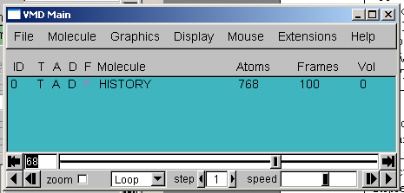

You can also animate the frames by pressing play button, and adjust the speed from the slider. Although your simulations will only have a small number of frames, some evidence of F motion should be seen at the higher temperatures. However, simulations at 300 K should show very different behaviour.

*Calculating RDFs with VMD*

To show quantitatively the different degrees of structural order at the two temperatures, the radial distribution function can be used. To access this from VMD, go to the ‘Extensions’ menu from the main window, and from the ‘Analysis’ sub-menu, select ‘Radial Pair Distribution Function g(r)’. This should bring up the following window:

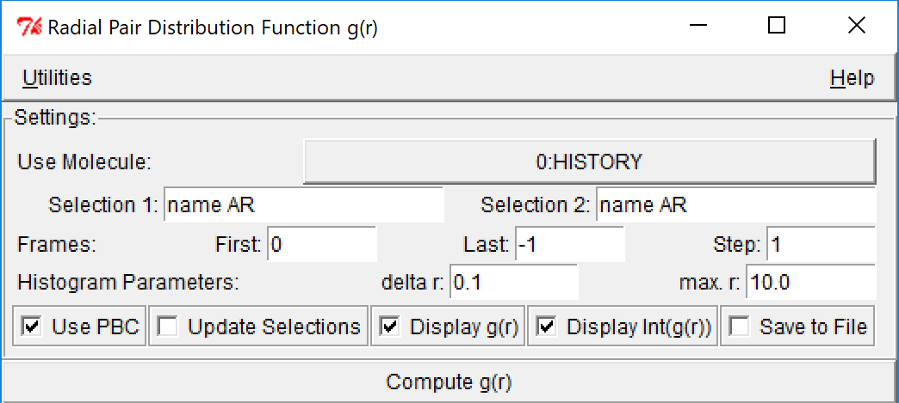

Change the text in ‘Selection 1’ and ‘Selection 2’ boxes to name AR, as above, and then click on ‘Compute g(r)’ button. This will generate the AR pair radial distribution functions. What do you notice about their form? Can you use these to make a qualitative statement about the relative degree of ordering at 85 and 110 K?

*2.3 Effect of Ensembles on the solid to liquid phase transition temperature*

One of the clear limitations of the algorithm used so far is that the volume was held fixed, and not surprisingly, this will suppress the phase transition, and hence we require to increase the temperature further to initiate the transition. In DL_POLY there are a number of algorithms that can be deployed to control the external condition. These include:

1. Fixed volume, fixed energy (NVE)
2. Fixed volume, constant temperature (NVT-Berendsen)
3. Fixed volume, constant temperature (NVT-Nosé-Hoover)
4. Constant pressure, constant temperature (NPT-Berendsen)
5. Constant pressure, constant temperature (NPT-Nosé-Hoover)
6. Constant stress, constant temperature (NST-Berendsen)
7. Constant stress, constant temperature (NST-Nosé-Hoover)

The ensemble we have used to date is the NVE or microcanonical ensemble. The others mentioned here either run at constant Temperature or constant Temperature and Pressure. The NPT allows the volume to change but retains the shape of the simulation cell, while NST allows the shape to change also. The Berendsen and Nosé-Hoover are different formulations, described elsewhere. From a practical point of view, Berendsen tends to be more robust/forgiving while Nosé-Hoover gives a more accurate representation of the true thermodynamics.

In the CONTROL file change ensemble nve

with ensemble npt hoover 0.1 0.5

Rerun simulations at 85 and 110K. Has a solid-liquid phase transition occurred? What is your evidence? Can you obtain an approximate transition temperature?

Note: the two numbers after hoover represent the relaxation times of the thermostat and barostat in ps, see manual for detailed explanation.

*2.4 Effect of Vacancies on the solid to liquid phase transition temperature*

Phase transitions are often require some nucleation event to begin the transition, which may happen at a defect. In this section we will modify the CONTROL and FIELD files to examine the effect of vacancies on the process.

In the CONFIG file delete the atom label and the coordinate position, which is on the following line for a chosen number of species, for example 4. And in FIELD change the nummols associated with AR, ie. From

Argon Atoms

NUMMOLS 108

To

Argon Atoms

NUMMOLS 104

Does this affect the melting temperature? Does the choice of vacancy locations matter?

NOTE: As you are perturbing the system, the number of equilibration steps may need increasing.

Rerun simulations at 85 and 110K. Has a solid-liquid phase transition occurred? What is your evidence? Can you obtain an approximate transition temperature?

1. ***Further exercises on structural changes***

The approaches described here can be consolidated by using DL_POLY to explore the effect of temperature on a number of different materials

*3.1 Melting temperature of other Lennard-Jones Solids*

If you wanted to stick to other simple materials, explore the solid-liquid phase transition of structurally related materials.

A Lennard-Jones material is made up of chargeless particles that only interact with each other via the Lennard-Jones potential. The Lennard-Jones potential can be expressed in the following form:

$$ϕ\left(r_{ij}\right)=4ε\left({\left(\frac{σ}{r_{ij}}\right)}^{12}-{\left(\frac{σ}{r_{ij}}\right)}^{6}\right)$$

where ϕ(rij) is the potential energy of the interaction between particles i and j separated by a distance rij, ϵ is the parameter relating to the depth of the potential well and σ is the distance at which there is zero interaction. The positive term represents the repulsive component of the interactions which stems from the repulsion between electron charge clouds and is dominant at very short distances. The negative term represents the attractive component of the interaction and stems from phenomena like London Dispersion and dominates at longer distances. The figure below illustrates the shape of ϕ(rij) and the corresponding force acting between two objects, F(rij) as a function of rij.

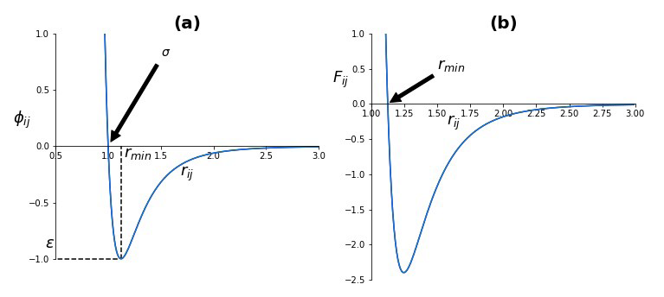

**Figure 2:** Shapes of (a) the Lennard-Jones potential, ϕ(rij), between two particles and (b) the corresponding force, F(rij) , acting between the two particles.

Choose a molecule from the list below and modify FIELD using parameters from the following table of LJ parameters. (recommend selecting one with larger  value)

|  |  |  |
| --- | --- | --- |
| molecule | /kJ/mol | /A |
| He | 0.085 | 2.56 |
| Ne | 0.296 | 2.75 |
| Ar | 0.964 | 3.41 |
| Kr | 1.363 | 3.83 |
| Xe | 1.904 | 4.06 |
| H2 | 0.308 | 2.93 |
| N2 | 0.791 | 3.7 |
| O2 | 0.981 | 3.58 |
| CO | 0.831 | 3.76 |
| CO2 | 1.571 | 4.49 |
| CF4 | 1.264 | 4.7 |
| CH4 | 1.239 | 3.78 |
| C2H6 | 2.020 | 3.95 |
| C(CH3)4 | 1.929 | 7.44 |
|  |  |  |

*3.2 Effect of temperature on the volume of framework materials*

Materials that show negative thermal expansion (contracts upon heating) are highly sought targets materials design. For example, negative thermal expansion materials can be used to produce thermal-expansion-adjustable composites for application in diffraction gratings and optical fibres, and these materials often possess auxetic behavior, leading to their application in a range of mechanical devices. Early simulation work suggested that most if not all materials with large open structures are likely to show negative thermal expansion, and lead to a large body of work on rigid unit modes to explain the molecular movements.

In this example, we have selected the siliceous form of a well-known zeolite, LTA, and we wish to examine whether it shows negative thermal expansion at low temperatures. Perform a range of constant pressure (or stress) simulations at low temperatures and identify the temperatures over which it contracts on heating. If use examine the FIELD file, you can see that it has Lennard-Jones parameters for the short range interactions. It differs from the examples above, by having both partial charges on the silicon and oxygen and a three body potential to assist keeping the O-Si-O angle close the tetrahedral value (109.5)

Acknowledgement:

Thanks to Dr Bill Smith (Daresbury) and Dr James Grant & Chris King (Bath)