<DEPARTMENT OF COMPUTER SCIENCE & ENGINEERING>
ABES ENGINEERING COLLEGE, GHAZIABAD
SOFTWARE REQUIREMENTS
SPECIFICATION (SRS)
Project Title: Retail Inventory Management System (Agile Capstone Case Study)
Project ID: P_022 | Methodology: Agile / Scrum (8 Epics, 15 Sprints)
Academic Compliance: IEEE Std 830-1998

SUBMITTED BY:  1. Shibu Kumar (2400320101035)  Degree: Bachelor of Technology (B.Tech)  Academic Year: 2026 - 2027 | UNDER THE GUIDANCE OF:  Prof. / Dr. <Supervisor Name>  <Designation / Title>  Department of Computer Science & Engg.  Status: 3rd Year Project Specification  Date of Submission: 30-09-2026

Document Revision & Approval History
Version | Date | Description / Major Changes | Prepared By | Reviewed By
0.1 | 15-Sep-2026 | Initial Draft & Scope Definition | Shibu Kumar | Project Guide
1.0 | 30-Sep-2026 | Final SRS Baseline (Spring Boot 3 / Angular 19 stack) | Shibu Kumar | HOD / Committee

Guidance Note: This Software Requirements Specification document conforms to the IEEE 1998 standard recommended practice. All sections are strictly designed for 3rd-year university lab evaluation, project reviews, and system design baselines.

1. Introduction

1.1 Purpose of the Document
This SRS defines the functional, non-functional, interface, data and use-case requirements of the Retail Inventory Management System (RIMS), Project ID P_022, following IEEE Std 830-1998. It is the agreed baseline between the student developer, academic supervisor and evaluators, and every later design, coding, testing and sprint task is traceable to the requirement IDs given here.

1.2 Scope of the Project
RIMS replaces spreadsheet-based stock handling in retail chains that run several warehouses (godowns) and stores. Traditional versus proposed system:
Aspect | Traditional Retail Process | Proposed RIMS (Automated Multi-Warehouse)
Stock visibility | Separate sheets per warehouse; data outdated within hours | Single source of truth: live Product × Warehouse matrix
Stock transfer | Phone/manual entries; partial updates create phantom stock | Atomic ACID transfer with pessimistic locking; zero discrepancy
Order handling | Order accepted without stock check; manual deduction | Real-time availability check and automatic deduction in one transaction
Reordering & reports | Shortages found late; month-end consolidation | Threshold alerts, supplier lead times, live KPI dashboard

- In scope: JWT authentication with RBAC, product catalog with SKU generation, multi-warehouse inventory, atomic transfers, sales-order lifecycle with auto stock deduction, supplier directory, KPI dashboard, Docker/CI-CD deployment. Out of scope: payment gateway, GST/accounting filing, native mobile apps, automatic purchase-order e-mails (future scope).

1.3 Definitions, Acronyms, and Abbreviations
Term | Meaning | Term | Meaning
SKU | Stock Keeping Unit – unique product code (e.g., SKU-ELE-000123) | JPA / ORM | Java Persistence API / Object-Relational Mapping (Hibernate)
ACID | Atomicity, Consistency, Isolation, Durability of a transaction | REST | Stateless, resource-oriented HTTP API style
RBAC | Role-Based Access Control (ADMIN, WAREHOUSE_MANAGER, STAFF) | DTO | Data Transfer Object between layers and API
JWT | JSON Web Token (RFC 7519), HMAC-SHA256 signed Bearer token | Pessimistic Lock | SELECT … FOR UPDATE row lock; others wait
Lead Time | Days from supplier order to goods receipt | Reorder Point | min_threshold level that triggers replenishment

1.4 References and Document Overview
IEEE Std 830-1998; Spring Boot 3.4, Spring Data JPA and Spring Security 6 reference documentation; Angular 19 documentation (angular.dev); MySQL 8.0 Reference Manual; RFC 7519; OWASP Top 10; The Scrum Guide. Overview: Section 2 describes the system and architecture, Section 3 the functional requirements by Epic, Section 4 the interfaces, Section 5 the database, Section 6 the NFRs, Section 7 the use cases, and Section 8 the sign-off.

2. Overall System Description

2.1 Product Perspective & 3-Tier Layered Architecture
RIMS sits between suppliers (inbound goods) and customers (outbound sales). The Presentation Layer (Angular 19 SPA on Nginx) calls the Application Layer (Spring Boot 3.4 REST API, Java 21) over HTTPS/JSON; the Database Layer (Spring Data JPA/Hibernate, HikariCP, MySQL 8.0 InnoDB) persists all data.
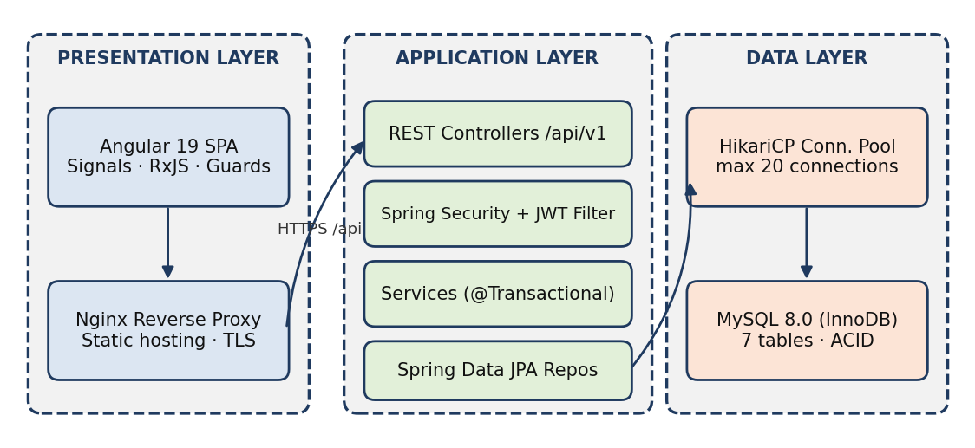
Figure 2.1: Presentation → Application → Database layers
Layer | Components | Responsibilities
Presentation | Angular 19 standalone components, Signals, RxJS, HttpInterceptor, route guards, Nginx | UI, validation, Bearer token attachment, auto-logout on 401, role-aware menus
Application | @RestController, @Service (@Transactional), Spring Security 6 JWT filter, @RestControllerAdvice | Request mapping, authN/authZ, business rules, transaction control, uniform ApiResponse DTO
Database | Spring Data JPA repositories, Hibernate, HikariCP, MySQL 8.0 | Persistence, pessimistic locking, constraints, ACID transactions

2.2 User Classes and Characteristics
Feature | ADMIN (full access, user mgmt, audit logs) | WAREHOUSE_MANAGER (multi-godown ops) | STAFF (store front-line)
Users, audit logs; delete products / warehouses / suppliers | ✔ | ✘ | ✘
Create / edit products, suppliers | ✔ | ✔ | ✘
View catalog and stock matrix | ✔ | ✔ | Read-only
Set thresholds; inter-warehouse transfers; low-stock alerts | ✔ | ✔ | ✘
Create orders / update order status | ✔ / ✔ | ✘ / ✔ | ✔ (fulfillment) / cancel own PENDING
KPI dashboard | Full | Full | Orders & revenue cards

Inventory Auditors review audit-log and stock reports exported by ADMIN; they have no separate login role in this release.

2.3 Operating Environment
Server: Linux (Ubuntu 22.04) or Windows 11 with Docker 24+, JVM 21 (Java 25 supported), Node.js 20 for the Angular build, MySQL 8.0 (InnoDB, utf8mb4); minimum 2 vCPU, 4 GB RAM. Client: latest two versions of Chrome, Edge, Firefox, Safari at ≥ 1366×768, responsive to 360×640; optional USB barcode scanner. Ports: API 5000, Angular 4200 (dev) / 80–443 (Nginx), MySQL 3306.

2.4 Design & Implementation Constraints
- ACID isolation: every stock-changing service method is @Transactional and rolls back on any RuntimeException. Pessimistic locking: inventory rows are read with @Lock(PESSIMISTIC_WRITE) (SELECT … FOR UPDATE).
- Stateless REST API: no HTTP session, Bearer JWT on every request, CORS limited to the SPA origin. Controllers call services only, services call repositories only, and entities are never exposed (DTOs are used).

2.5 Assumptions and Dependencies
Reliable network (≥ 2 Mbps) and NTP-synchronized server clock; every product is stocked in at least one warehouse; single currency (INR). Dependencies: Maven Central, npm, Docker Hub (mysql:8.0, temurin:21, nginx), GitHub Actions and a Jenkins server.

3. System Features & Functional Requirements (Mapped to 8 Agile Epics)

Epic 1: Core System Architecture & Error Handling
ID | Requirement | Rule / Validation | Prio
FR-1.1 | Stateless JWT filter | OncePerRequestFilter validates the Bearer token (HMAC-SHA256, expiry) and sets the SecurityContext; invalid → 401 | H
FR-1.2 | Global exception handler | @RestControllerAdvice: NotFound→404, Validation/InsufficientStock→400, AccessDenied→403, others→500 (safe message) | H
FR-1.3 | Centralized response DTO | Every endpoint returns ApiResponse<T> { success, message, data, timestamp } | H

Epic 2: Product & Category Catalog Management
ID | Requirement | Rule / Validation | Prio
FR-2.1 | SKU generation | SKU-<CAT3>-<6-digit sequence>, unique and immutable; price and cost_price ≥ 0 | H
FR-2.2 | Profit margin | Margin = price − cost_price; Margin % = ((price − cost_price) ÷ price) × 100, live in form and API | H
FR-2.3 | Category filtering & search | Params category, q (name/SKU), page, size; case-insensitive | M
FR-2.4 | Delete validation | ADMIN only; blocked if stock > 0 exists or product appears in order_items | H

Epic 3: Multi-Warehouse Inventory Control
ID | Requirement | Rule / Validation | Prio
FR-3.1 | Product × Warehouse matrix | One row per (product_id, warehouse_id) – composite unique; quantity ≥ 0; per-warehouse and total units | H
FR-3.2 | Minimum threshold | Low stock if quantity ≤ min_threshold; Shortfall = min_threshold − quantity; red badge and banner | H
FR-3.3 | Warehouse master & capacity | code unique, name, location, capacity; total units must not exceed capacity; delete blocked if stock exists | M

Epic 4: Atomic Inter-Warehouse Stock Transfers
ID | Requirement | Rule / Validation | Prio
FR-4.1 | Initiate transfer | productId, fromWarehouseId ≠ toWarehouseId, 0 < quantity ≤ source stock | H
FR-4.2 | Locking, deduct, upsert | Lock rows in ascending warehouse_id order (PESSIMISTIC_WRITE); deduct source; insert-or-increment destination; commit or rollback together | H
FR-4.3 | Zero discrepancy | Σ quantity of the product before = after the transfer (integration-tested) | H

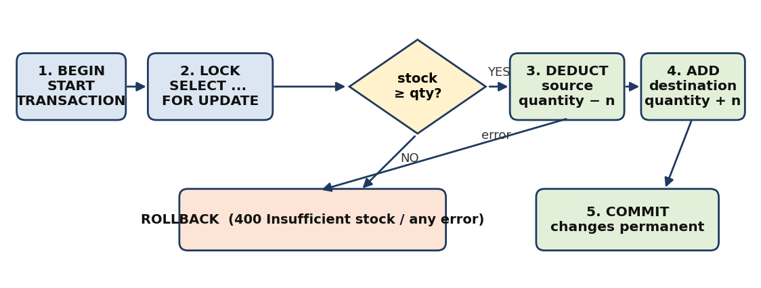  Figure 3.1: ACID transfer workflow | 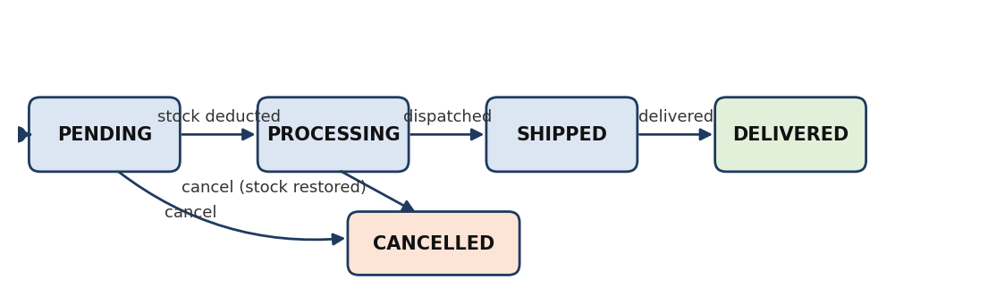  Figure 3.2: Order lifecycle states
@Transactional // ACID boundary: any RuntimeException => ROLLBACK
public void transfer(TransferRequest r) {
Inventory src = repo.findForUpdate(r.productId(), r.fromId()).orElseThrow(NotFound::new); // locked
if (src.getQuantity() < r.quantity()) throw new InsufficientStockException();
src.setQuantity(src.getQuantity() - r.quantity()); // deduct from source
Inventory dst = repo.findForUpdate(r.productId(), r.toId()).orElseGet(() -> newRow(r));
dst.setQuantity(dst.getQuantity() + r.quantity()); // add to destination (upsert)
repo.saveAll(List.of(src, dst)); // COMMIT on return
}

Epic 5: Sales Order Lifecycle & Automatic Stock Deduction
ID | Requirement | Rule / Validation | Prio
FR-5.1 | Multi-line order | customer_name, customer_email, warehouse_id, items[{productId, quantity > 0}]; order_number = ORD-YYYYMMDD-nnnn | H
FR-5.2 | Pricing | unit_price = product.price snapshot; subtotal = quantity × unit_price; total_amount = Σ subtotal | H
FR-5.3 | Real-time deduction | One transaction: lock rows, verify every line, deduct stock; any shortage rolls back the whole order | H
FR-5.4 | Status flow | PENDING → PROCESSING → SHIPPED → DELIVERED; CANCELLED from PENDING/PROCESSING restores stock atomically | H

Epic 6: Supplier & Vendor Management
ID | Requirement | Rule / Validation | Prio
FR-6.1 | Supplier directory | name, contact_person, email (unique), phone, address; searchable | M
FR-6.2 | Lead-time tracking | lead_time_days ≥ 0 (default 7); expected restock = reorder date + lead_time_days | M
FR-6.3 | Deletion safeguards | ADMIN only, confirmation modal, written to the audit log | M

Epic 7: Live KPI Analytics Dashboard
KPI (real-time aggregation) | Formula / Query | KPI | Formula / Query
Total Products | COUNT(products) | Total Orders | COUNT(orders)
Total Warehouses | COUNT(warehouses) | Total Revenue | SUM(total_amount) WHERE status <> 'CANCELLED'
Total Stock Units | SUM(inventory.quantity) | Low Stock Item Count | COUNT(inventory) WHERE quantity <= min_threshold
Recent 5 Orders | ORDER BY created_at DESC LIMIT 5 | Refresh / SLA | Single GET /dashboard, < 200 ms, role-scoped

Epic 8: Security, RBAC & DevOps
ID | Requirement | Rule / Validation | Prio
FR-8.1 | BCrypt hashing | BCryptPasswordEncoder (strength ≥ 10, salted); plain passwords never stored or logged | H
FR-8.2 | JWT & expiry | HMAC-SHA256, claims {sub, role, iat, exp}, 1-hour expiry, secret from environment variable | H
FR-8.3 | Method-level RBAC | @PreAuthorize('hasRole(...)') on endpoints; denial → 403 | H
FR-8.4 | Docker & CI/CD | Multi-stage Dockerfile (Maven → JRE 21), Nginx for Angular, Docker Compose (web, api, db); GitHub Actions and Jenkinsfile: Checkout → Build → Test → Image → Deploy | M

3.9 Agile / Scrum Roadmap – 8 Epics across 15 Sprints
Epic | Sprints | Sprint Goal & Deliverables
E1 Core Architecture & Error Handling | S1–S2 | Project skeletons, JWT filter, global handler, ApiResponse, Docker Compose base
E2 Product & Category Catalog | S3–S4 | Catalog APIs/UI, SKU generator, margin calculation
E3 Multi-Warehouse Inventory | S5–S6 | Warehouse and inventory APIs, stock matrix, low-stock banner
E4 Atomic Stock Transfers | S7–S8 | Transfer service with pessimistic locking, concurrency tests
E5 Sales Order Lifecycle | S9–S11 | Order APIs/UI, auto stock deduction, status machine
E6 Supplier Management / E7 KPI Dashboard | S12 / S13 | Vendor directory with lead times / real-time dashboard
E8 Security, RBAC & DevOps | S14–S15 | BCrypt, RBAC hardening, GitHub Actions + Jenkins, UAT and release

4. External Interface Requirements

4.1 User Interfaces
Responsive Angular 19 SPA (CSS Grid/Flexbox, Signals, toasts, keyboard-accessible modals). Screens: Login/Register (registration by ADMIN), Dashboard (KPI cards, low-stock banner, recent 5 orders), Product Catalog (SKU, price, cost, live margin, category filter), Multi-Warehouse Matrix (red badge at quantity ≤ min_threshold), Stock Transfer Modal, Orders Table (status chips, multi-item cart) and Supplier Directory (lead-time column, delete confirmation).

4.2 – 4.4 Hardware, Software and Communications Interfaces
- Hardware: standard PC; USB barcode scanners work as keyboard-wedge devices that type the SKU into the search box. Software: Spring Boot REST API on port 5000, Angular SPA on 4200 / 80, MySQL 8.0 on 3306 through JDBC/HikariCP, Docker, Nginx, GitHub Actions, Jenkins.
- Communications: HTTPS/HTTP with UTF-8 JSON under /api/v1; verbs GET, POST, PATCH, DELETE; header Authorization: Bearer <JWT> on all endpoints except login; CORS limited to the SPA origin.
Endpoint | Method | Roles | Request Payload | Status Codes
/auth/login, /auth/register | POST | Public / ADMIN | {email, password} / {name, email, password, role} | 200, 201, 400, 401, 403, 409
/products, /products/{id} | GET, POST, PATCH, DELETE | All / ADMIN, MGR / ADMIN | {name, category, price, costPrice} | 200, 201, 400, 401, 403, 404, 409
/warehouses | GET, POST, DELETE | All / ADMIN, MGR / ADMIN | {code, name, location, capacity} | 200, 201, 400, 401, 403, 404
/inventory (PATCH), /inventory/transfer (POST) | GET, PATCH, POST | All / ADMIN, MGR | {productId, warehouseId, quantity, minThreshold} / {productId, fromWarehouseId, toWarehouseId, quantity} | 200, 400, 401, 403, 404, 500
/orders, /orders/{id}/status | GET, POST, PATCH | All / ADMIN, STAFF / ADMIN, MGR | {customerName, customerEmail, warehouseId, items[{productId, quantity}]} / {status} | 200, 201, 400, 401, 403, 404, 500
/suppliers, /suppliers/{id} | GET, POST, PATCH, DELETE | All / ADMIN, MGR | {name, contactPerson, email, phone, address, leadTimeDays} | 200, 201, 400, 401, 403, 404
/dashboard | GET | All (scoped) | — | 200, 401

5. Database Design & Data Dictionary
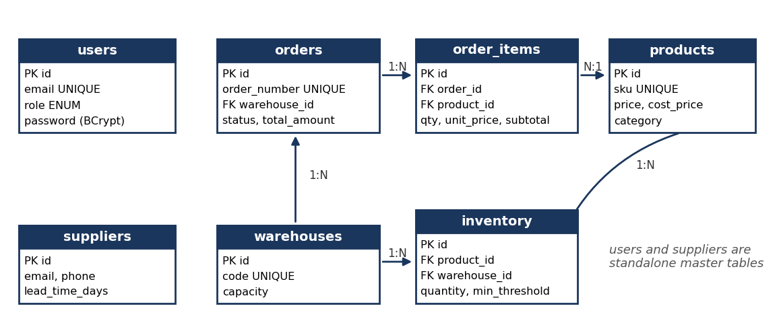
Figure 5.1: ER diagram – seven MySQL 8.0 tables (InnoDB, utf8mb4)
Keys & cascades: inventory → products and warehouses (RESTRICT) with UNIQUE(product_id, warehouse_id); order_items → orders (ON DELETE CASCADE) and products (RESTRICT); orders → warehouses (RESTRICT). Tables users and suppliers are standalone master tables.
CREATE TABLE inventory (id BIGINT AUTO_INCREMENT PRIMARY KEY, product_id BIGINT NOT NULL,
warehouse_id BIGINT NOT NULL, quantity INT NOT NULL DEFAULT 0 CHECK (quantity >= 0),
min_threshold INT NOT NULL DEFAULT 10, UNIQUE KEY uq_product_warehouse (product_id, warehouse_id),
FOREIGN KEY (product_id) REFERENCES products(id),
FOREIGN KEY (warehouse_id) REFERENCES warehouses(id));
CREATE TABLE order_items (id BIGINT AUTO_INCREMENT PRIMARY KEY, order_id BIGINT NOT NULL,
product_id BIGINT NOT NULL, quantity INT NOT NULL CHECK (quantity > 0),
unit_price DECIMAL(10,2) NOT NULL, subtotal DECIMAL(12,2) NOT NULL,
FOREIGN KEY (order_id) REFERENCES orders(id) ON DELETE CASCADE,
FOREIGN KEY (product_id) REFERENCES products(id));

Table | Field – Data Type – Nullable – Constraints | Business Description
users | id BIGINT NN PK AI; name VARCHAR(100) NN; email VARCHAR(150) NN UNIQUE; password VARCHAR(255) NN; role ENUM(ADMIN, WAREHOUSE_MANAGER, STAFF) NN DEFAULT STAFF; created_at TIMESTAMP NN DEFAULT NOW | Login identity; password holds the BCrypt hash; role drives RBAC
products | id BIGINT NN PK AI; sku VARCHAR(30) NN UNIQUE; name VARCHAR(150) NN; category VARCHAR(80) NN INDEX; price DECIMAL(10,2) NN ≥ 0; cost_price DECIMAL(10,2) NN ≥ 0; created_at, updated_at TIMESTAMP NN | SKU auto-generated and immutable; margin = price − cost_price
warehouses | id BIGINT NN PK AI; code VARCHAR(20) NN UNIQUE; name VARCHAR(100) NN; location VARCHAR(200) NN; capacity INT NN CHECK > 0; created_at TIMESTAMP NN | Godown master data; capacity is the maximum units
inventory | id BIGINT NN PK AI; product_id BIGINT NN FK; warehouse_id BIGINT NN FK; quantity INT NN DEFAULT 0 CHECK ≥ 0; min_threshold INT NN DEFAULT 10; UNIQUE(product_id, warehouse_id) | One row per product per warehouse; basis of the stock matrix and low-stock alert
suppliers | id BIGINT NN PK AI; name VARCHAR(150) NN; contact_person VARCHAR(100) NULL; email VARCHAR(150) NN UNIQUE; phone VARCHAR(20) NULL; address VARCHAR(255) NULL; lead_time_days SMALLINT NN DEFAULT 7 CHECK ≥ 0; created_at TIMESTAMP NN | Vendor directory and procurement lead time in days
orders | id BIGINT NN PK AI; order_number VARCHAR(20) NN UNIQUE; customer_name VARCHAR(120) NN; customer_email VARCHAR(150) NULL; warehouse_id BIGINT NN FK; total_amount DECIMAL(12,2) NN DEFAULT 0; status ENUM(PENDING, PROCESSING, SHIPPED, DELIVERED, CANCELLED) NN DEFAULT PENDING; created_at TIMESTAMP NN | total_amount = Σ order_items.subtotal; status follows the lifecycle in Figure 3.2
order_items | id BIGINT NN PK AI; order_id BIGINT NN FK CASCADE; product_id BIGINT NN FK; quantity INT NN CHECK > 0; unit_price DECIMAL(10,2) NN; subtotal DECIMAL(12,2) NN | unit_price is a price snapshot; subtotal = quantity × unit_price

6. Non-Functional Requirements (NFRs)
Category | Requirement | Verification
6.1 Performance | 95 % of API responses < 200 ms at 100 concurrent users; HikariCP pool (min idle 5, max 20); indexes on sku, category, status, (product_id, warehouse_id); pagination (20 rows) | JMeter load test, Actuator metrics
6.2 Safety & Data Integrity | Pessimistic locking (PESSIMISTIC_WRITE) prevents race conditions in concurrent orders and transfers; fixed lock order avoids deadlock; any failure → ROLLBACK; CHECK constraints block negative stock | Concurrent transfer/order integration tests, before/after unit reconciliation
6.3 Security | BCrypt salting; JWT HMAC-SHA256, 1-hour expiry; SQL injection prevented by JPA/Hibernate parameterized queries and Bean Validation; CSRF disabled only because the API is stateless and token-based; CORS whitelist, security headers, RBAC on every endpoint | OWASP ZAP scan, RBAC test matrix
6.4 Reliability & Availability | 99.9 % uptime target with Docker restart policy unless-stopped, health checks (/actuator/health), daily MySQL backup; no stack traces reach clients | Container kill/restart test, monitoring
6.5 Maintainability & Scalability | Controller–Service–Repository layering is microservice-ready; ≥ 80 % service test coverage (JUnit 5, Mockito, Testcontainers); OpenAPI docs; stateless API scales horizontally behind Nginx | Coverage report in GitHub Actions / Jenkins

7. Use Case Scenarios & Actor Matrix
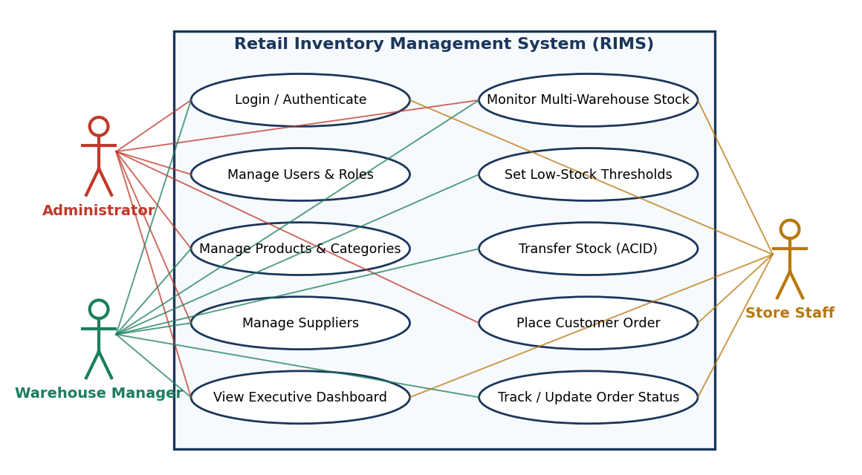
Figure 7.1: Use case diagram – ADMIN, WAREHOUSE_MANAGER and STAFF
Use Case | ADMIN | WAREHOUSE_MANAGER | STAFF
UC-01 User Authentication & JWT Issuance | Primary | Primary | Primary
UC-02 Inter-Warehouse Stock Transfer | Primary | Primary | —
UC-03 Place Customer Order & Deduct Inventory | Primary | — | Primary
UC-04 Generate Low Stock Alert | Receives | Primary | View only

UC-01: User Authentication & JWT Issuance
Field | Description
Actors / Pre | ADMIN, WAREHOUSE_MANAGER, STAFF; account exists in users, API and database running.
Main Flow | 1) User submits email and password. 2) SPA calls POST /auth/login. 3) System compares the password with the BCrypt hash. 4) JWT is issued (HMAC-SHA256, role claim, exp = now + 1 h). 5) SPA stores it and the interceptor attaches it to later calls. 6) User lands on the role-based dashboard.
Alternate | Wrong credentials → 401 (generic message); invalid input → 400; expired token → 401, interceptor logs the user out.
Post / Rules | Authenticated client session, no server session; passwords never returned or logged.

UC-02: Inter-Warehouse Stock Transfer
Field | Description
Actors / Pre | WAREHOUSE_MANAGER, ADMIN; authenticated; product and both warehouses exist.
Main Flow | 1) Manager selects product, source, destination, quantity. 2) POST /inventory/transfer. 3) Transaction starts and both inventory rows are locked (FOR UPDATE). 4) Source stock ≥ quantity is checked. 5) Source is deducted. 6) Destination is incremented or created (upsert). 7) COMMIT; updated quantities returned; low-stock check re-runs.
Alternate | Insufficient stock → rollback, 400; source = destination → 400; DB error → rollback, 500, no change; concurrent transfer waits for the lock and re-validates.
Post / Rules | Total units of the product unchanged; locks taken in ascending warehouse_id order.

UC-03: Place Customer Order & Deduct Inventory
Field | Description
Actors / Pre | STAFF, ADMIN; authenticated; selected warehouse holds stock.
Main Flow | 1) Staff enters customer details and adds items; live totals shown. 2) POST /orders. 3) Rows locked and every line verified. 4) unit_price copied from product; subtotal and total_amount calculated. 5) Order and order_items saved. 6) Stock deducted per line. 7) COMMIT; 201 with order_number; dashboard KPIs update.
Alternate | Any item short → full rollback, 400 listing shortages; empty cart or bad quantity → 400; cancel of PENDING/PROCESSING order restores stock.
Post / Rules | Unique order_number; stock reduced by exactly the ordered quantities; no partial fulfillment.

UC-04: Generate Low Stock Alert
Field | Description
Actors / Pre | WAREHOUSE_MANAGER, ADMIN (STAFF view only); inventory rows carry min_threshold.
Main Flow | 1) A transfer, order or adjustment changes stock, or the dashboard/matrix loads. 2) System tests quantity ≤ min_threshold. 3) Matching rows are flagged LOW STOCK and counted in Low Stock Item Count. 4) Banner lists product, warehouse, quantity and shortfall. 5) Manager checks supplier lead time and plans replenishment.
Alternate | Threshold lowered or stock restored (transfer, cancellation) → alert clears on next refresh.
Post / Rules | All low-stock items visible in real time; Shortfall = min_threshold − quantity; equality counts as low.

8. Academic Review & Sign-Off
This Software Requirements Specification document has been submitted and reviewed by the academic supervisory panel:
Project Coordinator / Guide | Internal Examiner | Head of Department (HOD)
Signature: ____________________  Date: ____________________ | Signature: ____________________  Date: ____________________ | Signature: ____________________  Date: ____________________

