<DEPARTMENT OF COMPUTER SCIENCE & ENGINEERING>
ABES ENGINEERING COLLEGE, GHAZIABAD
SOFTWARE REQUIREMENTS
SPECIFICATION (SRS)
Project Title: Retail Inventory Management System (Agile Capstone Case Study)
Project ID: P_022 | Methodology: Agile / Scrum (8 Epics, 15 Sprints)
Academic Compliance: IEEE Std 830-1998

SUBMITTED BY:  1. Shibu Kumar (2400320101035)  Degree: Bachelor of Technology (B.Tech)  Academic Year: 2026 - 2027 | UNDER THE GUIDANCE OF:  Prof. / Dr. <Supervisor Name>  <Designation / Title>  Department of Computer Science & Engg.  Status: 3rd Year Project Specification  Date of Submission: 30-09-2026

Document Revision & Approval History
Version | Date | Description / Major Changes | Prepared By | Reviewed By
0.1 | 15-Sep-2026 | Initial Draft & Scope Definition | Shibu Kumar | Project Guide
1.0 | 30-Sep-2026 | Final 3rd Year Mid-Term SRS Baseline | Shibu Kumar | HOD / Committee

Guidance Note: This Software Requirements Specification document conforms to the IEEE 1998 standard recommended practice. All sections are strictly designed for 3rd-year university lab evaluation, project reviews, and system design baselines.

1. Introduction

1.1 Purpose
The purpose of this Software Requirements Specification (SRS) document is to provide a complete, clear, and unambiguous definition of the functionality, external interfaces, performance targets, and constraints of the proposed system: ‘Retail Inventory Management System (RIMS)’. This specification serves as a binding reference agreement between student developers, project evaluators, academic supervisors, and prospective end users during the 3rd-year engineering curriculum.

1.2 Scope of the System
The proposed application is designed to solve the problem of stock discrepancies, manual multi-warehouse tracking and slow retail order handling by delivering an end-to-end automated platform. Key boundary guidelines include:
- In-Scope Capabilities: JWT-based user authentication with role-based workflows, product and category catalog with SKU auto-generation, multi-warehouse stock matrix with low-stock alerts, ACID inter-warehouse stock transfers, multi-item customer orders with automatic stock deduction, supplier directory with lead-time tracking, and a real-time analytical dashboard.
- Out-of-Scope Boundaries: Barcode/RFID hardware integration, external enterprise ERP or GST/accounting integration, native mobile applications, and live commercial payment processing (mock sandbox mode utilized).
- Expected Benefits: Zero stock discrepancy through atomic transactions, early low-stock warnings, faster order processing with live availability checks, elimination of redundant manual logging, and immediate accessibility across devices.

1.3 Definitions, Acronyms, and Abbreviations
Category | Term / Acronym | Definition / Standard Context
Standard | SRS | Software Requirements Specification (IEEE Std 830-1998 format).
Architecture | API / SPA | Application Programming Interface for data interchange via JSON/HTTPS; Single Page Application (Angular 19).
Security | JWT / RBAC | JSON Web Token for stateless authorization; Role-Based Access Control.
Database | CRUD / ACID | Create, Read, Update, Delete operations; Atomicity, Consistency, Isolation, Durability transaction guarantees.
Network | REST | Representational State Transfer stateless software architectural style.
Project Specific | SKU | Stock Keeping Unit – unique, system-generated product identifier.
Project Specific | Lead Time / Reorder Point | Days between ordering from a supplier and receipt / stock level (min_threshold) that triggers replenishment.

1.4 References
- IEEE Std 830-1998: IEEE Recommended Practice for Software Requirements Specifications.
- Software Engineering (10th Edition): Ian Sommerville, Pearson Education.
- Relevant Research Papers & APIs: OWASP Top 10; RFC 7519 (JSON Web Token); MySQL 8.0 Reference Manual; Angular 19 and Express.js official documentation; The Scrum Guide.

1.5 Document Overview
The remainder of this SRS is partitioned into structural sections: Section 2 outlines the product perspective, target user personas, operational context, and design constraints. Section 3 itemizes detailed functional requirements organized into logical software modules. Section 4 specifies external interfaces (UI, Hardware, Software, Network). Section 5 defines non-functional attributes (Performance, Reliability, Security). Section 6 provides standard academic modeling diagrams, the database design and the Agile sprint roadmap, and Section 7 records the academic review and sign-off.

2. Overall Description

2.1 Product Perspective
The project is structured as a self-contained multi-tier system comprising a presentation layer (Angular 19 SPA served by Nginx), an application/API logic tier (Node.js + Express.js in a 3-tier layered MVC pattern) and a persistent database backend (MySQL 8.0 with a connection pool). It sits between suppliers (inbound goods) and customers (outbound sales) and interfaces with external services strictly through secure, authenticated RESTful endpoints.
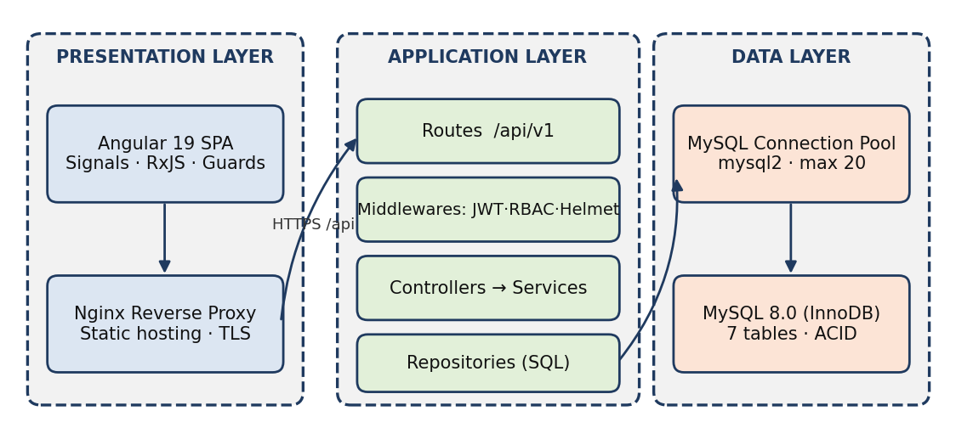
Figure 2.1: System context – 3-tier layered architecture of RIMS

2.2 User Classes and Characteristics
The target software accommodates distinct user personas with varying access hierarchies:
User Role / Persona | Technical Proficiency | Core Responsibilities & Rights
Administrator | High (DevOps / DB Management) | Complete access: user and role management, system configuration, catalog deletion, master data control and all modules.
Warehouse Manager | Intermediate (operations expert) | Multi-location stock monitoring, threshold management, inter-warehouse transfers, supplier management, order status updates, dashboard.
Cashier / Sales Staff | Basic (front-line, minimal training) | Customer order placement, read-only inventory look-up, customer order status, sales-only dashboard cards.

2.3 Operating Environment
The application operates within the following software and hardware environments:
- Client Requirements: Modern web browser (Google Chrome >= v110, Mozilla Firefox >= v108, Edge, Safari); minimum display resolution 1366x768 for desktop, responsive view down to 360x640.
- Server Runtime Environment: Linux (Ubuntu 22.04 LTS / Debian 12) or Windows host running Docker Engine 24+; Node.js 20 LTS with Express.js 5.x inside containers.
- Database Storage Tier: MySQL 8.0 (InnoDB, utf8mb4) community edition running as a Docker Compose service.

2.4 Design and Implementation Constraints
- Academic Budget Constraint: Utilization of local containerized hosting (Docker Compose) or free-tier cloud resources (Render, Railway, AWS Educate).
- Security Compliance: Passwords stored exclusively as salted Bcrypt hashes; JWT expiry of 1 hour with auto-logout on 401; parameterized SQL only.
- Modularity Standards: Adherence to layered MVC (routes → controllers → services → repositories) with RESTful conventions, versioned under /api/v1, CORS restricted to the SPA origin, and ACID compliance for every stock-changing operation.

2.5 Assumptions and Dependencies
- Assumptions: Users possess continuous Internet connectivity with minimal bandwidth of 2 Mbps; client clocks are synchronized via NTP; every product is stocked in at least one warehouse; a single base currency is used.
- Dependencies: Availability of Docker Hub base images, the npm registry, a Jenkins server for CI/CD, and the MySQL 8.0 image.

3. System Features and Functional Requirements
Requirements are categorized by functional subsystem modules with unique requirement identifiers (FR-x.x):

Module 1: Authentication and Access Governance (RBAC)
Req ID | Feature Description | Input / Validation Rule | Priority
FR-1.1 | User Account Registration (Admin) | Name, Email (unique), Password (>=8 chars, alphanumeric + symbol), Role ∈ {ADMIN, MANAGER, CASHIER} | High
FR-1.2 | Secure Credential Login | Registered Email + Password; verifies Bcrypt hash; issues JWT (HS256, 1-hour expiry) | High
FR-1.3 | Protected Routes & RBAC | JWT verified on every request; authorize(roles) returns 403 if the role is not permitted | High
FR-1.4 | Auth Interceptor & Auto-Logout | Angular interceptor attaches Bearer token; on HTTP 401 clears session and redirects to /login | High

Module 2: Product & Category Catalog Management
Req ID | Feature Description | Input / Validation Rule | Priority
FR-2.1 | Product Creation with SKU Auto-Generation | Name, Category, Cost Price, Selling Price (both >= 0); SKU generated as SKU-<CAT3>-<6-digit seq>, unique and immutable | High
FR-2.2 | Real-Time Profit Margin | Margin % = ((Selling − Cost) ÷ Selling) × 100, shown live in the form and computed on the server | Medium
FR-2.3 | Catalog Search, Update & Delete | Filter by name/category with pagination; delete allowed for Admin only and blocked if stock or order history exists | Medium

Module 3: Multi-Warehouse Inventory Control
Req ID | Feature Description | Input / Validation Rule | Priority
FR-3.1 | Warehouse Master Records | Name (unique), Location, is_active flag | Medium
FR-3.2 | Multi-Location Stock Matrix | productid × warehouseid quantity; upsert on UNIQUE(productid, warehouseid); quantity >= 0 (CHECK) | High
FR-3.3 | Low-Stock Threshold Alerts | minthreshold per record; alert badge and banner when quantity <= minthreshold | High

Module 4: Inter-Warehouse Stock Transfer
Req ID | Feature Description | Input / Validation Rule | Priority
FR-4.1 | Initiate Stock Transfer | productid, fromwarehouseid, towarehouse_id (must differ), quantity <= available stock | High
FR-4.2 | Atomic Transaction Protection | START TRANSACTION → SELECT … FOR UPDATE → deduct source → add destination → COMMIT; any error triggers ROLLBACK | High
FR-4.3 | Concurrency Safety | Row locks taken in ascending warehouse_id order; concurrent transfers never oversell or create discrepancy | High

Module 5: Customer Order Fulfillment & Automated Stock Deduction
Req ID | Feature Description | Input / Validation Rule | Priority
FR-5.1 | Multi-Item Cart with Live Pricing | customername, warehouseid, items[{product_id, quantity > 0}]; live line totals and grand total | High
FR-5.2 | Availability Check & Auto Deduction | All items verified inside one transaction; any shortage rolls back the whole order (no partial fulfilment) | High
FR-5.3 | Order Lifecycle Management | PENDING → PROCESSING → SHIPPED → DELIVERED / CANCELLED; cancellation restores stock atomically | Medium
FR-5.4 | Order Status Lookup | Search by order_no (ORD-YYYYMMDD-nnnn); read access for Cashier | Medium

Module 6: Supplier & Procurement Management
Req ID | Feature Description | Input / Validation Rule | Priority
FR-6.1 | Vendor Directory | Name, Contact Person, Email (unique), Phone, Address; delete blocked if products are linked | Medium
FR-6.2 | Procurement Lead-Time Tracking | leadtimedays integer >= 0; suggested reorder date = today + lead time when stock hits threshold | Medium

Module 7: Real-Time Executive Analytics Dashboard
Req ID | Feature Description | Input / Validation Rule | Priority
FR-7.1 | Inventory KPI Cards | Total Products = COUNT(products); Active Warehouses = COUNT(isactive=1); Total Units = SUM(quantity); Low-Stock Alerts = COUNT(quantity <= minthreshold) | Medium
FR-7.2 | Sales Revenue Metric | SUM(total_amount) of orders in PROCESSING, SHIPPED, DELIVERED status; refreshed within 5 s | Medium
FR-7.3 | Role-Scoped Dashboard | Cashier sees sales-related cards only; Admin and Manager see all KPIs | Low

4. External Interface Requirements

4.1 User Interfaces (UI)
The interface will follow standard UX usability best practices (clean sidebar navigation, breadcrumbs, modal dialogs for create/edit/transfer/delete). All forms provide immediate visual feedback (success toasts or inline error alerts under erroneous fields); low-stock conditions are shown as red/amber alert banners. Layouts use a responsive CSS Grid down to 360 px, and menu items are hidden according to the logged-in role.
Screen | Primary Users | Key Elements
Login | All | Email/password form, inline validation, error banner
Executive Dashboard | Admin, Manager, Cashier | KPI cards, low-stock alert banner, recent orders
Catalog & Inventory Matrix | Admin, Manager (Cashier read-only) | Product table with SKU and margin, product × warehouse stock grid
Transfer & Order Workspace | Manager / Cashier | Transfer modal; multi-item cart with live totals, order status tracker

4.2 Hardware Interfaces
- Standard Deployment: Standard input/output peripherals (Keyboard, Mouse, Display >= 720p); minimum server host 2 vCPU, 4 GB RAM, 20 GB disk.
- Embedded / IoT Variants: Not applicable in this release; barcode scanners may be supported as keyboard-wedge devices in future releases.

4.3 Software Interfaces
- Relational Database Connector: mysql2 driver with a connection pool (max 20) interfacing with MySQL 8.0 over TCP port 3306 using parameterized queries.
- DevOps Utilities: Docker multi-stage images, Docker Compose orchestration (web, api, db), Nginx reverse proxy, and a Jenkins pipeline (Checkout → Lint → Test → Build → Deploy).
REST API contract (base path /api/v1; all endpoints except login require Authorization: Bearer <JWT>):
Endpoint | Method | Roles | Request Payload | Status Codes
/auth/login | POST | Public | {email, password} | 200, 400, 401
/auth/register | POST | Admin | {name, email, password, role} | 201, 400, 401, 403
/products | GET / POST | All / Admin, Manager | {name, category, costprice, sellingprice, supplier_id} | 200, 201, 400, 401, 403
/products/:id | PATCH / DELETE | Admin, Manager / Admin | subset of product fields / — | 200, 400, 401, 403, 404
/warehouses | GET / POST | All / Admin | {name, location} | 200, 201, 400, 401, 403
/inventory | GET / PATCH | All / Admin, Manager | {productid, warehouseid, quantity, min_threshold} | 200, 400, 401, 403, 404
/inventory/transfer | POST | Admin, Manager | {productid, fromwarehouseid, towarehouse_id, quantity} | 200, 400, 401, 403, 404, 500
/orders | GET / POST | All / Admin, Cashier | {customername, warehouseid, items:[{product_id, quantity}]} | 200, 201, 400, 401, 403, 500
/orders/:id/status | PATCH | Admin, Manager | {status} | 200, 400, 401, 403, 404
/suppliers, /suppliers/:id | GET / POST / PATCH / DELETE | All (read) / Admin, Manager | {name, email, phone, leadtimedays} | 200, 201, 400, 401, 403, 404
/dashboard/kpis | GET | All (scoped) | — | 200, 401

4.4 Communication Interfaces
- Web Traffic Protocol: HTTPS (Hypertext Transfer Protocol Secure over Port 443 with TLS 1.2+/1.3) terminated at Nginx, with HTTP-to-HTTPS redirect.
- Data Serialization: All payload bodies exchanged using standard UTF-8 encoded application/json format; error body { status, message, details[] }.
- Security Headers & Policies: CORS whitelist (SPA origin only), Helmet headers (CSP, HSTS, X-Frame-Options), rate limiting (100 requests / 15 min per IP; 5 login attempts / 15 min).

5. Non-Functional Requirements (NFRs)
Attribute | Target Metric / Standard | Verification & Testing Method
5.1 Performance | API response time < 100 ms (95th percentile, reads) and < 300 ms for transactional writes at 50–100 concurrent users; page load < 2.0 s; MySQL connection pool (min 5 / max 20) with indexes on sku, category, (productid, warehouseid). | JMeter / Apache Benchmark load testing; MySQL EXPLAIN analysis.
5.2 Data Integrity | Full ACID compliance: every stock-changing operation runs in a transaction with row locks; ROLLBACK on any error; CHECK constraints prevent negative stock; zero discrepancy after transfers/orders. | Concurrency and forced-failure tests; before/after total-unit reconciliation.
5.3 Security | Zero plain-text passwords (Bcrypt, >= 10 rounds); JWT with 1-hour expiry; RBAC on every route; parameterized queries against SQL injection; CORS whitelist; Helmet headers; rate limiting. | OWASP ZAP dynamic vulnerability scan; manual penetration test; RBAC test matrix.
5.4 Reliability | Availability >= 99.5 % during academic review; global Express error handler and Angular ErrorHandler (no unhandled exceptions); /health endpoint; Docker restart policy; daily database backup. | Stress testing; container health-check monitoring; failure-injection tests.
5.5 Portability & DevOps | Docker multi-stage images, Docker Compose deployment, Nginx reverse proxy, Jenkins CI/CD; cross-browser compatibility (Chrome, Edge, Firefox, Safari) and responsive viewport. | Pipeline build/deploy runs; BrowserStack and DevTools responsive inspection.
5.6 Maintainability | Layered MVC, ESLint/Prettier, >= 80 % unit-test coverage on services, OpenAPI documentation. | Coverage report in Jenkins; code review checklist.

6. System Design and Analysis Models
University evaluation rubrics require standard graphical analysis models illustrating the dynamic and static behavior of the application:
Diagram Type | Objective & Scope | Deliverable Format
Use Case Diagram | Maps user actors (Administrator, Warehouse Manager, Cashier) to system features. | UML Standard diagram (Fig. 6.1)
Data Flow Diagram (DFD) | Illustrates information flow: Level 0 (Context) and Level 1 (Modular decomposition). | Gane-Sarson / Yourdon style flow chart (Fig. 6.2)
Entity-Relationship (ERD) | Details entities, primary/foreign keys, and normalization. | Crow’s-foot style relation schema (Fig. 6.3)
Activity / State Diagram | ACID stock-transfer workflow and order lifecycle state machine. | UML activity and state diagrams (Fig. 6.4, 6.5)
Sequence Diagram | Chronological sequence of messages between UI, Controller, and DB for the core order feature. | UML Sequence diagram with happy-path and error recovery (Fig. 6.6)

6.1 Use Case Diagram
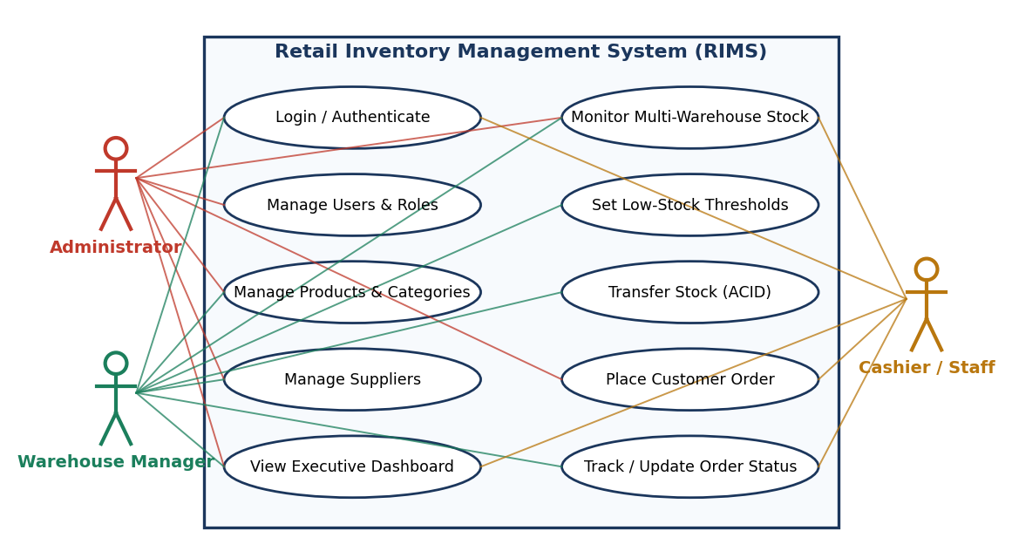
Figure 6.1: Use case diagram of RIMS

6.2 Data Flow Diagram (Level 0 and Level 1)
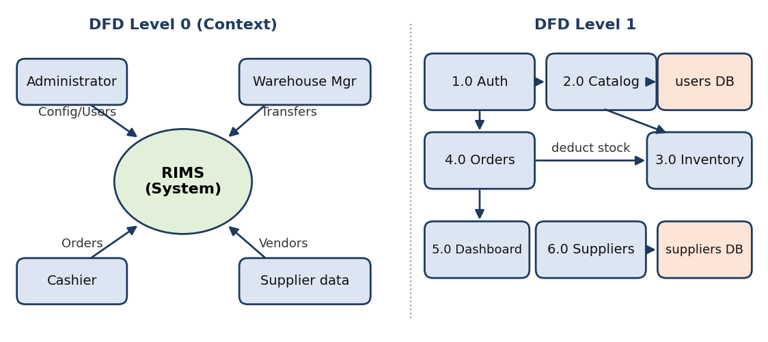
Figure 6.2: DFD Level 0 (context) and Level 1 (process decomposition)

6.3 Entity-Relationship Diagram and Data Dictionary
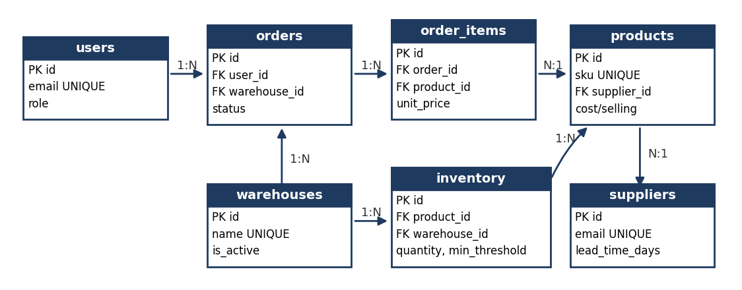
Figure 6.3: ER diagram of the seven MySQL tables
Table | Key Columns & Data Types | Constraints / Foreign Keys
users | id INT PK; name VARCHAR(100); email VARCHAR(150); password_hash VARCHAR(255); role ENUM(ADMIN, MANAGER, CASHIER) | email UNIQUE; role default CASHIER
products | id PK; sku VARCHAR(30); name VARCHAR(150); category VARCHAR(80); costprice, sellingprice DECIMAL(10,2); supplier_id INT | sku UNIQUE; prices >= 0; FK supplier_id → suppliers (SET NULL)
warehouses | id PK; name VARCHAR(100); location VARCHAR(200); is_active TINYINT(1) | name UNIQUE; is_active default 1
inventory | id PK; productid, warehouseid INT; quantity INT; min_threshold INT | UNIQUE(productid, warehouseid); quantity CHECK >= 0; FKs RESTRICT
suppliers | id PK; name VARCHAR(150); contactperson VARCHAR(100); email VARCHAR(150); phone VARCHAR(20); leadtime_days SMALLINT | email UNIQUE; leadtimedays default 7
orders | id PK; orderno VARCHAR(20); userid, warehouseid INT; customername VARCHAR(120); status ENUM(5 states); total_amount DECIMAL(12,2) | order_no UNIQUE; status default PENDING; FKs → users, warehouses (RESTRICT)
order_items | id PK; orderid, productid INT; quantity INT; unit_price DECIMAL(10,2) | orderid FK ON DELETE CASCADE; productid FK RESTRICT; quantity CHECK > 0

6.4 Activity Diagram – ACID Stock Transfer Workflow
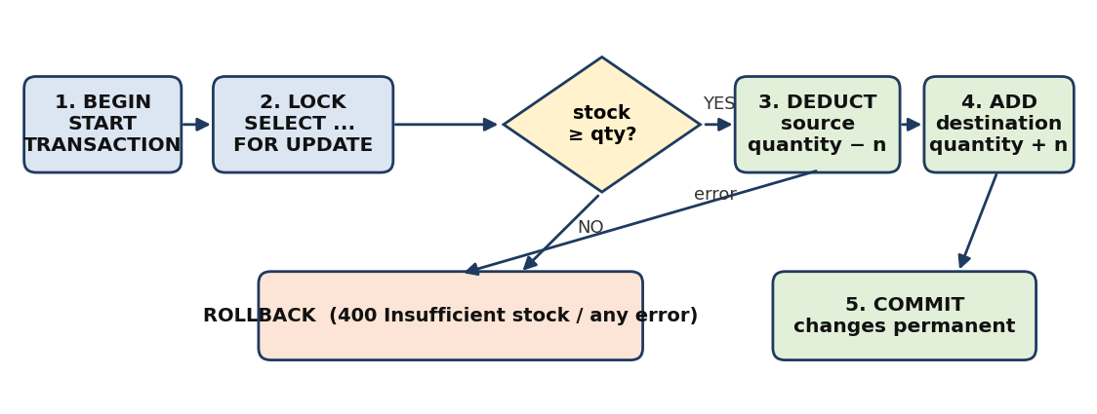
Figure 6.4: Begin → Lock → Check → Deduct → Add → Commit / Rollback
START TRANSACTION;
SELECT quantity FROM inventory WHERE product_id=? AND warehouse_id=? FOR UPDATE; -- lock source row
-- if quantity < requested: ROLLBACK; return 400 'Insufficient stock'
UPDATE inventory SET quantity = quantity - ? WHERE product_id=? AND warehouse_id=?; -- deduct
INSERT INTO inventory (product_id, warehouse_id, quantity) VALUES (?,?,?)
ON DUPLICATE KEY UPDATE quantity = quantity + VALUES(quantity); -- add
COMMIT; -- any error at any step: ROLLBACK

6.5 State Diagram – Order Lifecycle
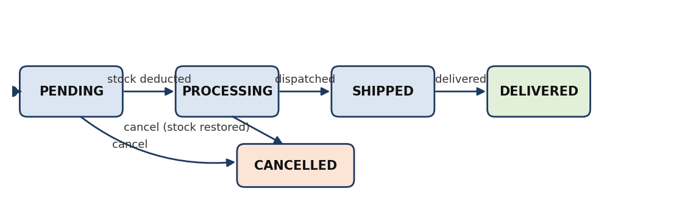
Figure 6.5: PENDING → PROCESSING → SHIPPED → DELIVERED / CANCELLED
Transitions are forward-only except cancellation. Cancelling a PENDING or PROCESSING order restores stock atomically; SHIPPED and DELIVERED orders cannot be cancelled.

6.6 Sequence Diagram – Customer Order Placement
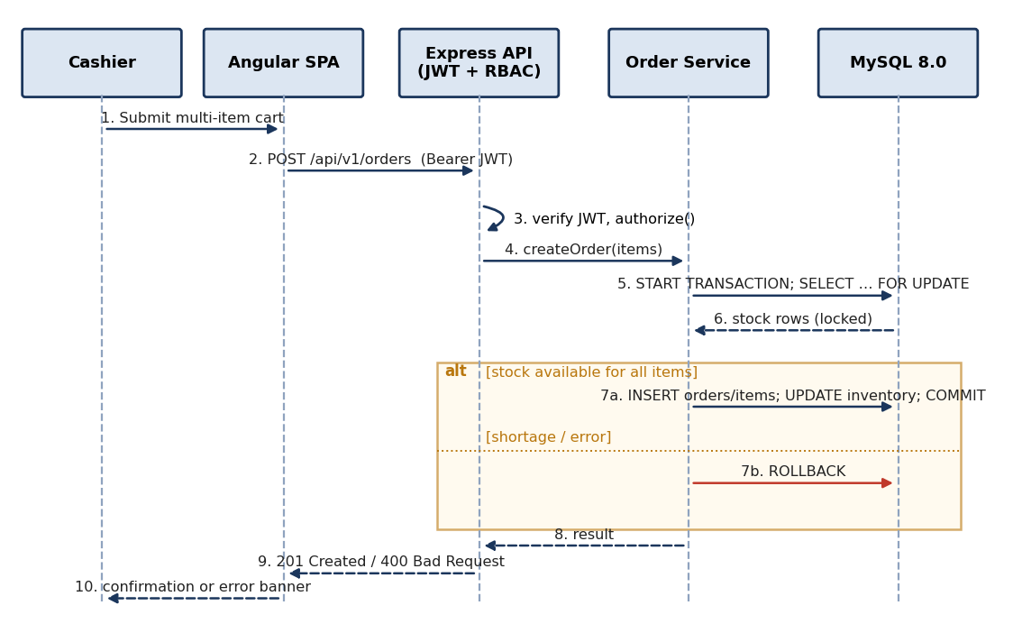
Figure 6.6: Order placement with transaction commit and rollback path

6.7 Agile / Scrum Sprint Roadmap (8 Epics across 15 Sprints)
Epic | Sprints | Sprint Goal | Key Deliverables
E1 Foundation & DevOps | S1–S2 | Repository, Docker Compose, CI skeleton, DB schema | Compose stack, Jenkinsfile, migrations
E2 Authentication & RBAC | S3–S4 | Secure login and role enforcement | JWT, Bcrypt, guards, interceptor
E3 Product & Category Catalog | S5–S6 | Catalog CRUD with SKU and margin | Product APIs/UI, SKU generator
E4 Warehouse & Inventory | S7–S8 | Stock matrix and low-stock alerts | Inventory APIs, alert banner
E5 Inter-Warehouse Transfer | S9 | ACID transfers | Transaction service, concurrency tests
E6 Order Fulfillment | S10–S11 | Multi-item cart, auto stock deduction | Order APIs/UI, lifecycle states
E7 Supplier Management | S12 | Vendor directory and lead times | Supplier CRUD/UI
E8 Dashboard, Hardening & Release | S13–S15 | KPI dashboard, security/performance hardening, UAT | Dashboard, Helmet/rate-limit, load tests, release

Two-week sprints with Planning, Daily Stand-up, Review and Retrospective. Definition of Done: code reviewed, tests passing, pipeline green, demonstrated to the Guide.

7. Academic Review & Sign-Off
This Software Requirements Specification document has been submitted and reviewed by the academic supervisory panel:
Project Coordinator / Guide | Internal Examiner | Head of Department (HOD)
Signature: ____________________  Date: ____________________ | Signature: ____________________  Date: ____________________ | Signature: ____________________  Date: ____________________

