1. Individual maize segmentation

**Step1**. Open files (.las, .xyz, .txt, etc.)

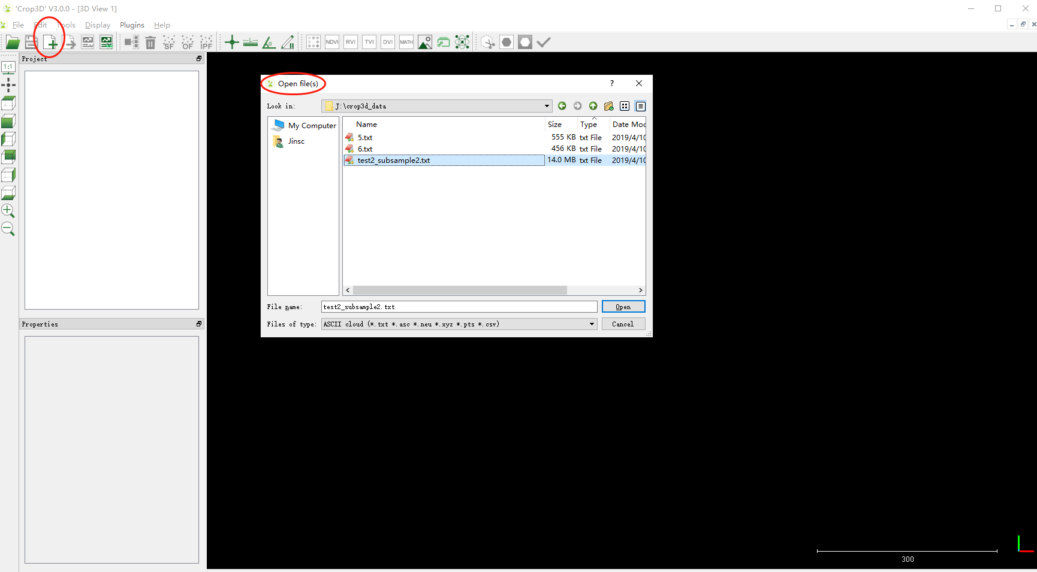

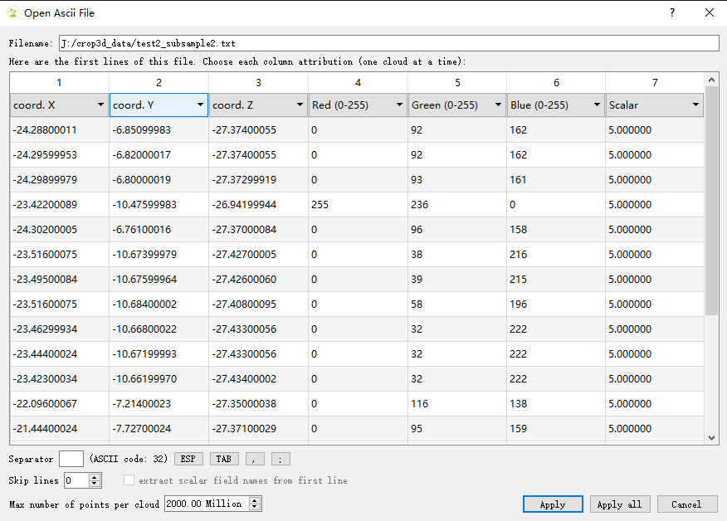

**Step 2.** Generate ground points

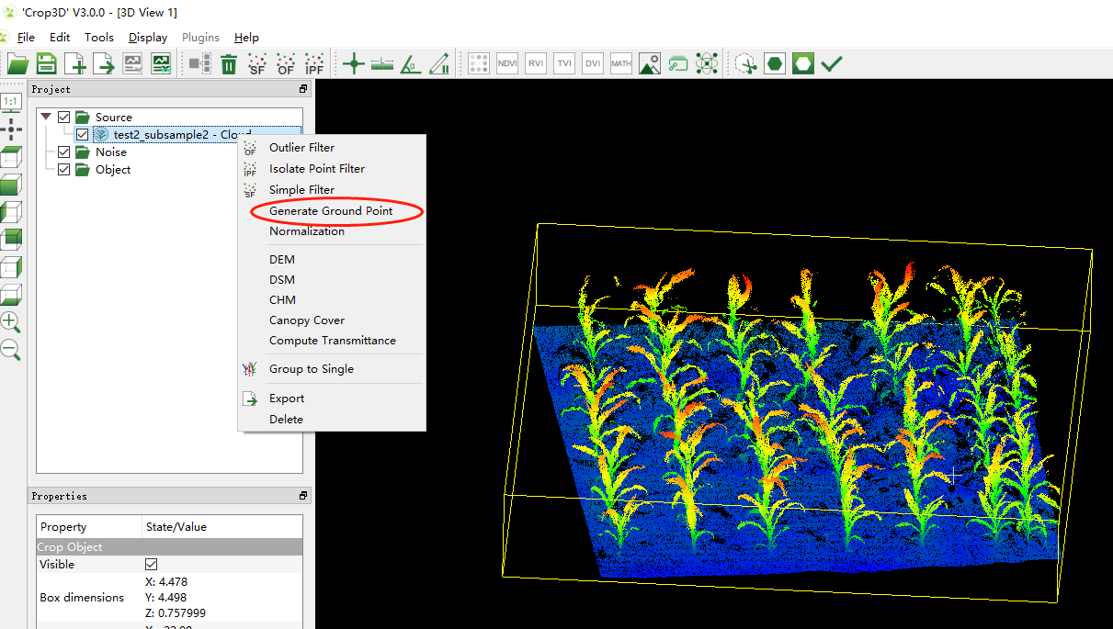

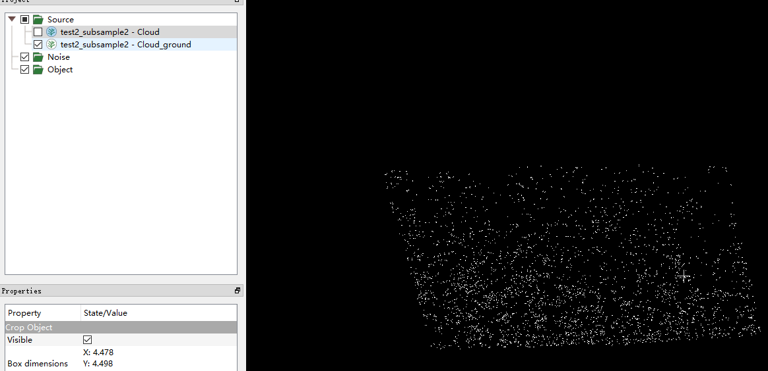

**Step3.** Data normalization with generated ground points (**Note**: the reason for data normalization is that it will increase the accuracy of individual segmentation)

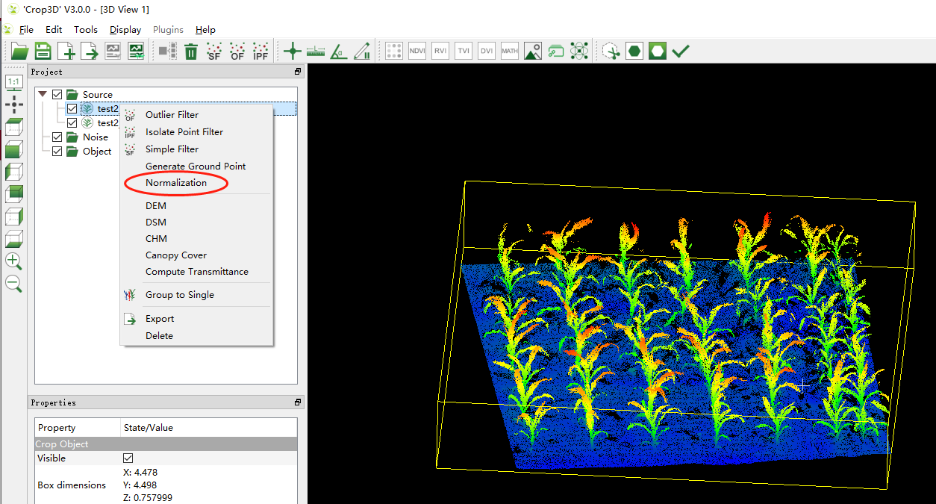

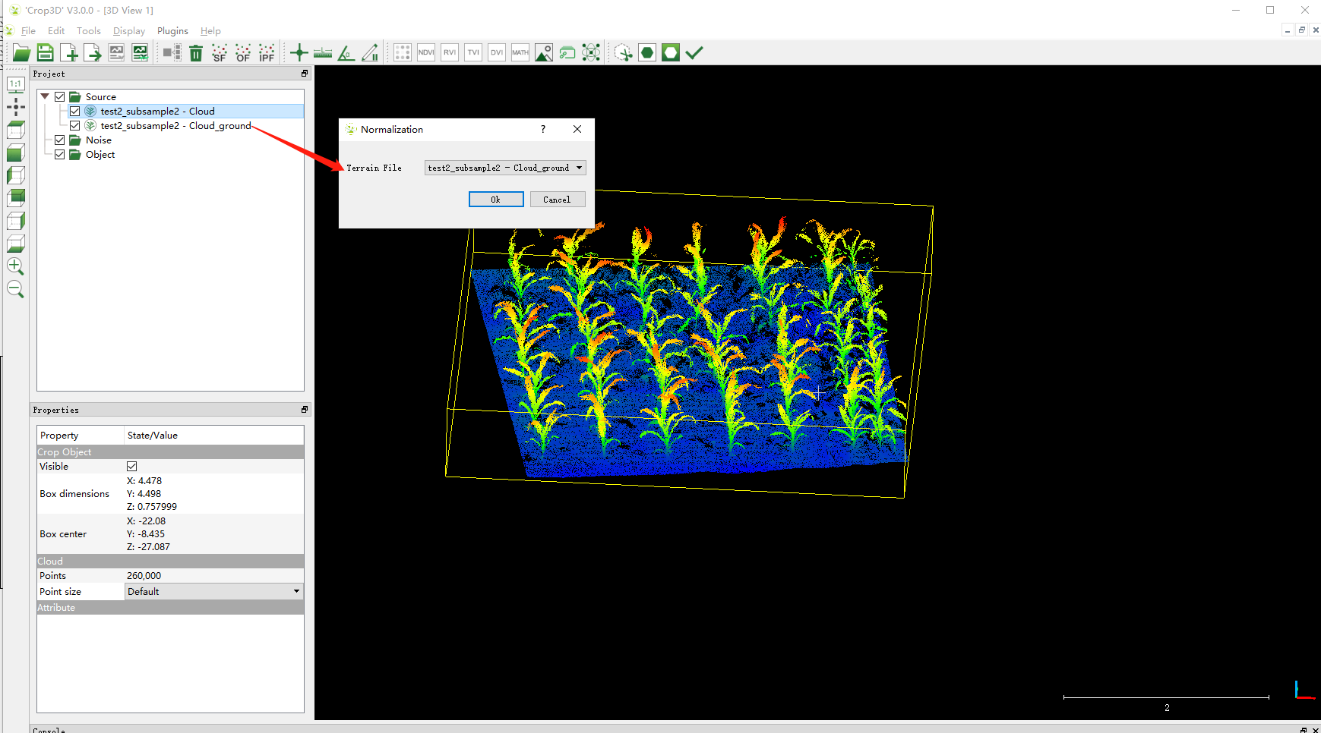

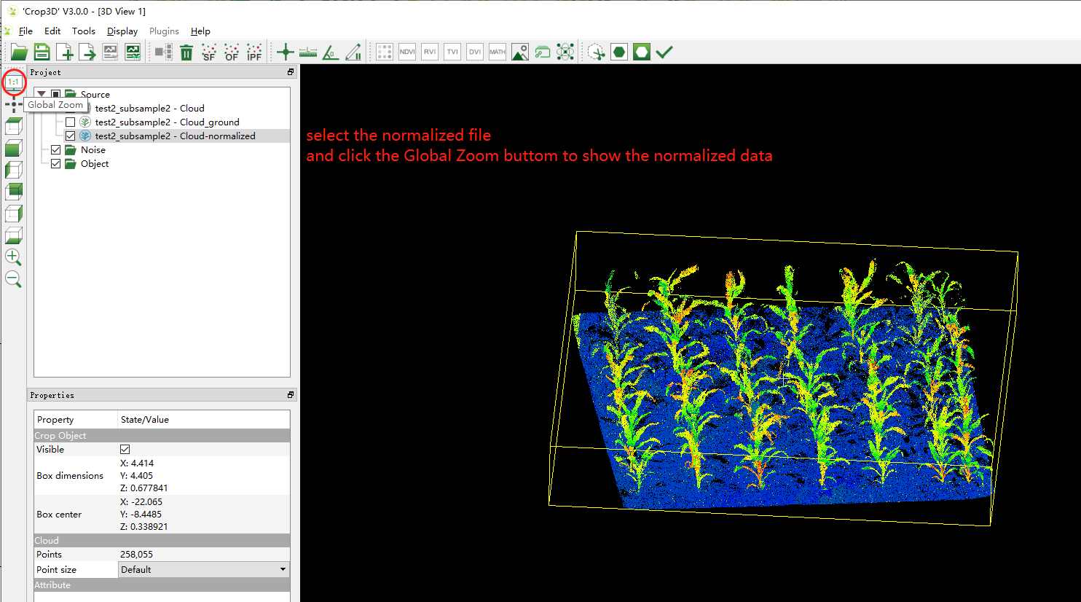

**Step4**. Individual segmentation with the normalized data (**Note**: this step requires a computer with a NVIDA GPU, and the memory depends on your data, which is usually higher than 4G.). For more details of the method, please refer to *Jin, S., Su, Y., Gao, S., Wu, F., Hu, T., Liu, J., Li, W., Wang, D., Chen, S., Jiang, Y., Pang, S., Guo, Q., 2018. Deep Learning: Individual Maize Segmentation From Terrestrial Lidar Data Using Faster R-CNN and Regional Growth Algorithms. Frontiers in Plant Science 9: 866-875*.

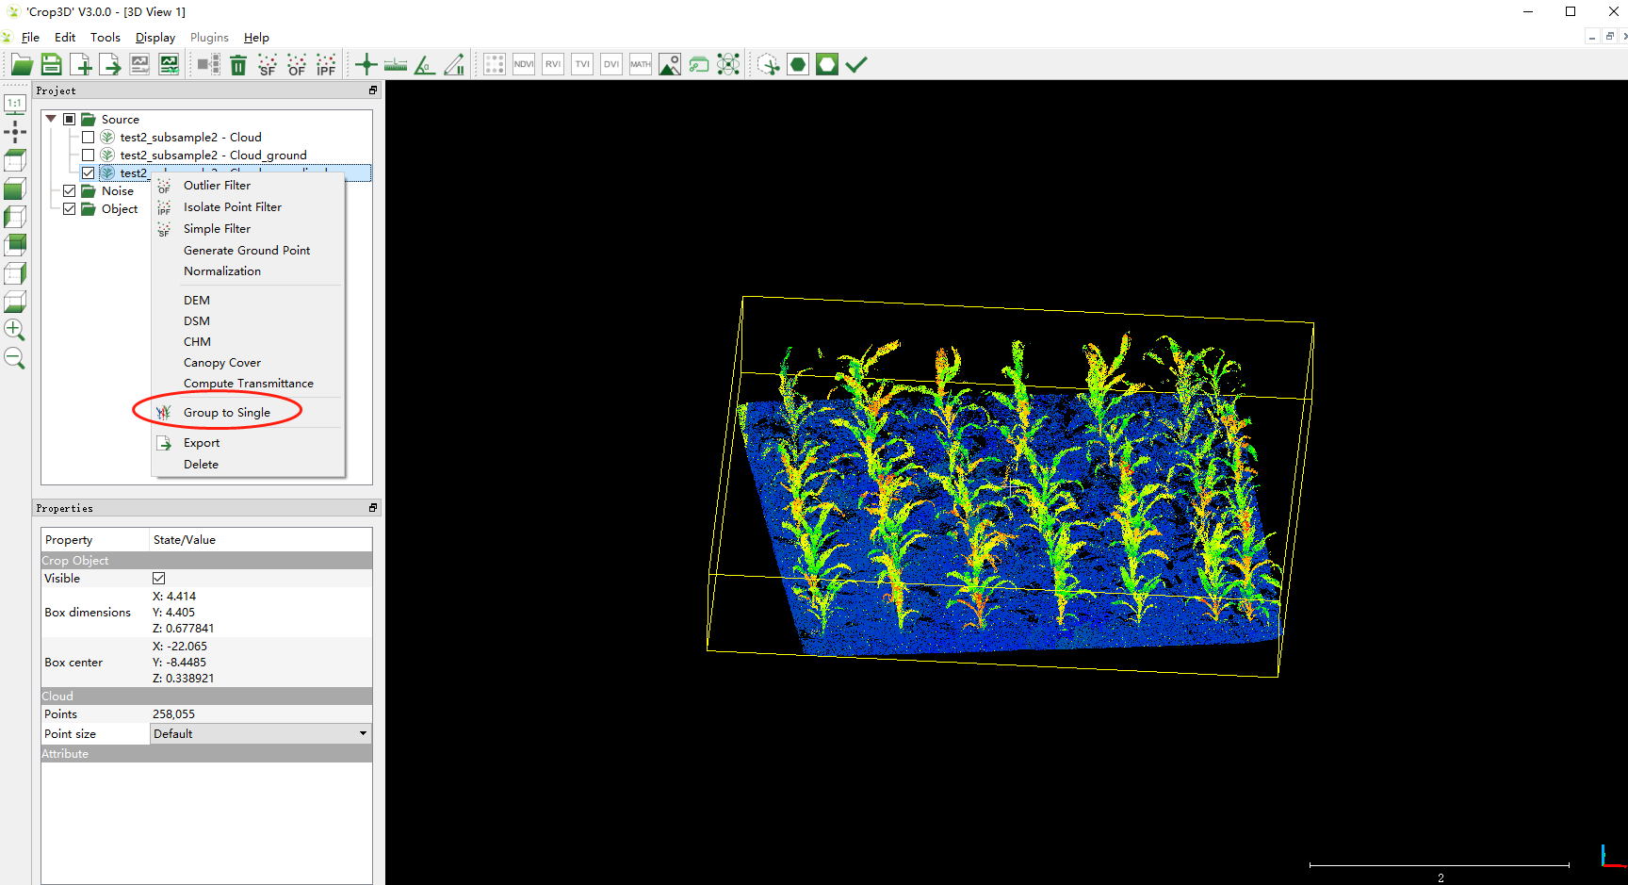

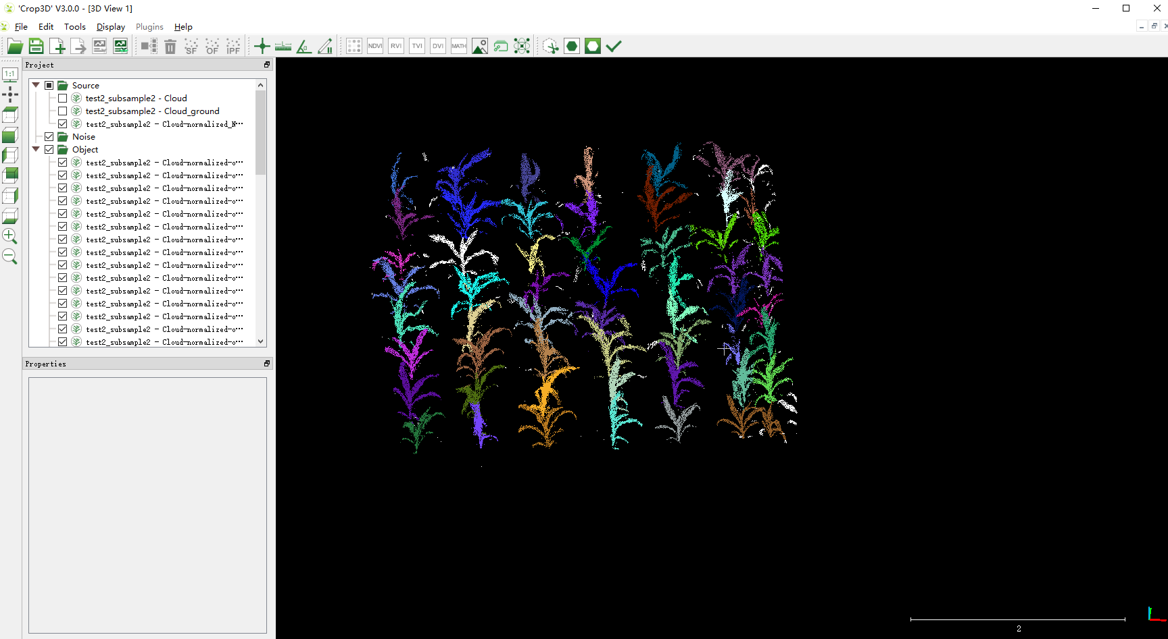

**Step5**. Results (maize location, height, crown size, projected leaf area, and 3D volume) can be exported by clicking the ***Statistic*** button.

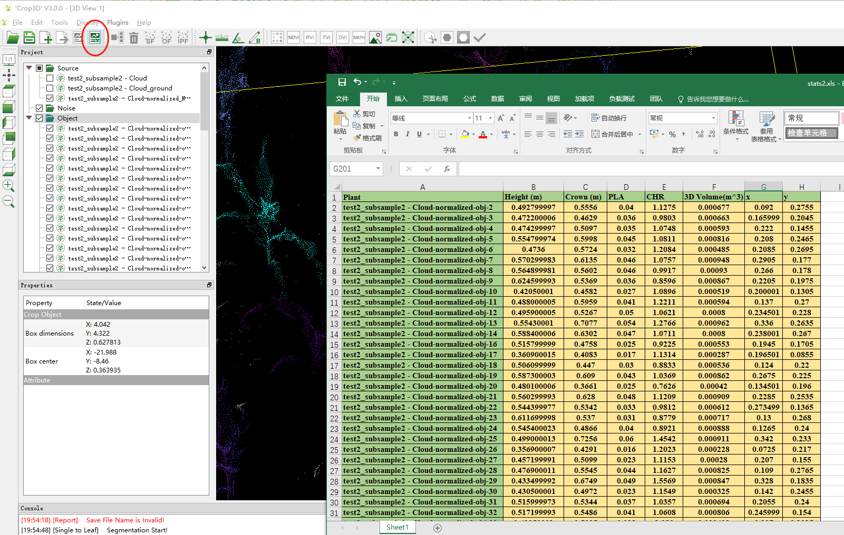

1. Stem-leaf segmentation

Step1: An individual maize exists in the ***Object*** tree (menu) can be segmented into stem and leaf instance using a regional growth segmentation method (**Note**: If you open an individual maize, the data will exists in ***Source*** tree by default and you have to drag it into the ***Object*** tree).

Parameters setting for the method can be found in *Jin, S., Su, Y., Wu, F., Pang, S., Gao, S., Hu, T., Liu, J., Guo, Q., 2018. Stem-Leaf Segmentation and Phenotypic Trait Extraction of Individual Maize Using Terrestrial LiDAR Data. IEEE Transactions on Geoscience and Remote Sensing, 1336-1346*.

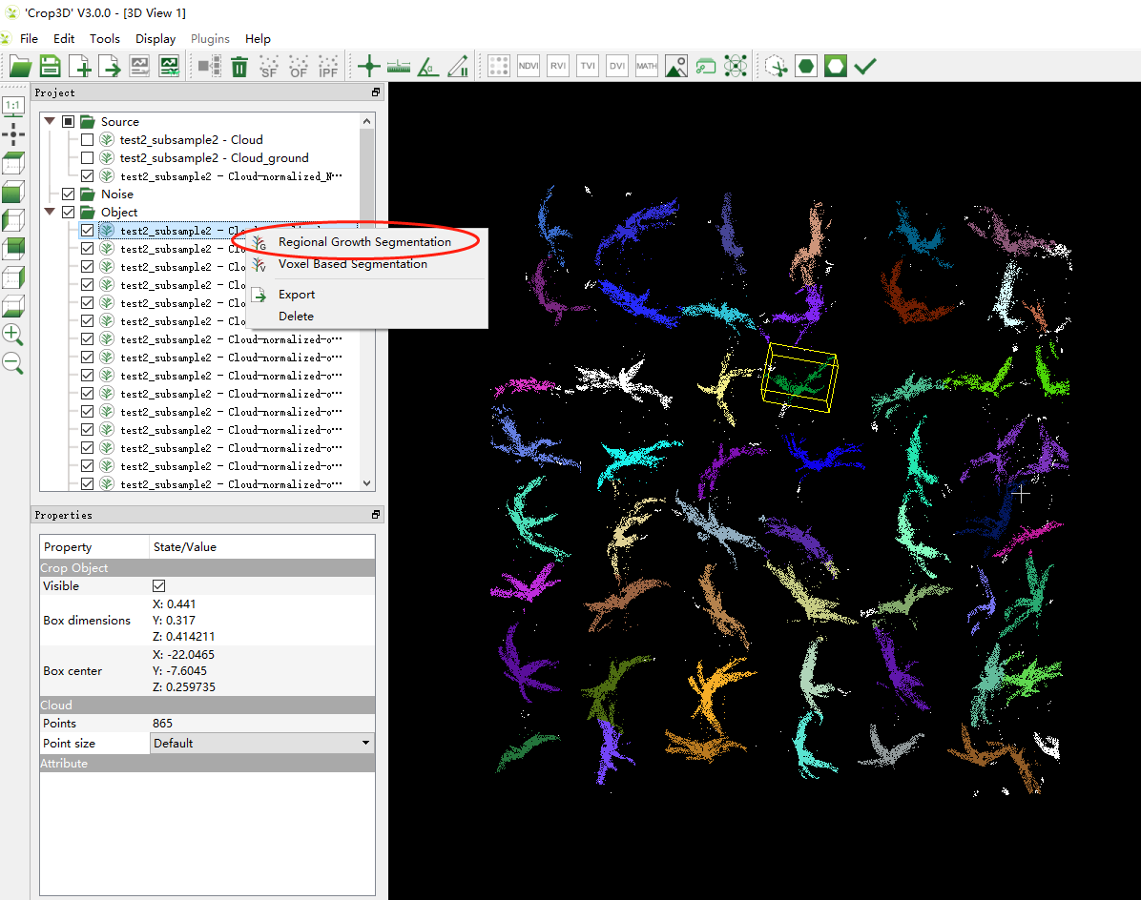

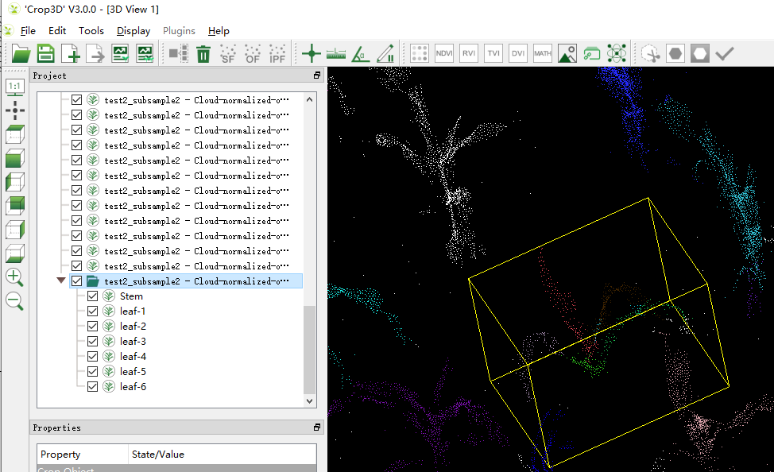

**Step2**. Results can be exported by clicking the ***Report*** button, which includes parameters at individual, stem, and leaf levels.

